Design and Development of iDetect: An OCR-Driven Discount ID Validity Checker System for Food Service Establishments in Valenzuela City

An Undergraduate Capstone Project Presented to the Faculty of
College of Engineering and Information Technology Department
Pamantasan ng Lungsod ng Valenzuela
Valenzuela City
In Partial Fulfillment of the Requirements for the Degree

Bachelor of Science in Information Technology

Presented by:
DE LOS REYES, CARLO M.
ENORIA, JORICH MARICAR C.
MERCADO, VESTI SAHM ANGIELO
SANTIAGO, ISHMAEL LUIS C.

May 2026

Table of Contents
Background of the Study 4
Project Context 8
Problem Statement 10
General Objective 13
Specific Objectives 14
Purpose and Description 19
Significance of the Study 24
For Local Government Units 25
For the Business Permit and Licensing Office 26
For Senior Citizens, Persons with Disabilities, and Government Revenue 26
For Academic Institutions 27
For Information Technology Research and Future Developers 28
Scope and Delimitation 29
Theoretical Framework 35
Routine Activity Theory 36
Fraud Management Lifecycle 40
The Eight Stages of the Fraud Management Lifecycle: 41
Application to Senior Citizen and PWD Discount Verification: 43
Integration of Theoretical Frameworks 44
Conceptual Framework 46
Definition of Terms 52
Technical Background 60
Optical Character Recognition (OCR) Technology 60
Database Integration and Real-Time Verification Architecture 62
Mobile Application Development for Point-of-Sale Environments 64
Review of Related Literature 65
Digital Identity Verification Systems and E-Government Integration 66
Fraud Detection and Prevention in Discount Programs 68
Mobile Point-of-Sale Verification Solutions and Usability Requirements 70
Philippine Senior Citizen and PWD Discount Implementation Challenges 72
Review of Related Systems 77
Philippine Local Government Unit Verification Platforms 77
Synthesis Matrix 85
Project Synthesis and Research Gap Identification 91
Key Findings from Literature Review 91
Critical Limitations of Existing Verification Systems 94
iDetect's Unique Contribution and Innovation 95
Research Justification and Expected Contributions 97
Success Metrics and Evaluation Framework 99
Table of Comparison 100
CHAPTER 3 DESIGN AND METHODOLOGY 101
Developmental Model (NA) 101
Research Design 102
Research Methodology 103
Research Instruments 103
Data Gathering Procedures 105
Ethical Considerations 106
Functional Requirements 113
Project Design 161
Existing System Context Diagram 162
Existing System Level 1 Diagram 163
Proposed System Context Diagram 166
Proposed System Level 1 Diagram 167
Proposed System Level 2 Diagram 175
Use Case Diagram 183
Entity Relationship Diagram 185
Database Dictionary 186
Activity Diagram 199
Testing and Evaluation Plan 212
Evaluation Tool 220
Test Cases 228
References: 249
Appendices: 257
Client Interview (Proof of Interview) 257
Transcription (Client Interview) 258
Project Planning 316
Work Breakdown Structure 316
Figure. 316
Work Breakdown Structure of IDetect 316
Work Breakdown Structure Dictionary 318
Critical Path Method 333
Critical Path Method 333
Gantt Chart 334
Stakeholder Engagement Plan 336
RACI Matrix 338
Picture of Exploratory Survey 341
Exploratory Requirements 342
Actual System Screenshot 343
IDetect Mobile App 343
BPLO Portal 344

CHAPTER I THE PROBLEM AND ITS BACKGROUND

Background of the Study
Senior citizens and persons with disabilities (PWDs) in the Philippines are legally entitled to significant government-mandated benefits under Republic Acts 9994 (Expanded Senior Citizens Act of 2010) and 10754 (An Act Expanding the Benefits and Privileges of Persons with Disability). These landmark legislations guarantee a 20% discount on goods and services and exemption from the 12% value-added tax (VAT), representing the government's commitment to protecting vulnerable populations and ensuring equitable access to essential commodities and services.
However, the implementation of these mandated discount programs faces a critical crisis that undermines their fundamental purpose. The proliferation of fraudulent identification cards has reached alarming proportions, with investigations revealing that fake PWD IDs outnumber legitimate credentials by nearly 5 to 1; approximately 8.5 million fraudulent IDs circulating compared to only 1.89 million legitimately registered PWDs (Bordey, 2024). This systematic exploitation resulted in ₱88.2 billion in lost government tax revenues in 2023 alone, as calculated by the Bureau of Internal Revenue, which has classified fraudulent PWD ID use as criminal tax evasion (Arceo, 2024).
The business sector bears substantial operational and financial burdens from this widespread fraud. Restaurant operators documented dramatic increases in discount claims; from approximately 5% of transactions in 2019 to over 30% by 2024, with industry losses approaching ₱166.1 billion in fraudulent discounts absorbed in 2023 compared to only ₱42.3 billion reaching legitimate beneficiaries (Arceo, 2024). Empirical evidence from major restaurant chains reveals the severity of validation challenges: one establishment reported rejecting 726 of 4,212 presented PWD IDs (17.24%) over a three-month period due to suspected fraudulent use (Arceo, 2024). Every fraudulent discount claimed comes directly from establishment margins, representing a structural financial burden that disproportionately affects food service businesses most frequently targeted by discount fraud (Arnaldo, 2024).
These validation failures create unintended consequences for legitimate beneficiaries. Businesses respond to pervasive fraud by implementing stricter validation procedures, developing skepticism toward all discount claimants, and subjecting authentic Senior Citizens and PWDs to uncomfortable interrogations, delayed transactions, and wrongful denials of entitled benefits. The Department of Justice issued clarifications in January 2025 noting that establishments cannot legally withhold privileges even when unable to validate authenticity immediately, as existing government registries do not yet contain complete listings of all eligible beneficiaries (Bautista, 2025). This places businesses in untenable positions, legally required to honor potentially fraudulent credentials or face ₱50,000–100,000 fines and 2–6 years imprisonment, yet lacking validation mechanisms capable of distinguishing legitimate from fraudulent claims.
Recognizing these challenges, local government units have initiated various anti-fraud measures. Valenzuela City Government launched the "Bawal ang Fake ID" campaign and introduced the VAL ID (Valenzuela ID Validation) Portal in May 2025, featuring newly designed identification cards with holographic seals and web-based validation capabilities (City Government of Valenzuela, 2025). Similarly, other municipalities developed dedicated platforms including the OSCA Taguig Senior Citizen ID Verification System and PDAO Taguig PWD ID Checker. At the national level, the Department of Social Welfare and Development announced the development of a unified PWD ID system, reflecting broader institutional recognition of the need for standardized credential management across the country (Serquiña, 2024).
Despite these initiatives, a critical gap persists in the validation ecosystem. Existing systems require manual data entry consuming 30–45 seconds per transaction, operate as one-way validation tools without mechanisms to automatically report suspicious credentials back to issuing authorities, are geographically restricted to single municipalities preventing cross-jurisdictional validation, and function as isolated solutions rather than integrated networks enabling coordinated fraud intelligence. Contemporary research on digital identity validation demonstrates that integrated systems achieve 70% or higher fraud reduction through coordinated intelligence sharing and real-time cross-validation (Protecht Group, 2025), yet no current Philippine platform combines automated data capture, real-time dual-database validation, mobile accessibility for point-of-sale environments, and bidirectional fraud reporting within a unified architecture.
International examples provide proven architectural patterns for addressing these challenges. Estonia's X-Road infrastructure processes over 2.7 billion data queries annually through a decentralized data exchange layer connecting independent agency databases, demonstrating that distributed validation architectures can maintain institutional sovereignty while enabling comprehensive cross-agency integration (Frost & Sullivan Institute, 2025). While the Estonian model operates within a distinct governance context, its core architectural principle; that multiple independent databases can be queried simultaneously through a unified interface without compromising data ownership, directly informs the multi-portal design approach explored in this study. Research on optical character recognition establishes that contemporary systems achieve 95–99% accuracy on standardized documents, with mobile implementations capable of real-time processing at 62 frames per second on mid-range smartphones (Liu et al., 2022; Gayer et al., 2023). These technological capabilities, when adapted to Philippine implementation contexts, create opportunities for transformative improvements in discount program validation.
Contemporary data privacy legislation establishes beneficiary rights extending beyond passive credential validation. The Data Privacy Act of 2012 (Republic Act 10173, Section 16) grants data subjects the right to reasonable access to their personal information and the ability to dispute inaccuracies or errors in such data. This legal framework, combined with Department of Justice clarifications requiring provisional approval even for unverifiable credentials, creates regulatory expectations that validation systems must enable beneficiary participation in validation processes rather than positioning vulnerable populations as passive subjects of institutional systems from which they have no recourse or visibility.

Project Context
This study is situated within the broader context of digital transformation efforts in Philippine local governance, specifically addressing the intersection of social welfare service delivery, fraud prevention, and technology-enabled business-government coordination. The project responds to the documented systemic failures in Senior Citizen and PWD discount validation detailed in the preceding section, where conventional manual approaches have proven inadequate in preventing the proliferation of fraudulent credential use.
The Philippine implementation context presents unique challenges absent in international digital identity systems. Unlike Estonia's unified infrastructure with near-universal digital ID adoption or Singapore's centralized SingPass platform (Goede, 2019), Philippine beneficiary data resides in over 1,700 independent local government unit databases with varying digitization levels, technical sophistication, and data quality standards. Research found that only 60% of Philippine LGUs have established operational Persons with Disability Affairs Offices as mandated by RA 10070, implying that 40% of municipalities and cities lack dedicated offices for PWD services, credential issuance, and validation support (Alampay et al., 2018).
This institutional fragmentation creates fundamental validation challenges. Senior Citizen and PWD identification cards lack standardized formats across issuing authorities, with designs varying by municipality, as the decentralized LGU-based issuance structure inherently produces inconsistent card formats across jurisdictions (House of Representatives, 2024). While the NCDA Executive Director publicly announced in December 2024 that a unified PWD ID and database system was under development (De Villa, 2025), the formal inter-agency mechanism to design and implement it was only established through NCDA Board Resolution No. 5, Series of 2025 (NCDA, 2025), and actual implementation across all LGUs remains incomplete as of the time of this writing. Consequently, establishments cannot authenticate credentials through visual security inspection alone, and forged IDs remain difficult to detect without database validation, yet database fragmentation prevents comprehensive cross-jurisdictional validation.
The technological landscape of existing validation solutions reveals substantial functional gaps. Local platforms; including the OSCA Taguig Senior Citizen ID Verification System, PDAO Taguig PWD ID Checker, and the VAL ID Valenzuela Portal, provide real-time database connectivity but remain fundamentally limited by the characteristics described in the preceding section: manual data entry requirements, geographic restriction to single municipalities, the lack of optical character recognition automation, and operation as one-way validation tools without bidirectional fraud reporting. National systems such as eVerify focus on PhilSys credentials rather than LGU-issued Senior Citizen and PWD IDs, creating a scope misalignment with discount validation requirements. International commercial solutions including Jumio and BlinkID demonstrate advanced technical capabilities but lack integration with local OSCA and PDAO databases and the absence of fraud reporting mechanisms enabling coordination between businesses and government authorities.
Within this context, iDetect represents a response grounded in both proven technological approaches and careful adaptation to Philippine institutional realities. The system addresses validation challenges through an integrated multi-portal architecture synthesizing automated OCR-based data extraction, validation against the single beneficiary registry, scoped by ID type, mobile-first design optimized for point-of-sale transaction speed, and bidirectional fraud reporting that creates fraud intelligence-sharing networks between business establishments and government administrative offices. Equally significant is the system's provision for beneficiary accountability, through real-time transaction notifications, transparent status monitoring, and a structured dispute resolution mechanism, iDetect positions Senior Citizens and PWDs as active and informed participants in the validation process rather than passive subjects with no visibility into how their credentials are being used. This comprehensive approach distinguishes iDetect from existing fragmented solutions, positioning it as a scalable model for strengthening social welfare program integrity while protecting legitimate beneficiaries' statutory rights.
These contextual realities frame the specific problems that iDetect addresses, as detailed in the following section.

Problem Statement
The continued misuse of fake Senior Citizen and PWD identification cards has created a multi-dimensional crisis affecting government revenues, business operations, and legitimate beneficiaries' access to statutory entitlements. As documented in the preceding section, the proliferation of fraudulent credentials has reached unprecedented proportions, with 8.5 million fake PWD IDs circulating compared to only 1.89 million legitimate registrations; a 4.5:1 ratio that fundamentally undermines the integrity of government-mandated discount programs under Republic Acts 9994 and 10754.
The economic consequences are severe and measurable. Government tax revenues lost ₱88.2 billion in 2023 due to fraudulent discount transactions, while businesses absorbed ₱166.1 billion in fraudulent discounts, exceeding the ₱42.3 billion provided to legitimate beneficiaries (Bordey, 2024). One major restaurant chain's experience exemplifies operational impact, rejecting 17.24% of presented PWD IDs as suspected fraudulent over a three-month period, representing nearly one in five credentials failing basic authenticity checks (Arceo, 2024). These validation failures translate to substantial financial losses for establishments: the combined 20% discount and 12% VAT exemption means businesses lose approximately 32% of transaction value when fraudulent IDs succeed.
Current validation approaches have proven inadequate in addressing this crisis. Existing platforms; including the OSCA Taguig Senior Citizen ID Verification System, PDAO Taguig PWD ID Checker, and Valenzuela City's VAL ID Portal, demonstrate four critical limitations that prevent comprehensive fraud prevention:
Manual data entry requirements consuming 30–45 seconds per transaction create operational bottlenecks in high-volume business environments, where validation delays accumulate to cause customer queue extensions and workflow disruptions.
Geographic restrictions limiting validation to single municipalities create problems for businesses serving broader populations, requiring multiple platform usage for comprehensive coverage.
Absence of optical character recognition automation forces staff to manually type ID details from physical cards, introducing transcription errors and consuming time that compounds across thousands of daily transactions.
One-way validation architecture represents the most critical limitation, establishments can query databases to check credentials, but no automated mechanisms exist to report suspicious IDs back to issuing authorities, creating a fundamental disconnect in the fraud prevention ecosystem.
This fragmented approach produces cascading consequences across stakeholder groups. Businesses face untenable legal positions: Department of Justice clarifications prohibit denying discounts even for unverifiable credentials, yet establishments absorb ₱166.1 billion in fraudulent discounts annually while risking ₱50,000–100,000 fines for wrongful denial. Local government units lack the fraud intelligence necessary for targeted investigations, as suspicious credentials identified by establishments during transactions are not systematically reported or tracked. Legitimate Senior Citizens and PWDs experience prolonged validation scrutiny, inconsistent treatment across establishments, and wrongful denials as businesses develop skepticism toward all discount claimants. Government revenues continue declining as systematic fraud exploitation persists unchecked.
The core problem is the absence of an integrated validation system combining five essential capabilities: (1) automated data capture through OCR technology eliminating manual entry bottlenecks; (2) validation querying the single beneficiary registry, scoped by ID type; (3) mobile accessibility optimized for point-of-sale use without requiring desktop access; (4) bidirectional fraud reporting and intelligence sharing enabling suspicious credentials to be automatically flagged and coordinated across all connected establishments and government authorities; and (5) beneficiary accountability mechanisms enabling Senior Citizens and PWDs to monitor their own credential activity, dispute erroneous denials, and report unauthorized use in compliance with Republic Act 10173 Section 16 data subject rights. A critical accountability gap exists when validation systems generate false positives, legitimate beneficiaries wrongly flagged due to database errors, OCR misreads, or outdated records currently have no mechanism to view their validation status, understand denial reasons, or dispute incorrect flags. This power imbalance, where vulnerable populations face system-generated barriers without recourse while businesses and government agencies possess complete information asymmetry, directly violates the spirit of the Data Privacy Act. Without such comprehensive integration, Valenzuela City continues experiencing escalating fraud incidents, financial losses for establishments, incomplete fraud intelligence for local government units, wrongful denials affecting legitimate beneficiaries, and operational barriers affecting all stakeholders in the validation ecosystem.
In response to these documented deficiencies, this study addresses the following research questions:
- How can an OCR-based mobile validation system reduce the time required to authenticate Senior Citizen and PWD identification cards at food service establishments in Valenzuela City compared to current manual validation methods?
- To what extent can validation against the single beneficiary registry, scoped by ID type, combined with a bidirectional fraud reporting and synchronization pipeline, reduce the acceptance of fraudulent credentials among participating establishments?
- How can a multi-portal role-based architecture enable coordinated fraud intelligence sharing between business establishments and Valenzuela City's local government units while maintaining compliance with the Data Privacy Act of 2012 (Republic Act 10173)?
- How does the inclusion of a beneficiary-facing dispute resolution and notification mechanism address the accountability gap experienced by legitimate Senior Citizens and PWDs who are wrongfully denied statutory discount privileges?
- How does iDetect perform against the ISO 25010 quality characteristics; specifically functional suitability, performance efficiency, usability, reliability, and security, as evaluated by business establishment staff, LGU personnel, and Senior Citizen and PWD beneficiaries?

General Objective
This study aims to design, develop, and evaluate iDetect, an integrated OCR-based identification validation system that connects food service establishments in Valenzuela City with local government unit databases through a five-portal architecture enabling efficient, accurate, and automated validation of Senior Citizen and PWD identification cards. The system provides establishments with a reliable, secure, and mobile-accessible platform for validating credentials, prevents fraud through coordinated intelligence sharing, and facilitates real-time bidirectional communication with local government units to ensure the integrity of government-mandated discount programs under Republic Acts 9994 and 10754.
The system operates through five integrated portals serving distinct stakeholder groups: (1) a Client Portal enabling business establishment staff to perform automated OCR-based validation with real-time database cross-checking; (2) a BPLO Portal enabling the Business Permit and Licensing Office to manage establishment accounts and monitor system operations without accessing sensitive beneficiary data; (3) an OSCA Portal enabling the Office of Senior Citizens Affairs to receive flagged credentials, conduct investigations, and update official records; (4) a PDAO Portal providing parallel functionality for the Persons with Disability Affairs Office in managing PWD credential validation and fraud investigation; and (5) a Beneficiary Mobile Application enabling Senior Citizens and PWDs to monitor validation status, receive transaction notifications, dispute erroneous denials through structured review processes, and report unauthorized use of their credentials.
Through this comprehensive approach, iDetect aims to reduce fraudulent credential acceptance, accelerate validation processing time, strengthen business-government coordination, protect legitimate beneficiaries from wrongful denial, ensure Data PrTo design an OCR-based validation workflow that optimizes mobile camera capture through real-time image quality assessment, automated preprocessing (deskewing, contrast enhancement, noise reduction), confidence-based automatic processing or manual review thresholds, and instant visual feedback guiding users toward optimal capture conditions.ivacy Act compliance, and support equitable implementation of discount programs across Valenzuela City.

Specific Objectives
This study aims to achieve the following objectives across three development phases:
A. Design Objectives
- To design a five-portal role-based architecture integrating Client (mobile), BPLO (web), OSCA (web), PDAO (web), and Beneficiary (mobile) portals with strict data compartmentalization between Senior Citizen and PWD databases, role-specific access controls for each stakeholder group, and accessible interfaces employing large touch targets, high-contrast color schemes, and minimal text input requirements in conformance with WCAG 2.1 AA standards.
- To design an OCR-based verification workflow that optimizes mobile camera capture through real-time image quality assessment, automated preprocessing (deskewing, contrast enhancement, noise reduction), and instant visual feedback guiding users toward optimal capture conditions.
- To design a bidirectional fraud intelligence pipeline enabling one-tap suspicious credential flagging by establishment staff, with automatic routing to appropriate LGU portals, complete transaction context transmission, and real-time fraud confirmation synchronization across all connected portals.
- To design beneficiary accountability mechanisms that provide Senior Citizens and PWDs with real-time transaction notifications, ID status monitoring, structured dispute submission with supporting documentation upload, and resolution tracking in compliance with Republic Act 10173 data subject rights.
- To design fraud analytics dashboards for LGU administrators visualizing temporal patterns, geographic distribution of flagged credentials, establishment-specific trends, and flagged-to-confirmed conversion rates to support evidence-based investigation and resource allocation.
B. Development Objectives
- To develop a Tesseract OCR integration capable of field-level extraction of ID number, full name, beneficiary type, validity period, and issuing office, with confidence scoring to determine automatic processing or manual review thresholds, and a preprocessing pipeline optimized for non-standardized Philippine LGU credential formats.
- To develop a validation engine that queries the single beneficiary registry, scoped by ID type, through secure RESTful API integration, returns a validation status (VALID, SUSPICIOUS, INVALID, or MANUAL REVIEW) without exposing beneficiary personal data to establishments, and completes validation cycles in under 30 seconds from capture to result display.
- To develop a bidirectional fraud intelligence pipeline that transmits suspicious credential flags from the Client Portal to appropriate LGU portals with captured ID image, extracted data, establishment identification, timestamp, and validation outcome, and propagates confirmed fraudulent credential status updates in real time across all connected Client Portal instances, transforming isolated detection events into coordinated network-wide prevention.
- To develop a beneficiary dispute resolution and notification system that enables structured report submission with pre-populated transaction details, denial reason selection, optional supporting documentation upload, automatic routing to OSCA or PDAO investigation queues, and resolution notification delivery via SMS and push notifications.
- To develop a role-based authentication and authorization system implementing two-factor authentication for beneficiary accounts, business permit validation for establishment accounts, and institutionally issued credential validation for BPLO, OSCA, and PDAO administrators, ensuring that each portal exposes only the data and functions appropriate to its user role.
- To develop a comprehensive audit logging infrastructure recording all validation attempts, fraud flags, database modifications, dispute submissions, and administrative actions with immutable timestamps, user attribution, and complete transaction context, supporting both RA 10173 compliance and ISO 25010 security characteristic evaluation.
C. Evaluation Objectives
The IDETECT system will be evaluated against the following ISO 25010 quality characteristics:
1. Functional Suitability
- Functional Completeness: All specified user functions for verification, management, and reporting are implemented.
- Functional Correctness: OCR accuracy, database cross-checking, and discount calculations produce correct results.
- Functional Appropriateness: Features align with stakeholder needs and regulatory compliance requirements.
2. Performance Efficiency
- Time Behavior: Verification transactions complete in under 30 seconds; system response time meets real-time requirements.
- Resource Utilization: Optimal use of mobile device resources, server capacity, and network bandwidth.
- Capacity: System handles concurrent users across multiple establishments without degradation.
3. Compatibility
- Co-existence: System operates alongside existing LGU databases and business systems.
- Interoperability: Seamless integration with the OSCA and PDAO records held in one beneficiary registry; API compatibility for future extensions.

4. Usability
- Appropriateness Recognizability: Users can readily understand system capabilities and functions.
- Learnability: New users achieve proficiency in verification processes with minimal training.
- Operability: Interface design supports efficient task completion for all user roles.
- User Error Protection: System prevents incorrect operations and provides clear guidance.
- User Interface Aesthetics: Visual design is professional, accessible, and culturally appropriate.
- Accessibility: Interface accommodates users with varying technical literacy and abilities.
5. Reliability
- Maturity: System operates without frequent failures during normal operation.
- Availability: System maintains 99% uptime during business hours.
- Fault Tolerance: Graceful handling of network interruptions, poor image quality, and database connection issues.
- Recoverability: Data integrity maintained and quick recovery from failures.
6. Security
- Confidentiality: Beneficiary personal information protected from unauthorized access.
- Integrity: Verification data and audit logs cannot be tampered with.
- Non-repudiation: All transactions are logged with complete traceability.
- Accountability: User actions are tracked and attributable to specific accounts.
- Authenticity: User identities and establishment credentials are verified.

7. Maintainability
- Modularity: System components can be modified independently.
- Reusability: Code components can be reused for future enhancements.
- Analyzability: System logs and diagnostics support troubleshooting.
- Modifiability: System can be updated to accommodate new requirements or regulations.
- Testability: Comprehensive testing can be performed on all system functions.
8. Portability
- Adaptability: System functions across different mobile devices and operating systems (Android, iOS).
- Installability: Easy deployment to business establishments and government offices.
- Replaceability: System can integrate with or replace existing manual verification processes.

Purpose and Description
The purpose of this study is to design, develop, and evaluate iDetect, an integrated OCR-based identification validation system that enables food service establishments in Valenzuela City to efficiently and accurately authenticate Senior Citizen and PWD identification cards while creating coordinated fraud prevention networks between businesses and local government units. As established in the problem statement, the project addresses the documented crisis where fake IDs outnumber legitimate credentials 4.5 to 1.
iDetect responds to fundamental limitations in existing validation approaches by integrating four capabilities absent in current fragmented solutions: automated data extraction through Optical Character Recognition technology, validation querying the single beneficiary registry, scoped by ID type, mobile-first architecture optimized for point-of-sale transaction speed, and a bidirectional fraud intelligence pipeline enabling automatic flagging to appropriate government authorities and real-time synchronization of confirmed fraud status across all connected establishments.
The system comprises five interconnected portals serving distinct stakeholder groups with appropriate functional boundaries and data access controls:
Client Portal (Mobile Application) enables food service establishment staff to capture ID images through smartphone cameras, automatically extract credential data via Tesseract OCR with field-level validation, validate authenticity in real-time against authoritative government databases, receive instant validation results (VALID, SUSPICIOUS, INVALID, or MANUAL REVIEW) with clear visual indicators, flag suspicious credentials for automatic transmission to appropriate LGU offices, access transaction history for audit purposes, and manually input ID details when OCR confidence is insufficient. The mobile-first design eliminates desktop access requirements, enabling validation directly at point of sale without workflow disruption.
BPLO Portal (Web-based) enables the Business Permit and Licensing Office to verify and approve legitimate establishment accounts, manage business access including approval, suspension, and revocation capabilities, monitor technical performance metrics, coordinate technical issue resolution, and access operational dashboards. Critical functional boundary: BPLO maintains administrative oversight without accessing flagged ID records or personal beneficiary information, ensuring clear separation between business account management and validation intelligence functions.
OSCA Portal (Web-based) enables the Office of Senior Citizens Affairs to manage the Senior Citizen ID database, receive notifications of flagged credentials within seconds with complete transaction context, review and investigate suspicious credentials, mark confirmed fraudulent IDs preventing future successful use, and generate fraud analytics reports including temporal patterns and geographic distribution. Strict data compartmentalization ensures OSCA accesses only Senior Citizen data without visibility into PWD records.
PDAO Portal (Web-based) provides parallel functionality for the Persons with Disability Affairs Office with identical capabilities for PWD credential management: database administration, real-time flagged ID notifications, investigation workflows, fraudulent credential marking, and analytics generation. Data compartmentalization ensures PDAO accesses only PWD data without visibility into Senior Citizen records.
Beneficiary Mobile Application (Mobile Application for iOS and Android) enables Senior Citizens and PWDs to exercise Data Privacy Act rights and participate actively in validation processes rather than serving as passive subjects of system decisions. The application addresses the power imbalance inherent in one-way validation architectures by providing four core accountability capabilities.
Real-Time Transaction Transparency. Upon each validation attempt at participating establishments, beneficiaries receive immediate notifications via SMS and push notifications detailing business name, transaction timestamp, validation outcome (Approved or Denied), and specific denial reasons when applicable; such as ID number mismatch, database record not found, or ID expired. This transparency mechanism enables beneficiaries to detect unauthorized credential use within minutes rather than discovering fraud through unexpected service denials, and allows legitimate beneficiaries to immediately understand and contest system decisions affecting their statutory rights.
Self-Service Status Monitoring. Beneficiaries authenticate using their ID number paired with their birthdate, matching information already printed on physical credentials, verified through a one-time PIN sent to their registered mobile number. Upon authentication, the application displays current ID status synchronized with the OSCA and PDAO records in the beneficiary registry, last successful validation details, upcoming expiration dates, and issuing office contact information. This capability allows beneficiaries to proactively verify their standing before attempting discount transactions, reducing anxiety associated with potential denial and enabling advance correction of database discrepancies.
Structured Dispute Resolution. When beneficiaries receive denial notifications for transactions they believe should succeed, the application provides a standardized dispute mechanism: (1) select the flagged transaction from notification history with pre-populated business details and denial reason, (2) choose a dispute category; Wrong Denial (I Am Valid), ID Used Without My Authorization, Business Refused Provisional Approval, or Database Contains Incorrect Information, (3) provide a brief written explanation, (4) optionally upload supporting documentation such as a physical ID photo or barangay certification, and (5) submit directly to the appropriate OSCA or PDAO portal for staff review. The system enforces service-level agreements: automatic acknowledgment notification within 24 hours, status updates as OSCA or PDAO staff review evidence, and final resolution notification with explanation upon case closure. All disputes are reviewed by OSCA or PDAO personnel; not automated systems, ensuring human judgment and institutional authority govern accountability processes. This workflow transforms opaque denial processes into transparent, accountable review mechanisms where beneficiaries can challenge system errors with documented evidence and guaranteed response timelines.
Bidirectional Fraud Reporting. The application inverts traditional fraud detection by enabling beneficiaries to report incidents that businesses and administrative systems cannot independently detect: (1) unauthorized use alerts when their ID is used at establishments they did not visit, prompting immediate flagging to OSCA or PDAO if confirmed unauthorized, (2) business refusal reports when establishments deny discounts despite system approval, documenting potential DOJ Opinion violations for BPLO investigation, and (3) database discrepancy alerts when beneficiaries notice incorrect personal information in their displayed records, triggering OSCA or PDAO validation and correction processes. These beneficiary-initiated reports create upward accountability flows contributing fraud intelligence that businesses and government agencies cannot independently generate.
The integrated architecture creates a bidirectional accountability ecosystem, transforming one-way surveillance into mutual verification where businesses validate beneficiaries through OCR, beneficiaries validate system accuracy through dispute mechanisms, and OSCA or PDAO mediates conflicts with transparent, documented processes, distinguishing iDetect from existing one-way validation tools. When establishments flag suspicious credentials during transactions, the system automatically routes these flags to appropriate LGU portals (OSCA for Senior Citizen IDs, PDAO for PWD IDs) with complete transaction context. LGU administrators investigate flagged credentials, update official validation status, and mark confirmed fraudulent IDs in master databases. These database updates propagate in real time to all system users, when one establishment's flag results in official fraudulent marking, subsequent validation attempts at other establishments immediately reflect this updated status, preventing continued fraudulent use. This bidirectional synchronization transforms passive validation into coordinated intelligence sharing, enabling systematic response to fraud rather than isolated detection.
Technical implementation leverages proven approaches adapted to Philippine contexts. Tesseract OCR engine processes captured ID images with preprocessing including contrast enhancement, noise reduction, and deskewing to maximize extraction accuracy despite non-standardized credential formats. Field-level validation applies pattern recognition to verify extracted data conforms to expected formats (ID number structures, date ranges, issuing office codes), with confidence scoring determining whether automatic processing proceeds or manual review becomes necessary. Real-time database queries utilize secure API integration with OSCA and PDAO systems, implementing privacy-preserving designs returning the validation status without exposing comprehensive personal data to businesses. Mobile application architecture follows three-action limit principles (launch, scan, view) documented in point-of-sale usability research (Thompson et al., 2023), eliminating unnecessary authentication dialogs or navigation steps that increase adoption resistance.
iDetect is designed to reinforce the integrity of government-mandated discount programs under Republic Acts 9994 and 10754 while protecting legitimate beneficiaries from undue scrutiny. By reducing validation time from 30–45 seconds (manual entry) to under 30 seconds (automated OCR), the system eliminates customer queue delays that create pressure for rushed, inadequate validation. Automated flagging removes confrontational aspects of fraud detection; suspicious credentials are reported to authorities without requiring establishment staff to make accusatory determinations during customer interactions. Consistent validation treatment across participating establishments ensures that legitimate Senior Citizens and PWDs receive entitled benefits uniformly without arbitrary denial resulting from individual establishment skepticism.
The following section examines the significance of addressing these validation challenges for multiple stakeholder groups and broader Philippine digital governance objectives.

Significance of the Study
This study holds significant value for multiple stakeholder groups affected by the ongoing challenges of Senior Citizen and PWD discount ID verification in Valenzuela City, with implications extending to digital governance, social welfare program integrity, and technology-enabled public service delivery.

For Business Establishments
Food service operators in Valenzuela City will gain direct operational relief from documented verification burdens. By automating data capture through OCR, iDetect reduces average verification time from the current 45–60 seconds required by manual entry to under 30 seconds, allowing establishments to maintain service quality during peak hours without queue disruptions. .
The bidirectional fraud reporting architecture removes the confrontational burden of fraud detection from frontline staff. Rather than requiring cashiers to make on-the-spot determinations about credential authenticity; a position that exposes them to customer conflict and legal liability, suspicious credentials are flagged automatically to the appropriate LGU portal. This protects establishments legally while ensuring compliance with Department of Justice clarifications requiring discount provision even for unverifiable credentials.

For Local Government Units
The Office of Senior Citizens Affairs (OSCA) and Persons with Disability Affairs Office (PDAO) of Valenzuela City will gain fraud intelligence capabilities entirely absent in current verification systems. The automated reporting pipeline transmits suspicious credentials detected by establishments directly to LGU portals with complete transaction context, enabling targeted investigations that manual, isolated processes cannot support.
LGU administrators will also gain access to fraud analytics dashboards revealing temporal patterns, geographic distributions, and flagged-to-confirmed conversion rates; actionable intelligence that transforms reactive case handling into evidence-based enforcement. The continuous validation loop further strengthens database accuracy, as discrepancies identified during verification are systematically reported back to issuing authorities for correction, converting static records into dynamically maintained systems.

For the Business Permit and Licensing Office
The BPLO Portal provides the Business Permit and Licensing Office with regulatory oversight capabilities that respect clear institutional boundaries. BPLO administrators can verify establishment legitimacy, manage system access based on business permit status, and monitor technical performance — all without accessing sensitive beneficiary data or verification intelligence held by OSCA and PDAO. This separation of concerns enables effective oversight while preserving the institutional sovereignty of LGU offices over beneficiary information.

For Senior Citizens, Persons with Disabilities, and Government Revenue
iDetect's significance for beneficiaries extends beyond convenience to fundamental dignity and rights protection. Faster, consistent verification eliminates the prolonged scrutiny that many legitimate beneficiaries find demeaning, and reduces the discriminatory skepticism that emerges when businesses become wary of honoring discounts due to widespread fraud (Luna, 2020).
Beyond operational improvements, the Beneficiary Mobile Application addresses rights protections mandated by Republic Act 10173, Section 16. Existing verification systems fail these provisions by denying beneficiaries any visibility into their verification records. iDetect corrects this by enabling beneficiaries to view their verification status and transaction history, satisfying the right to reasonable access; dispute erroneous denials through structured OSCA/PDAO review processes, satisfying the right to correction; and receive documented denial explanations, satisfying transparency principles. This converts system-generated barriers to statutory benefits into procedural fairness with genuine recourse.
The economic impact is equally substantial. Senate investigations revealed ₱88.2 billion in lost government tax revenues in 2023 from fraudulent discount transactions, while businesses absorbed ₱166.1 billion in fraudulent discounts. Even a 50% reduction in fraudulent credential acceptance; conservative relative to the 70%+ reductions documented in comparable international systems, would recover tens of billions annually in revenues currently lost to systematic exploitation, directly improving the financial sustainability of discount programs for legitimate beneficiaries.

For Academic Institutions
For Pamantasan ng Lungsod ng Valenzuela's College of Engineering and Information Technology, this capstone demonstrates applied research addressing a documented problem affecting the local community. The integration of theoretical frameworks; Routine Activity Theory and the Fraud Management Lifecycle, with practical multi-portal system development illustrates how IT education prepares graduates for technology leadership roles in public sector contexts. The project's documentation contributes to institutional knowledge supporting future capstone work in government-facing technology applications.

For Information Technology Research and Future Developers
This study contributes empirical evidence addressing gaps in existing literature regarding OCR-based verification in non-standardized Philippine identification ecosystems, mobile point-of-sale usability in low-resource contexts, and fraud detection patterns specific to social welfare discount programs. The practical application of Routine Activity Theory to social welfare fraud prevention; demonstrating how technology-enabled capable guardianship disrupts the routine activities of fraudulent credential use; offers a transferable theoretical model for similar studies.
For future researchers and developers, the study provides comprehensive documentation of design decisions, stakeholder coordination strategies, functional requirement derivation, and evaluation methodologies applicable to analogous verification systems. Research opportunities identified include machine learning approaches to credential pattern recognition, blockchain applications for privacy-preserving credential verification, and comparative analysis of verification system effectiveness across Philippine LGUs with varying institutional capacities. The graduated deployment model demonstrated here; beginning with digitized urban LGUs while building toward broader coverage; also provides a practical blueprint for scaling digital governance initiatives within the Philippine LGU ecosystem.

Scope and Delimitation
This study focuses on the design, development, and evaluation of iDetect, an OCR-based identification validation system for Senior Citizen and PWD credentials in food and service establishments within Valenzuela City.
Geographic Scope. The study covers only Valenzuela City. iDetect validates Senior Citizen and PWD IDs issued by the Valenzuela City OSCA and PDAO and integrates only with their databases. Credentials from other municipalities and establishments outside Valenzuela City are out of scope, since each LGU maintains its own independent database with a different data structure. The architecture is nonetheless built to support future multi-municipal expansion, which is identified as a Capstone 2 direction.
Business Establishment Scope. The system is limited to commercial food and service establishments: restaurants, cafes, and fast-food chains, based on the documented 17.24% PWD ID rejection rate in these settings and the high-volume, time-sensitive nature of their transactions. Other business types, including retail stores, pharmaceutical/drugstore businesses, transportation services, and healthcare facilities, are explicitly excluded from this study, as their validation workflows, transaction volumes, and discount program contexts differ enough to warrant separate system designs.
Client Portal (Mobile Application). This module is scoped to image capture of physical credentials, automated field-level data extraction through Tesseract OCR, validation against the beneficiary registry, scoped by ID type, result display with clear visual indicators, one-tap flagging of suspicious credentials, transaction history access, and compliance report generation. Manual data entry is included as a fallback for cases where OCR confidence is insufficient.
BPLO Portal (Web-based). This portal is limited to establishment account management, business permit validation, system access control, and technical performance monitoring. It is explicitly barred from accessing flagged credential records or beneficiary personal information, as fraud investigation remains the exclusive domain of the OSCA and PDAO portals.
OSCA and PDAO Portals (Web-based). Each portal is restricted to its own credential type only. The OSCA portal manages Senior Citizen ID records, flagged-credential notifications, fraud investigation, and analytics, with no access to PWD records. The PDAO portal provides the same functions exclusively for PWD records, with no access to Senior Citizen records.
Beneficiary Mobile Application. This application covers account registration via ID number, birthdate, and OTP; real-time validation status monitoring; notification receipt; structured dispute submission; and transaction history access. All dispute adjudication and record correction remain the exclusive responsibility of authorized OSCA and PDAO personnel. The application is further limited to devices running Android 8.0 and later or iOS 12.0 and later.
Technical and Data Scope. The system is built on the Tesseract OCR engine with image preprocessing, a RESTful API for real-time database integration, and role-based access control, encrypted data transmission, two-factor authentication, and audit logging. Data queries are limited to the fields needed to confirm validity of ID number, full name, beneficiary type, validity period, and issuing office and the system returns only the validation result to establishments, without exposing full personal data, consistent with the minimum-disclosure principle under Republic Act 10173.
Delimitation
ID Format. The system is configured for the standardized ID layout currently issued by Valenzuela City OSCA and PDAO. Credentials in other physical formats, including older or redesigned cards, fall outside the automated extraction scope and are handled through manual entry instead.
No Biometric Verification. iDetect performs database record matching rather than biometric verification, so it does not use facial recognition, fingerprint matching, or iris scanning. A VALID result confirms that the credential data matches an active record, not that the presenter is the registered holder; physical identity confirmation remains the responsibility of establishment staff.
No Eligibility Determination or ID Issuance. The system validates existing credentials only. It does not determine beneficiary eligibility, issue new IDs, or independently modify validation status; these remain administrative functions of OSCA and PDAO.
Discount Program Coverage. The system covers only the 20% discount and VAT exemption established under Republic Acts 9994 and 10754 for food service contexts. Other benefit programs and non-food-service discount entitlements are outside its scope.
Optional Beneficiary Registration. Registration on the Beneficiary Mobile Application is entirely voluntary and does not affect a beneficiary's legal entitlement to discounts. The app provides supplementary transparency features, but non-registration has no bearing on the validation results given to establishment staff.
Credential Condition. Automated OCR extraction assumes credentials in readable physical condition. Cards with heavy damage, wear, or illegible fields fall outside reliable automated extraction and are handled through the manual entry fallback.
Internet Connectivity. Real-time verification requires stable internet connectivity, with a locally cached list of revoked and suspended IDs, queued scans, and queued flag submission for brief interruptions. Extended connectivity loss that prevents database queries is outside the system's designed operating conditions, though SMS notifications still function independently of data connectivity.
Database Currency. Verification accuracy depends on the currency and completeness of the OSCA and PDAO databases at the time of query. Outdated or incomplete records fall outside the system's ability to resolve in real time, though the dispute resolution mechanism provides recourse for affected beneficiaries.
Legal Framework. iDetect operates within, and does not alter, the existing legal framework under Republic Acts 9994 and 10754. It functions as a fraud intelligence and reporting mechanism, not a gatekeeping tool, and establishments continue providing mandated discounts during validation processing.

Theoretical Framework
The design and development of iDetect is anchored in two complementary theoretical frameworks that provide a conceptual foundation for understanding fraud prevention mechanisms and ensuring system reliability in the context of Senior Citizen and PWD identification validation. These frameworks; Routine Activity Theory and the Fraud Management Lifecycle Theory, offer distinct but interconnected perspectives on how technology-enabled validation systems can effectively address systematic fraud exploitation while maintaining trustworthiness and user acceptance.
Figure 1.

Routine Activity Theory (Cohen & Felson, 1979)
As illustrated in Figure 1, RAT identifies three convergent elements that enable crime. Routine Activity Theory (RAT), originally developed by Cohen and Felson (1979) in criminology, posits that crime occurs when three elements converge in time and space: (1) a motivated offender willing to commit fraud, (2) a suitable target that can be exploited, and (3) the absence of a capable guardian providing effective oversight or protection. According to RAT, crime prevention is most effective when interventions focus on reducing target suitability and increasing capable guardianship rather than solely addressing offender motivation, as altering criminal inclinations is substantially more difficult than modifying situational opportunities for crime commission.
Application to the Discount Validation Context:
In the context of discount program fraud in Valenzuela City, all three RAT elements are demonstrably present. Motivated offenders exist in substantial numbers, as documented in the Background of the Study, investigations revealed 8.5 million individuals using fraudulent PWD IDs compared to 1.89 million legitimate registrations, indicating large populations seeking financial gain through credential fraud. Reports indicate that the combined 20% discount and 12% VAT exemption can represent a 32% reduction in transaction value, and many establishments particularly in the restaurant sector have reported significant increases in sales attributed to PWD customers, rising from approximately 5% to around 30%, much of which is suspected to involve fraudulent use of PWD IDs (Arceo, 2024).
Suitable targets manifest as business establishments with limited capacity to validate credential authenticity. The current manual validation process consuming 30–45 seconds per transaction creates vulnerabilities that offenders exploit during peak operational hours when thoroughness conflicts with customer service demands. The lack of standardized ID formats across municipalities and the absence of real-time validation tools further increase target suitability, making establishments easy prey for fraudsters who understand that overwhelmed staff facing long customer queues are unlikely to conduct rigorous authentication.
Most critically, the absence of capable guardianship represents the fundamental weakness enabling systematic fraud. Existing validation systems function as weak guardians requiring manual data entry, lacking OCR automation, operating as one-way validation tools, and providing no mechanisms for reporting suspicious IDs back to authorities. This fragmented guardianship allows fraudulent credentials to circulate undetected across multiple establishments, as coordinated intelligence sharing between businesses and government agencies does not exist systematically.
iDetect as Capable Guardian:
iDetect directly addresses the "absence of capable guardianship" by introducing technologically-enabled, multi-layered guardian mechanisms operating through three distinct channels:
Automated Surveillance: OCR technology combined with real-time database validation creates constant, automated surveillance of credential authenticity. Unlike human-dependent manual validation subject to fatigue, distraction, and varying diligence, this guardian operates consistently and tirelessly, examining every presented ID with up to 99% accuracy under optimal conditions in under 30 seconds (Liu et al., 2022). The automation eliminates human judgment variability, the system applies identical validation standards regardless of time pressure, customer behavior, or staff experience level.
Real-Time Intelligence: By cross-referencing credentials against authoritative OSCA and PDAO databases in real-time, iDetect transforms passive validation into active fraud detection. The system immediately identifies mismatches between presented credentials and official records, inconsistencies in extracted data, or credentials flagged previously by other establishments. This intelligence capability effectively blocks fraudulent attempts at the point of transaction rather than detecting fraud retrospectively through audit processes.
Network Guardianship: The bidirectional reporting mechanism creates what RAT theorists call "collective guardianship", a network effect where multiple establishments and government offices function as interconnected guardians rather than isolated validation points. When one establishment flags a suspicious credential, that intelligence is immediately shared with LGUs and propagated across the entire network through database synchronization. This network approach prevents fraudulent IDs from succeeding elsewhere even after initial detection, transforming isolated validation failures into systemic fraud prevention.
According to RAT principles, increasing capable guardianship reduces crime opportunities by raising the perceived risk of detection and apprehension for offenders (Felson, 2002). iDetect increases this perceived risk substantially: fraudsters can no longer assume that credentials rejected at one establishment will succeed at another, nor can they exploit intelligence gaps between businesses and government authorities. The systematic increase in guardianship capability addresses what Clarke and Eck (2003) call "situational crime prevention", modifying the environment to make fraud attempts more difficult, risky, and less rewarding through architectural changes rather than attempting to reform offender motivation.
RAT emphasizes that effective guardianship must be present (physically available at crime locations), capable (possessing necessary tools and authority), and willing to intervene (actively monitoring and responding rather than passively observing). iDetect satisfies all three criteria: presence through mobile accessibility enabling validation at every point of transaction, capability through advanced technology combining OCR, database integration, and automated flagging, and willingness through automated enforcement protocols requiring no discretionary human judgment that might be swayed by social pressure or compassion appeals commonly used by fraudsters to circumvent validation.

Figure 2.

Fraud Management Lifecycle (Wilhelm, 2004)
As illustrated in Figure 2, FML theory identifies eight stages that form a cycle for a systematic approach to fraud management. The Fraud Management Lifecycle (FML) Theory, developed by Wilhelm (2004), provides a holistic and systematic approach to fraud management through eight interconnected stages that form a dynamic, evolving, and adaptive cycle. This framework recognizes that effective fraud management extends beyond simple detection to encompass comprehensive lifecycle management from deterrence through prosecution, with each stage playing a critical role in overall fraud prevention and mitigation.
Wilhelm (2004) emphasizes that "effective fraud management requires a balance in the competing and complementary actions within the Fraud Management Lifecycle, highlighting that success depends not on focusing exclusively on any single stage but rather on coordinated activity across all stages. The framework has been validated across five industries with significant economic crime, demonstrating functional applicability across various organizational contexts including banking, telecommunications, insurance, and retail sectors (Wilhelm, 2004).

The Eight Stages of the Fraud Management Lifecycle:
1. Deterrence: The first stage is characterized by actions and activities intended to stop or prevent fraud before it is attempted; that is, to turn aside or discourage even the attempt at fraud (Wilhelm, 2004). Deterrence mechanisms create psychological and practical barriers that dissuade potential fraudsters from attempting fraudulent activities. In the context of identity verification systems, the visible presence of technology-enabled authentication serves as a deterrent signal that fraudulent credentials will be detected.
2. Prevention: Prevention involves proactive actions and activities designed to prevent fraud from occurring by eliminating opportunities for fraudulent exploitation (Wilhelm, 2004). Unlike deterrence which focuses on discouraging attempts, prevention focuses on blocking execution through system controls, validation mechanisms, and access restrictions that make fraud technically difficult or impossible to complete.
3. Detection: Detection stage involves actions and activities, such as statistical monitoring programs, used to identify and locate fraud prior to, during, and subsequent to the completion of the fraudulent activity (Wilhelm, 2004). The intent of detection is to uncover or reveal the presence of fraud or fraud attempts through automated systems, pattern recognition, anomaly detection, and manual review processes that identify discrepancies between presented credentials and authoritative records.
4. Mitigation: The goal of mitigation is to stop losses from occurring or continuing to occur and/or to hinder a fraudster from continuing or completing the fraudulent activity (Wilhelm, 2004). Wilhelm emphasizes that successful fraud management revolves around the appropriate allocation of sufficient, efficient, and early mitigation efforts, as timely intervention directly reduces financial impact and prevents fraud propagation.
5. Analysis: Analysis involves systematic study of fraud incidents using root cause analysis, pattern recognition, and data analytics to understand fraud factors, identify trends, and extract actionable intelligence from fraud events (Wilhelm, 2004). This stage transforms individual fraud incidents into organizational learning, enabling continuous improvement of fraud management capabilities through evidence-based insights.
6. Policy: The policy stage encompasses creation, evaluation, and deployment of fraud reduction policies based on analysis findings and organizational requirements (Wilhelm, 2004). Effective policies translate fraud intelligence into actionable guidelines, controls, and procedures that standardize fraud management practices across the organization and establish accountability mechanisms.
7. Investigation: Investigation involves detailed examination of fraud incidents to gather evidence, establish facts, determine responsibility, and support enforcement actions (Wilhelm, 2004). Thorough investigations provide the evidentiary foundation necessary for both internal corrective actions and external legal proceedings while identifying systemic vulnerabilities requiring remediation.
8. Prosecution: Prosecution encompasses legal actions against fraudsters, whether civil or criminal, to impose consequences for fraudulent behavior (Wilhelm, 2004). Wilhelm emphasizes the interconnection between prosecution and deterrence: "a lack of attention to prosecution stage activities, be it civil or criminal, can result in a reduction of the various types of deterrence," demonstrating how backend accountability reinforces frontend prevention through visible consequences.
Application to Senior Citizen and PWD Discount Verification:
In the context of iDetect, the Fraud Management Lifecycle provides a systematic framework for understanding how technology-enabled validation systems address fraudulent credential use through coordinated lifecycle management:
- Deterrence: The visible presence of OCR-based scanning and database cross-checking at point of sale raises the perceived risk of detection, discouraging fraudulent ID presentation before it is attempted.
- Prevention: Real-time validation against the OSCA and PDAO records prevents fraudulent credentials from successfully obtaining discounts by blocking unregistered or revoked credentials at the transaction point.
- Detection: Automated OCR extraction combined with confidence scoring and cross-database pattern matching identifies suspicious credentials during transactions; including credentials flagged by prior establishments, surfacing fraud that manual inspection would miss.
- Mitigation: The one-tap suspicious credential flagging mechanism stops ongoing fraud losses by immediately alerting OSCA or PDAO while allowing the transaction to proceed in compliance with DOJ provisional approval requirements, preventing continued fraudulent use without exposing establishments to legal liability.
- Analysis: Fraud analytics dashboards in the OSCA and PDAO portals enable pattern recognition across establishments, revealing temporal trends, geographic fraud concentrations, and flagged-to-confirmed conversion rates that transform individual incidents into systemic intelligence.
- Policy: The BPLO portal facilitates policy implementation and system governance, enabling the Business Permit and Licensing Office to manage establishment access and monitor compliance with system protocols aligned with fraud intelligence findings.
- Investigation: Structured OSCA and PDAO investigation workflows provide standardized processes for examining flagged credentials, with complete transaction context; captured ID image, extracted data, establishment identifier, and timestamp, supporting evidence-based case resolution.
- Prosecution: Immutable audit logging and evidence-gathering capabilities support legal action against systematic fraud exploitation, contributing to the deterrence cycle by demonstrating visible consequences for fraudulent credential use.
Wilhelm's emphasis on balanced activity levels across lifecycle stages directly informs iDetect's integrated multi-portal architecture. Rather than focusing exclusively on detection (the most visible stage), the system implements comprehensive lifecycle management through coordinated stakeholder engagement: business establishments perform detection, local government offices conduct investigation, and the integrated system enables analysis and policy refinement through fraud intelligence sharing.

Integration of Theoretical Frameworks
Routine Activity Theory and the Fraud Management Lifecycle Theory complement each other by addressing different aspects of the validation challenge. RAT provides a crime prevention lens, explaining how iDetect reduces fraud opportunities by introducing capable guardianship into a previously vulnerable ecosystem. The Fraud Management Lifecycle Theory provides a systematic fraud management lens, explaining how comprehensive lifecycle activities across deterrence, prevention, detection, mitigation, analysis, policy, investigation, and prosecution ensure that guardianship is not only present but also effective, adaptive, and sustainable.
Together, these frameworks guide iDetect's design principles:
From RAT: The system must function as a capable, present, and willing guardian through automated surveillance, real-time validation, and network intelligence sharing.
From Fraud Management Lifecycle: Guardianship effectiveness depends on systematic lifecycle management; therefore, the system must implement coordinated activities across all eight stages — deterrence through visible validation presence, prevention through database cross-checking, detection through OCR and pattern recognition, mitigation through instant flagging, analysis through fraud analytics dashboards, policy implementation through BPLO governance, investigation through OSCA and PDAO workflows, and prosecution support through evidence gathering.
Synthesis: Effective fraud prevention requires both the presence of a guardian (RAT) and the systematic management of fraud across its complete lifecycle (FML). iDetect achieves this synthesis by combining technological guardianship with comprehensive lifecycle management mechanisms, creating a coordinated fraud prevention ecosystem where detection capabilities are reinforced by deterrence, prevention, mitigation, analysis, policy, investigation, and prosecution activities working in concert.
This integrated theoretical foundation informs not only system design but also evaluation criteria. Success is measured not just by technical performance metrics (OCR accuracy, processing speed) but by crime prevention outcomes (reduced fraud incidents), lifecycle management indicators (deterrence effectiveness, detection rates, mitigation speed, investigation completion, prosecution support), and stakeholder coordination metrics (intelligence sharing quality, policy implementation consistency, continued adoption), reflecting both theoretical perspectives working in combination to produce meaningful impact.

Conceptual Framework

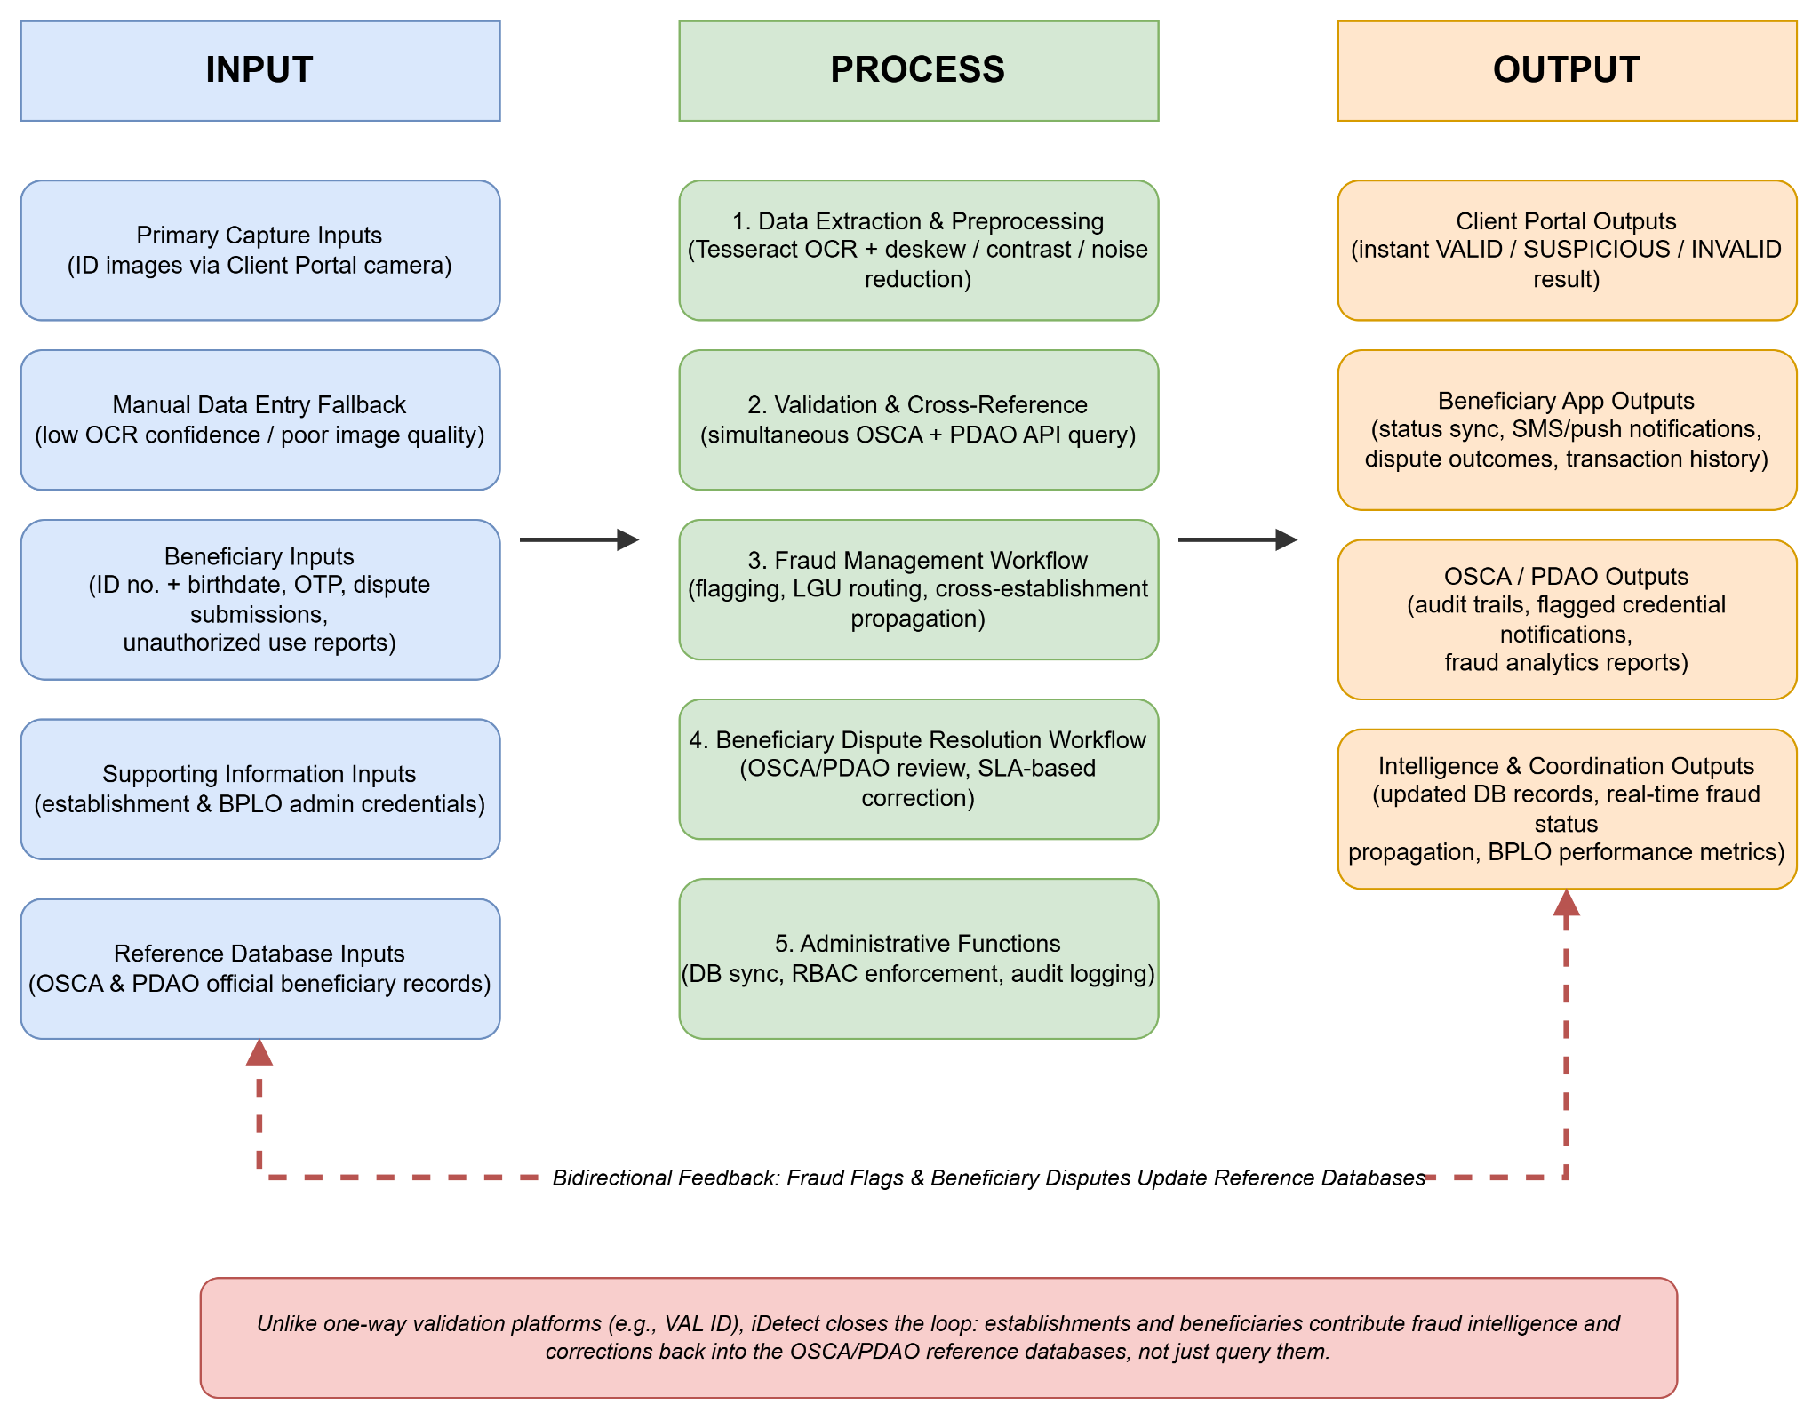
Figure 3.

As illustrated in Figure 3 the integrated multi-portal architecture of iDetect, showing the relationships between system components, stakeholder interactions, data flows, and validation workflows across all five portals. The framework demonstrates how the Client Portal, BPLO Portal, OSCA Portal, PDAO Portal, and Beneficiary Mobile Application function cohesively to create a comprehensive, closed-loop fraud prevention and beneficiary accountability ecosystem.
The framework is structured using the Input-Process-Output (IPO) model, adapted for a multi-stakeholder, multi-portal validation system. Each column of the model corresponds to a distinct phase of system operation, and the flows between columns are bidirectional, reflecting iDetect's core architectural distinction from existing one-way validation platforms.
Input
The input stage encompasses all data entering the system across its five portals.
Primary capture inputs originate from the Client Portal, where establishment staff use mobile devices to photograph Senior Citizen or PWD identification cards. These images serve as the primary data source for automated OCR-based extraction. Manual data entry is included as a fallback input for cases where OCR confidence falls below the defined threshold due to image quality or card condition constraints. Reference database inputs consist of the official beneficiary records maintained by the Valenzuela City OSCA and PDAO, which are queried in real time during each validation attempt.
Supporting information inputs include business establishment credentials and permit data used to authenticate Client Portal access, and BPLO administrator credentials used to manage establishment accounts through the BPLO Portal.
Beneficiary inputs enter the system exclusively through the Beneficiary Mobile Application. These include the beneficiary's ID number and birthdate for account registration, a mobile one-time password (OTP) for two-factor authentication, structured dispute submissions with optional supporting documentation such as ID photographs and barangay certifications, and unauthorized credential use reports.
Input characteristics define the quality boundaries of the system. The format covers digital images, structured data fields, authentication tokens, and structured dispute forms. Quality requirements specify that image clarity must be sufficient for OCR field-level extraction, and that the system supports only the single standardized ID format currently issued by the Valenzuela City OSCA and PDAO per beneficiary type, a deliberate delimitation of the field-level extraction design. Validation points include ID format compliance, data completeness checks, and OTP verification.
Process
The process stage encompasses five sequential and concurrent workflows executed across the system's portals.
The first process, Data Extraction and Preprocessing, is executed by the Client Portal upon image capture. The Tesseract OCR engine extracts field-level data from the captured credential image following a preprocessing pipeline of deskewing, contrast enhancement, and noise reduction. Extracted fields include the ID number, full name, beneficiary type, validity period, and issuing office. Confidence scoring determines whether the extraction result is sufficient for automatic processing or requires manual entry fallback. Field validation checks that extracted data conforms to expected formats and completeness requirements before proceeding.
The second process, Validation and Cross-Reference, performs RESTful API queries against the OSCA and PDAO records, matching the submitted ID number first and then cross-validating the extracted name and date of birth. Extracted credential data is cross-checked against official government records and a validation result is determined: VALID when data matches official records within tolerance thresholds; SUSPICIOUS when discrepancies are detected that indicate potential fraud; and INVALID when no matching record is found, the record is past its validity end date, or the record is revoked.
The third process, Fraud Management Workflow, is triggered when a SUSPICIOUS or INVALID result is generated or when establishment staff manually flag a credential. The system automatically transmits the flagged credential with complete transaction context to the appropriate LGU portal; OSCA for Senior Citizen credentials and PDAO for PWD credentials. Confirmed fraudulent credentials are propagated in real time to all connected Client Portal instances, transforming an isolated detection event into a coordinated network-wide prevention response. OSCA and PDAO administrators manage investigation workflows, mark confirmed fraud, and update database records upon investigation completion.
The fourth process, Beneficiary Dispute Resolution Workflow, is executed through the Beneficiary Mobile Application and the OSCA and PDAO portals. Dispute submissions from beneficiaries are automatically routed to the appropriate LGU investigation queue. Authorized LGU personnel review submitted evidence and process corrections under defined service-level agreements: 24-hour acknowledgment and 48–72 hour resolution for database errors, with explanatory notifications issued for cases requiring extended timelines. Upon confirmation, official records are corrected and resolution outcomes are delivered to the beneficiary via SMS and push notification.
The fifth process, Administrative Functions, operates continuously across all portals. Database synchronization ensures consistency across OSCA and PDAO systems and all connected portal instances. BPLO administrators manage establishment registration and access through the BPLO Portal. Role-based access control enforces strict data compartmentalization; OSCA administrators access only Senior Citizen records, PDAO administrators access only PWD records, BPLO administrators access only establishment management functions, and establishment staff receive only validation status without exposure to beneficiary personal data. Immutable audit logging records all validation attempts, fraud flags, dispute submissions, and administrative actions with complete transaction context.
Output
The output stage encompasses the results produced for each stakeholder group across the five portals.
Immediate outputs delivered to establishment staff through the Client Portal include instant validation results displaying the VALID, SUSPICIOUS, INVALID, or MANUAL REVIEW status, transaction confirmation with relevant credential details, and offline scans saved for automatic verification when connectivity is restored.
Beneficiary outputs delivered through the Beneficiary Mobile Application include real-time validation status synchronized with government databases reflecting Active, Suspended, Expired, or Revoked states; transaction notifications via SMS and push alert when credentials are validated at any participating establishment; dispute resolution outcomes including staff responses and final resolution notices; and a complete transaction history log with establishment details.
Logging and reporting outputs delivered to OSCA and PDAO administrators include complete immutable audit trails for compliance and legal purposes, real-time flagged credential notifications with full transaction context, fraud analytics reports visualizing temporal trends and geographic distributions, and investigation outcome documentation with updated record status.
Intelligence and coordination outputs include updated OSCA and PDAO database records reflecting all verification events and investigation outcomes, real-time propagation of confirmed fraudulent credential status across all connected establishments, and performance metrics accessible to BPLO administrators covering system usage statistics and establishment compliance data.
Output characteristics define the quality standards of system-generated results. Timeliness requires validation results to be delivered in under 30 seconds from capture to display. Accessibility is governed by role-based controls ensuring each stakeholder group accesses only outputs appropriate to their function. Format covers digital status displays, downloadable analytics reports, SMS notifications, and structured database records. Privacy is enforced through minimum-disclosure design, returning only validation status to establishments while limiting full beneficiary data to authorized LGU personnel. Retention is governed by Republic Act 10173 and applicable government record-keeping regulations.
Bidirectional Flow as the Core Architectural Distinction
The IPO model as applied to iDetect emphasizes bidirectional information flow as the system's defining architectural contribution. Unlike existing validation platforms, which operate as one-way query systems where establishments retrieve validation status from government databases without any return channel, iDetect establishes a closed-loop ecosystem. Establishments not only query OSCA and PDAO databases to validate credentials, they also contribute fraud intelligence back to those databases through the automated flagging pipeline. Beneficiaries not only receive the outcomes of validation decisions, they also submit dispute inputs that correct those decisions through structured LGU review. This bidirectionality transforms iDetect from a validation tool into a coordinated fraud prevention network spanning all five portals and all stakeholder groups within the discount program ecosystem.

Definition of Terms
This section provides operational definitions of key terms used throughout this study. Definitions are specific to the context of iDetect and the discount ID validation problem domain. Terms are arranged alphabetically for ease of reference.
Agile Methodology. A software development approach organizing work into iterative sprints with continuous feedback, testing, and incremental delivery. iDetect was developed using Agile, allowing the research team to refine system design and functional requirements based on ongoing stakeholder input across each development phase.
Audit Log. An immutable, time-stamped record of system events; including validation attempts, fraud flags, dispute submissions, database modifications, and administrative actions, with full user attribution and transaction context. Audit logs serve as iDetect's primary mechanism for accountability and compliance investigation, and cannot be altered or deleted by any user role.
Beneficiary. A Senior Citizen or Person with Disability (PWD) who holds a valid government-issued identification card entitling them to the statutory 20% discount and 12% VAT exemption under Republic Acts 9994 and 10754. Beneficiaries interact with iDetect through the Beneficiary Mobile Application and are the subjects of validation queries initiated by business establishments.
Beneficiary Mobile Application. The fifth portal of iDetect, designed for use by Senior Citizens and PWDs. It enables beneficiaries to register accounts, monitor real-time validation status, receive transaction notifications, submit dispute reports, track resolution progress, and report suspected unauthorized use of their credentials. Registration is entirely voluntary and does not affect a beneficiary's entitlement to statutory discounts.
Bidirectional Fraud Reporting. A system architecture enabling two-way information exchange between business establishments and local government units. Unlike one-way validation systems where establishments can only query databases, iDetect allows establishments to both retrieve validation results and automatically transmit suspicious credential reports to the appropriate LGU portal, OSCA for Senior Citizen credentials, PDAO for PWD credentials. Once an OSCA or PDAO administrator confirms a credential as fraudulent, that status is immediately propagated across all connected Client Portal instances at every participating establishment, preventing the same fraudulent credential from succeeding elsewhere in the network.
BPLO (Business Permit and Licensing Office). The local government office responsible for issuing business permits and regulating commercial establishments. The BPLO Portal enables administrators to manage establishment accounts and monitor technical performance, without accessing beneficiary data or validation intelligence held by OSCA and PDAO.
Capable Guardian. A Routine Activity Theory concept referring to any person, system, or mechanism that is present, capable, and willing to prevent criminal activity through surveillance, detection, or intervention. iDetect functions as a technology-enabled capable guardian, disrupting the routine activities that enable fraudulent credential use at food service establishments.
Client Portal. The mobile application component of iDetect used by food service establishment staff to capture ID images, perform OCR-based validation, receive real-time validation results, flag suspicious credentials for LGU transmission, and access transaction history. Designed for point-of-sale use with optimization for transaction speed and minimal workflow disruption.
Confidence Scoring. A numerical value produced by the Tesseract OCR engine indicating certainty that extracted text matches the source image. Fields scoring below a defined threshold are routed to manual entry fallback rather than automated processing.
Data Compartmentalization. A security design principle ensures each user role accesses only the data necessary for its function, with technical controls preventing access beyond those boundaries. OSCA administrators access only Senior Citizen records; PDAO administrators access only PWD records; BPLO administrators access only establishment information; and establishment staff receive only validation status without exposure to beneficiary personal data.
Discount ID Validation. The process of authenticating a Senior Citizen or PWD identification card at the point of sale to confirm the cardholder's entitlement to the statutory 20% discount and 12% VAT exemption. In iDetect, this process is automated through OCR-based data extraction and real-time validation against the single beneficiary registry, scoped by ID type.
Dispute Resolution. A structured process enabling beneficiaries who experience an erroneous denial to formally contest the outcome through the Beneficiary Mobile Application. Submissions are routed to the appropriate OSCA or PDAO investigation queue, reviewed with any supporting documentation, and resolved under a 24-hour acknowledgment and 48–72 hour resolution SLA. Outcomes are communicated via SMS and push notification, and confirmed errors result in official record correction.
Field-Level Extraction. An OCR processing approach that maps specific data fields; ID number, full name, beneficiary type, validity period, and issuing office, to defined positional regions on a credential's surface, extracting each field independently rather than processing the card as undifferentiated text. This approach requires the credential to conform to a single supported physical layout; credentials in other formats fall outside the reliable operating range of automated extraction.
Fraud Management Lifecycle. A theoretical framework developed by Wilhelm (2004) describing eight interconnected stages of fraud management: deterrence, prevention, detection, mitigation, analysis, policy, investigation, and prosecution. In iDetect, this lifecycle is operationalized across the system's multi-portal architecture, from the visible presence of OCR-based scanning (deterrence and prevention) through automated flagging (detection and mitigation) to OSCA/PDAO investigation workflows and audit-supported evidence gathering (investigation and prosecution). See the Theoretical Framework chapter for the complete application of each stage.
Fraudulent Credential. A counterfeit, altered, or improperly obtained Senior Citizen or PWD identification card used to illegitimately claim statutory discounts. This includes unauthorized externally manufactured cards, physically altered legitimate cards, and legitimate cards used by individuals who are not the registered cardholder.
ISO 25010. An international standard published by the International Organization for Standardization defining a hierarchical model of software product quality characteristics. This study uses ISO 25010 to evaluate iDetect across eight characteristics: functional suitability, performance efficiency, compatibility, usability, reliability, security, maintainability, and portability.
Multi-Portal Architecture. A system design in which a single integrated platform is accessed through distinct, role-specific interfaces, portals, each tailored to a specific stakeholder group's functions and data access rights. iDetect implements a five-portal architecture: Client Portal, BPLO Portal, OSCA Portal, PDAO Portal, and Beneficiary Mobile Application, governed by role-based access control.
OCR (Optical Character Recognition). A technology that converts printed or handwritten characters in an image into machine-readable digital text. The Tesseract OCR engine processes images of Senior Citizen and PWD identification cards captured via mobile camera, extracting credential data without requiring manual entry.
OSCA (Office of Senior Citizens Affairs). The local government office responsible for programs and services for senior citizens, maintaining the Senior Citizen ID database, and enforcing RA 9994 provisions. OSCA administrators manage Senior Citizen validation records, investigate flagged credentials, mark confirmed fraud, and generate fraud analytics, access compartmentalized to Senior Citizen records only.
PDAO (Persons with Disability Affairs Office). The local government office responsible for programs and services for persons with disability, maintaining the PWD ID database, and enforcing RA 10754 provisions. PDAO administrators manage PWD validation records, investigate flagged credentials, mark confirmed fraud, and generate fraud analytics, access compartmentalized to PWD records only.
Point-of-Sale (POS) Validation. Authentication of credentials during active customer transaction processing at a checkout or service counter, requiring results within seconds to avoid workflow disruption and service quality degradation. iDetect targets a validation cycle of under 30 seconds from image capture to result display.
RESTful API (Representational State Transfer Application Programming Interface).A standardized architectural style enabling communication between software systems over HTTP. In iDetect, RESTful APIs facilitate real-time integration between the Client Portal and the OSCA and PDAO databases, enabling validation queries and fraud flag transmission without exposing underlying database structures.
Role-Based Access Control (RBAC). A security framework granting system access and data visibility based on predefined user roles, each assigned specific permissions aligned to its operational responsibilities. iDetect implements RBAC across five roles: establishment staff, BPLO administrator, OSCA administrator, PDAO administrator, and beneficiary.
Routine Activity Theory (RAT). A criminological framework developed by Cohen and Felson (1979) positing that crime occurs when three elements converge: a motivated offender, a suitable target, and the absence of a capable guardian. RAT provides the theoretical basis for iDetect's fraud prevention design, in which the system functions as a capable guardian reducing the suitability of fraudulent credentials as targets for exploitation.
Service-Level Agreement (SLA). A defined commitment specifying the timeframe within which a service or process will be completed. In iDetect, SLAs govern dispute resolution: OSCA and PDAO administrators must acknowledge submissions within 24 hours and resolve database error disputes within 48–72 hours, with explanatory notifications issued for cases requiring extended timelines.
Suspicious Credential. An identification card assigned a SUSPICIOUS validation result due to database mismatches, data field inconsistencies, pattern anomalies, or staff assessment. This triggers the fraud reporting pipeline and transmits the credential to the appropriate LGU portal for investigation; it is not a final fraud determination, final adjudication rests with OSCA or PDAO administrators.
Two-Factor Authentication (2FA). A security mechanism requiring users to verify their identity through two independent methods before accessing a system. iDetect implements 2FA for the Beneficiary Mobile Application using ID number and birthdate as primary credentials, combined with a mobile one-time password (OTP) as the secondary factor, balancing security with accessibility for elderly users.
Validation Result Status. The classification assigned to each credential validation attempt processed by iDetect, comprising four possible values: VALID, indicating the credential matches official OSCA or PDAO records within acceptable tolerance; SUSPICIOUS, indicating discrepancies that warrant LGU investigation; INVALID, indicating no matching record exists or the matched record is revoked or expired; and MANUAL REVIEW, indicating that OCR extraction quality was too low for automated validation and staff must verify the credential manually. The Beneficiary Mobile Application additionally displays four account-level states; Active, Suspended, Expired, and Revoked, reflecting the current standing of the beneficiary's registered credential.

CHAPTER 2 REVIEW OF RELATED LITERATURE AND SYSTEMS

Technical Background
The development of iDetect requires foundational understanding of several interconnected technologies and methodologies that enable automated identity validation in point-of-sale environments. This technical background section establishes the core technological concepts, implementation frameworks, and system architectures that inform the design and development of the proposed integrated validation system.

Optical Character Recognition (OCR) Technology
Optical Character Recognition is a foundational technology enabling automated extraction of text from images, converting printed or handwritten characters into machine-readable digital format. In identity validation contexts, OCR serves as the critical first step by extracting data from identification documents such as passports, driver's licenses, and government-issued identification cards. Modern OCR systems have evolved from template-matching approaches to deep learning-based implementations capable of processing complex document layouts with high accuracy rates.
Contemporary OCR research demonstrates high accuracy rates when processing standardized identity documents. Liu, James, Gupta, and Raviv (2022) conducted comprehensive studies on Machine-Readable Zone (MRZ) extraction from passports and visa documents using convolutional neural networks, achieving a 100% MRZ detection rate and 99.25% character recognition accuracy. This high accuracy makes OCR viable for automated validation systems where manual data entry would be time-prohibitive. However, accuracy varies significantly with image quality: research comparing OCR engines on typewritten documents found that commercial solutions like Abbyy FineReader achieved 95–98% character accuracy at optimal scanning resolutions between 200–500 dots per inch (Stančić & Trbušić, 2020).
Mobile OCR implementation introduces unique requirements beyond traditional document processing. Unlike office environments where documents can be rescanned if results are unsatisfactory, point-of-sale validation demands real-time performance with minimal user interaction. Gayer, Ershova, and Arlazarov (2023) demonstrated that mobile devices can perform real-time OCR extraction within the Machine-Readable Zone using YOLO-based models, achieving 62 frames per second on mid-range smartphones while maintaining high accuracy. Their optimized 1-megabyte model proved 83 times faster than previous implementations, demonstrating that computational constraints of mobile devices need not compromise performance. However, mobile implementations must accommodate variations in document quality, lighting conditions, and operator skill levels while maintaining accuracy sufficient for fraud detection.
The operational advantages of OCR over manual data entry manifest in both time savings and error reduction. Industry research demonstrates that OCR-based systems achieve accuracy rates of 99.95–99.99% compared to manual entry accuracy of 96–99% (Martinez, 2025). A study of laboratory point-of-care testing found that manual transcription had an error rate of 3.7%, with 14.2% of those errors containing significant and potentially dangerous discrepancies (Mays et al., 2019). A multi-center study across ICUs in three countries found that OCR implementation reduced data entry time by an average of 43.9%, with processing time decreasing from 6.0 minutes to 3.4 minutes per document (Nitayavardhana et al., 2025). For high-volume retail environments processing thousands of daily transactions, these improvements compound to create substantial efficiency gains while simultaneously reducing fraud opportunities enabled by data entry errors.
OCR accuracy degrades significantly under poor capture conditions, with error rates reaching 50% on documents affected by blurring and skewing (Hamdi et al., 2019). This sensitivity necessitates a robust preprocessing pipeline; including image quality assessment, deskewing, denoising, contrast enhancement, and user guidance during capture, to maintain validation reliability despite non-standardized Philippine credential formats and variable capture quality. Additionally, field-level accuracy proves more critical than character-level accuracy for identity validation, research shows that a 2.52% character error rate produced only 48.6% field-level accuracy for ID numbers and dates (Lerouge et al., 2024), requiring validation against known patterns such as ID number formats and date ranges.
While OCR technology enables efficient extraction of data from physical credentials, validating the authenticity of that extracted data requires integration with authoritative databases. The following section examines the architectural patterns and implementation requirements for real-time validation systems that connect document scanning capabilities with government record databases.

Database Integration and Real-Time Verification Architecture
Database integration constitutes the foundational fraud detection mechanism for credential validation, confirming that presented credentials match records in authoritative government databases. Real-time validation systems require instant connectivity to source databases maintained by respective agencies, with query responses provided with minimal latency to avoid transaction delays at point of sale. The architectural challenge lies in enabling distributed database access while maintaining data sovereignty, privacy protection, and query performance.
International examples demonstrate proven architectural patterns. Estonia's X-Road system processes over 2.7 billion data queries annually through a decentralized data exchange layer connecting independent agency databases (Frost & Sullivan Institute, 2025). Rather than centralizing identity data, X-Road functions as a secure query layer where agencies maintain database autonomy while enabling cross-system validation. This distributed architecture provides multiple advantages: reduced single-point-of-failure risk, maintained agency sovereignty over data, real-time currency since queries access source systems directly, and inherent auditability through mandatory query logging. Research on digital identity interoperability emphasizes that such systems must ensure data integrity, confidentiality, and privacy during exchange through proper authentication, encryption, and access control mechanisms (Ibor et al., 2024).
Real-time validation capabilities distinguish modern integrated systems from batch-processing legacy approaches. Big data analytics enable real-time fraud detection mechanisms that monitor transactions as they occur and flag suspicious activities for further investigation (Udeh et al., 2024). Financial fraud detection systems must process thousands of transactions per second with sub-100 millisecond latency constraints (Curry, 2025). While identity validation operates at lower transaction volumes than financial systems, the architectural principles transfer: instant access to validation data requires high-memory configurations, NVMe storage for sustained operations, and database indexing strategies optimized for validation query patterns.
The Philippine context introduces specific challenges absent in standardized national ID systems. Unlike Estonia's unified infrastructure (e-Estonia, 2023) or Singapore's centralized SingPass (GovTech Singapore, 2023), Philippine Senior Citizen and PWD beneficiary data reside in over 1,700 independent local government unit databases with varying digitization levels, data quality standards, and technical sophistication. This fragmentation necessitates validation architecture tolerant to incomplete database coverage; the system must function optimally when authoritative validation is available while implementing alternative fraud detection mechanisms when database confirmation proves impossible. Privacy considerations further constrain implementation: businesses require a validation status (VALID, SUSPICIOUS, INVALID, or MANUAL REVIEW) without gaining access to comprehensive beneficiary information, requiring privacy-preserving query designs that return validation status without exposing detailed personal data.

Mobile Application Development for Point-of-Sale Environments
Mobile-first application architecture has transformed point-of-sale operations by enabling validation systems deployable on existing staff smartphones without requiring specialized hardware investment. However, mobile user experience design faces substantial challenges evidenced by research finding that zero percent of 138 major mobile e-commerce sites achieved "good" overall user experience ratings, with 62% rated mediocre or worse (Baymard Institute, 2024). This pervasive usability challenge demonstrates that mobile interface excellence requires deliberate design effort rather than emerging naturally from functional implementation.
Point-of-sale systems possess specific usability requirements distinguishing them from general mobile applications. Research by Nielsen and Molich (2016) synthesizing usability evaluation models identifies twelve critical factors: learnability, efficiency, memorability, error frequency and severity, satisfaction, accessibility, visibility, feedback, consistency, error prevention, help availability, and aesthetic minimalism. These factors reflect POS operational realities: high staff turnover necessitates rapid learnability without extensive training, high transaction volumes demand efficiency minimizing time per validation, varying technical proficiency requires consistent interfaces minimizing memorization, and customer-facing operation mandates error prevention rather than error correction requiring visible recovery processes.
Research on technology adoption establishes the three-action limit as a critical threshold: systems requiring more than three discrete user actions face significant adoption resistance (Thompson et al., 2023). For identity validation, this constraint directly impacts workflow design; the optimal sequence of opening an application, scanning credential, and receiving validation consumes all three actions, leaving no room for login screens, menu navigation, or confirmation dialogs without exceeding the adoption resistance threshold. This necessitates architectural decisions enabling automatic background authentication, immediate camera activation on launch, and automatic processing without explicit confirmation steps.
Mobile interface design must accommodate device-specific constraints including limited screen real estate requiring careful information prioritization, touch interfaces demanding finger-sized interaction targets, and variable connectivity necessitating offline-capable functionality. Research by Budiu and Nielsen (2021) on mobile user experience emphasizes that mobile UX encompasses more than visual design; it extends to how users interact with and feel about the application, incorporating emotional responses, efficiency perceptions, and overall satisfaction. User preference studies prevent information overload by establishing what users actually need versus what designers assume, enabling selective display of essential validation information while relegating detailed logs and statistics to administrative interfaces accessed separately rather than cluttering transaction screens.

Review of Related Literature
This section presents a thematic review of scholarly and industry literature organized into four interconnected themes that inform iDetect's conceptual foundation, technical design, and implementation strategy. The review synthesizes international research on identity validation technologies with Philippine-specific studies on discount program implementation, establishing contextually grounded understanding of both proven technological approaches and the local institutional challenges that shape system design requirements.

Digital Identity Verification Systems and E-Government Integration
Digital identity validation systems represent a fundamental shift from paper-based identification toward electronic credentials that enable secure, efficient, and auditable service access. International implementations provide evidence-based insights into database integration strategies, public-private partnership governance, and fraud prevention mechanisms that are directly applicable to localized validation solutions such as iDetect.
Estonia's comprehensive digital governance ecosystem represents the most extensively documented case of successful national-scale implementation, achieving full digitalization of government services by 2024 (Frost & Sullivan Institute, 2025). The system's foundation rests on the X-Road data exchange infrastructure and digital ID cards issued to the overwhelming majority of the population, collectively processing over 2.7 billion data queries and demonstrating both scalability and sustained operational reliability. The Estonian model operates on the once-only principle, whereby citizens provide personal information to the government only once, after which agencies share data internally rather than requiring repeated submissions across service interactions. This architectural decision produces measurable efficiency outcomes: citizens file taxes in under three minutes and register businesses in under fifteen minutes without physical office visits. Academic analysis of the X-Road architecture documents how its combination with legally recognized digital signatures enables comprehensive service integration spanning contract execution, medical records access, prescription management, and secure online voting (Margetts & Naumann, 2017). The model's most significant contribution to validation system design is its demonstration that unified architecture renders document forgery effectively obsolete, as credentials must pass database validation regardless of their physical appearance.
Singapore's National Digital Identity framework demonstrates a complementary approach emphasizing public-private sector integration. Built on the SingPass platform, the system extends government authentication into banking, e-commerce, and private commercial transactions. Comparative analysis by Goede (2019) examining digital transformation pathways in Estonia, Singapore, and Curaçao reveals that while Estonia's transformation was led from the public sector with strong banking and telecommunications partnerships, Singapore's approach involved the private sector; particularly the corporate ICT industry, from the outset as an equal development partner. Both pathways nonetheless converge on a shared prerequisite: robust legal frameworks establishing digital signatures' equivalence to handwritten signatures, providing the trust infrastructure that enables citizen adoption and private sector participation.
The evidence from large-scale implementations carries direct implications for iDetect's architectural design. Integrated validation infrastructures that connect government databases with private sector users through standardized protocols have achieved documented fraud reduction exceeding 70% through coordinated intelligence sharing and real-time cross-validation (Protecht Group, 2025). However, the literature consistently emphasizes that technological capability alone does not produce these outcomes; success depends on governance structures, institutional trust mechanisms, and architectural decisions that respect the sovereignty of data-owning agencies. The distributed architecture principle, in which a validation system functions as a secure query layer connecting decentralized databases rather than centralizing all identity data into a single repository, is identified as essential for maintaining agency control while enabling integration. For Philippine LGU contexts, where institutional sovereignty over beneficiary databases is a sensitive governance consideration, this principle implies that iDetect should enable real-time lookups against authoritative OSCA and PDAO databases rather than replicating or centralizing beneficiary records.

Fraud Detection and Prevention in Discount Programs
The proliferation of fraudulent credentials in Philippine discount programs has reached crisis proportions documented through formal government investigation. Senate Committee hearings revealed 8.5 million fraudulent PWD IDs in circulation compared to only 1.89 million legitimate credentials registered with the National Council on Disability Affairs, a 4.5:1 fraudulent-to-legitimate ratio with severe economic consequences (Bordey, 2024). Of ₱208.4 billion in total discount transactions recorded during 2023, an estimated ₱166.1 billion involved fraudulent credentials, with the Bureau of Internal Revenue calculating direct tax revenue losses at ₱88.2 billion for that year alone and classifying systematic fraudulent PWD ID use as criminal tax evasion (Gonzales, 2024).
Industry-specific data demonstrates operational impact on businesses. Restaurant operators documented a dramatic 22.21% increase in the ratio of PWD to senior citizen discount claims within just two years, from 2022 to 2024, with establishments rejecting approximately 17% of PWD cards presented due to suspected fraud (Arnaldo, 2024). One major restaurant chain reported rejecting 726 of 4,212 presented PWD IDs during three months, a 17.24% rejection rate indicating nearly one in five credentials failed even basic authenticity checks (Arceo, 2024). This likely understates true fraud prevalence given legal constraints: a Department of Justice opinion issued January 2025 clarified that establishments cannot legally deny discounts even when unable to validate authenticity, placing businesses in untenable positions of absorbing fraudulent costs or risking legal liability for denying potentially legitimate beneficiaries (Cervantes, 2025).
Multi-factor authentication frameworks provide proven technical approaches to credential validation by requiring multiple independent validation factors before granting access or confirming eligibility. A systematic review by Bonneau and colleagues (2024) analyzing 70 academic papers and 13 industry tools documented widespread adoption, with 77% of reviewed implementations achieving NIST standards compliance. Contemporary implementations increasingly incorporate behavioral biometrics: continuous authentication through keystroke dynamics, mouse patterns, and touchscreen gestures, enabling fraud detection throughout a transaction rather than only at initial authentication. Research on secure financial transaction systems implementing two-layer validation combining multi-factor authentication with machine learning achieved classification accuracies of 97.938% using logistic regression, 97.881% with decision trees, and 96.717% with random forest algorithms (Kumar & Singh, 2024).
Pattern recognition and anomaly detection constitute complementary approaches enabling identification of behavioral patterns that distinguish legitimate from fraudulent use. Machine learning algorithms trained on historical transaction data establish behavioral baselines against which subsequent transactions are evaluated. Research documents ensemble methods achieving 94.3% fraud detection accuracy and neural networks achieving 93.7% on comparable classification tasks (Wang et al., 2024). These approaches prove particularly effective for credential-based fraud, where transaction frequency, geographic distribution, temporal patterns, and establishment preferences provide fraud signals independent of credential physical authenticity. Geographic impossibility detection flags credentials used at multiple distant locations within impossible timeframes; frequency analysis identifies abnormal transaction volumes; and network analysis using graph databases identifies fraud rings where multiple credentials share suspicious structural commonalities.
The body of literature on fraud detection in discount and welfare programs establishes several design implications specific to iDetect's context that differ from financial fraud prevention systems. First, the documented ₱166.1 billion in fraudulent transactions and 4.5:1 fraud ratio provides compelling economic justification for comprehensive technological intervention, even a 50% reduction in fraudulent credential acceptance, substantially below the 70% or greater reductions documented in financial systems, would recover an estimated ₱44 billion annually in tax revenue while reducing fraudulent business discount absorption by ₱83 billion. Second, adaptation from financial fraud detection to discount program contexts requires specific design adjustments: discount beneficiaries require simpler validation processes than sophisticated financial users; false positive rates that are tolerable in financial contexts become disproportionately harmful when they result in wrongful denial of statutory entitlements to vulnerable populations; and the fragmented database infrastructure of Philippine LGUs precludes exclusive reliance on database validation, necessitating multi-layer detection combining database cross-referencing, pattern recognition, and coordinated network intelligence. These constraints directly inform iDetect's design decisions regarding result display, the beneficiary dispute mechanism, and the bidirectional fraud reporting architecture.

Mobile Point-of-Sale Verification Solutions and Usability Requirements
The proliferation of smartphone technology has created the infrastructure for deploying validation systems without specialized hardware, making mobile-based solutions viable for business environments ranging from large restaurant chains to small food stalls. However, realizing this potential requires careful application of mobile-specific usability principles that differ substantially from those governing desktop software or dedicated POS terminals.
A systematic literature review by Harrison and colleagues (2024) analyzing 205 documents identified the STFM framework: encompassing Scenarios, Themes, Features, and Methodologies, as an organizing principle for mobile user experience research, with usability, satisfaction, and engagement emerging as the most frequently studied dimensions. The PACMAD quality model extends traditional usability evaluation by incorporating performance, accessibility, compatibility, and mobility dimensions alongside conventional metrics, recognizing that mobile applications function under substantially different usage conditions than stationary software — variable lighting, divided attention, time pressure, and intermittent connectivity are all characteristic of mobile point-of-sale environments.
Industry benchmarking reveals pervasive usability deficiencies even among well-resourced implementations. Analysis of 138 leading mobile commerce sites found none achieving a rating of good overall user experience, with 62% rated mediocre or worse and only 38% achieving decent ratings (Baymard Institute, 2024). This benchmark, representing over 200,000 hours of cumulative mobile UX research, demonstrates that achieving satisfactory mobile usability is difficult even for organizations with substantial design resources, establishing that validation systems intended for food service environments require deliberate, evidence-based design effort rather than incidental attention. Research on point-of-sale technology adoption identifies workflow integration and interaction simplicity as critical adoption factors, documenting that systems requiring more than three discrete actions face significant staff resistance, and that each additional interaction step creates cognitive load that extends transaction time and increases error rates (Thompson et al., 2023).
Point-of-sale environments impose requirements that extend beyond general mobile application usability principles. Validation must complete within seconds to avoid customer queue delays that degrade service quality. Staff possess varying levels of technical proficiency, requiring interfaces that minimize training requirements and support consistent task completion regardless of operator experience. Business environments typically lack on-site IT support, necessitating self-explanatory error recovery and maintenance accessible to non-technical users. Research by Seffah and colleagues (2016) synthesizing usability evaluation models identifies twelve critical POS usability factors, including learnability, efficiency, memorability, error tolerance, satisfaction, accessibility, system visibility, feedback clarity, interface consistency, error prevention, help availability, and aesthetic minimalism. These factors reflect operational realities: high staff turnover necessitates rapid learning curves; high transaction volumes demand processing efficiency; customer-facing operation requires that errors be prevented rather than corrected mid-transaction.
Research by Constantine and Lockwood (2021) establishes that quality of use must be treated as a primary design objective rather than an ancillary feature, directly linking usability outcomes to adoption rates and functional value realization. The critical distinction between user interface and user experience, where visual design quality does not substitute for interaction quality, is particularly relevant to validation systems, where a visually polished interface that fails to support efficient ID capture, clear result interpretation, and rapid flag submission provides poor operational value regardless of its aesthetic quality.
These findings carry specific design implications for iDetect. The three-action limit identified in POS adoption research directly constrains the validation workflow to a launch-capture-view sequence, requiring that authentication, database querying, and result display occur automatically in the background without requiring staff to navigate confirmation dialogs or intermediate screens. The PACMAD model's emphasis on mobility and divided-attention contexts informs iDetect's image quality guidance system, which provides real-time visual feedback to guide staff toward optimal capture conditions rather than presenting error messages after failed attempts. The finding that 62% of mobile implementations achieve mediocre or worse usability ratings establishes that exceeding the industry baseline is achievable through deliberate adherence to the evidence-based design principles documented in the literature.

Philippine Senior Citizen and PWD Discount Implementation Challenges
Philippine discount program implementation faces systemic challenges rooted in institutional capacity limitations, legal ambiguities, infrastructure fragmentation, and validation system inadequacies that collectively define the operating environment within which iDetect must function. Understanding these constraints is essential for designing a system that delivers meaningful fraud prevention within Philippine institutional realities rather than against them.
Republic Act 9994 (Expanded Senior Citizens Act of 2010) and Republic Act 10754 (Expanding Benefits and Privileges for Persons with Disability) mandate 20% discounts and 12% VAT exemptions on qualifying purchases, with implementing rules directing that provisions be construed liberally and in favor of beneficiaries when interpretive ambiguities arise. The Department of Justice opinion issued in January 2025 operationalizes this principle by clarifying that establishments cannot legally withhold discount privileges even when unable to validate credential authenticity immediately, noting explicitly that the Department of Health PWD Registry does not yet contain a complete beneficiary listing (Cervantes, 2025). This legal framework places establishments in a structurally untenable position: legally required to honor potentially fraudulent credentials without validation mechanisms capable of distinguishing legitimate from fraudulent claims, while facing ₱50,000 to ₱100,000 fines and imprisonment for wrongful denial of legitimate beneficiaries. This legal architecture has direct implications for iDetect's design: the system cannot function as a transaction gatekeeper that delays or blocks discounts pending validation, but must instead operate as a real-time intelligence-gathering mechanism that builds a coordinated fraud evidence base for subsequent LGU enforcement action.
Institutional capacity research reveals significant structural gaps in program administration. Research conducted by the University of the Philippines Center for Local and Regional Governance found that only 60% of Philippine local government units had established operational Persons with Disability Affairs Offices as mandated by Republic Act 10070, with 33 provinces, 25 cities, and 282 municipalities lacking dedicated PDAO offices entirely (Alampay et al., 2018). This 40% coverage gap directly links institutional capacity to validation capability: municipalities without functional PDAO offices cannot maintain accurate beneficiary databases, cannot investigate fraud reports, and cannot respond to establishment validation queries. The funding structure compounds these disparities, as Republic Act 9994 specifies that operational appropriations shall be determined and approved by individual LGUs rather than allocated through guaranteed national funding. The result is validation infrastructure directly correlated with LGU fiscal capacity; wealthier urban LGUs invest in digital systems and trained personnel while resource-constrained rural municipalities maintain paper records with minimal technical capacity.
Identification standardization presents a further structural challenge distinct from institutional capacity gaps. Unlike national credentials such as passports or driver's licenses that adhere to standardized formats governed by a single issuing authority, Philippine Senior Citizen and PWD credentials are issued independently by over 1,780 LGUs, each with the administrative discretion to determine card design, field layout, and security features (Respicio Law, 2024). While the National Council on Disability Affairs announced a unified PWD ID design in January 2024, implementation across all LGUs remains incomplete and uneven. This non-standardization creates compounding validation challenges: establishments cannot authenticate credentials through visual security inspection of standardized features; forged IDs are difficult to detect without database validation; and database fragmentation, each LGU maintaining separate OSCA and PDAO systems with no centralized national registry, prevents cross-jurisdictional validation. It is within this context that the Philippine Statistics Authority's PhilSys national identification system is relevant but insufficient: while PhilSys establishes a unified national identity record, it does not capture or integrate the LGU-specific Senior Citizen and PWD eligibility records that validation of discount entitlement requires. OSCA and PDAO databases remain the authoritative sources for discount program eligibility, and iDetect's integration with these LGU databases directly addresses the gap that PhilSys does not cover.
Cultural factors introduce additional implementation dynamics that technical design must accommodate. Research by Inabangan, Garcia, and Abocejo (2019) evaluating Republic Act 9994 implementation identified Filipino cultural values that shape both over-utilization and underutilization patterns: a jackpot mentality that encourages maximum benefit exploitation, a helpfulness norm that facilitates credential sharing among family members, and a shyness norm that prevents beneficiaries from asserting rights when establishments resist providing discounts. These dynamics produce a validation environment where some individuals systematically maximize benefits while legitimate beneficiaries underutilize entitlements due to social discomfort. The Senate Committee on Ways and Means hearing held on December 5, 2024 documented restaurant operators reporting that the proportion of PWD-discounted transactions had risen from 5% to 30% of total sales, with the majority of the increase attributed to suspected fraudulent claims (Bacelonia, 2024). The crisis has had documented secondary effects on legitimate beneficiaries: those whose disabilities are not visibly apparent are subjected to heightened scrutiny and skepticism at the point of sale, creating discriminatory treatment that harms the populations the legislation was designed to protect (Lauengco, 2024).
These Philippine-specific findings establish implementation requirements that extend beyond general validation system design. The 60% PDAO coverage rate implies that initial iDetect deployment must prioritize digitized urban LGUs with functional OSCA and PDAO offices, while the system architecture is designed to accommodate future expansion as institutional capacity develops in under-resourced municipalities. The DOJ opinion requiring provisional discount provision regardless of validation outcome mandates a non-gatekeeping design in which iDetect generates fraud intelligence for LGU action without delaying or blocking transactions at the point of sale. Cultural dynamics requiring non-confrontational validation processes inform the result display design, presenting validation outcomes as data quality indicators rather than fraud accusations, and the beneficiary dispute mechanism, which provides structured recourse for legitimate beneficiaries subjected to erroneous system-generated denials while maintaining dignity throughout the interaction.
The four bodies of literature reviewed in this chapter converge on a set of conditions that existing validation systems have not simultaneously addressed in the Philippine discount program context. International evidence on digital identity validation establishes that integrated, bidirectional, database-connected validation achieves fraud reduction exceeding 70%, but existing Philippine implementations operate as one-way query systems without fraud reporting channels. Fraud detection literature establishes that multi-layer validation combining database cross-referencing with coordinated network intelligence is necessary for high-fraud environments, but existing local validation platforms provide no mechanism for establishments to contribute intelligence back to issuing authorities. Mobile POS usability research establishes that validation systems must complete within seconds through minimal-step workflows, but existing platforms require manual data entry that consistently exceeds 30 to 45 seconds per transaction. Philippine implementation literature establishes that legitimate beneficiaries face wrongful denials and lack recourse mechanisms, while the legal framework requires provisional discount provision regardless of validation outcome, a combination that existing systems address neither technically nor procedurally.
The research gap addressed by this study is the absence of an integrated validation platform that simultaneously provides automated OCR-based credential capture, real-time dual-database cross-validation, bidirectional fraud intelligence sharing between establishments and LGU authorities, and a beneficiary accountability mechanism enabling Senior Citizens and PWDs to monitor validation status, dispute erroneous denials, and exercise data privacy rights under Republic Act 10173. iDetect is designed to address this gap through its five-portal architecture, serving the distinct operational needs of business establishments, BPLO administrators, OSCA personnel, PDAO personnel, and beneficiaries within a single integrated system.

Review of Related Systems
This section examines existing identity validation systems relevant to iDetect's functional requirements, analyzing both local Philippine implementations and international commercial solutions. The review identifies technological capabilities, operational strengths, and critical limitations of current systems, establishing the functional and technical gaps iDetect addresses through its integrated multi-portal architecture.

Philippine Local Government Unit Verification Platforms
Figure 4.
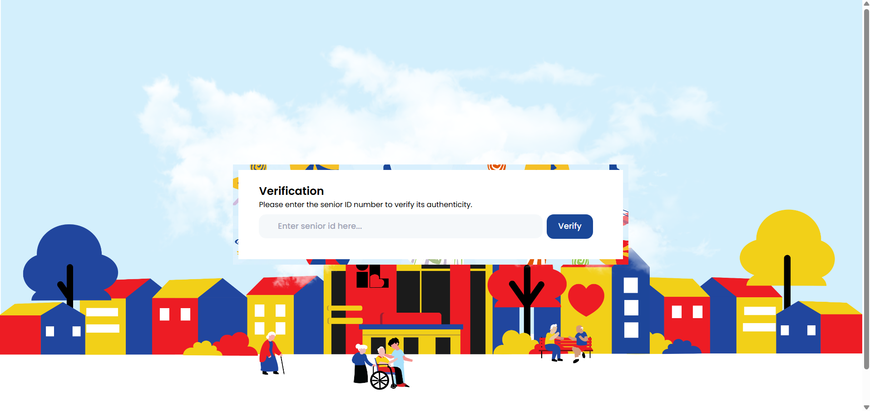
OSCA Taguig
OSCA Taguig Senior Citizen Verification System. The Office of the Senior Citizens Affairs in Taguig City operates an online platform enabling establishments to validate Senior Citizen IDs by entering ID numbers into a web portal (Office of the Senior Citizens Affairs Taguig, n.d.). The system queries the official OSCA database and returns basic cardholder information for validation. Primary strengths include real-time database connectivity, simple web interface accessible through standard browsers, and immediate validation results enabling establishments to confirm authenticity quickly without requiring specialized software or hardware. However, the system presents notable limitations: validation requires manual data entry of ID information consuming 30–45 seconds per transaction, functionality is restricted exclusively to Taguig City-issued IDs precluding validation of credentials from other municipalities, no OCR capability exists for automated data extraction from ID images, and the platform lacks automated fraud reporting mechanisms to notify OSCA authorities of suspicious IDs detected during validation processes.
Figure 5.
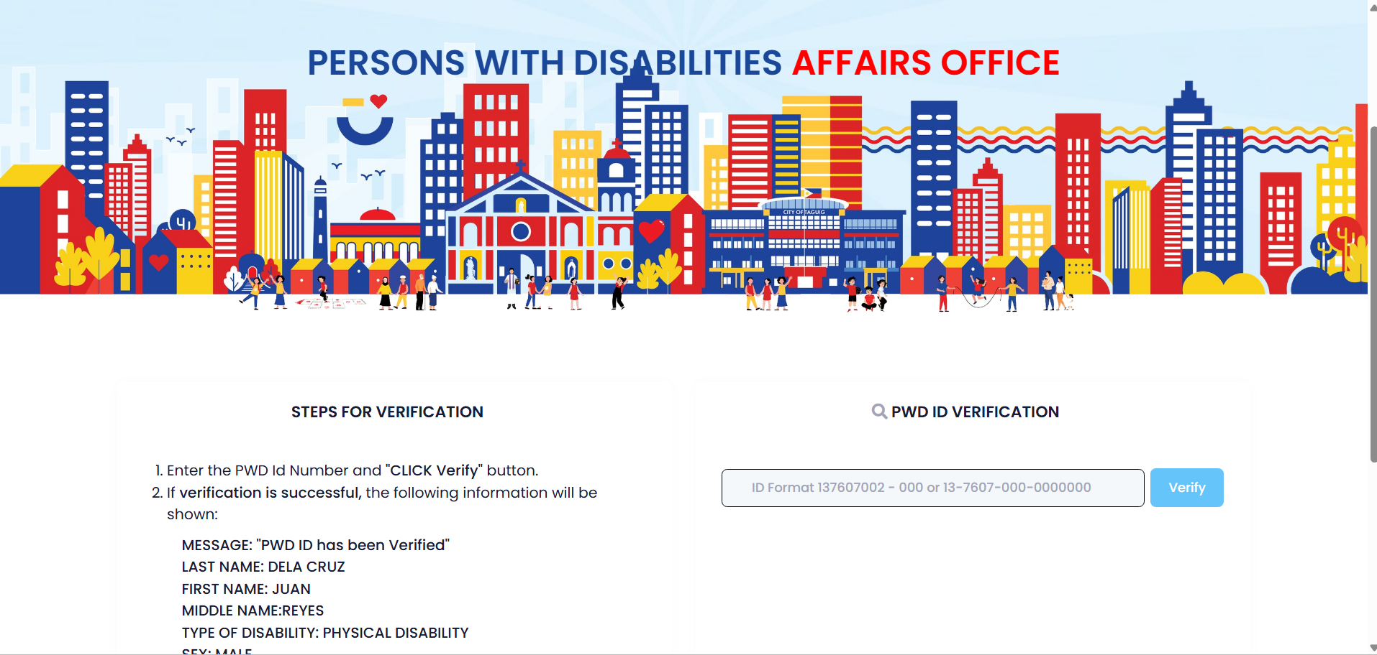
PDAO Taguig
PDAO Taguig PWD ID Verification System. The Persons with Disabilities Affairs Office in Taguig City provides parallel functionality for PWD credential validation through a web-based portal connected to the PDAO database (Persons with Disabilities Office Taguig, 2024). Authorized users search ID numbers to confirm legitimacy, benefiting from direct database access, controlled user authorization, and real-time validation. Despite these strengths, significant limitations exist: manual input of ID details remains required consuming validation time, restriction to Taguig PWDs exclusively limits utility for establishments serving broader populations, the system operates separately from senior citizen validation requiring establishments to use multiple platforms for comprehensive discount validation, and absence of automatic data extraction features makes the system time-consuming for high-volume business environments where transaction speed directly impacts customer experience and operational efficiency.
Figure 6.
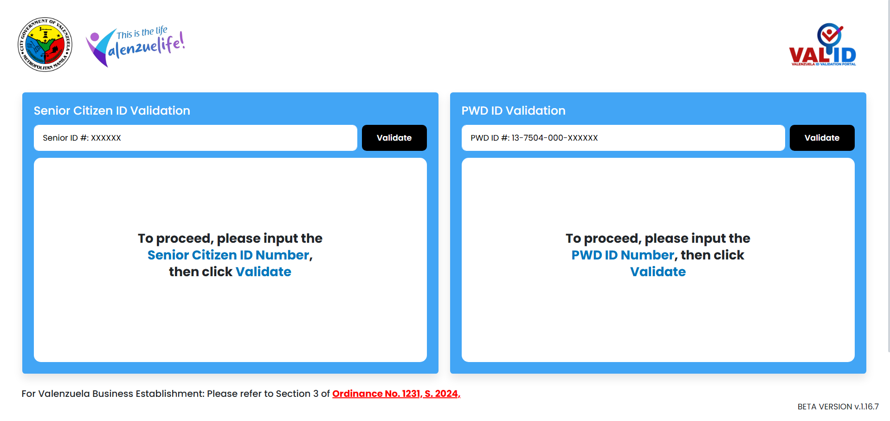
VALID (Valenzuela ID Validation Portal)
VAL ID (Valenzuela ID Validation Portal). VAL ID represents Valenzuela City's integrated platform for validating both Senior Citizen and PWD IDs through a web-based system connecting to city databases maintained by OSCA and PDAO (City Government of Valenzuela, 2025). The portal operates under the legal authority of Ordinance No. 1231, Series of 2024, which formally mandates its use by covered establishments. Launched officially May 20, 2025, the portal features newly designed ID cards with holographic seals and can be accessed via desktop or mobile devices at valid.valenzuela.gov.ph. The platform's key strengths include a unified approach to multiple ID types reducing platform switching for businesses, real-time connectivity to local government databases enabling current validation status checks, specific service to Valenzuela businesses addressing local validation needs, and a clear legal mandate establishing institutional legitimacy and compliance expectations. However, VAL ID presents operational challenges: validation requires manual entry of ID details consuming processing time, the system is not optimized for high-transaction retail environments where validation speed is critical to maintaining customer flow, no OCR integration exists for automated data capture from ID images, and the platform lacks automated fraud reporting mechanisms to notify government offices of suspicious IDs detected by establishments, functioning as a one-way validation tool without bidirectional intelligence sharing between businesses and authorities.
National-Level Identity Verification Platforms
Figure 7.
eVerify
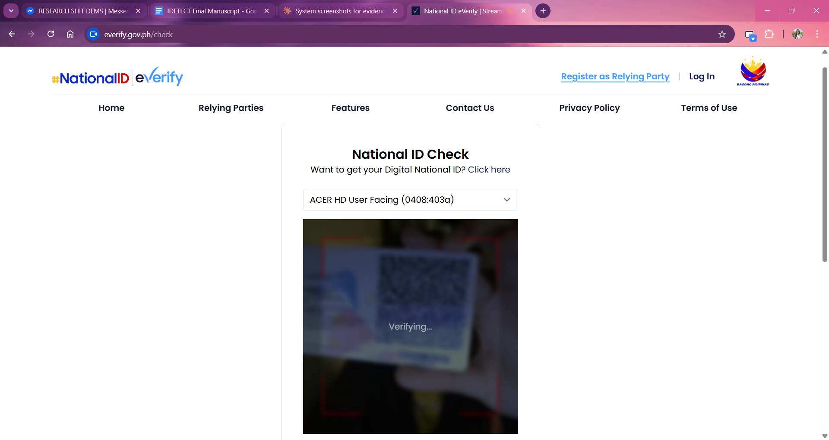

eVerify (Philippine Statistics Authority). The eVerify system, developed and managed by Philippine Statistics Authority, is a national-level digital validation platform designed to authenticate Philippine Identification System (PhilSys) credentials through secure API access for authorized institutional users. Officially launched June 2024, eVerify aims to strengthen identity validation by providing a standardized, centralized, and secure mechanism for validating PhilSys numbers across participating organizations (Philippine Statistics Authority, 2024). Despite its robust framework, eVerify presents several limitations for Senior Citizen and PWD discount validation. The system is primarily focused on PhilSys-based authentication and does not support validation of local government unit-issued senior citizen or PWD identification cards commonly used in availing statutory discounts. Furthermore, eVerify does not incorporate optical character recognition or image-based ID scanning features, limiting usability in point-of-sale environments. The validation workflow is not optimized for real-time discount processing, and formal institutional authorization requirements may pose challenges for small-scale businesses and retail establishments lacking institutional relationships with government validation systems.
International Commercial Identity Verification Solutions
Figure 8.
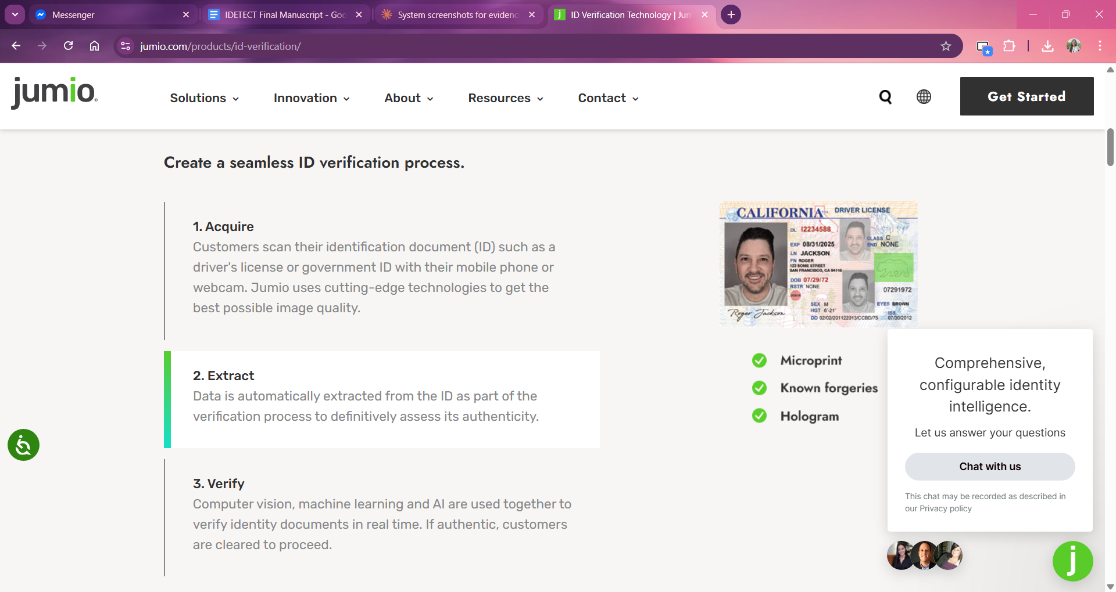
JUMIO
Jumio Identity Verification System. Jumio enables validation of government-issued IDs (passports, driver's licenses, national IDs) through a user-facing workflow where individuals scan the ID front and back and take a selfie, with the system automatically extracting data via OCR, performing liveness and face-match checks, and returning a validation result (Jumio Corporation, 2023). Strengths include real-time automated validation, support for diverse ID types globally, OCR-based data extraction, liveness detection and biometric face matching deterring fraud, and a fast, user-friendly interface suitable for high-volume or online onboarding. However, Jumio has critical limitations for the Philippine discount validation context: designed mainly for eKYC/online identity verification rather than point-of-sale discount validation, not tailored for local Philippine Senior Citizen or PWD discount workflows, may not integrate with local government databases, depends on internet connectivity and quality of images, and is not specific to Senior/PWD IDs used by Philippine LGUs.
Figure 9.
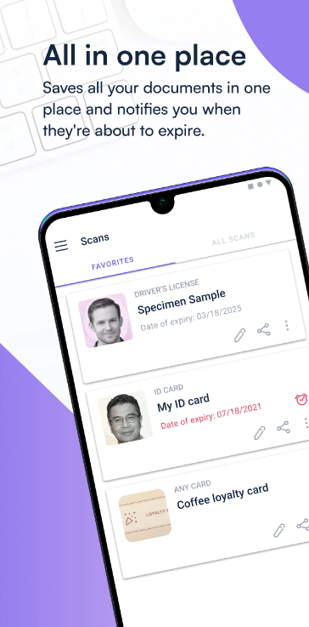
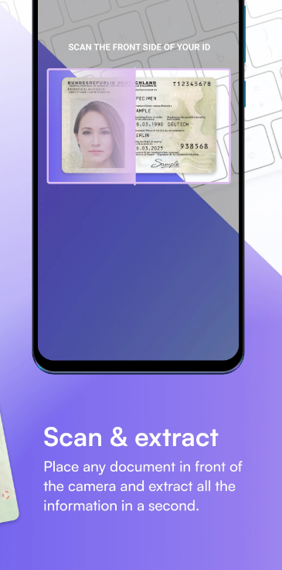
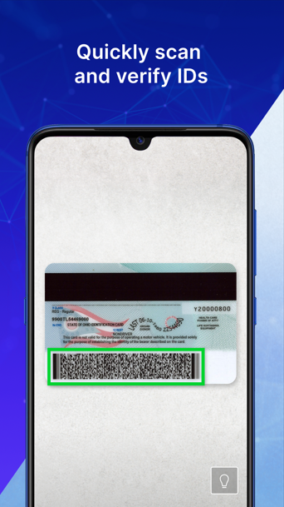
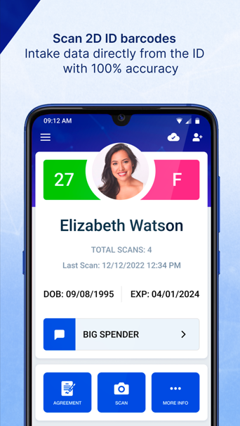
Veri Scan & BlinkID

VeriScan and BlinkID/IDSafe. VeriScan is a mobile ID scanning tool developed by IDScan.net that decrypts barcode data from government IDs and provides real-time age verification and visitor management features (IDScan.net, 2024). BlinkID (now IDSafe) uses AI-powered OCR and NFC technology to extract and validate identity document data from over 190 countries, offering real-time authenticity checks (Microblink, 2024). Both systems demonstrate strengths in barcode/chip reading capabilities, global document coverage, offline functionality, and established commercial deployment. However, shared limitations include: limited support for Philippine non-barcode identification documents, lack of integration with Philippine government OSCA and PDAO databases, subscription requirements for full functionality, and absence of automated reporting mechanisms for flagging suspicious credentials to government authorities. These systems excel at data extraction but lack the government-database integration and fraud reporting architecture required for coordinated discount program validation.

Figure 10.
Scanova, CodeREADr, and Microblink Identity Verification
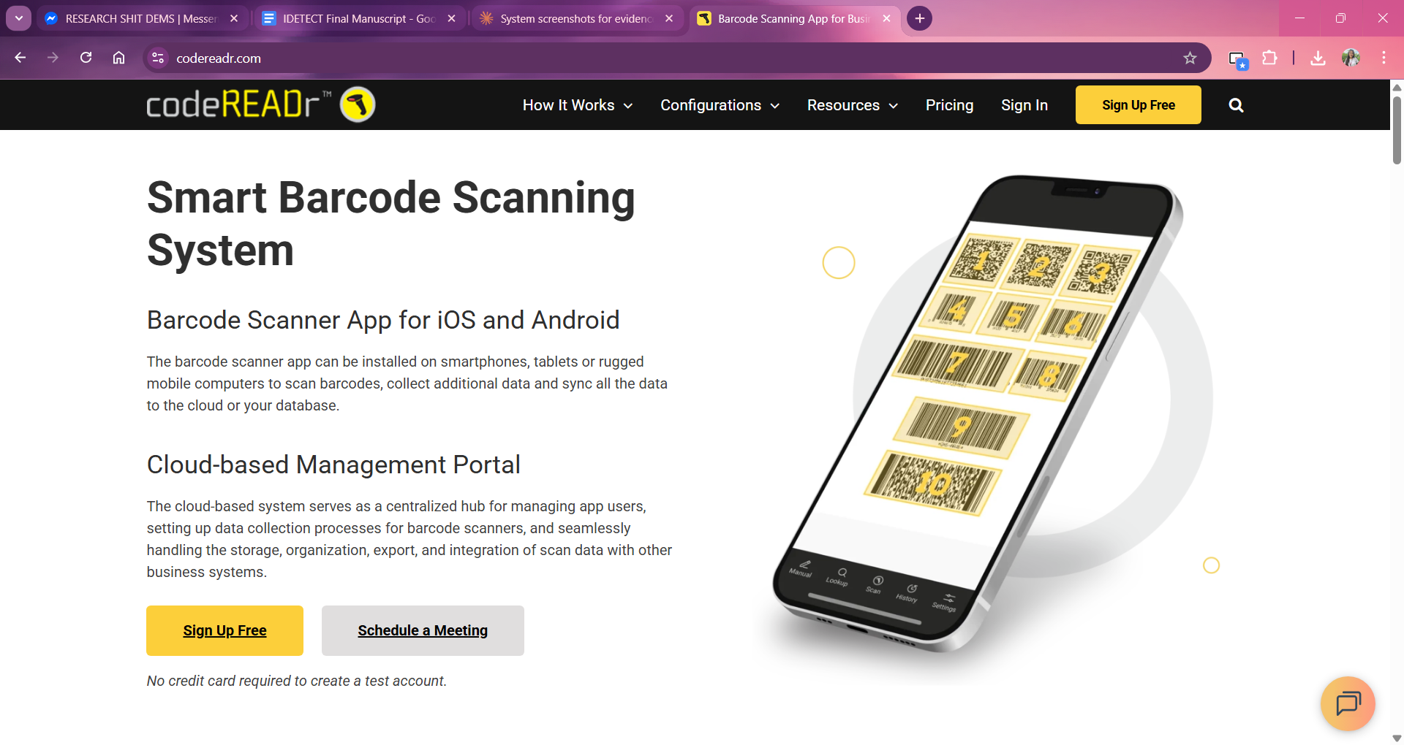
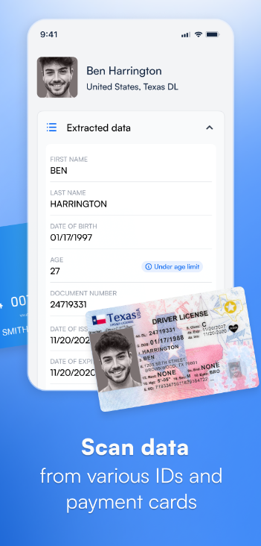
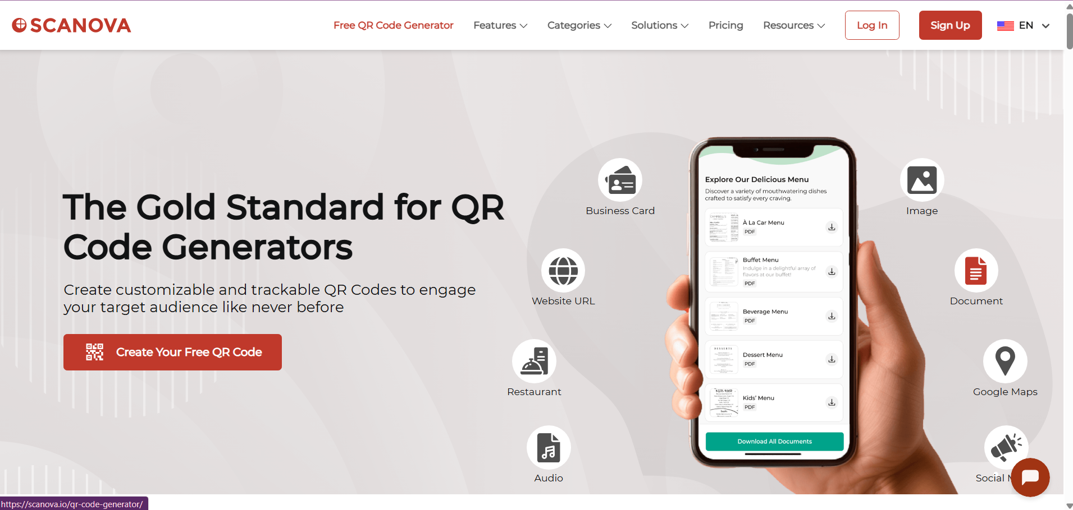
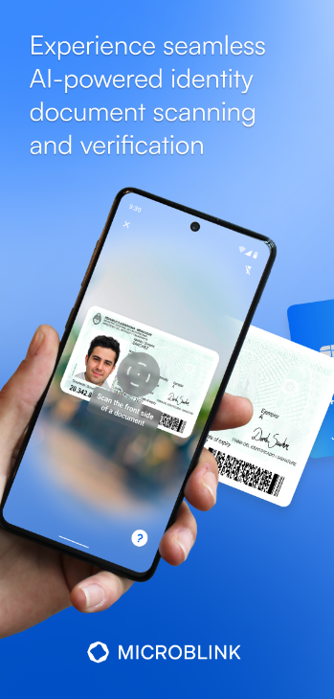

Scanova, CodeREADr, and Microblink Identity Verification. Scanova provides lightweight QR and barcode scanning with fast decoding and scan history logging (Scanova, 2024). CodeREADR offers enterprise data-capture across barcodes, QR codes, NFC, and OCR with configurable workflows and audit trails (CodeREADR Inc., 2024). Microblink Identity Verification uses AI-powered computer vision to scan and validate over 2,500 document types from 200+ countries (Microblink, 2024). These systems demonstrate advanced technical capabilities including multi-modal data capture, offline scanning, and robust audit logging. However, common limitations restrict Philippine discount validation applicability: designed as general-purpose solutions rather than being specifically tailored for Philippine LGU-issued credentials, lack native integration with local OSCA and PDAO databases requiring custom development, and absence of automated fraud reporting mechanisms enabling coordinated intelligence sharing between businesses and government administrative offices. While technically sophisticated, these international systems require substantial adaptation for Philippine discount program context.

Synthesis Matrix
Table 1.
System Matrix Table
Author/Study | OCR Technology & Accuracy | Digital Identity Systems | Fraud Detection Methods | Mobile POS Usability | Philippine Context Challenges | Implications for iDetect
Liu et al. (2022) | 99.25% character recognition accuracy on MRZ extraction using CNNs; 100% MRZ detection rate on passports | - | - | - | - | Establishes OCR viability for ID validation; sets accuracy benchmark for iDetect
Gayer et al. (2023) | Real-time MRZ detection at 62 FPS on mid-range smartphones; 1MB optimized model 83× faster than previous implementations | - | - | Mobile OCR feasible for real-time point-of-sale use | - | Demonstrates mobile OCR is technically feasible for iDetect's client portal
Stančić & Trbušić (2020) | Abbyy FineReader: 95-98% accuracy at 200-500 DPI on typewritten documents | - | - | - | - | Shows image quality directly impacts OCR accuracy; informs preprocessing requirements
Hamdi et al. (2019) | OCR error rates reaching 50% on degraded documents (blurred/skewed images) | - | - | - | - | Necessitates robust preprocessing (deskewing, contrast enhancement) and manual fallback
Lerouge et al. (2024) | 2.52% character error rate = only 48.6% field-level accuracy for ID numbers and dates | - | - | - | - | Field-level validation more critical than character-level; requires pattern matching for ID formats
Martinez (2025) | OCR reduces processing time 90-95% (15 min → 1 min per document); 99.95-99.99% accuracy vs 96-99% manual entry | - | - | - | - | Quantifies time savings and error reduction benefits for iDetect implementation
Mays et al. (2019) | Manual transcription error rate: 3.7% in point-of-care testing | - | - | - | - | Manual entry introduces verification inaccuracies; OCR automation eliminates transcription errors that could enable fraudulent credentials to pass validation
Nitayavardhana et al.,2025) | OCR reduced data entry time by 43.9% (6.0 min → 3.4 min) | - | - | - | - | Validates iDetect's efficiency claims; projects similar reductions from 45-60 seconds to under 30 seconds in discount validation
Frost & Sullivan Institute (2024) | - | Estonia's X-Road: 2.7B queries/year; 99% digital ID adoption; distributed architecture maintains agency sovereignty | - | - | - | Provides architectural model: distributed database integration maintaining LGU sovereignty
Margetts & Naumann (2017) | - | Estonia's 'once-only' principle; 2% GDP annual savings; citizens file taxes in <3 min | - | - | - | Demonstrates measurable efficiency gains from integrated validation systems
Goede (2019) | - | Compared Estonia (government-led) vs Singapore (public-private collaboration); both require robust legal frameworks | - | - | - | Shows multiple pathways to digital transformation; informs iDetect's public-private coordination
Protecht Group (2025) | - | Integrated systems achieve 70%+ fraud reduction through coordinated intelligence sharing | Real-time cross-verification and intelligence sharing critical for fraud reduction | - | - | Sets target: 50%+ fraud reduction (conservative vs 70%+ international benchmark)
Ibor et al. (2024) | - | Digital identity interoperability requires data integrity, confidentiality, privacy during exchange | - | - | - | Informs privacy-preserving design: a validation status without exposing full beneficiary data
Udeh et al. (2024) | - | - | Discusses big data analytics and ML for real-time fraud detection through continuous transaction monitoring. | - | - | Validates the shift from batch processing to real-time analysis to proactively identify and flag suspicious activities.
Curry (2025) | - | - | Identifies performance benchmarks for fraud detection: processing thousands of transactions/sec at sub-100ms latency. | - | - | Defines the technical success criteria for the system's speed and throughput to ensure high-velocity transaction safety.
Bordey (2024) | - | - | 8.5M fake PWD IDs vs 1.89M legitimate (4.5:1 ratio); ₱88.2B tax losses in 2023 | - | Documents fraud crisis magnitude in Philippines | Establishes problem urgency and economic justification (₱44B recovery potential at 50% reduction)
Gonzales (2024) | - | - | ₱166.1B fraudulent discounts in 2023; BIR classifies fake ID use as criminal tax evasion | - | Legal classification strengthens enforcement potential | Supports fraud reporting mechanism to authorities with legal backing
Arceo (2024) | - | - | Major restaurant chain: 17.24% PWD ID rejection rate (726 of 4,212 over 3 months) | - | Industry data quantifies fraud prevalence | Validates need for automated verification; establishes baseline metrics
Arnaldo (2024) | - | - | PWD discount claims increased from 5% (2019) to 30% (2024); 17% rejection rate at establishments | - | 22.21% increase in PWD-to-Senior ratio (2022-2024) | Documents fraud trend escalation requiring urgent intervention
Bonneau et al. (2024) | - | - | Multi-factor authentication: 77% achieve NIST compliance; behavioral biometrics enable continuous authentication | - | - | MFA principles inform field-level validation and pattern recognition
Kumar & Singh (2024) | - | - | MFA + ML: 97.938% accuracy (logistic regression); 97.881% (decision trees); 96.717% (random forest) | - | - | ML fraud detection achievable; informs future pattern recognition enhancements
Wang et al. (2024) | - | - | Ensemble methods: 94.3% fraud detection accuracy; neural networks: 93.7% accuracy | - | - | Establishes multi-layer detection feasibility for behavioral pattern analysis
Baymard Institute (2024) | - | - | - | 0% of 138 mobile commerce sites achieved 'good' UX; 62% rated mediocre/worse | - | Sets usability challenge: deliberate design needed to exceed poor industry baseline
Thompson et al. (2023) | - | - | - | Three-action limit: systems requiring >3 actions face significant adoption resistance | - | Constrains workflow to launch-scan-view; necessitates auto-authentication
Harrison et al. (2024) | - | - | - | PACMAD model: performance, accessibility, compatibility, mobility + traditional metrics | - | Informs comprehensive usability evaluation framework for iDetect
Nielsen & Molich (2016) | - | - | - | 12 POS usability factors: learnability, efficiency, memorability, errors, satisfaction, etc. | - | Defines evaluation criteria for mobile interface design
Cervantes (2025) | - | - | DOJ Jan 2024: establishments cannot deny discounts for unverifiable credentials | - | Legal constraint in Philippines | Requires provisional approval architecture vs gatekeeping; intelligence gathering approach
Alampay et al. (2018) | - | - | - | - | Only 60% of Philippine LGUs have operational PDAOs (33 provinces, 25 cities, 282 municipalities lacking) | Necessitates graduated deployment starting with digitized urban LGUs; explains incomplete database coverage
Respicio Law (2024) | - | - | - | - | Senior citizen IDs have no standard design; formats vary by municipality across 1,780+ LGUs | Requires OCR optimization for non-standardized credentials vs international systems designed for standardized docs
Inabangan et al. (2019) | - | - | - | - | Filipino cultural factors: 'jackpot mentality, helpfulness, shyness' affect discount program implementation | Informs non-confrontational verification design; flags presented as data quality issues not fraud accusations

Project Synthesis and Research Gap Identification
The synthesis of technical background, thematic literature review, and existing system analysis establishes both the necessity and feasibility of iDetect while revealing critical gaps in current validation infrastructure. This section integrates findings across research themes to articulate iDetect's unique contribution to Philippine discount program validation, positioning the system as a response to documented technological capabilities, implementation challenges, and systemic fraud reaching ₱88.2 billion annually in lost tax revenues.

Key Findings from Literature Review
The literature review reveals five fundamental findings informing iDetect's design:
OCR Technology and Accuracy: The foundational viability of the iDetect system is supported by the high-performance standards of modern Optical Character Recognition (OCR). Research by Liu et al. (2022) establishes a benchmark of 99.25% character recognition accuracy, suggesting that automated extraction is a reliable alternative to manual entry. Industry research further demonstrates that OCR-based systems achieve accuracy rates of 99.95–99.99% compared to manual entry accuracy of 96–99%, with manual transcription error rates reaching 3.7% in laboratory settings, of which 14.2% contain potentially dangerous discrepancies (Martinez, 2025; Mays et al., 2019). However, the transition from laboratory settings to point-of-sale environments introduces significant variables. Hamdi et al. (2019) observe that environmental factors such as blurred or skewed images can cause accuracy to degrade to as low as a 50% error rate, while even under optimal scanning conditions, commercial OCR engines average only 95–98% character accuracy (Stančić & Trbušić, 2020), underscoring that OCR performance is highly conditional on capture quality rather than uniformly reliable. Furthermore, Lerouge et al. (2024) posits that field-level accuracy, specifically for critical data like ID numbers, is more difficult to maintain than individual character recognition. These findings necessitate iDetect's focus on robust preprocessing and pattern-matching algorithms. A multi-center study across ICUs demonstrated that well-implemented OCR systems can reduce data entry time by an average of 43.9%, with processing time decreasing from 6.0 minutes to 3.4 minutes per document (Nitayavardhana et al., 2025), supporting the feasibility of significant efficiency gains in automated credential validation systems.
Digital Identity Validation Systems and E-Government Integration: The architectural philosophy of iDetect mirrors international best practices in e-government. Estonia's X-Road serves as a primary model, demonstrating how a distributed architecture can maintain agency sovereignty while facilitating billions of annual queries (Frost & Sullivan Institute, 2024). Whether through government-led models or public-private collaborations, successful integration requires robust legal frameworks and the "once-only" principle to maximize efficiency (Goede, 2019; Margetts & Naumann, 2017). Real-time financial fraud detection systems similarly employ distributed architectures to achieve sub-100 millisecond latency through in-memory caching and optimized query patterns (Curry, 2025; Udeh et al., 2024). iDetect adopts these architectural principles for instant validation.
Fraud Detection and Prevention in Discount Programs: The urgency for an integrated validation system is driven by the severe economic impact of identity fraud. Bordey (2024) and Gonzales (2024) document a crisis in the Philippines where fraudulent PWD IDs outnumber legitimate ones by a 4.5:1 ratio, resulting in approximately ₱88.2 billion in tax losses in 2023. While integrated international systems have achieved 70% fraud reduction through coordinated intelligence sharing (Protecht Group, 2025), iDetect adopts a targeted approach to the local retail sector. Ensemble detection methods and behavioral pattern analysis approaches documented by Wang et al. (2024) and Kumar & Singh (2024), which reach detection accuracies of over 94%, inform the evidentiary case for iDetect's fraud flagging design, which provides a proactive defense against the unauthorized use of discount privileges through database cross-referencing and cross-establishment flag correlation.
Mobile Point-of-Sale Validation Solutions and Usability Requirements: The practical utility of iDetect depends on its seamless integration into the fast-paced retail workflow. Baymard Institute (2024) notes that the majority of mobile commerce interfaces fail to meet basic usability standards, which leads to significant adoption resistance. As Thompson et al. (2023) suggests, systems requiring more than three user actions are likely to be abandoned by staff. iDetect addresses these constraints by leveraging optimized mobile OCR models that achieve 62 FPS on mid-range devices (Gayer et al., 2023) and following the PACMAD usability model (Harrison et al., 2024) to ensure that the validation process remains efficient under the pressures of a point-of-sale environment.
Philippine Senior Citizen and PWD Discount Implementation Challenges: Finally, the system must navigate a highly fragmented domestic landscape. Respicio Law (2024) highlights that Senior Citizen IDs lack a standard design across the 1,780+ LGUs in the Philippines, while Alampay et al. (2018) notes that many municipalities still lack operational PDAO offices. This lack of standardization is complicated by legal mandates; Cervantes (2025) reports that establishments are legally prohibited from denying discounts based solely on unverifiable credentials. Moreover, Inabangan et al. (2019) emphasizes cultural factors such as "helpfulness" and "shyness" that can impede strict enforcement. iDetect therefore utilizes a non-confrontational flagging architecture, prioritizing data quality and intelligence gathering over direct rejection to remain compliant with local regulations and cultural sensitivities.
The synthesis of current literature reveals a critical research gap: while high-accuracy OCR and distributed identity models exist globally, they have not been integrated into a mobile-first solution tailored to the fragmented and legally complex Philippine discount program ecosystem. Current manual validation methods are insufficient to stem the billions in tax leakages caused by a 4.5:1 fraud-to-legitimacy ratio. By harmonizing technical feasibility with the specific legal constraints and cultural nuances of the Philippine retail sector, iDetect provides a unique, real-time validation tool that balances efficient business operations with robust fraud detection. This research fills the void between high-level e-government theory and the practical, day-to-day requirements of local business establishments.

Critical Limitations of Existing Validation Systems
Existing systems, both local and international, present substantial functional gaps preventing comprehensive discount program fraud prevention:
Local government platforms (OSCA Taguig, PDAO Taguig, VAL ID Valenzuela) provide database validation but remain fundamentally limited by manual data entry requirements consuming 30–45 seconds per transaction, geographic restriction to single municipalities preventing cross-LGU validation needed by regional businesses, lack of OCR automation forcing staff to manually type ID details from physical cards, and operation as one-way validation tools without automated fraud reporting mechanisms enabling suspicious credentials to circulate undetected across multiple establishments even after initial detection. Most critically, these systems function as isolated municipal solutions rather than integrated networks, preventing intelligence sharing and coordinated fraud response.
National systems (eVerify) focus on PhilSys credentials rather than LGU-issued Senior Citizen and PWD IDs, creating fundamental scope misalignment with discount validation requirements. The system's institutional authorization model proves impractical for small retail establishments, while absence of mobile-optimized workflows and OCR capabilities limits point-of-sale applicability.
International commercial solutions (Jumio, VeriScan, BlinkID, Microblink) demonstrate advanced technical capabilities including multi-modal scanning, global document coverage, and robust data extraction, but present critical limitations for the Philippine context: designed for international standardized documents rather than non-standardized Philippine LGU credentials, lack integration with local OSCA and PDAO databases requiring custom development work, absence of fraud reporting mechanisms enabling coordination between businesses and government authorities, and commercial subscription models potentially prohibitive for small establishments. These systems excel at technical data extraction but lack the government-ecosystem integration essential for coordinated fraud prevention.
The fundamental gap: no existing system integrates automated OCR-based data capture, real-time validation against OSCA and PDAO records held in one beneficiary registry, mobile-first point-of-sale design optimized for transaction speed, and bidirectional fraud reporting creating intelligence-sharing networks between businesses and government administrative offices. Current solutions address validation in isolation without creating the coordinated fraud prevention ecosystem necessary to combat systematic exploitation reaching ₱88.2 billion annually.

iDetect's Unique Contribution and Innovation
iDetect addresses identified gaps through integrated multi-portal architecture synthesizing proven technological approaches with Philippine-specific implementation requirements:
Automated OCR-based validation workflow. The Client Portal (mobile application) enables business establishments to capture ID images through smartphone cameras, automatically extract data using Tesseract OCR with field-level validation, and receive validation results in under 30 seconds — reducing transaction time by 40–60% compared to manual entry systems. This automation directly addresses the operational burden documented in local platforms while implementing mobile-first design absent in national systems. Critical distinction from commercial solutions: optimization for Philippine LGU-issued credentials rather than international standardized documents, with preprocessing specifically tuned for non-standardized formats and manual fallback enabling operation when OCR confidence is insufficient.
Real-time, type-scoped registry validation. Unlike existing platforms validating single credential types or operating in isolated municipalities, iDetect integrates with both OSCA and PDAO records enabling comprehensive discount validation through a single application. The distributed database architecture following Estonia's X-Road principles maintains LGU sovereignty while enabling cross-validation: Valenzuela OSCA and PDAO maintain independent databases accessed through a secure API layer rather than attempting centralization that would face institutional resistance. Privacy-preserving design returns a validation status of VALID, SUSPICIOUS, INVALID, or MANUAL REVIEW without exposing comprehensive beneficiary data to businesses, balancing validation requirements against data protection obligations.
Bidirectional fraud reporting and intelligence sharing. iDetect's most significant innovation: automated mechanisms enabling suspicious credentials flagged by establishments to be immediately transmitted to the appropriate LGU portal (OSCA for Senior Citizen IDs, PDAO for PWD IDs) for investigation, with confirmed fraudulent records synchronized back into official databases and propagated across all system users. This creates an active fraud prevention ecosystem rather than passive validation, transforming disconnected validation points into coordinated intelligence networks. When an establishment flags suspicious credentials, the system automatically notifies LGU administrators, provides establishment contact for investigation follow-up, updates database validation status preventing future use, and generates fraud analytics enabling pattern recognition across establishments, capabilities absent in all reviewed systems.
Multi-portal role-based architecture. iDetect operates through five interconnected portals serving distinct stakeholder needs: Client Portal (mobile) for business validation, BPLO Portal (web) for business account management and technical oversight without accessing beneficiary data, OSCA Portal (web) for Senior Citizen database management and fraud investigation, PDAO Portal (web) for PWD database management and fraud investigation, and the Beneficiary Mobile Application for Senior Citizens and PWDs to monitor their own validation status, receive transaction notifications, and submit disputes. This separation maintains clear functional boundaries: business regulators oversee system operations without accessing validation intelligence, fraud investigators access relevant beneficiary data without business operational details, businesses receive validation services without comprehensive database access, and beneficiaries access their own transaction history and dispute channels without administrative system privileges. The architecture enables coordination while maintaining appropriate information compartmentalization protecting privacy and institutional sovereignty.
Philippine context adaptation. Critical design decisions directly address local implementation challenges: a graduated deployment strategy beginning with Valenzuela City, where digitized OSCA and PDAO offices provide the institutional foundation for reliable operation, with system architecture explicitly designed to support future multi-municipal expansion as broader national PDAO coverage develops toward addressing the 60% national coverage reality; a provisional approval architecture complying with the DOJ prohibition on denying unverifiable credentials, balancing legal requirements with fraud detection through intelligence gathering; multi-layer detection combining database validation with cross-establishment flag correlation to compensate for incomplete database coverage; and non-confrontational interface design presenting flags as data quality issues rather than fraud accusations, addressing cultural sensitivity requirements. The system builds incrementally toward comprehensive validation while delivering immediate fraud reduction value to participating LGUs and establishments.

Research Justification and Expected Contributions
The convergence of the documented fraud crisis (₱88.2 billion annual tax losses), proven technological capabilities (95–99% OCR accuracy, 70%+ fraud reduction through integrated systems), and identified validation gaps establishes compelling justification for iDetect development. The system addresses documented needs across multiple stakeholder groups:
Business establishments gain efficient validation tools reducing transaction time 40–60%, decreasing fraudulent discount absorption, and enabling compliance with legal validation obligations without requiring multiple platform usage or extensive staff training.
Local government units receive fraud intelligence unavailable in current systems, enabling targeted investigations, database accuracy improvements, and evidence supporting enforcement actions against systematic fraud, transforming passive validation into active fraud prevention.
Legitimate beneficiaries experience faster validation without prolonged scrutiny, consistent treatment across participating establishments, and protection against wrongful denial as validation becomes more reliable and less dependent on individual establishment judgment.
Government revenue protection through substantial fraud reduction: even a 50% reduction in fraudulent transactions would recover ₱44 billion annually in tax revenues while reducing business discount absorption by ₱83 billion, creating measurable economic impact justifying implementation investment.
Beyond immediate operational benefits, iDetect contributes to broader digital transformation of Philippine local governance. The system demonstrates a scalable model for LGU-business coordination addressing social service delivery challenges through integrated technology rather than isolated solutions. Implementation experience will generate empirical data addressing research gaps identified in the literature review: validation effectiveness in non-standardized ID ecosystems, public-private partnership implementation at micro-enterprise scale, fraud detection patterns specific to Philippine discount programs, and trust-building mechanisms in contexts characterized by institutional fragmentation and established fraudulent credential markets.

Success Metrics and Evaluation Framework
The system's success is measured across multiple dimensions reflecting its comprehensive approach. Technical performance metrics include OCR accuracy rates under operational conditions, average validation time from credential capture to result display, and system uptime and reliability. Operational effectiveness metrics encompass fraud reduction percentages comparing flagged suspicious credentials before and after implementation, transaction processing time improvements measured at participating establishments, and database validation adoption rates tracking the proportion of transactions receiving authoritative confirmation. Stakeholder adoption metrics monitor business establishment enrollment and active usage rates, staff training completion and proficiency levels, and user satisfaction scores from both establishments and legitimate beneficiaries. Fraud intelligence metrics track suspicious credential reports submitted, investigation outcomes and confirmation rates, and fraud pattern identification enabling systemic interventions. These multidimensional success criteria demonstrate that technology alone proves insufficient without corresponding attention to usability, governance, and contextual adaptation. iDetect's integrated approach synthesizing OCR automation, database integration, mobile usability, fraud intelligence sharing, and Philippine-specific design adaptations represents the comprehensive solution architecture required to address systematic validation failures enabling the documented ₱88.2 billion annual fraud crisis.
This comprehensive literature review and system analysis establishes the foundation for iDetect's design and methodology presented in Chapter 3. The integration of proven OCR technologies, established database architectures, documented fraud detection methodologies, and Philippine-specific implementation considerations creates a research-informed approach addressing the ₱88.2 billion fraud crisis while respecting the unique constraints of Philippine local government capacity and legal frameworks.

Table of Comparison
Table 2.
Comparison of iDetect with Existing ID Validation Systems
Systems | OCR extraction | Real-time OSCA/PDAO validation | Auto fraud reporting | Mobile POS design | Dual database integration
OSCA Taguig Senior Citizen ID Verification System | ✗ | ✓ | ✗ | ✗ | ✗
PDAO Taguig PWD ID Verification System | ✗ | ✓ | ✗ | ✗ | ✗
VALID (Valenzuela ID Validation Portal) | ✗ | ✓ | ✗ | ✗ | ✓
eVerify Philippines - National ID Verification System | ✗ | ✓ | ✗ | ✗ | ✗
Jumio Identity Verification System | ✓ | ✗ | ✗ | ✓ | ✗
VeriScan | ✗ | ✗ | ✗ | ✓ | ✗
BlinkID | ✓ | ✗ | ✗ | ✓ | ✗
Scanova | ✗ | ✗ | ✗ | ✓ | ✗
CodeREADr | ✓ | ✗ | ✗ | ✓ | ✗
Microblink Identity | ✓ | ✗ | ✗ | ✓ | ✗
Proposed System: IDetect | ✓ | ✓ | ✓ | ✓ | ✓
Note: OCR extraction = optical character recognition-based automated data extraction; Real-time OSCA/PDAO validation = real-time validation against the beneficiary registry with Office of Senior Citizens Affairs and Persons with Disability Affairs Office; Auto fraud reporting = automated bidirectional fraud reporting to local government units; Mobile POS design = mobile-first design optimized for point-of-sale environments; Dual database integration = integration with both OSCA and PDAO databases. iDetect is the only system integrating all five capabilities. This comparison focuses on systems with similar scope (ID verification for discount programs). International digital identity platforms (X-Road, SingPass) are discussed in Section 2.2 as architectural models rather than direct competitors due to different scope and purpose.

CHAPTER 3 DESIGN AND METHODOLOGY

Developmental Model (NA)

Figure 11.

Agile Methodology
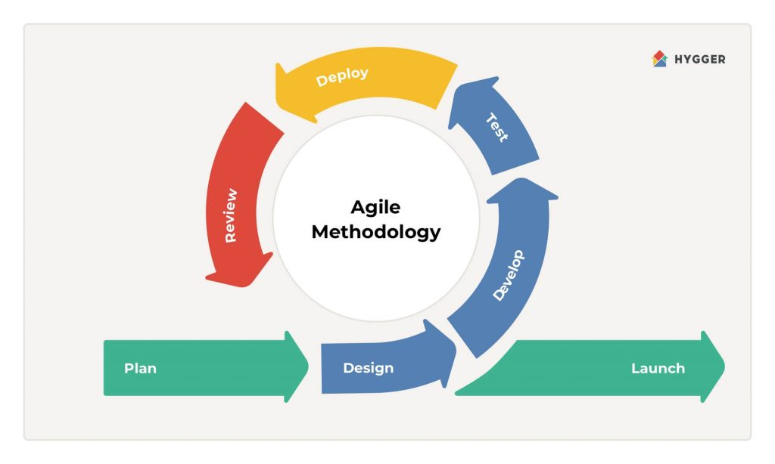
The development of iDetect follows the Agile software development methodology. Agile was selected due to the iterative and adaptive nature of the project, which demands continuous stakeholder feedback and flexibility in responding to evolving technical and institutional requirements particularly given the complexity of integrating an OCR processing pipeline with under varying data access conditions, and developing five distinct portals for the BPLO, OSCA, PDAO, Client Portal, and Beneficiary Mobile Application.
Development is organized into sprint cycles, with each sprint focused on specific system components: system infrastructure and environment setup, authentication and role-based access control, BPLO account provisioning, OCR image capture and preprocessing, single-registry verification scoped by ID type, fraud flagging and reporting, LGU portal fraud management, beneficiary self-service features, offline synchronization, audit logging, and data privacy compliance. Each sprint concludes with a review and testing phase, and stakeholder demonstrations are conducted at the end of each sprint cycle to ensure continuous alignment with user needs and the functional requirements defined in the study.
This iterative approach enables the team to identify and resolve challenges early such as OCR accuracy limitations on non-standardized LGU credential formats, database access arrangements with OSCA and PDAO, and cross-portal data compartmentalization while maintaining systematic progress toward a fully functional and validated iDetect system within the 32-day critical path established in the project's Work Breakdown Structure.

Research Design
Applied research is defined as original investigation undertaken to acquire new knowledge directed primarily towards a specific, practical aim or objective, and is about using existing stock knowledge with the appropriate methodology towards the resolution of a practical problem (de Mello & Wood, 2019). Descriptive research is a nonexperimental design that observes and documents a phenomenon as it naturally occurs without manipulating any variables (Siedlecki, 2020), and is useful when the focus is on practical improvement in a specific setting rather than on theory building (Doyle et al., 2020). This study employed a Descriptive Applied research Design, which was appropriate because the primary aim of the study is not to generate abstract theoretical knowledge but to produce a functional, deployable solution while describing the existing conditions and problems that the solution addresses. As the researchers utilized and built upon existing knowledge in optical character recognition (OCR), real-time database verification, and digital identity systems to develop iDetect, an OCR-Based Discount ID Validation Application tailored to the specific operational needs of business establishments, government offices, and legitimate beneficiaries in Valenzuela City. The study is exploratory and descriptive, where the researchers investigated and described the existing verification landscape, identified the critical gaps in current systems such as the VALID Portal, OSCA Taguig, and PDAO Taguig, and applied these findings alongside established technologies to produce a functional and deployable solution that directly addresses the documented problem of fraudulent Senior Citizen and PWD identification cards. The results of system testing and evaluation were likewise presented as observed, without manipulating any variables.

Research Methodology
The study adopts a mixed-methods research methodology, integrating both qualitative and quantitative approaches to comprehensively address the research objectives. The mixed-methods design was selected because the study requires both numerical measurement such as OCR accuracy rates, validation transaction response times within the required fraud detection rates and descriptive, contextual data that cannot be fully captured through quantitative means alone, such as stakeholder experiences, usability concerns, and operational realities at the point of sale.
In the qualitative strand, data were gathered through consultations with representatives from the BPLO, OSCA, PDAO, and food service establishments in Valenzuela City to understand current verification processes, pain points, and system requirements. Document analysis of related legislation including Republic Acts 9994 and 10754 as well as the Data Privacy Act of 2012 (RA 10173) and Department of Justice opinions on discount compliance informed the system's legal and regulatory design.

Research Instruments
The primary data collection instruments used in the exploratory phase were four structured survey questionnaires (Questionnaires A through D) developed by the research team and validated through adviser review prior to administration. Each questionnaire was tailored to the specific knowledge domain and operational context of its target respondent group.
Questionnaire A was administered to Senior Citizen and PWD beneficiaries and covered four thematic areas: current experience with discount ID validation, challenges and concerns in availing discount privileges, need for an improved validation system, and data privacy and transparency concerns. Questionnaire B was administered to business establishment staff and owners and addressed the current validation process and its challenges, the impact of fraudulent IDs on business operations, the need for a digital validation solution, and legal and compliance concerns. Questionnaire C was administered to OSCA and PDAO personnel and covered current beneficiary database management practices, fraud reporting and investigation challenges, inter-agency coordination and data sharing, and data privacy and compliance concerns. Questionnaire D was developed for BPLO personnel and addressed monitoring of business compliance with discount laws, fraud prevention and enforcement challenges, the need for an integrated validation and reporting system, and data management and revenue protection, this questionnaire was not administered due to respondent unavailability.
All questionnaires employed a four-point Likert scale with the following response options: 4 (Strongly Agree), 3 (Agree), 2 (Disagree), and 1 (Strongly Disagree). A four-point scale was deliberately selected over a five-point scale to eliminate the neutral midpoint, compelling respondents to express a directional position on each item. This design decision reduces central tendency bias and produces clearer signals from the data, which is particularly important given the small sample size of this exploratory study.
Secondary data was gathered through documentary review of existing literature, legal instruments (Republic Acts 9994, 10754, and 10173), published government reports, and publicly available documentation of existing validation systems including the OSCA Taguig Senior Citizen ID Verification System, PDAO Taguig PWD ID Checker, and the Valenzuela City VALID Portal. This secondary data informed the review of related literature and systems in Chapter 2 and provided contextual grounding for the functional requirements specified in this chapter.

Prior to the actual data gathering, the research instrument underwent validation by the researchers’ adviser, who possesses sufficient knowledge and expertise relevant to the study. The questionnaire was carefully reviewed to ensure the clarity, relevance, and appropriateness of the survey items. Necessary revisions and corrections were made based on the recommendations provided during the validation process to improve the reliability and trustworthiness of the instrument.

Data Gathering Procedures
Prior to data collection, the research team secured the necessary permissions and prepared the survey instruments through adviser consultation and review. Informed consent was communicated verbally to all respondents, and participation was made entirely voluntary. Respondents were assured that all responses would be kept strictly confidential and used solely for academic purposes. In accordance with the Data Privacy Act of 2012 (Republic Act 10173), no personally identifiable information beyond optional name disclosure was collected, and all completed questionnaires were stored securely and accessed only by the research team.
Interview. The developers conducted structured interviews with key stakeholders, specifically business establishment staff, managers, and authorized LGU personnel from OSCA, PDAO and BPLO. These interviews aimed to gather in-depth qualitative information regarding their existing ID validation workflows, common challenges encountered, frequency of fraudulent ID incidents, and expectations for an improved validation system. Each interview followed a pre-defined guide to ensure consistency in the data collected. Responses were recorded, summarized, and used to finalize the functional and non-functional requirements of the iDetect system.
Questionnaires. The developers administered structured and validated survey questionnaires to business establishments, Senior Citizen and PWD beneficiaries, and LGU personnel. These questionnaires were designed to gather quantitative data related to user experience, satisfaction with current validation practices, time spent per validation, and perceived usefulness of an automated system.
Internet Research. The developers conducted extensive internet research to collect background information, existing studies, and technological references relevant to the project. This included reviewing documentation on Optical Character Recognition (OCR), fraud detection systems, database integration practices, and digital validation standards. The developers also examined online platforms used by various LGUs, such as VALID, OSCA Taguig, and PDAO Taguig systems, to identify their strengths, limitations, and areas where iDetect can provide significant improvements. The information gathered through online research helped establish the theoretical foundation of the study and supported the rationale for system development.

Ethical Considerations
The conduct of this study involved the collection of primary data from human respondents and the design of a system that processes sensitive personal information of vulnerable population groups. In recognition of these responsibilities, the research team observed the following ethical principles throughout all phases of the study.
Informed Consent and Voluntary Participation
Prior to the administration of survey questionnaires, all respondents were informed of the nature, purpose, and academic scope of the study. Participation was made entirely voluntary, with respondents explicitly informed of their right to decline participation or withdraw at any point without consequence. No incentives were offered in exchange for participation. Written or verbal consent was obtained from all respondents before questionnaire administration proceeded. For beneficiary respondents, Senior Citizens and PWDs, the research team ensured that the consent process was conducted in plain, accessible language, and that researchers remained available to clarify any items in the questionnaire throughout the administration process.
Confidentiality and Data Privacy
All survey responses were treated with strict confidentiality. Name disclosure was made optional across all four questionnaires, and no personally identifiable information beyond voluntary demographic data was collected or retained. Completed questionnaires were stored securely and accessed exclusively by the research team for the purpose of academic analysis. Raw data will not be shared with third parties, and no individual respondent's responses will be attributed or reported in a manner that could identify them. These practices are consistent with the provisions of Republic Act 10173, the Data Privacy Act of 2012, which establishes the rights of data subjects to privacy and informed consent in the collection and processing of their personal information.
Protection of Vulnerable Populations
The study's beneficiary respondents; Senior Citizens and PWDs, constitute legally recognized vulnerable populations under Republic Acts 9994 and 10754. The research team exercised heightened care in their engagement with these groups. Survey instruments were designed using simple, clear language to minimize comprehension barriers. Face-to-face administration was conducted to ensure accessibility for respondents with lower digital literacy or physical mobility constraints, with researchers available to provide assistance without influencing responses. No questions were designed to cause distress, embarrassment, or pressure, and no respondent was asked to disclose the nature of their disability or any personal medical information.
Responsible System Design
The system developed in this study; iDetect, processes sensitive personal data of Senior Citizens and PWDs, including ID numbers, names, validity periods, and validation transaction records. The research team incorporated the following ethical design principles in the system's architecture to protect data subjects throughout development:
Minimum disclosure design ensures that business establishment staff receive only the validation status; VALID, SUSPICIOUS, INVALID, or MANUAL REVIEW, without access to comprehensive personal data held in OSCA and PDAO databases. Role-based access control enforces strict data compartmentalization, ensuring that each portal accesses only the data necessary for its defined function. Beneficiary autonomy is preserved through the optional registration model of the Beneficiary Mobile Application, ensuring that no new technological barrier prevents vulnerable populations from accessing statutory discount privileges. The dispute resolution mechanism provides structured recourse for beneficiaries who experience erroneous denials, operationalizing their rights to data access, correction, and transparency under Republic Act 10173, Section 16. Immutable audit logging ensures that all data access events are traceable, supporting accountability for all system users including government administrators.
Honest Reporting of Finding
The research team commits to reporting all findings accurately and without selective omission, including the acknowledged limitations of the exploratory data collection; particularly the absence of BPLO respondents and the small overall sample size. These are disclosed fully in the methodology chapter rather than minimized or obscured. All cited sources are properly attributed, and no data has been fabricated, falsified, or misrepresented in any section of this study.

Requirement Analysis/Documentation - Existing Process
Prior to designing iDetect, the development team conducted an exploratory analysis of the existing Senior Citizen and PWD discount validation process in Valenzuela City. The current practice relies primarily on manual visual inspection of the physical ID card by establishment staff. Some businesses use the VAL ID Portal to manually type in the ID number and query the Valenzuela City OSCA or PDAO database, but this requires 30 to 45 seconds per transaction and is limited to IDs issued within Valenzuela City only. No platform currently supports automated data capture, mobile-optimized workflows, or cross-establishment fraud intelligence sharing.
The existing validation process is characterized by its exclusive reliance on human judgment and unaided visual inspection, without access to government databases, standardized security feature checklists, or systematic fraud reporting mechanisms. The following documents this process as practiced prior to the availability of digital validation tools.
The Existing Manual Verification Process
Step 1: Physical Presentation of the ID - A customer presents their Senior Citizen or PWD identification card at the cashier or service counter when requesting the statutory 20% discount and 12% VAT exemption. The card is handed directly to the establishment staff member processing the transaction. No standardized protocol governs what happens next; validation practices vary significantly across establishments and even across individual staff members within the same establishment (BusinessMindedPinoy, 2024).

Step 2: Visual Inspection of Physical Security Features - The staff member examines the physical card by sight and touch. Documented visual inspection practices include checking for the presence of official government seals and the signature of the issuing OSCA head or PDAO officer; inspecting for holographic overlays by tilting the card under available light; checking whether the cardholder photograph appears genuine, professionally taken, and consistent with the person presenting the card; examining the card material and print quality for signs of home printing or low-quality reproduction; and looking for physical signs of tampering such as peeling laminate, altered text, or inconsistent formatting (Pagsolingan, 2025; Respicio Law, 2024).
This step is the primary and often only validation action taken. However, its effectiveness is fundamentally limited by the absence of a standardized national ID format. Unlike the Philippine passport or driver's license, which have uniform designs issued by a single national authority, Senior Citizen and PWD IDs are issued independently by over 1,780 local government units, each with discretion over card design, field layout, color scheme, and security feature specifications (Rita, as cited in GMA News, 2024). A cashier trained to recognize the Valenzuela City OSCA ID format has no reliable visual reference for authenticating an ID issued by a different municipality; and a well-produced fake of an unfamiliar format is effectively indistinguishable from the genuine article through visual inspection alone.
Step 3: Cross-Reference with Secondary Identification - Staff members are advised, but not legally required, to request a secondary government-issued ID such as a passport, driver's license, or UMID to confirm that the name and birthdate on the Senior Citizen or PWD ID match another valid credential (Sison, as cited in Inquirer Lifestyle, 2025; BusinessMindedPinoy, 2024). In practice, this cross-reference is inconsistently applied, particularly in high-volume food service environments during peak hours where transaction throughput pressure discourages additional validation steps. Furthermore, this step confirms identity consistency between documents but does not validate that the presented credential is registered in any government database, a fraudulent ID with a matching secondary ID still passes this check.
Step 4: Subjective Judgment and Transaction Completion - Having completed visual inspection and optional secondary ID cross-reference, the staff member makes a subjective determination, based entirely on personal judgment, whether to honor the discount. If the card appears genuine, the discount is applied and the transaction is completed. If the card appears suspicious, the staff member faces a structurally untenable decision: deny the discount and risk a ₱50,000 to ₱100,000 fine and imprisonment under RA 9994 and RA 10754 for wrongful denial of a legitimate beneficiary, or honor the discount and absorb the cost of potential fraud (DOJ Legal Opinion, January 2025; Cervantes, 2025). In the absence of any validation mechanism that produces a defensible record of the determination, most establishments default to honoring the discount regardless of suspicion to avoid legal liability (Inquirer News, 2025).
Step 5: No Fraud Reporting Mechanism - If a staff member or manager believes a presented credential is fraudulent, there is no standardized, accessible mechanism for reporting the suspected fake ID to OSCA, PDAO, or any other government authority. The Restaurant Owners of the Philippines (Resto PH) documented in their August 2024 position paper that establishments have been identifying and internally flagging suspicious IDs since as early as 2019, but no systematic channel exists for transmitting these observations to issuing authorities (Rappler, 2024). Suspected fraudulent credentials are noted informally, if at all, in transaction logbooks maintained for BIR audit purposes, but these records do not reach OSCA or PDAO and do not result in database updates, investigations, or cross-establishment alerts. Each suspicious credential encounter remains an isolated event with no network effect on fraud prevention.
Critical Limitations of the Existing Process
The manual validation process described above produces five documented systemic failures that directly inform iDetect's functional requirements:
No Database Cross-Reference. Visual inspection cannot confirm whether a credential is registered in any government database. A high-quality counterfeit of a legitimate ID format passes visual inspection without triggering any alert. The DOH PWD registry exists as a potential cross-reference but is acknowledged by the DOH itself to be incomplete, with legitimate PWDs whose records were not encoded by their LGU appearing as unverifiable even when their IDs are genuine (Laqui, 2025; Cervantes, 2025). The OSCA registry has no publicly accessible validation interface for establishment use.
Validation Speed and Inconsistency. Manual entry into available platforms such as the Valenzuela VAL ID portal, where used, requires staff to type credential details by hand, consuming 30 to 45 seconds per transaction and introducing transcription errors (Arceo, 2024). Where no platform is used, the entire validation consists of a visual inspection lasting seconds, producing neither a defensible record nor any database confirmation.
No Standardized Security Feature Reference. With over 1,700 distinct ID formats across Philippine LGUs, establishment staff cannot reliably distinguish genuine from fraudulent credentials for municipalities other than their own. Patrick Chan of the Hotel and Restaurant Association of the Philippines explicitly cited this as a primary validation challenge during the January 2024 House Ways and Means Committee hearing, noting that with "1,700 different types of PWD cards" in circulation, meaningful comparison against any unified national registry becomes practically unworkable (Rita, 2024).
No Fraud Intelligence Feedback Loop. Suspicious credentials identified by establishments generate no actionable intelligence for OSCA, PDAO, or law enforcement. Each establishment operates in isolation, with no mechanism to alert other businesses or authorities when a suspected fraudulent credential is encountered. This absence of coordination enables the same fraudulent credential to be successfully used across multiple establishments indefinitely.
Legal Paralysis at the Point of Decision. The DOJ legal opinion of January 2025 confirming that establishments cannot deny discounts even for unverifiable credentials removed the last practical deterrent available to staff facing suspected fraud at the point of sale. Without a validation mechanism that produces a government-backed determination, staff have no legally defensible basis for denial and no alternative but to honor all presented credentials (Bautista, 2025; Laqui, 2025).

Functional Requirements
1.1 System Infrastructure and Environment Setup
Description and Priority
This foundational feature covers the establishment of the project development environment, including the project repository, database schemas, API scaffolding, and all development tooling required before any portal feature can be built or tested. All subsequent development tasks across the BPLO, OSCA, PDAO, Client Portal, and Beneficiary Mobile Application depend on a stable and verified baseline environment.
Priority: High
Stimulus / Response
Positive Flow
- The system administrator initializes the project repository and configures the required development tooling (e.g., version control, CI/CD pipelines, linters).
Response: The repository is successfully created, all team members are granted appropriate access, and the development environment is confirmed operational.
- The developer runs the database migration scripts to set up the initial database schemas.
Response: All database schemas are successfully created and verified, with seed data populated where applicable.
- The developer deploys the API scaffolding and runs a health check.
Response: The API endpoints respond correctly, confirming that the base infrastructure is stable and ready for feature development across all portals (BPLO, OSCA, PDAO, Client Portal, and Beneficiary Mobile Application).
Negative Flow
- The system administrator attempts to initialize the repository but encounters a configuration or permission error.
Response: The system notifies the administrator of the specific error, and repository setup is halted until the issue is resolved.
- The developer runs the database migration scripts but encounters a schema conflict or connection failure.
Response: The system rolls back any partial migrations, logs the error details, and notifies the developer that environment setup cannot proceed until the database issue is resolved.
Functional Requirements
REQ - 1.1.1: The system development environment shall be configured with a project repository, development tools, mobile and web frameworks, database instances, and API scaffolding verified and operational before any portal development task begins, providing a working baseline for all subsequent features.
REQ - 1.1.2: All database tables, relationships, and initial seed data for OSCA, PDAO, BPLO, establishment, and beneficiary records shall be defined, along with the RESTful API endpoint structure across all five portals, as part of the database schema and API scaffolding setup.
1.2. Admin Account Pre-Configuration
Description and Priority
This feature covers the pre-configuration of administrator accounts for BPLO, OSCA, and PDAO officers prior to system deployment. Each office manages its own personnel credentials through its respective portal, and no cross-portal administrative access is permitted.
Priority: High
Stimulus / Response
Positive Flow
- A system administrator creates and pre-configures an admin account for a BPLO, OSCA, or PDAO officer prior to system deployment.
Response: The account is successfully created within the respective office portal, credentials are generated, and the officer is notified with their login details.
- An office administrator logs into their respective portal using the pre-configured credentials.
Response: The system authenticates the officer and grants access exclusively to their assigned portal (BPLO, OSCA, or PDAO), with no visibility or access to other portals.
- An office administrator manages personnel credentials within their own portal (e.g., adding or updating staff accounts).
Response: The system saves the changes and reflects them within the office's portal only, maintaining data isolation across BPLO, OSCA, and PDAO.
Negative Flow
- A system administrator attempts to create an admin account with incomplete or invalid credentials (e.g., duplicate username, missing required fields).
Response: The system rejects the account creation, displays a specific validation error, and prompts the administrator to correct the input before resubmitting.
- An officer attempts to log in using incorrect or expired credentials.
Response: The system denies access, displays an authentication error, and prompts the officer to verify their credentials or contact their system administrator.
Functional Requirements
REQ - 1.2.1: BPLO Administrator accounts must be created and verified with correct portal access permissions before establishment account provisioning can begin.
REQ - 1.2.2: OSCA and PDAO Administrator accounts must be created and verified with correct portal access permissions, ensuring each office manages only its own records with no cross-portal access.
2.1. Logging In and Authenticating Users
Description and Priority
This feature allows all system users: establishment staff, BPLO officers, OSCA administrators, PDAO administrators, and beneficiaries to securely log in to their respective portals using role-specific credentials. Two-factor authentication is enforced for beneficiary accounts to balance security with accessibility.
Priority: High
Stimulus / Response
Positive Flow
- An establishment staff enters their registered username and password in the Client Portal login screen.
Response: The system shall authenticate the credentials, verify the establishment’s active business permit status, and grant access to the validation dashboard.
- A beneficiary enters their ID number and birthdate, then submits the OTP sent to their registered mobile number.
Response: The system shall validate both authentication factors against the OSCA/PDAO database records and grant access to the Beneficiary Mobile Application.
- A BPLO, OSCA, or PDAO administrator enters their institutionally issued credentials in their respective portal login screen.
Response: The system shall authenticate the credentials against the administrator account database, verify the account is active, and grant access to the appropriate administrative portal dashboard.
Negative Flow
- A user enters incorrect login credentials three consecutive times.
Response: The system shall temporarily lock the account for a defined cooling-off period and display a lockout notification with instructions to contact their administrator.
- A beneficiary enters a correct ID number and birthdate but submits an expired or incorrect OTP.
Response: The system shall deny access and prompt the beneficiary to request a new OTP, with a maximum resend limit per session.
Functional Requirements
REQ - 2.1.1: The system shall authenticate establishment staff credentials by verifying the username and password against the account database, and confirm that the associated establishment account has an approved and active status within the Client Portal.
REQ - 2.1.2: The system shall implement two-factor authentication for beneficiaries by requiring their ID number paired with their birthdate as the primary factor, and a one-time PIN delivered to their registered mobile number as the secondary factor within the login workflow.
REQ - 2.1.3: The system shall pre-configure administrator accounts for BPLO, OSCA, and PDAO officers prior to system deployment, with each office responsible for managing its own personnel credentials through its respective portal, and no cross-portal administrative access permitted.
REQ - 2.1.4: The system shall temporarily lock a user account after three consecutive failed login attempts and notify the account holder through their registered contact, requiring administrator intervention or a cool-down period before access is restored.
REQ - 2.1.5: The system shall enforce role-based access control so that each authenticated user type: establishment staff, BPLO administrator, OSCA administrator, PDAO administrator, and beneficiary can only access portal features and data corresponding to their assigned role.

2.2 Provisioning and Managing Establishment Accounts
Description and Priority
This feature enables BPLO officers to directly create, manage, and control iDetect Client Portal accounts for food service establishments in Valenzuela City. Rather than self-registering establishments, BPLO initiates account creation on behalf of eligible establishments, both newly registered businesses and existing ones upon validation of a valid Valenzuela City business permit. BPLO officers retain full authority to activate, suspend, or revoke establishment accounts at any time, without accessing beneficiary data or validation intelligence.
Priority: High
Stimulus / Response
Positive Flow
- A food service establishment (new or existing) approaches the BPLO office and requests iDetect access. The BPLO officer retrieves or verifies the establishment’s business permit from the BPLO registry and initiates account creation on behalf of the establishment.
Response: The system shall allow the BPLO officer to create an establishment account by entering the valid business permit number and designated staff credentials directly within the BPLO Portal, and shall immediately activate the account upon successful submission.
- The BPLO officer completes account creation and provides the establishment’s staff with their login credentials.
Response: The system shall generate and display the newly created account credentials to the BPLO officer, send an automated notification to the establishment (via email or SMS) containing their login details and instructions for accessing the Client Portal validation dashboard.
- An establishment staff initiates a password reset by entering their registered email or mobile number on the Client Portal login screen.
Response: The system shall send a one-time reset link or PIN to the registered contact, allow the staff to set a new password upon validation, and log the reset event in the system audit trail.
Negative Flow
- A BPLO officer attempts to create an account using a business permit number that is not found in the BPLO registry, is expired, or does not correspond to a food service establishment in Valenzuela City.
Response: The system shall block account creation, display a specific error message identifying the invalid or ineligible permit, and prevent the record from being saved until a valid permit is entered.
- A BPLO officer suspends or revokes an active establishment account due to a policy violation, business permit expiry, or closure.
Response: The system shall immediately revoke the establishment’s Client Portal access, notify the establishment staff of the suspension or revocation with a stated reason, and log the action including the BPLO officer’s identity, timestamp, and reason in the audit trail.
- An establishment staff cannot complete self-service password reset because their registered contact details are outdated or inaccessible.
Response: The system shall direct the staff to contact their BPLO officer, who may update the registered contact details and trigger a new reset through the BPLO Portal.
Functional Requirements
REQ - 2.2.1: The system shall allow a BPLO officer to directly create a Client Portal account for a food service establishment by entering a valid Valenzuela City business permit number and designated staff credentials within the BPLO Portal, covering both newly registered and existing business establishments.
REQ - 2.2.2: The system shall validate the submitted business permit number against the BPLO registry in real time, and shall block account creation if the permit is not found, is expired, or belongs to a non-food-service establishment outside Valenzuela City.
REQ - 2.2.3: Upon account creation, the system shall automatically deliver login credentials and onboarding instructions to the establishment’s registered contact (via email or SMS), and shall record the creating officer, timestamp, and associated permit number in the system log.
REQ - 2.2.4: The BPLO officer shall have authority to activate, suspend, or revoke any establishment account at any time through the BPLO administrative dashboard, without accessing flagged ID records, beneficiary personal information, or validation transaction records and the system shall send automated notifications to establishment staff upon any account status change (activation, suspension, revocation) initiated by a BPLO officer, including the stated reason for any adverse action.
REQ - 2.2.5: The system shall monitor the business permit expiry dates of all active establishment accounts and display a flagged alert on the BPLO Portal dashboard for any establishment whose permit is approaching expiry within 30 days or has already expired, without automatically suspending the account, so that the BPLO officer may take appropriate manual action.
REQ - 2.2.6: The system shall allow an establishment staff to reset their Client Portal password through a self-service mechanism by submitting their registered email address or mobile number, receiving a one-time reset credential, and setting a new password within a defined expiry window, with the event logged in the audit trail and The BPLO officer shall have authority to update an establishment’s registered contact details and trigger a credential reset through the BPLO Portal when self-service password reset cannot be completed by the establishment staff.
REQ - 2.2.7: The BPLO Portal shall display an operational dashboard showing total active establishment accounts, recently provisioned accounts, pending administrative actions, and technical performance metrics to support BPLO oversight responsibilities without exposing any validation or beneficiary data.
2.3 Capturing and Preprocessing ID Images
Description and Priority
This feature allows establishment staff to capture a Senior Citizen or PWD ID image using the Client Portal mobile application camera. The system performs real-time image quality assessment and applies preprocessing steps: deskewing, contrast enhancement, and noise reduction to maximize OCR accuracy before extraction.
Priority: High
Stimulus / Response
Positive Flow
- An establishment staff opens the Client Portal and points the device camera at a Senior Citizen or PWD identification card.
Response: The system shall display a real-time camera viewfinder with on-screen guidance indicating optimal ID positioning, lighting conditions, and distance, and provide instant visual feedback confirming image quality is sufficient before capturing.
- The establishment staff captures an image that passes the image quality assessment threshold.
Response: The system shall automatically apply preprocessing algorithms including deskewing, contrast enhancement, and noise reduction to the captured image before passing it to the OCR extraction engine.
Negative Flow
- The establishment staff captures an image that is blurry, poorly lit, or significantly skewed beyond correctable limits.
Response: The system shall display an image quality warning, reject the captured image, and prompt the staff to recapture the ID under better conditions before proceeding to OCR extraction.
- The establishment staff attempts to capture a physically damaged or heavily worn ID with illegible sections.
Response: The system shall notify the staff that image quality is insufficient for automated OCR processing and offer the manual data entry fallback option to continue the validation process.
Functional Requirements
REQ - 2.3.1: The system shall provide an establishment staff with a real-time camera viewfinder overlay displaying guidance on ID positioning, distance, and lighting to facilitate optimal image capture before OCR processing within the Client Portal mobile application.
REQ - 2.3.2: The system shall perform automated image quality assessment on each captured frame and reject images that fall below the defined quality threshold, prompting the establishment staff to recapture the ID before extraction proceeds.
REQ - 2.3.3: The system shall apply an automated preprocessing pipeline including deskewing, contrast enhancement, and noise reduction to all accepted captured ID images before passing them to the OCR engine to maximize extraction accuracy against non-standardized Philippine LGU credential formats.
REQ - 2.3.4: The system shall allow an establishment staff to switch to manual data entry as a fallback mechanism when OCR confidence scoring falls below the acceptable processing threshold, enabling continuation of the validation workflow without automated extraction.
REQ - 2.3.5: The Client Portal mobile application shall support Android 8.0 and later and iOS 12.0 and later to ensure compatibility with devices used across food service establishment environments in Valenzuela City.
2.4 Extracting and Validating OCR Data Fields
Description and Priority
This feature covers the automatic extraction of credential data from preprocessed ID images using OCR engine, applying confidence scoring and field-level pattern validation to verify that extracted data conforms to expected formats before presenting results for staff confirmation.
Priority: High
Stimulus / Response
Positive Flow
- The preprocessed ID image is passed to the OCR engine by the Client Portal.
Response: The system shall automatically extract the ID number, full name, beneficiary type, validity period, and issuing office fields, apply confidence scoring to each extracted field, and display the extracted data on the staff’s screen for confirmation before database validation.
- All extracted fields meet or exceed the confidence threshold and pass field-level pattern validation.
Response: The system shall proceed automatically to validation against the beneficiary registry using the extracted credential data without requiring additional staff input.
Negative Flow
- The OCR engine extracts data but one or more fields fall below the confidence threshold or fail field-level pattern validation.
Response: The system shall highlight the low-confidence or invalid fields, retain extractable data in the form, and prompt the establishment staff to manually correct or confirm the flagged fields before proceeding to validation.
- The OCR engine is unable to extract any usable data from the preprocessed image.
Response: The system shall display an extraction failure message and activate the manual data entry fallback, allowing the staff to type in the credential details directly.
Functional Requirements
REQ - 2.4.1: The system shall use OCR engine to automatically extract the ID number, full name, beneficiary type, validity period, and issuing office from preprocessed ID images, applying confidence scoring to each extracted field within the data extraction workflow.
REQ - 2.4.2: The system shall apply field-level pattern validation to all OCR-extracted data, verifying that ID number format, date ranges, and issuing office codes conform to expected Philippine LGU credential structures before proceeding to database validation.
REQ - 2.4.3: The system shall display OCR-extracted fields to the establishment staff for review and confirmation to make sure all fields are right and accurate.
REQ - 2.4.4: The system shall allow an establishment staff to manually edit any pre-populated field returned by the OCR engine before submitting data for database validation, ensuring staff can correct OCR errors without restarting the capture process.
2.5 Verifying Credentials Against the Beneficiary Registry
Description and Priority
This feature queries the single beneficiary registry, scoped by the detected beneficiary type (senior citizen or PWD), using the extracted credential data. The submitted ID number is matched first, and the OCR-extracted name and date of birth are then cross-validated against the matched record. The system returns a validation status (VALID, SUSPICIOUS, INVALID, or MANUAL REVIEW) to the establishment staff within 30 seconds without exposing comprehensive beneficiary personal data.
Priority: High
Stimulus / Response
Positive Flow
- The establishment staff confirms the OCR-extracted or manually entered credential data and initiates database validation.
Response: The system shall query the OSCA or PDAO records matching the detected ID type through secure RESTful API integration, check the other registry for a cross-type conflict only when no matching record is found, and display the validation result: VALID, SUSPICIOUS, INVALID, or MANUAL REVIEW with a clear visual indicator within 30 seconds from submission.
- The database query returns an active, unexpired record matching the submitted ID number, and the OCR-extracted name and date of birth match the stored record.
Response: The system shall display a VALID result with green visual confirmation to the establishment staff and log the transaction in the audit history, without revealing any comprehensive personal data beyond the validation outcome.
Negative Flow
- The database query returns an INVALID status because the submitted ID number does not match any record in the beneficiary registry for either beneficiary type.
Response: The system shall display an INVALID result with a red visual indicator, inform the establishment staff of the non-match outcome, and prompt the option to flag the credential as suspicious for LGU investigation.
- The database query cannot be completed because the network connection is unavailable during the validation attempt.
Response: The system shall display a connectivity error message, save the scan to the encrypted local offline queue, display a MANUAL REVIEW status stating that the scan will be verified automatically once connectivity is restored, submit the queued scan upon reconnection, and display the server result to the staff member when it is returned.
- The submitted ID number matches no record for the detected beneficiary type, but a record for the same ID number exists under the other beneficiary type in the registry.
Response: The system shall return a SUSPICIOUS status to the establishment staff, log the conflict details in the audit trail, and automatically route a discrepancy alert to both the OSCA and PDAO portals for administrative review.
- The database query finds a record for the submitted ID number, but the OCR-extracted name does not match the stored full name (Jaro-Winkler similarity below 0.80) or the OCR-extracted date of birth does not match the stored birthdate.
Response: The system shall return a SUSPICIOUS status instead of VALID, display the specific mismatch to the establishment staff, withhold approval of the discount until the cardholder's identity is confirmed, and log the extracted name, extracted date of birth, and name match score in the audit trail.
- The OCR process cannot extract both the name and the date of birth from the submitted credential, or the OCR extraction quality score is below the configured threshold.
Response: The system shall return a MANUAL REVIEW status instead of VALID, instruct the establishment staff to physically inspect the ID before approving the discount, and log the transaction in the audit history.
Functional Requirements
REQ - 2.5.1: The system shall query the OSCA or PDAO records matching the submitted ID number and beneficiary type through secure RESTful API integration to determine validation status, and shall check the other registry for a cross-type conflict only when no matching record is found.
REQ - 2.5.2: The system shall display the validation result using distinct color-coded visual indicators, green for VALID, amber for SUSPICIOUS, red for INVALID, and a distinct indicator for MANUAL REVIEW to enable rapid result interpretation by establishment staff in high-volume point-of-sale environments.
REQ - 2.5.3: The system shall complete the full validation cycle from credential data submission to result display within 30 seconds under normal network conditions, meeting the real-time point-of-sale performance requirement.
REQ - 2.5.4: The system shall log each validation transaction, including the credential data submitted, validation status returned, timestamp, and establishment identifier, to the verification_logs table immediately upon completion of the validation cycle.
REQ - 2.5.5: The system shall return a SUSPICIOUS validation status when the submitted ID number matches no record for the detected beneficiary type but a record exists under the other beneficiary type in the registry, and shall automatically insert fraud flag records routed to both portals, logging the conflict details in the audit trail for administrative resolution.
REQ - 2.5.6: The system shall save the scan to the encrypted local device queue when a network error prevents reaching the server, display a MANUAL REVIEW status with a notice that the scan will be verified automatically once connectivity is restored, submit the queued scan upon reconnection, and display the server result to the staff member. Each queued scan carries a device-generated identifier so that a resubmitted scan is recorded only once, and the time of the original scan is retained. A scan performed offline shall never be displayed as VALID, and a queued scan that cannot be submitted shall be retried, with the staff alerted after five failed attempts.
REQ - 2.5.7: The system shall cross-validate the OCR-extracted full name against the matched beneficiary record using Jaro-Winkler similarity with a minimum score of 0.80, and the OCR-extracted date of birth against the stored birthdate using an exact match, and shall return a SUSPICIOUS validation status when either field does not match.
REQ - 2.5.8: The system shall return a MANUAL REVIEW validation status instead of VALID when the OCR process fails to extract both the name and the date of birth, or when the OCR extraction quality score is below the configured threshold, and shall record the extracted fields, name match score, and field match result in the verification_logs table.
2.6 Flagging and Reporting Suspicious Credentials
Description and Priority
This feature allows establishment staff to flag suspicious or invalid credentials with a single tap after a validation transaction. The system automatically routes the flag report including the captured ID image, extracted data, establishment identifier, and timestamp to the appropriate LGU portal for investigation.
Priority: High
Stimulus / Response
Positive Flow
- An establishment staff taps the flag button after receiving a SUSPICIOUS or INVALID validation result.
Response: The system shall display a confirmation prompt and, upon confirmation, transmit the captured ID image, OCR-extracted data, establishment identifier, transaction timestamp, and validation outcome to the OSCA Portal for Senior Citizen IDs or the PDAO Portal for PWD IDs.
- The flag report is successfully transmitted to the appropriate LGU portal.
Response: The system shall display a confirmation message to the establishment staff, log the flag submission in the establishment’s transaction history, and generate a reference number for tracking the report status.
Negative Flow
- An establishment staff attempts to submit a flag report while the device has no network connection.
Response: The system shall queue the flag report locally on the device with all associated data and automatically transmit it to the appropriate LGU portal upon connectivity restoration, notifying the staff of the pending submission status.
- An establishment staff accesses the flag submission interface but decides not to proceed and cancels the action.
Response: The system shall discard the flag submission without transmitting any data to LGU portals and return the staff to the validation result screen without logging a flag event.
- An establishment staff attempts to flag a credential that returned INVALID because no matching record was found in either database, leaving the beneficiary type unconfirmed.
Response: The system shall prompt the establishment staff to manually select whether the credential is a Senior Citizen ID (route to OSCA) or a PWD ID (route to PDAO) before allowing flag submission.
Functional Requirements
REQ - 2.6.1: The system shall allow an establishment staff to flag a suspicious credential with a single tap from the validation result screen, routing the report automatically to the OSCA Portal for Senior Citizen IDs or the PDAO Portal for PWD IDs based on the beneficiary type detected during validation.
REQ - 2.6.2: The system shall include the captured ID image, OCR-extracted data fields, establishment identifier, transaction timestamp, and validationoutcome in every fraud flag transmission sent to the appropriate LGU portal.
REQ - 2.6.3: The system shall generate a unique reference number for each submitted flag report, display it to the establishment staff upon successful transmission, and associate it with the corresponding transaction entry in the audit history.
REQ - 2.6.4: The system shall queue fraud flag reports locally when the mobile device is offline and automatically submit them to the appropriate LGU portal upon connectivity restoration, preserving all associated data throughout the queuing period.
REQ - 2.6.5: The system shall prompt the establishment staff to manually select the beneficiary type: Senior Citizen or PWD before routing a flag report when the validation returned INVALID due to no record found in either database and the credential type could not be confirmed automatically.
REQ - 2.6.6: The system shall detect when a flag report is submitted for a credential that already has an active open investigation in the OSCA or PDAO portal, and shall log the new submission as a supplementary report linked to the existing investigation record rather than creating a duplicate case.
2.7 Managing Senior Citizen Records and Investigating Fraud (OSCA)
Description and Priority
This feature enables OSCA administrators to manage the Senior Citizen ID database, receive notifications of flagged credentials within seconds with complete transaction context, review and investigate suspicious records, and mark confirmed fraudulent IDs to prevent future successful validations across the network.
Priority: High
Stimulus / Response
Positive Flow
- A flag report for a Senior Citizen ID is transmitted from the Client Portal to the OSCA Portal.
Response: The system shall immediately notify the OSCA administrator through the portal dashboard, displaying the captured ID image, extracted data fields, flagging establishment details, and transaction timestamp for review.
- An OSCA administrator reviews a flagged credential and confirms it as fraudulent.
Response: The system shall update the credential status in the OSCA database to REVOKED, propagate the status change within seconds to all connected Client Portal instances, and prevent future VALID outcomes for that credential.
Negative Flow
- An OSCA administrator reviews a flagged credential and determines it is legitimate after investigation.
Response: The system shall dismiss the flag, restore the Active status in the database, and notify the establishment that submitted the flag of the investigation outcome.
- An OSCA administrator attempts to access PWD ID records or PDAO Portal data from within the OSCA Portal.
Response: The system shall deny access and display an authorization error, enforcing strict data compartmentalization that limits OSCA administrators to Senior Citizen records only.
Functional Requirements
REQ - 2.7.1: The OSCA Portal shall receive notifications of each flag report within seconds transmitted from the Client Portal for Senior Citizen IDs, displaying the captured image, extracted data, flagging establishment identifier, and transaction timestamp within the OSCA investigation dashboard.
REQ - 2.7.2: The OSCA administrator shall investigate flagged credentials and mark confirmed fraudulent IDs as REVOKED within the OSCA Portal, triggering a database status update within seconds that propagates across all connected Client Portal instances to prevent future VALID validations of that credential.
REQ - 2.7.3: The system shall restrict OSCA Portal access to Senior Citizen ID records only, preventing OSCA administrators from viewing PWD records, PDAO portal data, or BPLO business account information at all times through enforced data compartmentalization.
REQ - 2.7.4: The OSCA Portal shall enable administrators to add, update, and manage Senior Citizen ID records in the OSCA database, including status changes reflecting investigation outcomes, renewal processing, and record corrections identified through dispute resolutions.
REQ - 2.7.5: The OSCA Portal shall generate fraud analytics reports displaying temporal patterns, geographic distribution of flagged credentials, establishment-specific flagging trends, and flagged-to-confirmed conversion rates to support evidence-based enforcement strategies.
2.8 Managing PWD Records and Investigating Fraud (PDAO)
Description and Priority
This feature provides the PDAO Portal with parallel functionality to the OSCA Portal specifically for PWD credential management. PDAO administrators manage the PWD ID database, receive flagged credential reports, investigate suspicious records, and mark confirmed fraudulent IDs. PWD data is strictly compartmentalized from Senior Citizen records.
Priority: High
Stimulus / Response
Positive Flow
- A flag report for a PWD ID is transmitted from the Client Portal to the PDAO Portal.
Response: The system shall immediately notify the PDAO administrator through the portal dashboard, displaying the captured ID image, extracted data fields, flagging establishment details, and transaction timestamp for investigation.
- A PDAO administrator reviews a flagged credential and confirms it as fraudulent.
Response: The system shall update the credential status in the PDAO database to REVOKED, synchronize the status change within seconds across all connected Client Portal instances, and generate an investigation outcome record for the audit trail.
Negative Flow
- A PDAO administrator reviews a flagged PWD credential and determines it is legitimate.
Response: The system shall dismiss the flag, restore the Active status in the PDAO database, and notify the flagging establishment of the resolution outcome.
- A PDAO administrator attempts to access Senior Citizen records or OSCA Portal data.
Response: The system shall deny access and display an authorization error, enforcing strict data compartmentalization that limits PDAO administrators to PWD records only.

Functional Requirements
REQ - 2.8.1: The PDAO Portal shall receive notifications of each flag report within seconds transmitted from the Client Portal for PWD IDs, displaying the captured image, extracted data, flagging establishment identifier, and transaction timestamp within the PDAO investigation dashboard.
REQ - 2.8.2: The PDAO administrator shall investigate flagged credentials and mark confirmed fraudulent IDs as REVOKED within the PDAO Portal, triggering a status update propagated across all connected Client Portal instances within seconds to prevent future VALID validations of that credential.
REQ - 2.8.3: The system shall restrict PDAO Portal access to PWD ID records only, preventing PDAO administrators from viewing Senior Citizen records, OSCA portal data, or BPLO business account information through enforced data compartmentalization.
REQ - 2.8.4: The PDAO Portal shall enable administrators to add, update, and manage PWD ID records in the PDAO database, including status changes from investigation outcomes, renewal processing, and record corrections identified through beneficiary dispute resolutions.
REQ - 2.8.5: The PDAO Portal shall generate fraud analytics reports displaying temporal patterns, geographic distribution of flagged PWD credentials, establishment-specific trends, and flagged-to-confirmed conversion rates to support evidence-based enforcement and resource allocation.

2.9 Synchronizing Fraud Status Across Establishments
Description and Priority
This feature ensures that when an OSCA or PDAO administrator confirms a flagged credential as fraudulent, the updated REVOKED status is immediately propagated to all connected Client Portal instances across all participating establishments, transforming isolated fraud detection into coordinated network-wide prevention.
Priority: High
Stimulus / Response
Positive Flow
- An OSCA or PDAO administrator marks a previously flagged credential as confirmed fraudulent in the portal.
Response: The system shall immediately update the credential status in the master database and propagate the change within seconds to all connected Client Portal instances, so that any subsequent validation attempt of that credential returns an INVALID result.
- An establishment staff attempts to verify a credential that was confirmed fraudulent after the last local cache refresh.
Response: The system shall query the live database, detect the updated REVOKED status, and return an INVALID validation result to the establishment staff.
Negative Flow
- A Client Portal instance is offline when OSCA or PDAO updates a credential status to REVOKED.
Response: The system shall synchronize the updated status to that Client Portal instance automatically upon connectivity restoration, ensuring the fraudulent credential cannot receive a VALID result once the device reconnects.
- An OSCA or PDAO administrator reverts a REVOKED credential status to Active following a successful dispute resolution.
Response: The system shall propagate the reinstated Active status across all connected Client Portal instances within seconds, allowing the credential to once again return a VALID outcome during validation transactions.
Functional Requirements
REQ - 2.9.1: The system shall propagate any credential status change confirmed by an OSCA or PDAO administrator and delivered to all connected Client Portal instances within seconds, ensuring network-wide synchronization within 10 seconds of the database update under normal network conditions.
REQ - 2.9.2: The system shall return an INVALID validation result for any credential whose status has been updated to REVOKED in the OSCA or PDAO master database, regardless of which establishment’s Client Portal initiates the validation attempt.
REQ - 2.9.3: The system shall synchronize pending status updates to offline Client Portal instances automatically upon connectivity restoration to ensure fraudulent credential records are applied without requiring manual refresh by establishment staff.
REQ - 2.9.4: The system shall maintain a complete audit log of all credential status changes, including the administrator who made the change, the timestamp, the previous status, and the new status, for all OSCA and PDAO database modifications within the fraud synchronization workflow.

2.10 Registering a Beneficiary Account
Description and Priority
This feature allows Senior Citizens and PWDs to register accounts in the Beneficiary Mobile Application using their ID number and birthdate, verified against the OSCA or PDAO database and confirmed through an OTP sent to their registered mobile number. Registration is optional and does not affect a beneficiary’s right to receive discounts.
Note: Beneficiary account deletion (right to erasure under RA 10173 Section 16) is acknowledged as a data subject right but is outside the scope of this capstone implementation. Beneficiaries seeking account removal are directed to their respective OSCA or PDAO office.
Priority: High
Stimulus / Response
Positive Flow
- A beneficiary enters their Senior Citizen or PWD ID number and birthdate in the registration screen of the Beneficiary Mobile Application.
Response: The system shall verify the submitted ID number and birthdate against the corresponding OSCA or PDAO database, and if matched, send a one-time PIN to the mobile number registered with that credential for identity confirmation.
- The beneficiary enters the correct OTP within the allowed time window.
Response: The system shall activate the beneficiary account, link it to the beneficiary’s ID record in the OSCA or PDAO database, and navigate the beneficiary to their account dashboard.
Negative Flow
- The beneficiary enters an ID number and birthdate that do not match any record in the OSCA or PDAO database.
Response: The system shall deny registration and display a message advising the beneficiary to verify their details with their local OSCA or PDAO office.
- The beneficiary fails to enter the OTP within the allowed time window.
Response: The system shall expire the OTP, display a timeout notification, and offer the beneficiary the option to request a new OTP, with a defined maximum number of resend attempts per registration session.
Functional Requirements
REQ - 2.10.1: The system shall allow a beneficiary to initiate account registration by submitting their Senior Citizen or PWD ID number and birthdate, which the system verifies against the corresponding OSCA or PDAO database record before proceeding to OTP confirmation.
REQ - 2.10.2: The system shall send a one-time PIN to the mobile number registered in the beneficiary’s OSCA or PDAO database record as the secondary validation factor during account registration, linking the beneficiary account to their registered device.
REQ - 2.10.3: The system shall activate a beneficiary account only upon successful validation of both the primary authentication factor (ID number and birthdate) and the secondary factor (OTP) within the registration workflow, ensuring account ownership is confirmed before access is granted.
REQ - 2.10.4: The system shall treat beneficiary account registration as optional, ensuring that business establishments provide mandated Senior Citizen and PWD discounts regardless of whether a beneficiary has registered in the application, creating no new technological barrier for vulnerable populations.
2.11 Sending Real-Time Transaction Notifications
Description and Priority
This feature delivers immediate SMS and push notifications to beneficiaries upon each validation attempt of their ID at participating establishments, providing the business name, transaction timestamp, and validation outcome including specific denial reasons, enabling beneficiaries to detect unauthorized credential use in near real time.
Priority: High
Stimulus / Response
Positive Flow
- An establishment staff completes a validation of a beneficiary’s ID through the Client Portal.
Response: The system shall immediately send both an SMS and a push notification to the beneficiary’s registered mobile number and linked device, containing the establishment name, transaction date and time, and the validation outcome: Approved or Denied.
- A validation transaction results in a Denied outcome.
Response: The system shall include the specific denial reason such as ID number mismatch, database record not found, ID expired, or status marked as REVOKED in the notification delivered to the beneficiary.
Negative Flow
- A validation attempt occurs but the beneficiary’s mobile number or device is temporarily unreachable at the time of the transaction.
Response: The system shall log the transaction and queue the notification for delivery once the beneficiary’s device is reachable, without delaying or disrupting the establishment’s validation workflow.
- A beneficiary receives a transaction notification for an establishment they confirm they did not visit.
Response: The system shall provide a direct action within the notification interface allowing the beneficiary to submit an unauthorized use alert, which routes immediately to the appropriate OSCA or PDAO portal.
Functional Requirements
REQ - 2.11.1: The system shall deliver an SMS and push notification to the beneficiary’s registered mobile number and linked device upon each validation transaction at a participating establishment, including the establishment name, transaction timestamp, and validation outcome (Approved or Denied).
REQ - 2.11.2: The system shall include the specific denial reason in the notification when a validation transaction returns a Denied outcome, providing the beneficiary with actionable information to understand the basis for the denial within the notification message.
REQ - 2.11.3: The system shall deliver SMS transaction notifications independently of mobile data access, ensuring that beneficiaries without active internet connectivity still receive validation alerts through the SMS channel.
REQ - 2.11.4: The system shall allow a beneficiary to submit an unauthorized credential use alert directly from within the transaction notification interface, automatically routing the alert to the appropriate OSCA or PDAO portal for immediate investigation.
REQ - 2.11.5: The system shall maintain a complete transaction notification history accessible within the Beneficiary Mobile Application, displaying all past validation attempts associated with the beneficiary’s ID in chronological order with establishment names, timestamps, and outcomes.
2.12 Checking ID Validation Status
Description and Priority
This feature allows authenticated beneficiaries to view their current ID validation status synchronized with OSCA or PDAO master databases, including last successful validation details, upcoming expiration dates, and issuing office contact information, enabling proactive validation of standing before discount transactions.
Priority: High
Stimulus / Response
Positive Flow
- An authenticated beneficiary navigates to the ID Status screen in the Beneficiary Mobile Application.
Response: The system shall retrieve and display the beneficiary’s current ID status: Active, Suspended, Expired, or Revoked, synchronized with the OSCA or PDAO master database, along with the last successful validation transaction details and upcoming expiration date.
- A beneficiary checks their status and finds it shows Active with no anomalies.
Response: The system shall display issuing office contact information alongside the status to allow the beneficiary to reach out proactively if they have questions about their record.
Negative Flow
- A beneficiary checks their ID status and finds it is marked Suspended or Revoked.
Response: The system shall display the status with an explanation of what it means, provide the applicable dispute or appeal pathway if the beneficiary believes the status is incorrect, and display OSCA or PDAO contact details.
- The Beneficiary Mobile Application cannot retrieve the current ID status due to a network interruption.
Response: The system shall not display a previously retrieved status as current; it shall display a notice that the current ID status requires a network connection.
12.3 Functional Requirements
REQ - 2.12.1: The system shall display the beneficiary’s current ID status: Active, Suspended, Expired, or Revoked, synchronized with the OSCA or PDAO master database within the Beneficiary Mobile Application upon authenticated access to the ID Status screen.
REQ - 2.12.2: The system shall display the last successful validation transaction details including the establishment name, date, and outcome alongside the current ID status to provide the beneficiary with recent validation activity context.
REQ - 2.12.3: The system shall display the beneficiary’s ID expiration date and issuing office contact information within the ID Status screen to enable proactive renewal and direct communication with the issuing authority.
REQ - 2.12.4: The system shall not display a cached or previously retrieved ID status when a beneficiary accesses the ID Status screen without network connectivity, and the Beneficiary Mobile Application shall require connectivity to display the current status.
2.13 Submitting and Tracking Dispute Resolutions
Description and Priority
This feature provides Senior Citizens and PWDs with a structured dispute mechanism to challenge erroneous validation denials. Beneficiaries select a dispute category, provide a written explanation, and optionally upload supporting documentation. The system routes the dispute to OSCA or PDAO for human-reviewed adjudication with guaranteed acknowledgment and resolution timelines.
Priority: High
Stimulus / Response
Positive Flow
- A beneficiary selects a denied transaction from their notification history and taps the Dispute button.
Response: The system shall open the dispute submission form pre-populated with the transaction reference number, establishment details, and denial reason, and present the dispute category selection menu to the beneficiary.
- The beneficiary completes the dispute form by selecting a category, entering a written explanation, and optionally uploading supporting documentation, then submits the dispute.
Response: The system shall route the dispute to the appropriate OSCA or PDAO investigation queue, generate a dispute reference number, and send an automatic acknowledgment notification to the beneficiary within 24 hours confirming receipt.
Negative Flow
- The beneficiary attempts to submit a dispute form without providing a written explanation in the required field.
Response: The system shall display a validation error on the explanation field and prevent submission until the mandatory content is provided, with an on-screen message indicating why the form cannot be submitted.
- The OSCA or PDAO dispute review exceeds the service-level agreement timeframe without resolution.
Response: The system shall escalate the overdue dispute within the LGU portal, send a status update notification to the beneficiary confirming the case is still under active review, and record the escalation event in the audit trail.
Functional Requirements
REQ - 2.13.1: The system shall allow a beneficiary to initiate a dispute from a denied transaction record in the notification history, pre-populating the dispute form with the transaction reference number, establishment details, and denial reason to minimize manual input.
REQ - 2.13.2: The system shall present the beneficiary with five dispute category options as the first step of the dispute submission workflow: Wrong Denial (I Am Valid), ID Used Without My Authorization, Business Refusal of an Approved Discount, Incorrect Database Information, and Other. Business discount refusal incidents may also be reported through the fraud reporting feature in Section 2.14.
REQ - 2.13.3: The system shall require a beneficiary to provide a written explanation in the dispute form and allow the optional upload of supporting documentation such as physical ID photos or barangay certifications before the dispute submission can proceed.
REQ - 2.13.4: The system shall route the submitted dispute to the appropriate OSCA or PDAO investigation queue based on the beneficiary’s ID type, send an automatic acknowledgment notification within 24 hours of submission, and provide a unique dispute reference number for tracking.
REQ - 2.13.5: The system shall enable the beneficiary to track the status of a submitted dispute from within the application, displaying status updates as OSCA or PDAO staff review evidence, and delivering a final resolution notification with explanation upon case closure.
REQ - 2.13.6: The OSCA or PDAO staff shall judge all disputes through human review within the portal, with the system enforcing service-level agreements of 24-hour acknowledgment and 48-to-72-hour resolution for database errors, and automated escalation notifications for cases exceeding defined timelines.
2.14 Reporting Fraud as a Beneficiary
Description and Priority
This feature enables beneficiaries to report three types of fraud incidents that businesses and government agencies cannot independently detect: unauthorized credential use by another person, business refusal of a system-approved discount, and database discrepancy alerts for incorrect personal information in their displayed records.
Priority: High
Stimulus / Response
Positive Flow
- A beneficiary receives a transaction notification for an establishment they confirm they did not visit and submits an unauthorized use alert.
Response: The system shall route the alert immediately to the appropriate OSCA or PDAO portal with the transaction details, prompt the administrator to investigate, and if confirmed unauthorized, flag the credential for cross-establishment network protection.
- A beneficiary submits a business refusal report indicating that an establishment denied their discount despite the system returning a VALID result.
Response: The system shall route the report to the BPLO Portal for investigation of a potential DOJ Opinion violation, log the incident with transaction details, and send an acknowledgment notification to the beneficiary.
- A beneficiary identifies incorrect personal information in their displayed ID record and submits a database discrepancy alert.
Response: The system shall route the discrepancy report to the appropriate OSCA or PDAO portal for validation and correction, acknowledge receipt to the beneficiary with a reference number, and update the beneficiary’s record upon confirmation by the LGU administrator.
Negative Flow
- A beneficiary submits a fraud report without providing sufficient details to enable investigation.
Response: The system shall display a validation prompt requesting minimum required information before allowing submission, and provide guidance on what details are needed for the report to be actionable by LGU investigators.
Functional Requirements
REQ - 2.14.1: The system shall allow a beneficiary to submit an unauthorized credential use alert when their ID is used at an establishment they did not visit, routing the alert immediately to the appropriate OSCA or PDAO portal with the transaction reference, establishment details, and beneficiary confirmation statement.
REQ - 2.14.2: The system shall allow a beneficiary to submit a business refusal report when an establishment denies a discount despite the system returning a VALID validation result, routing the report to the BPLO Portal for investigation of potential DOJ Opinion non-compliance. The BPLO Portal shall receive and display beneficiary-submitted business refusal reports routed from the Beneficiary Mobile Application, showing the transaction reference, establishment identifier, validation outcome, and beneficiary confirmation statement, enabling the BPLO officer to investigate potential DOJ Opinion non-compliance by the flagged establishment.
REQ - 2.14.3: The system shall allow a beneficiary to submit a database discrepancy alert when they identify incorrect personal information in their displayed record, routing the report to the appropriate OSCA or PDAO portal for validation and correction of the master database entry.
REQ - 2.14.4: The system shall generate an acknowledgment notification with a reference number for each beneficiary-submitted fraud report, confirming receipt and providing the beneficiary with a means to track the investigation status within the application.
2.15 Operating Offline and Synchronizing Data
Description and Priority
This feature provides limited offline capability for the Client Portal by caching the revoked and suspended ID status list locally to block flagged IDs, queuing scans performed offline for automatic verification, while the Beneficiary Mobile Application is online-only and does not keep previously loaded information for use without network access. Pending actions queue locally and synchronize automatically upon connectivity restoration.
Priority: Medium
Stimulus / Response
Positive Flow
- An establishment staff attempts a validation while the device has no network connection.
Response: The system shall check the locally cached status list and, if the ID is marked revoked or suspended, display the blocking result immediately. Otherwise, the scan shall be saved to the encrypted offline queue and displayed as MANUAL REVIEW with a clear offline label until it is verified on reconnection.
- The mobile device reconnects to the network after a period of offline operation.
Response: The system shall automatically synchronize all queued fraud flag reports and pending actions with the server, and refresh the locally cached status list with the latest database ID statuses without requiring manual intervention from the staff.
Negative Flow
- An establishment staff attempts to verify an ID that is not revoked or suspended in the local status cache while the device is offline.
Response: The system shall save the scan to the encrypted offline queue and display a MANUAL REVIEW result stating that the scan has been saved and will be verified automatically once connectivity is restored. Staff may defer the transaction or proceed provisionally in compliance with DOJ provisional approval requirements.
- The device fails to synchronize queued reports after connectivity restoration due to a server-side error.
Response: The system shall retain the queued reports and scans locally, retry synchronization automatically at the next available opportunity, and alert the staff with a notification when a queued scan has failed five times.
Functional Requirements
REQ - 2.15.1: The system shall cache the revoked and suspended ID status list locally on the Client Portal mobile device to block flagged IDs during offline operation, keyed by a SHA-256 hash of the normalized ID number, and shall display offline-scanned IDs to the establishment staff as MANUAL REVIEW with clear offline mode labeling until they are verified on reconnection. The offline notice shall also show the time elapsed since the cached list was last synchronized, or state that it has never been synchronized.
REQ - 2.15.2: The system shall queue fraud flag reports and other pending actions locally when the Client Portal device is offline and automatically submit them to the appropriate LGU portal upon connectivity restoration without requiring manual resubmission by staff.
REQ - 2.15.3: The system shall display an offline notice on each scan result that could not be checked against the server, stating that the ID was not checked against its current status and that the scan is saved and will sync automatically when the connection returns, so that queued offline scans are distinguished from live validation outcomes.
REQ - 2.15.4: The Beneficiary Mobile Application is online-only and shall not store transaction history or ID status for display without network access; it shall require connectivity to retrieve them.
Known Limitations
Scanned-ID history: the list of recently scanned ID numbers kept on the device is stored without encryption. Only the offline scan queue is encrypted. Encrypting this history is planned as future work.
Block-list hashing: the cached block list stores unsalted SHA-256 hashes of normalized ID numbers. If the cache from a lost device is obtained, guessed ID numbers can be tested against the hashes. Hashing is used so offline matching works without a server-side secret; this trade-off was accepted and is recorded here for review.
2.16 Logging Audit Trails and Transaction History
Description and Priority
This feature ensures that all validation transactions, fraud flag submissions, database status changes, administrator actions, and dispute events are permanently logged in a tamper-evident audit trail stored in the system database, supporting compliance reporting, accountability tracking, and fraud pattern analysis.
Priority: High
Stimulus / Response
Positive Flow
- A validation transaction is completed through the Client Portal.
Response: The system shall immediately log the transaction record in the audit database including the credential data submitted, validation status returned, establishment identifier, staff account identifier, and timestamp.
- An OSCA or PDAO administrator marks a credential as fraudulent.
Response: The system shall log the action in the audit trail with the administrator’s account identifier, the credential affected, the previous and new status, and the exact timestamp, creating a permanent non-repudiable record of the database modification.
- An establishment staff requests a compliance report summary for a defined date range from the transaction history screen.
Response: The system shall generate a summary report of all validation transactions within the requested period, including counts of VALID, SUSPICIOUS, and INVALID outcomes, and present it on screen for staff review.
Negative Flow
- An user attempts to delete or modify a logged audit record.
Response: The system shall deny the modification, maintain the integrity of all audit records, and log the attempted modification as a security event in the audit trail.

Functional Requirements
REQ - 2.16.1: The system shall permanently log every validation transaction in the audit database immediately upon completion, including the credential data submitted, validation status, establishment identifier, staff account identifier, and transaction timestamp to support accountability tracking.
REQ - 2.16.2: The system shall log all database status changes made by OSCA or PDAO administrators in the audit trail, recording the administrator account identifier, the affected credential, the previous status, the new status, and the exact timestamp of each modification.
REQ - 2.16.3: The system shall log all fraud flag submissions, dispute events, and administrator investigation outcomes in the audit trail with associated reference numbers, timestamps, and user identifiers to maintain complete traceability across the fraud management lifecycle.
REQ - 2.16.4: The system shall prevent any user from deleting or modifying audit log records, maintaining tamper-evident transaction history that supports regulatory compliance, fraud investigation, and legal proceedings when required.
REQ - 2.16.5: The system shall allow establishment staff to generate compliance report summaries from their transaction history for defined date ranges, displaying counts and outcomes of validation transactions to support internal audit and regulatory reporting requirements.
REQ - 2.16.6: The system shall retain all audit log records for a minimum of 5 years from the date of creation, after which records may be archived to long-term storage, supporting regulatory compliance, fraud investigation, and legal evidentiary requirements under applicable Philippine data governance laws.
REQ - 2.16.7: The system shall restrict audit trail read access to BPLO administrators for business account and system operation logs, OSCA administrators for Senior Citizen validation and fraud investigation logs, and PDAO administrators for PWD validation and fraud investigation logs, in accordance with the data compartmentalization rules enforced across all portals.
2.17 Securing Data and Ensuring Privacy Compliance
Description and Priority
This feature covers the security controls, encrypted data transmission, data minimization principles, and Republic Act 10173 (Data Privacy Act of 2012) compliance mechanisms implemented across all iDetect portals, ensuring beneficiary personal information is protected while enabling transparency and access rights for data subjects.
Priority: High
Stimulus / Response
Positive Flow
- An establishment staff submits a validation transaction that queries the OSCA or PDAO database.
Response: The system shall transmit all data over encrypted channels using industry-standard protocols, return only the the validation status to the Client Portal without exposing comprehensive personal data, and store only the minimum necessary transaction data in the audit log.
- A beneficiary exercises their RA 10173 Section 16 right to access their validation records.
Response: The system shall provide the beneficiary with access to their current ID status, transaction history, and any dispute records associated with their credential through the authenticated Beneficiary Mobile Application, fulfilling the statutory data access right.
Negative Flow
- An unauthorized actor attempts to access the OSCA or PDAO database directly through an unauthenticated API request.
Response: The system shall reject the request, log the unauthorized access attempt with the request source and timestamp in the security audit trail, and notify the system administrator of the security event.
- A user attempts to access another user role’s data or portal features beyond their assigned permissions.
Response: The system shall deny access, display an authorization error message, and log the unauthorized access attempt in the audit trail for administrator review.
Functional Requirements
REQ - 2.17.1: The system shall transmit all data between the Client Portal, LGU portals, and backend databases over encrypted channels using industry-standard encryption protocols, protecting credential data and validation results from interception during transmission.
REQ - 2.17.2: The system shall implement role-based access control across all portals ensuring that BPLO administrators access only business account data, OSCA administrators access only Senior Citizen records, PDAO administrators access only PWD records, establishment staff access only validation results, and beneficiaries access only their own records.
REQ - 2.17.3: The system shall return only validation status responses: VALID, SUSPICIOUS, INVALID, or MANUAL REVIEW to the Client Portal without transmitting comprehensive beneficiary personal data, implementing privacy-preserving query design that minimizes data exposure to business establishments.
REQ - 2.17.4: The system shall provide beneficiaries with access to their validation status, transaction history, and dispute records through the authenticated Beneficiary Mobile Application, fulfilling the data subject access rights mandated by Republic Act 10173 Section 16 of the Data Privacy Act of 2012.
REQ - 2.17.5: The system shall log all unauthorized access attempts, authentication failures, and permission violation events in a dedicated security audit trail with the source, timestamp, and type of event, supporting security monitoring and incident response across all portals.
REQ - 2.17.6: The system shall support generation of a breach incident report by the system administrator in the event of a confirmed data security breach, containing the nature of the breach, affected data categories, and estimated number of affected data subjects, in accordance with the 72-hour notification obligation to the National Privacy Commission under Republic Act 10173.
REQ - 2.17.7: The Client Portal mobile application and Beneficiary Mobile Application shall enforce automatic session expiry after a defined period of inactivity, requiring the user to re-authenticate before resuming access, to prevent unauthorized use of unattended authenticated sessions on shared or lost devices.
2.18 Designing an Accessible and Multilingual Interface
Description and Priority
This feature ensures beneficiary- and frontline-staff-facing iDetect interfaces employ large touch targets, high-contrast color schemes, bilingual support in English and Filipino, minimal text input requirements, and progressive disclosure of complex features, maintaining WCAG 2.1 AA accessibility standards to accommodate users with varying technical literacy and abilities. Bilingual support is prioritized for the Beneficiary Mobile Application and the Client Portal's core validation workflow, where the accessibility need is concentrated among elderly Senior Citizen beneficiaries and untrained frontline establishment staff; BPLO, OSCA, and PDAO administrative portals are scoped to English only, consistent with existing internal LGU system conventions for staff who use the system as part of trained daily operations.
Priority: Medium
Stimulus / Response
Positive Flow
- A beneficiary aged 60 or above opens the Beneficiary Mobile Application for the first time.
Response: The system shall display large touch targets, high-contrast text, clear iconography, and simple onboarding guidance in both English and Filipino, minimizing cognitive load for elderly users with potentially lower digital literacy.
- An establishment staff with no prior training opens the Client Portal on their first day.
Response: The system shall guide the staff through the three-step validation workflow: launch, scan, view result using inline contextual prompts and clear visual feedback at each step, enabling proficiency without prior formal training.
Negative Flow
- A beneficiary switches the application language preference from English to Filipino.
Response: The system shall immediately render all interface labels, instructions, notifications, and status messages in Filipino throughout the application without requiring a session restart.
- A user interacts with a feature beyond the primary validation or status view workflow.
Response: The system shall apply progressive disclosure, surfacing only the information and controls needed for the immediate task and revealing advanced features only upon deliberate navigation.
Functional Requirements
REQ-2.18.1: The Client Portal and Beneficiary Mobile Application shall employ large touch targets meeting WCAG 2.1 AA minimum size guidelines and high-contrast color schemes to accommodate users with varying visual acuity and motor dexterity, including elderly Senior Citizen beneficiaries.
REQ-2.18.2: The Beneficiary Mobile Application shall provide full bilingual support in English and Filipino, allowing users to switch language preference at any time with all interface text, notifications, and guidance rendered in the selected language immediately upon change. The Client Portal's launch-scan-result validation workflow shall provide bilingual support in English and Filipino for the same reason. BPLO, OSCA, and PDAO administrative portals are scoped to English only, as these are internal government back-office tools used by trained permanent staff.
REQ-2.18.3: The Client Portal validation workflow shall adhere to the three-action limit of launch, scan, and view result by implementing automatic background authentication, immediate camera activation upon launch, and automatic processing without intermediate confirmation dialogs to minimize adoption resistance.
REQ-2.18.4: The system shall apply progressive disclosure across all portals and applications, surfacing only the controls and information required for the immediate task during primary workflows and revealing advanced features such as fraud analytics dashboards and bulk management tools only upon deliberate navigation.
REQ-2.18.5: Beneficiary- and frontline-staff-facing interfaces shall minimize mandatory text input requirements, pre-populating fields where data is already known from the authenticated session or the current transaction context, to reduce burden on frontline establishment staff and elderly or low-literacy beneficiaries.

Project Design
iDetect is designed as a five-portal, role-separated system where each stakeholder group, the business establishments, BPLO, OSCA, PDAO, and beneficiaries that accesses only the data and functions relevant to their role. The Client Portal (mobile application) delivers an OCR-first validation workflow following a three-action sequence: launch, scan, and view result. Captured ID images are preprocessed through deskewing, contrast enhancement, and noise reduction before Tesseract OCR extracts the required credential fields. The extracted data is then validated against the OSCA and PDAO records through secure RESTful APIs, returning a VALID, SUSPICIOUS, INVALID, or MANUAL REVIEW status to the establishment without exposing comprehensive personal data. This design reduces validation time from 45–60 seconds (manual entry) to under 30 seconds.
The bidirectional fraud reporting pipeline is iDetect's most significant architectural innovation. When a suspicious credential is flagged by an establishment, the system automatically routes the flag with captured image, extracted data, and transaction context to the appropriate LGU portal. When an OSCA or PDAO administrator confirms fraud, the updated status propagates within seconds across all connected Client Portal instances, preventing the same credential from succeeding at any other establishment in the network. The BPLO Portal manages establishment accounts and system oversight without accessing beneficiary data, maintaining strict data compartmentalization across all portals.
The Beneficiary Mobile Application operationalizes the data subject rights established by RA 10173, providing Senior Citizens and PWDs with real-time transaction notifications, ID status visibility, a structured dispute mechanism with guaranteed 24-hour acknowledgment and 48–72-hour resolution, and the ability to report unauthorized credential use directly to OSCA or PDAO. All interfaces comply with WCAG 2.1 AA accessibility standards and support bilingual English and Filipino, with progressive disclosure ensuring that primary workflows remain simple for elderly or low-literacy users. All data is transmitted over encrypted channels, all actions are recorded in a tamper-evident audit trail, and sessions auto-expire after inactivity to protect unattended devices.

Existing System Context Diagram
Figure 12.
VALID Context Diagram
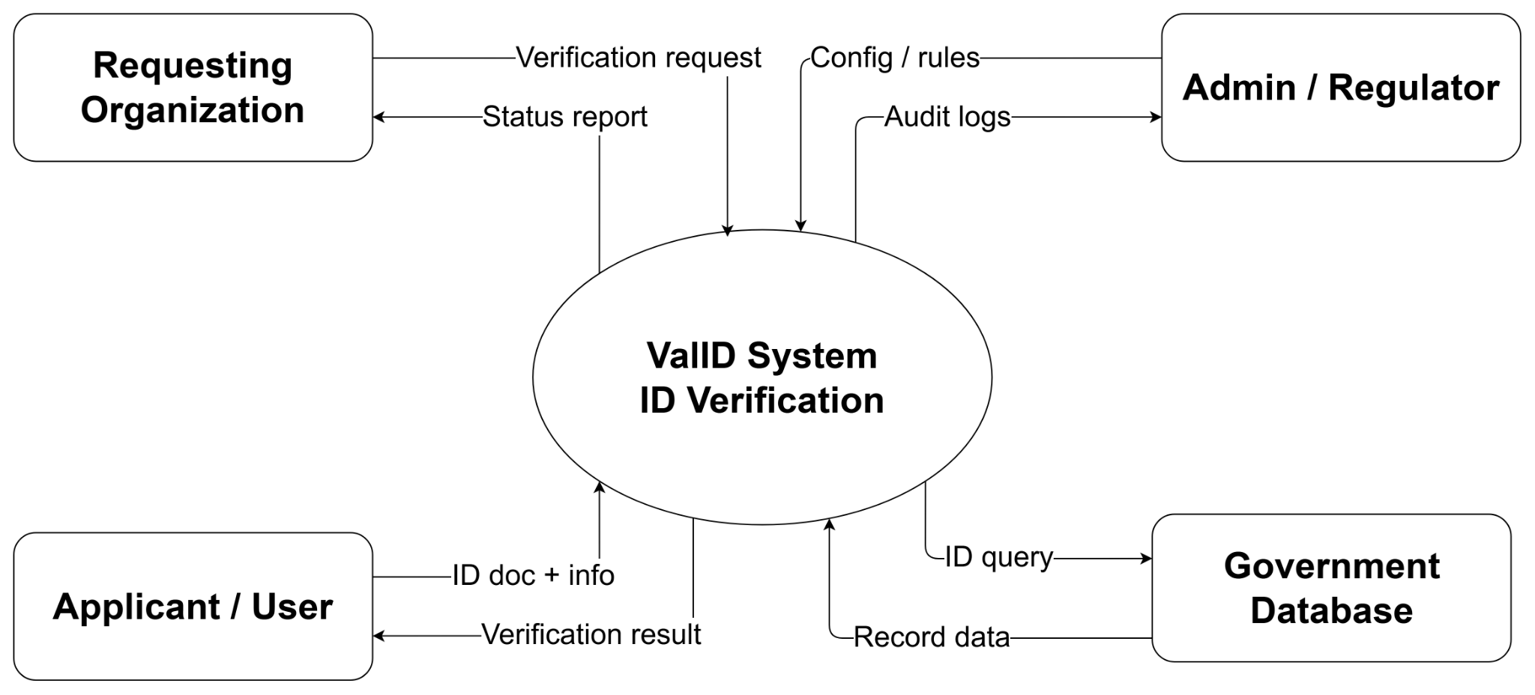

This diagram presents the context diagram of the ValID System, an existing ID validation platform used as a related system in this study. It interacts with four external entities. The Requesting Organization submits validation requests and receives status reports in return. The Admin/Regulator provides configuration rules to govern the validation process and receives audit logs for oversight. The Applicant/User submits their ID document and personal information, and is returned a validation result. The Government Database is queried by the system to retrieve official record data for cross-referencing against submitted credentials. Overall, the ValID System serves as a centralized validation hub that connects organizations, users, and government data sources highlighting both its capabilities and its limitations relative to iDetect's more comprehensive and bidirectional approach.

Existing System Level 1 Diagram
Figure 13.
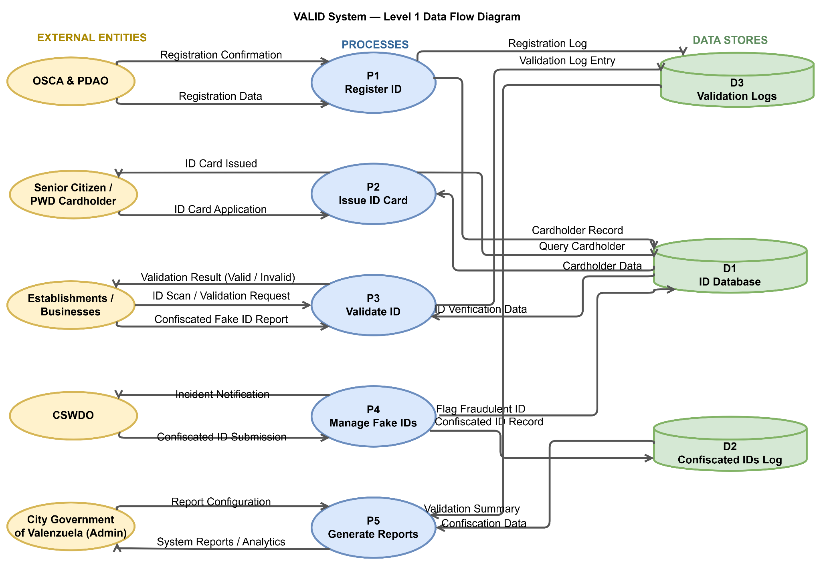
VALID System

valID is an ID management system for Senior Citizens and Persons with Disabilities (PWD) under the City Government of Valenzuela. The system involves five external actors: OSCA & PDAO, who initiate registration; the Senior Citizen/PWD cardholder, who receives and uses the ID; Establishments and Businesses, which verify IDs at the point of service; CSWDO, which handles fraud cases; and the City Government Admin, who oversees the entire system.
The system runs through five processes. P1 (Register ID) captures applicant information and stores it in the ID Database and Validation Logs. P2 (Issue ID Card) prints and releases the ID to the cardholder once registration is confirmed. P3 (Validate ID) allows businesses to check an ID's authenticity against the database, with each check recorded in the Validation Logs. P4 (Manage Fake IDs) enables CSWDO to flag and confiscate fraudulent IDs, logging them in the Confiscated IDs Log. Finally, P5 (Generate Reports) allows the admin to pull summaries from all data stores for monitoring and decision-making.
Supporting these processes are three data stores: D1 (ID Database), which holds all registered ID records; D2 (Confiscated IDs Log), which tracks flagged fake IDs; and D3 (Validation Logs), which records the history of ID checks. Together, these components cover the full lifecycle of a senior/PWD ID from registration and issuance, through daily use and validation, to fraud management and administrative reporting.

Proposed System Context Diagram
Figure 14.
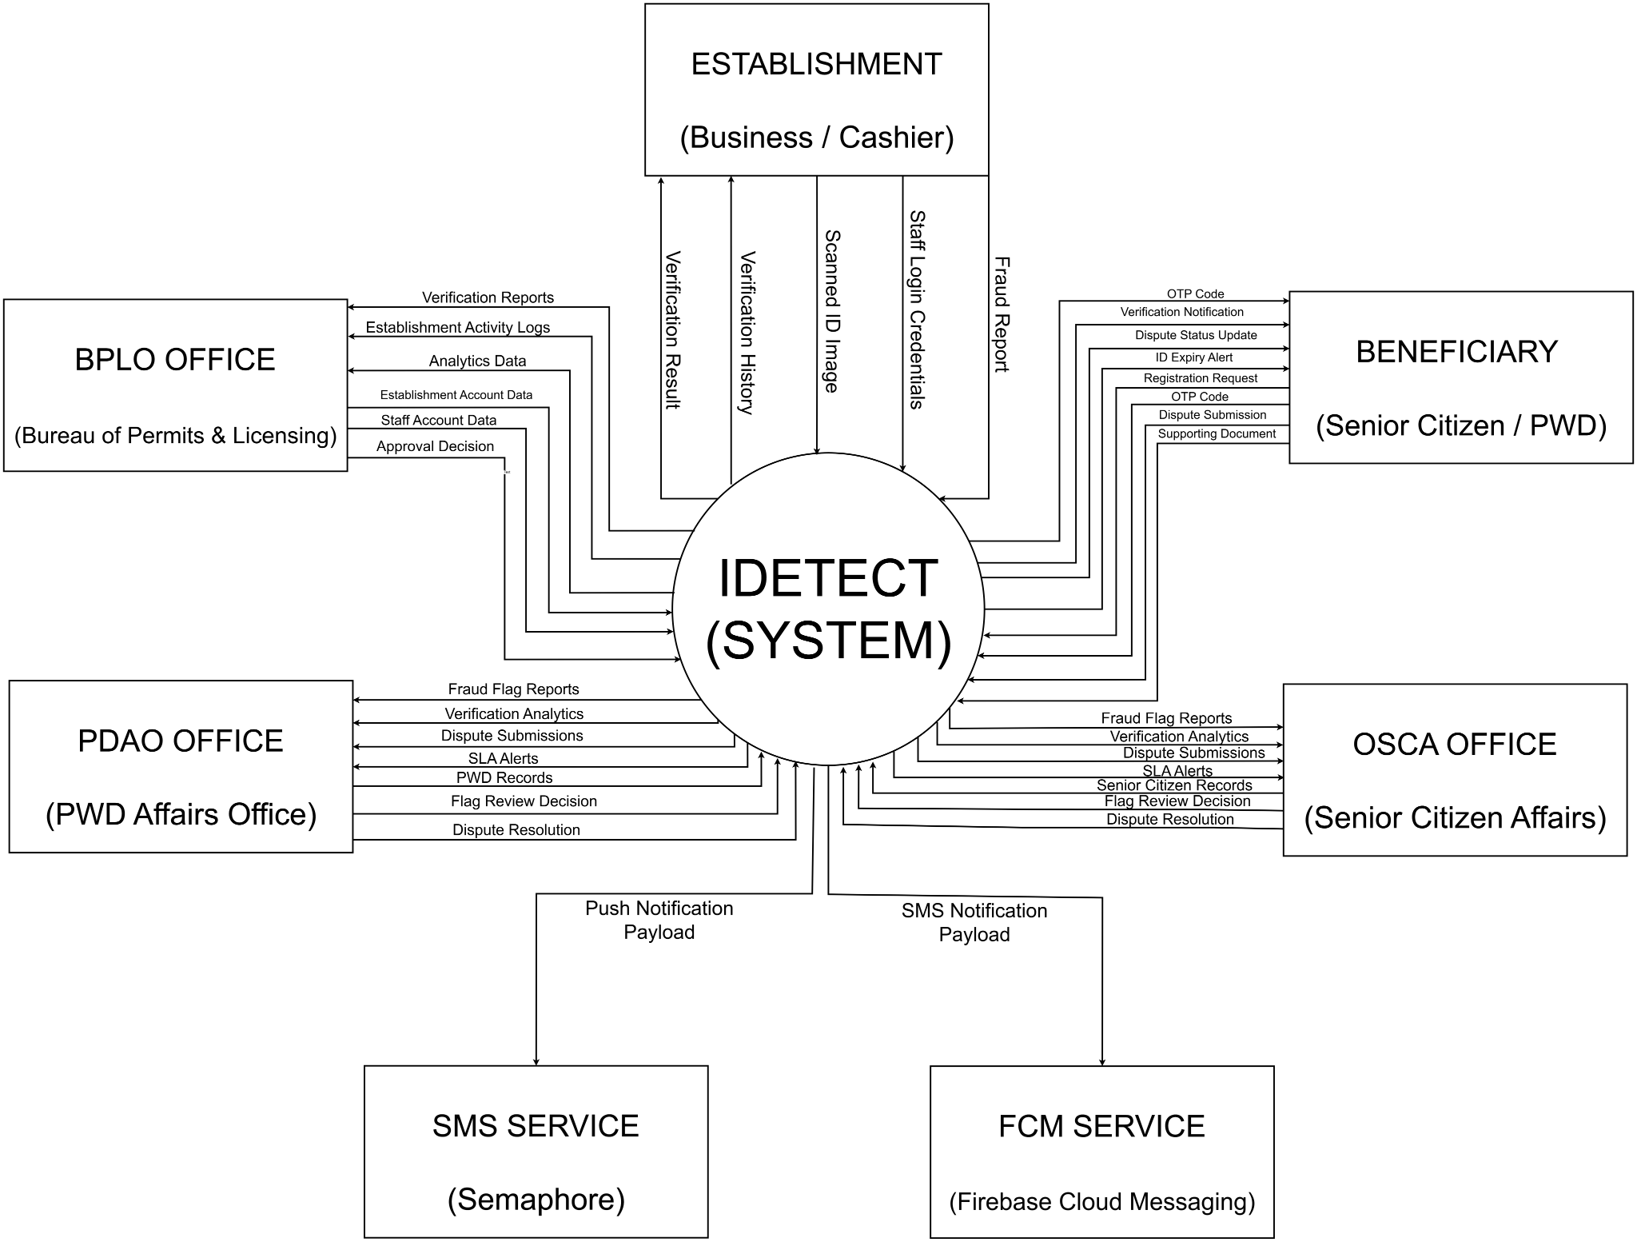
IDETECT Context Diagram
The Context Diagram illustrates the overall data flow between the iDetect system and its external entities. The system interacts with six key actors: the Establishment (Business/Cashier), which submits scanned ID images and fraud reports; the Beneficiary (Senior Citizen/PWD), who receives OTP codes and validation notifications; the BPLO Office, which receives validation reports and analytics data; the OSCA and PDAO Offices, which handle fraud flag reports, dispute submissions, and flag review decisions; and external services, Semaphore (SMS Service) and Firebase Cloud Messaging (FCM Service), which handle notification delivery. This diagram establishes the boundaries of the iDetect system and the nature of data exchanged with each stakeholder.

Proposed System Level 1 Diagram
Figure 15.
Authentication.
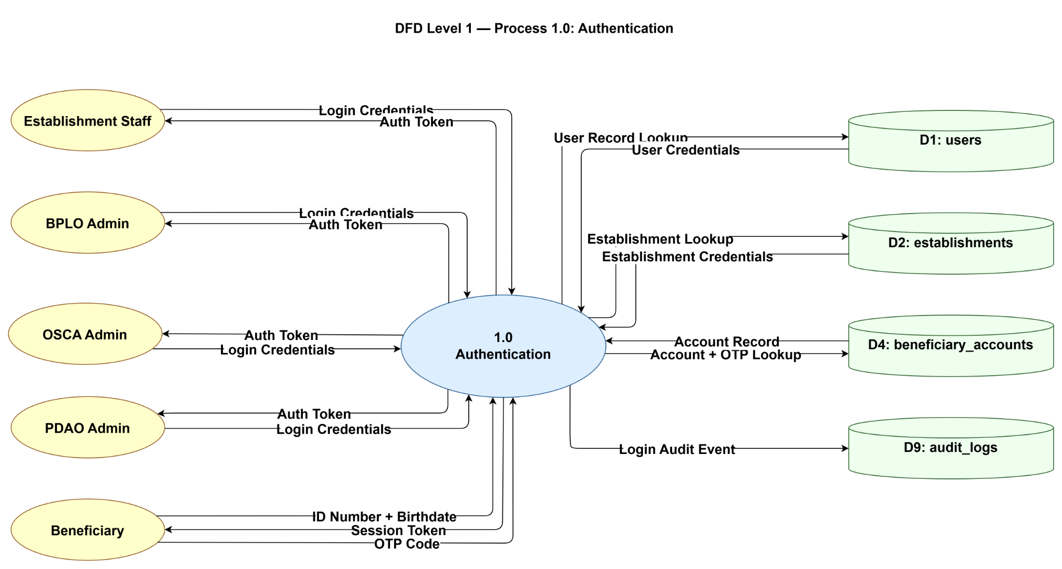
This diagram details the authentication process within iDetect, showing how different user types gain access to the system. Establishment Staff, BPLO Admins, OSCA Admins, and PDAO Admins each submit login credentials and receive authentication tokens. Beneficiaries authenticate using their ID number, birthdate, and an OTP code, receiving a session token in return. The process interacts with four data stores: D1 (users) for user record lookup, D2 (establishments) for establishment credential validation, D4 (beneficiary_accounts) for account and OTP lookup, and D9 (audit_logs) to record login audit events.
Figure 16.
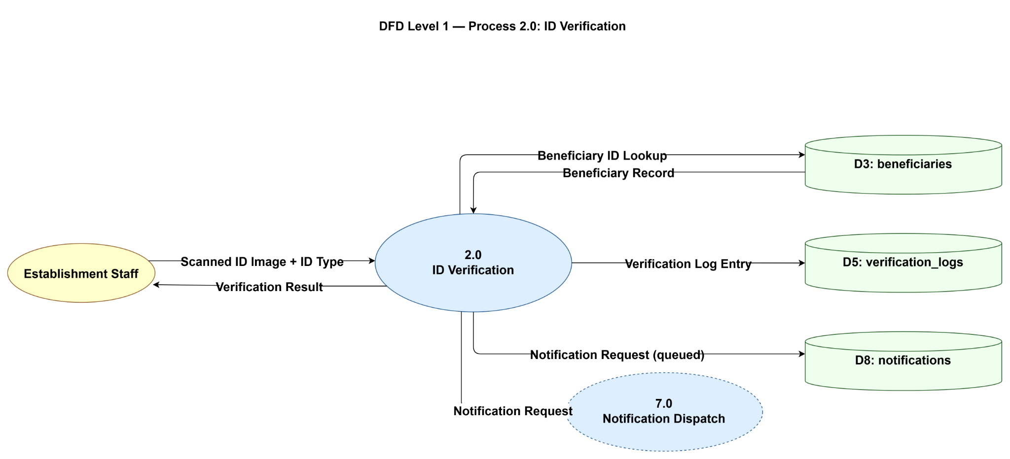
ID Verification

This diagram shows how iDetect handles the core ID verification flow. Establishment Staff submits a scanned ID image along with the ID type, and the system returns a verification result. Internally, the process queries the D3 (beneficiaries) data store to look up the beneficiary record, logs the verification outcome to D5 (verification_logs), and queues a notification request to D8 (notifications). The process also triggers Process 7.0 (Notification Dispatch) to send real-time alerts to the beneficiary following a verification event.

Figure 17.
Fraud Management
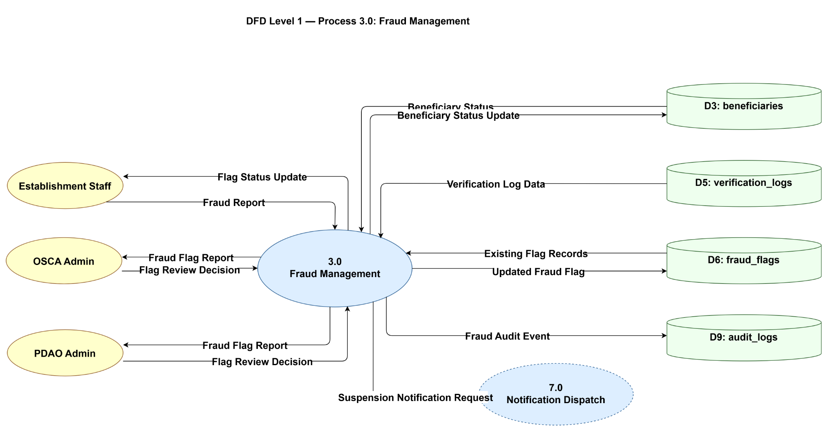
`This diagram covers iDetect's fraud management workflow. Establishment Staff can submit fraud reports and receive flag status updates. OSCA and PDAO Admins send flag review decisions and receive fraud flag reports in return. The process reads from and writes to D6 (fraud_flags) to manage existing and updated fraud records, retrieves verification log data from D5 (verification_logs), updates beneficiary status in D3 (beneficiaries), and records fraud audit events in D9 (audit_logs). Confirmed fraud cases trigger a suspension notification request sent to Process 7.0 (Notification Dispatch).

Figure 18.
Beneficiary Record Management
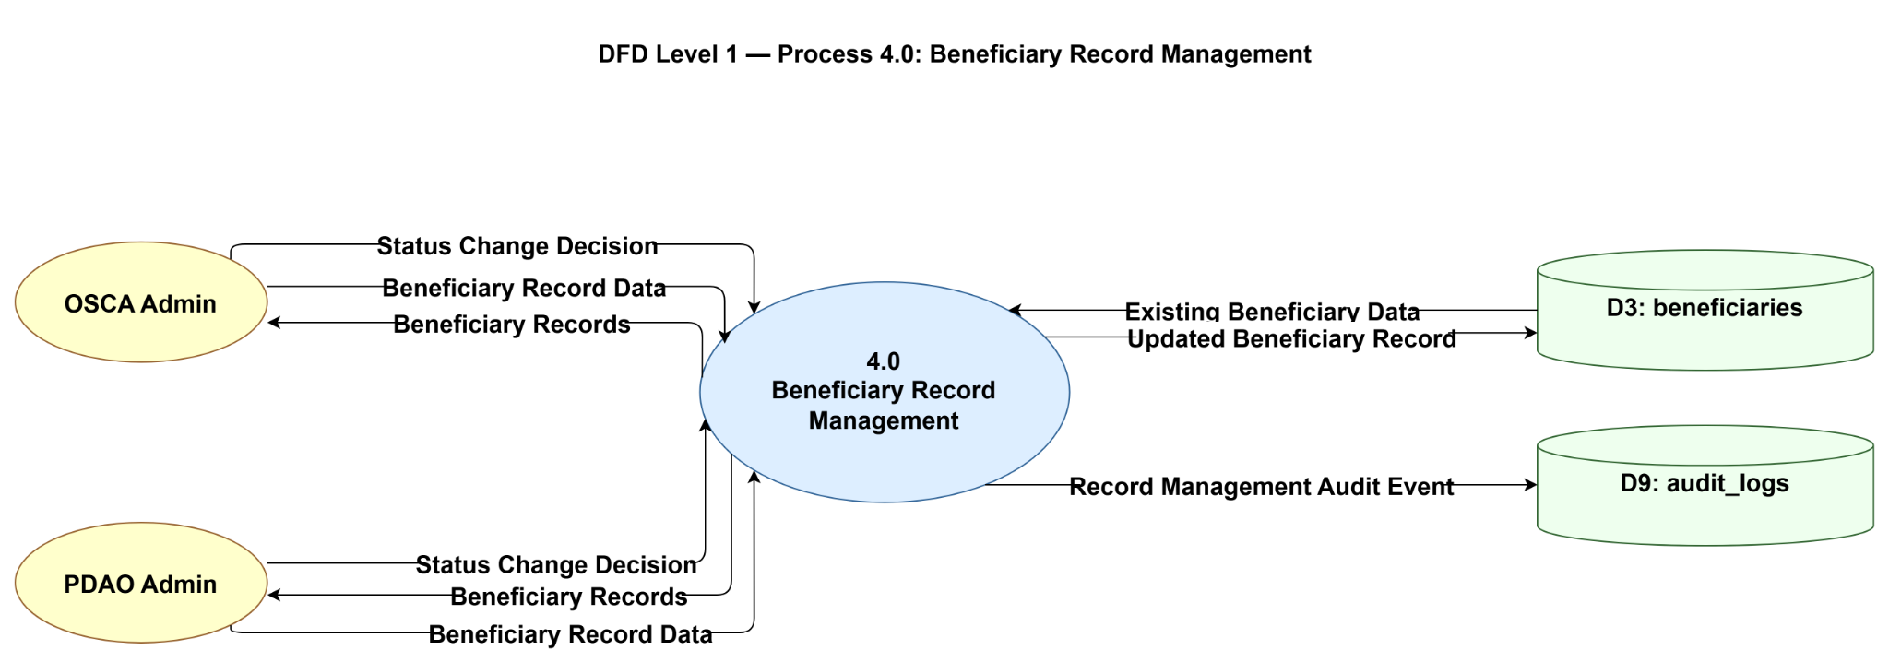
This diagram depicts how beneficiary records are managed within iDetect. Both OSCA and PDAO Admins can submit status change decisions and beneficiary record data, and receive updated beneficiary records in response. The process reads existing beneficiary data from and writes updated records back to D3 (beneficiaries). All record modifications are logged as audit events in D9 (audit_logs), ensuring traceability of any changes made to beneficiary information.

Figure 19.
Establishment Management
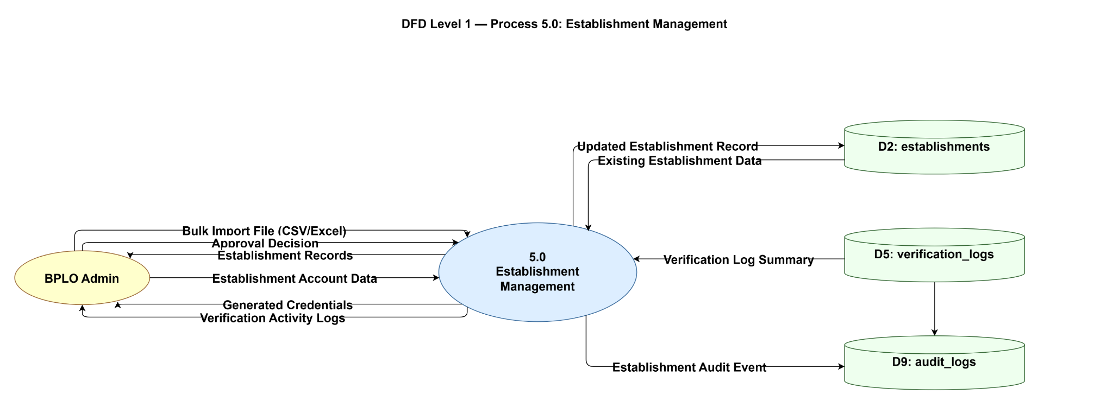
This diagram illustrates how the BPLO Admin manages registered business establishments within iDetect. The admin can upload bulk import files, submit approval decisions, and access establishment records and account data, receiving generated credentials and verification activity logs in return. The process reads from and writes to the establishments data store to keep records current, pulls verification log summaries for monitoring purposes, and captures all management actions as audit events to maintain a complete activity trail.

Figure 20.
Dispute Resolution
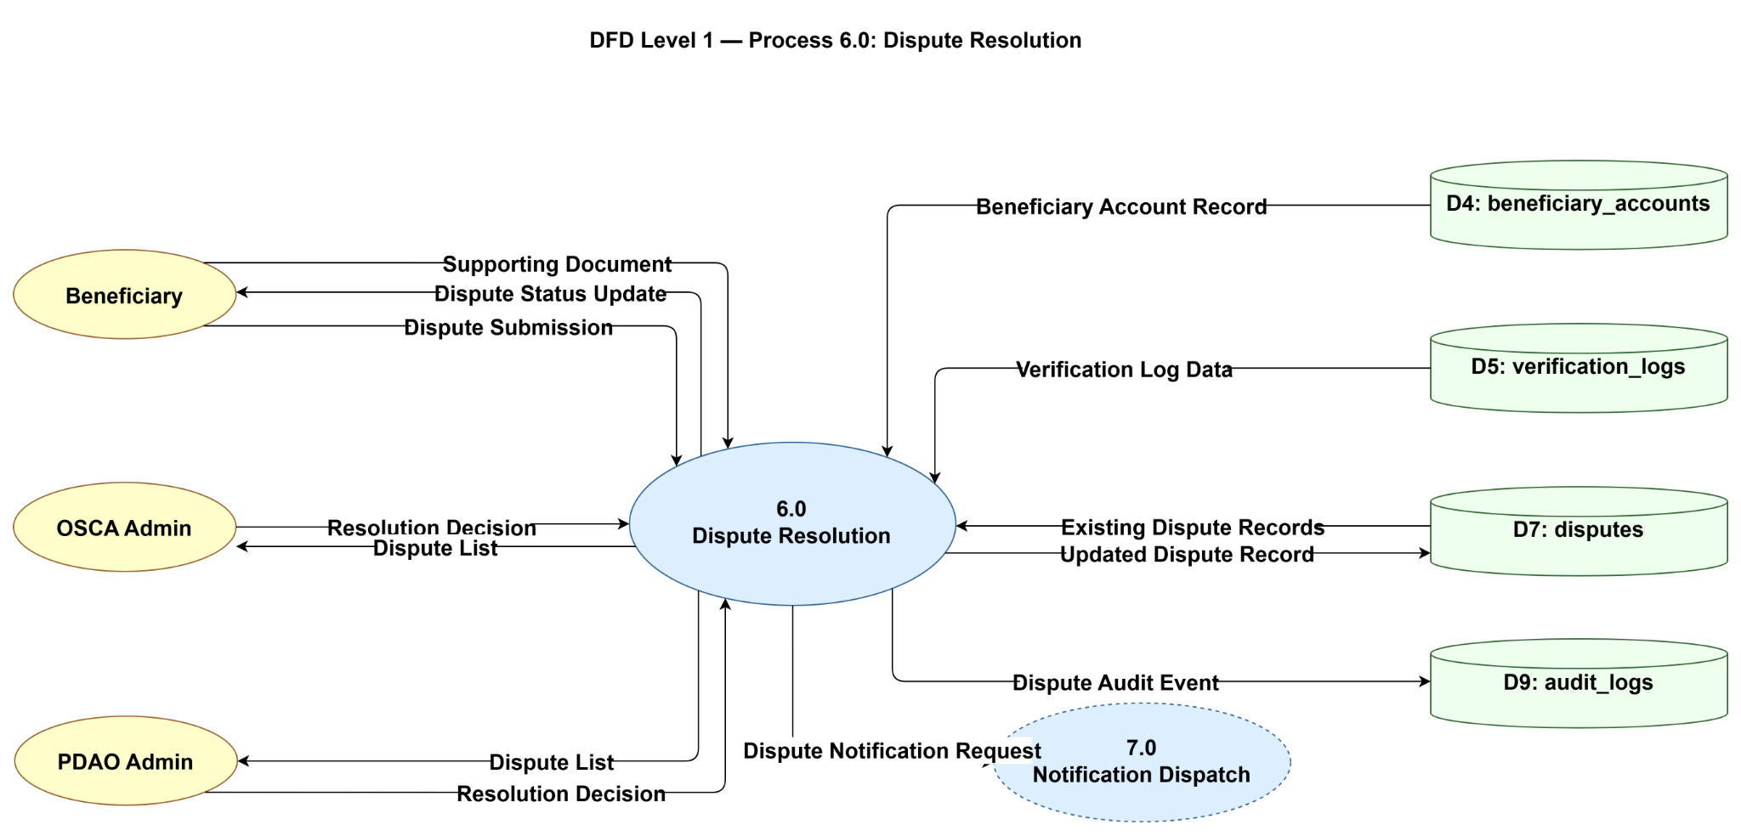
This diagram shows how iDetect handles disputes raised by beneficiaries against verification outcomes. Beneficiaries submit supporting documents and dispute requests, and receive status updates as their case progresses. OSCA and PDAO Admins access the dispute list and issue resolution decisions accordingly. The process references beneficiary account records and verification log data to assess each case, updates the disputes data store with the resolution, and logs all dispute activity for audit purposes. Resolved disputes also trigger a notification request through the Notification Dispatch process to keep the beneficiary informed.

Figure 21.
Notification Dispatch
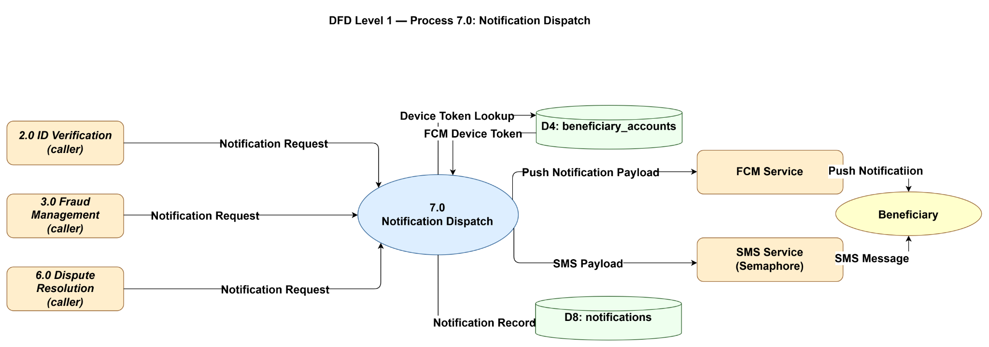

This diagram covers the centralized notification process that serves the rest of the iDetect system. Notification requests are received from three calling processes ID Verification, Fraud Management, and Dispute Resolution and routed accordingly. The process retrieves the beneficiary's FCM device token from the accounts data store, then delivers alerts through two channels: push notifications via Firebase Cloud Messaging and SMS messages via Semaphore. All dispatched notifications are recorded in the notifications data store for reference.

Figure 22.
Reporting & Analysis
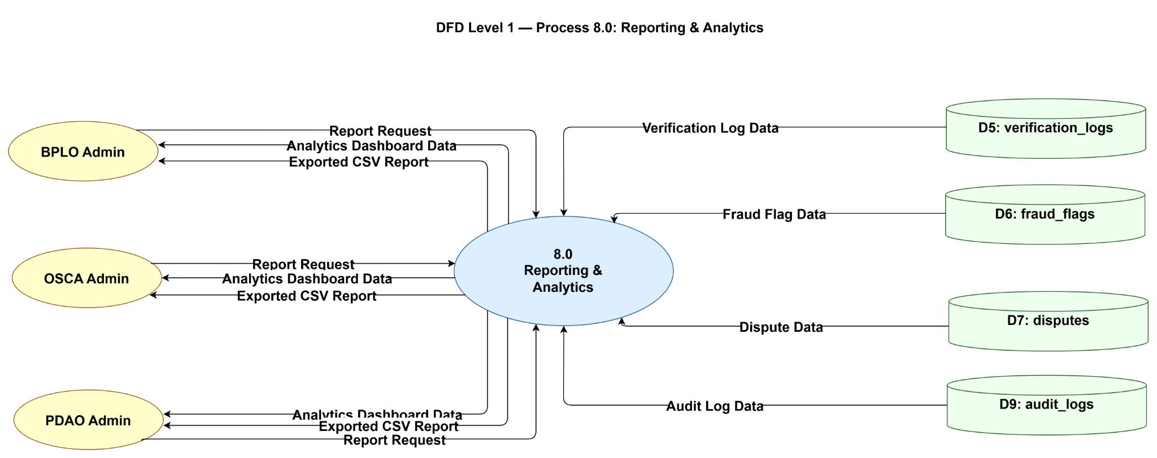
This diagram presents how iDetect generates insights for administrative oversight. BPLO, OSCA, and PDAO Admins can each submit report requests and receive analytics dashboard data along with exportable CSV reports tailored to their respective roles. The process pulls data from four sources: verification logs, fraud flags, dispute records, and audit logs to compile comprehensive reports that support decision-making and performance monitoring across all offices.

Proposed System Level 2 Diagram
Figure 23.
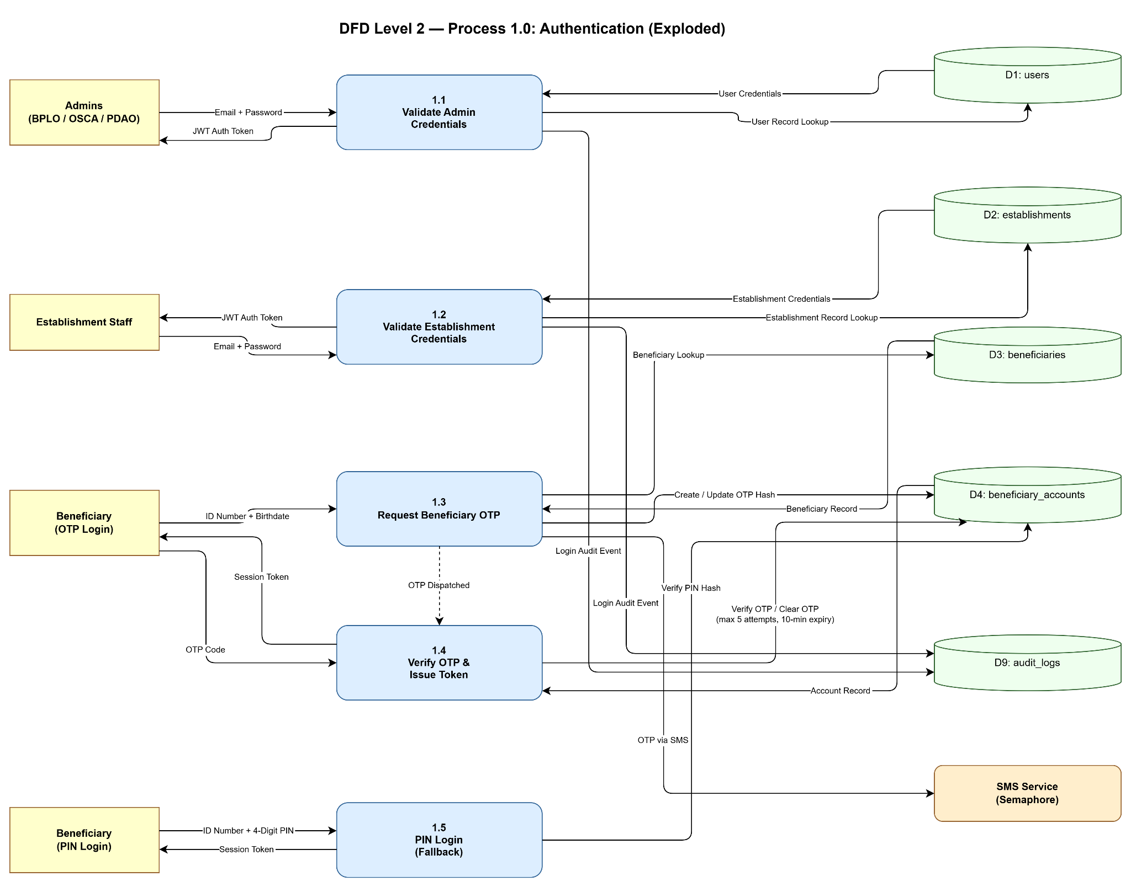
Authentication

Figure 23 presents the Level 2 decomposition of the Authentication process, illustrating five distinct sub-processes that collectively govern access control across all user classes in the iDetect system. Sub-process 1.1 handles credential validation for administrative users (BPLO, OSCA, and PDAO personnel) through the web portals, performing role verification and account lockout enforcement against the users table (D1) prior to issuing a signed JSON Web Token (JWT). Sub-process 1.2 performs analogous authentication for establishment staff through the mobile client portal, validating credentials against the establishments table (D2) and enforcing an active-status requirement. Sub-processes 1.3 and 1.4 implement a two-step one-time password (OTP) mechanism for beneficiary login: 1.3 generates a six-digit OTP with a ten-minute expiry, stores its bcrypt hash in the beneficiary_accounts table (D4), and dispatches the OTP via SMS through the Semaphore gateway; 1.4 then verifies the submitted OTP against the stored hash, enforces a maximum of five verification attempts, clears the OTP fields upon success, and issues a session token to the beneficiary. Sub-process 1.5 provides an alternative PIN-based login path for returning beneficiaries, bypassing the OTP flow through direct bcrypt hash comparison against D4. All authentication events are written to the audit_logs table (D9) to maintain a traceable access record.

Figure 24.
ID Verification
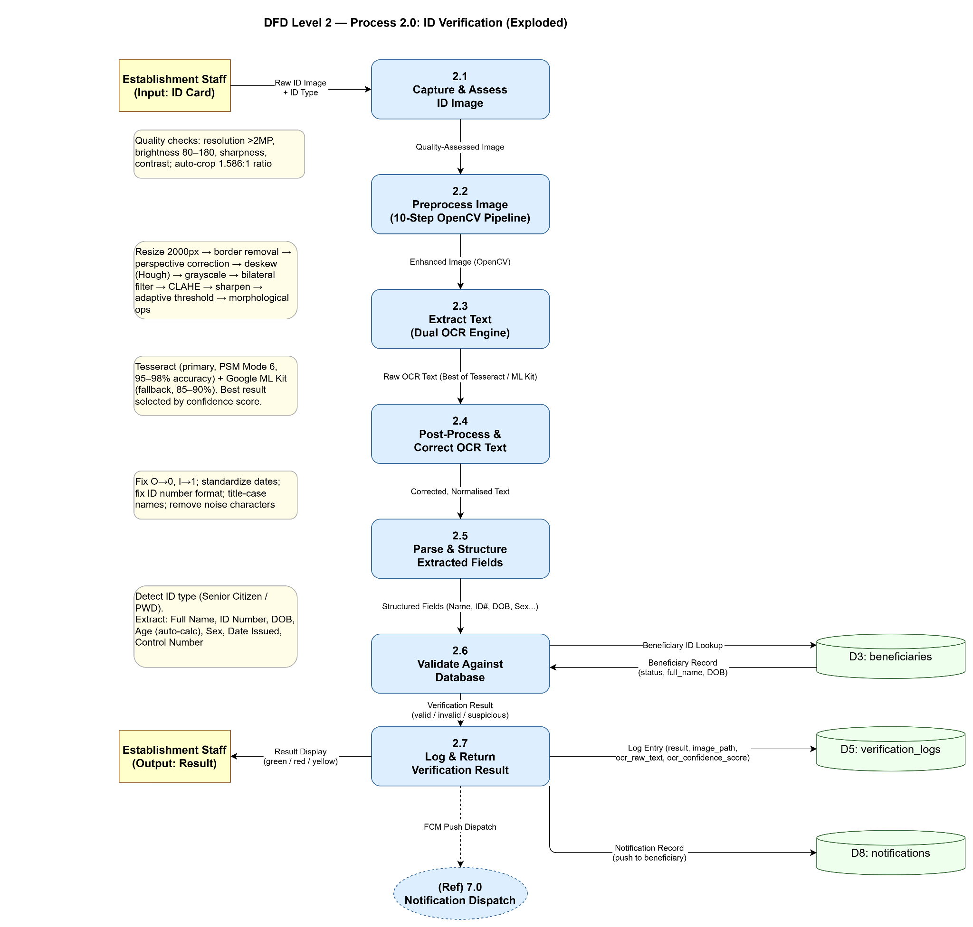

Figure 24 presents the Level 2 decomposition of the ID Verification process, revealing the multi-stage image processing and optical character recognition (OCR) pipeline that constitutes the core technical innovation of the iDetect system. The process follows a strictly sequential flow across seven sub-processes. Sub-process 2.1 captures the physical ID card through the mobile camera interface and applies quality assessment algorithms, enforcing minimum resolution thresholds (greater than 2 megapixels), acceptable brightness ranges (80–180), Laplacian variance for sharpness evaluation, and automatic cropping to the ISO/IEC 7810 ID-1 aspect ratio of 1.586:1. Sub-process 2.2 applies a ten-step image enhancement pipeline using the OpenCV library, encompassing resizing, border removal, perspective correction, deskewing via Hough Transform, grayscale conversion, bilateral filtering for noise reduction, CLAHE contrast enhancement, sharpening, adaptive thresholding, and morphological operations. Sub-process 2.3 executes a dual-engine OCR strategy, utilizing Tesseract OCR as the primary engine (PSM Mode 6, achieving 95–98% accuracy under optimal conditions) with Google ML Kit as a fallback, selecting the result with the higher confidence score. Sub-processes 2.4 and 2.5 perform post-processing and structured parsing respectively, correcting common OCR character substitution errors, standardizing date formats, and extracting named fields—including full name, ID number, date of birth, sex, date issued, and control number—with automatic age calculation. Sub-process 2.6 validates the extracted data against the beneficiaries table (D3), verifying both record existence and beneficiary enrollment status. Sub-process 2.7 returns a color-coded verification result (valid, invalid, or suspicious) to the establishment staff, writes a comprehensive log entry to the verification_logs table (D5), and enqueues a push notification to the beneficiary's registered mobile device via the Notification Dispatch process (P7.0).

Figure 25.
Fraud Management
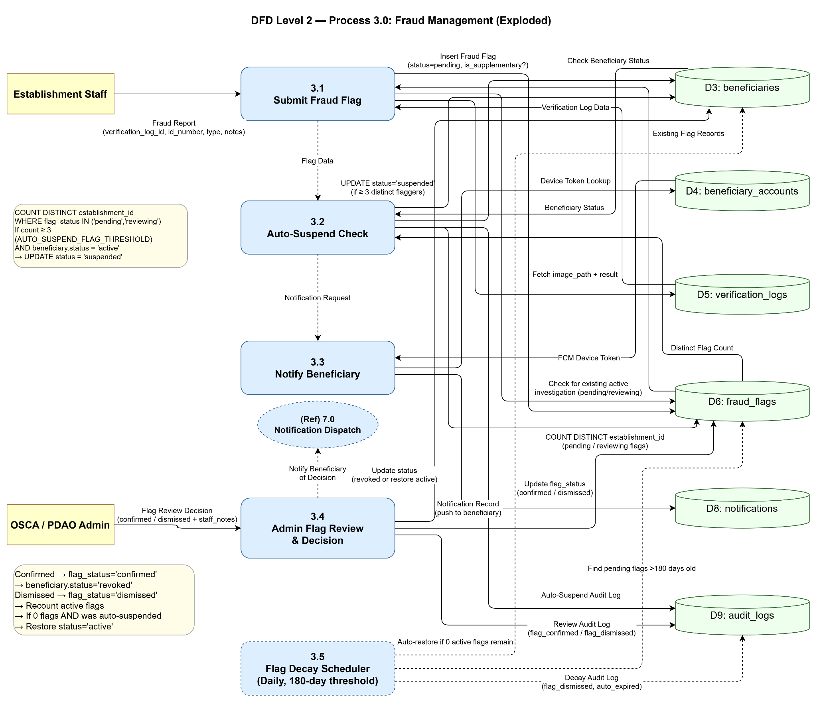

Figure 25 presents the Level 2 decomposition of the Fraud Management process, detailing the automated and human-supervised mechanisms that govern fraudulent ID detection, investigation, and resolution within iDetect. Sub-process 3.1 receives a fraud report submitted by an establishment staff member following a suspicious or invalid verification outcome. The sub-process retrieves the associated image and verification result from the verification_logs table (D5), checks the fraud_flags table (D6) for any existing active investigation pertaining to the same ID number, and either creates a primary flag or links the submission as a supplementary flag (via is_supplementary and parent_flag_id attributes) to prevent duplicate investigation records. Sub-process 3.2 implements the system's automated risk escalation mechanism: it counts the number of distinct establishment identifiers (DISTINCT establishment_id) across all pending or active flags for the implicated beneficiary. Should this count meet or exceed the configurable threshold (default: three distinct establishments, governed by the AUTO_SUSPEND_FLAG_THRESHOLD environment variable) and the beneficiary's current status is active, the system automatically updates the beneficiaries table (D3) to reflect a suspended status and records the action in the audit_logs table (D9). Sub-process 3.3 dispatches the corresponding push notification to the beneficiary's registered device using the stored token from the beneficiary_accounts table (D4). Sub-process 3.4 represents the human review stage, in which an OSCA or PDAO administrator evaluates the flag evidence and issues a decision: a confirmed decision updates the beneficiary's status to revoked, while a dismissed decision triggers a recount of active flags and, where no remaining active flags exist and the suspension was system-generated, automatically restores the beneficiary to active status. Sub-process 3.5 represents an automated daily scheduler (flagDecayScheduler.js) that expires pending flags exceeding 180 days without administrative action, preventing indefinitely stale reports from contributing to future auto-suspension thresholds.

Figure 26.
Dispute Resolution
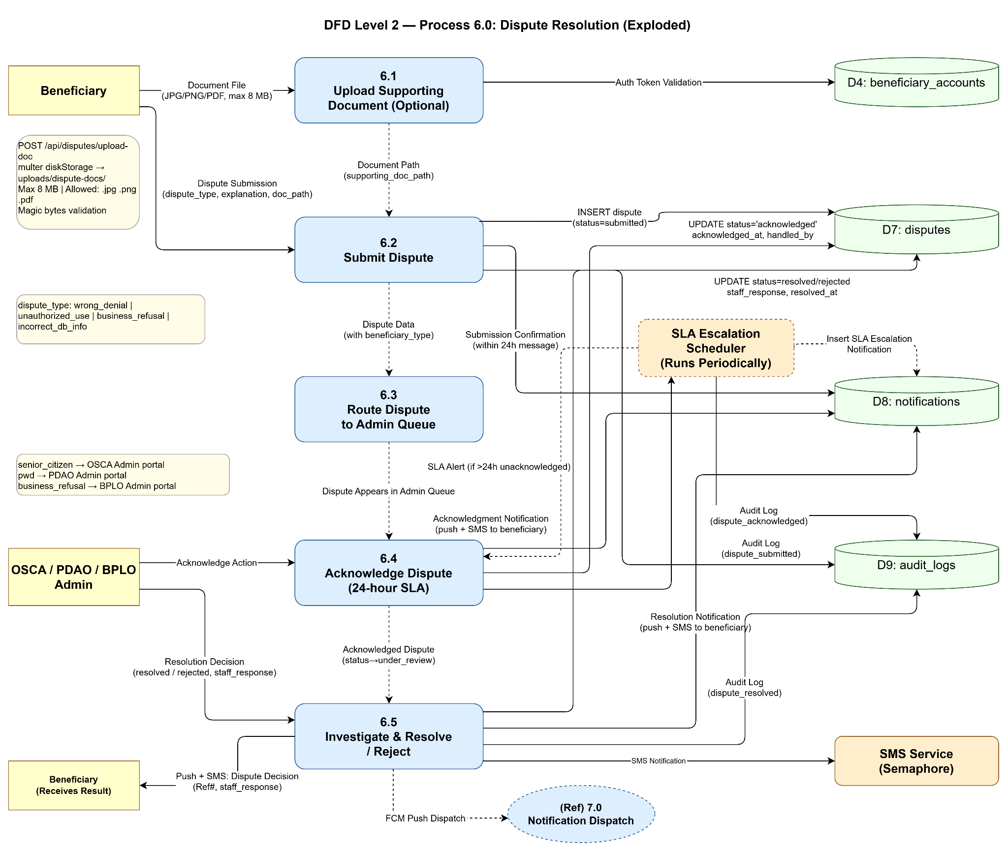

Figure 26 presents the Level 2 decomposition of the Dispute Resolution process, delineating the structured, SLA-governed workflow through which beneficiaries may formally challenge verification outcomes or administrative decisions within the iDetect system. Sub-process 6.1 provides an optional document upload mechanism whereby beneficiaries may attach supporting evidence (JPEG, PNG, or PDF files not exceeding 8 megabytes) prior to dispute submission; the sub-process validates uploaded files using both extension filtering and magic byte inspection before storing them in a dedicated server directory. Sub-process 6.2 records the formal dispute submission, capturing the dispute type (wrong_denial, unauthorized_use, business_refusal, incorrect_db_info, or other), explanatory text, and optional document reference into the disputes table (D7) with an initial status of submitted, while simultaneously logging the event in audit_logs (D9) and dispatching a submission acknowledgment notification to the beneficiary through notifications (D8). Sub-process 6.3 performs dispute routing based on the beneficiary's enrollment type, directing senior citizen disputes to the OSCA portal, PWD disputes to the PDAO portal, and business refusal disputes to the BPLO portal. Sub-process 6.4 represents the acknowledgment stage, in which the assigned administrator formally acknowledges receipt of the dispute within the mandated 24-hour SLA window; the slaEscalationScheduler service runs periodically and automatically inserts an escalation notification into D8 when this window is exceeded without action. Sub-process 6.5 completes the workflow, allowing the administrator to issue a final resolution decision (resolved or rejected) along with a mandatory staff response; the outcome is persisted to D7, and the beneficiary is notified of the decision via both push notification (routed through the Notification Dispatch process, P7.0) and SMS through the Semaphore gateway. All state transitions throughout the process are recorded in audit_logs (D9) to ensure a complete and auditable dispute trail.

Use Case Diagram
Figure 27.
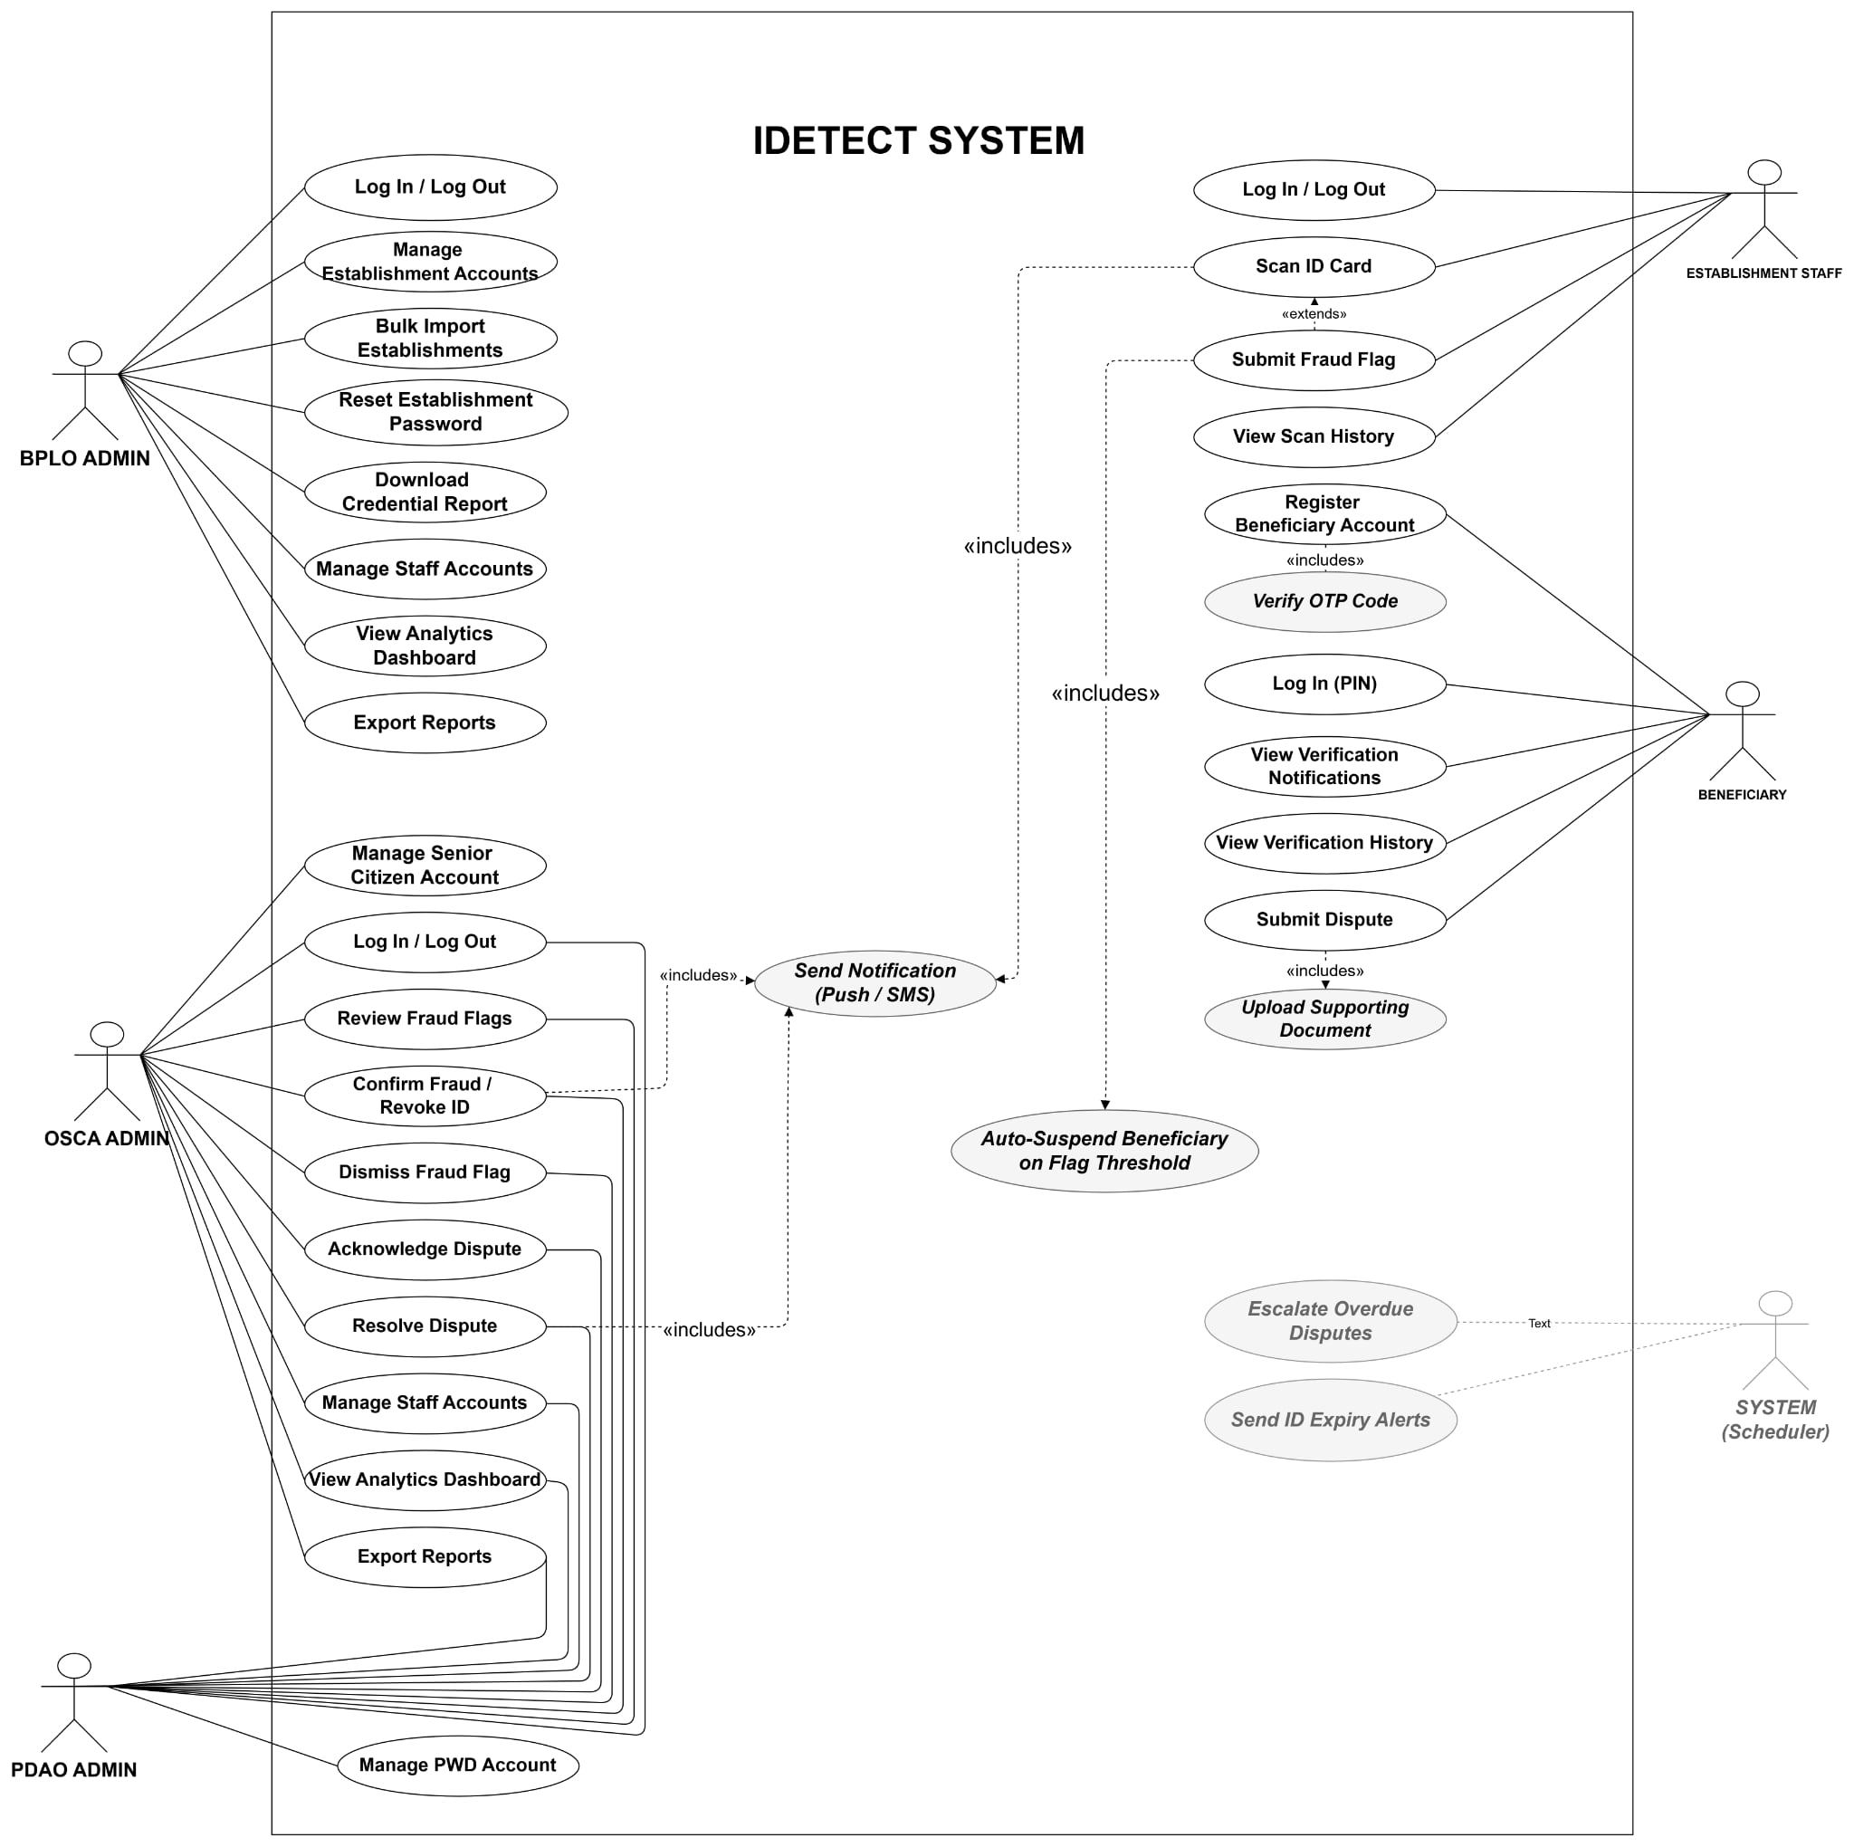
The Use Case Diagram outlines the functional scope of iDetect across its four main actors. The BPLO Admin oversees establishment management, handling account creation, bulk imports, credential reports, password resets, staff accounts, analytics, and fraud-related actions such as confirming or revoking IDs, dismissing fraud flags, and resolving disputes. The PDAO Admin shares similar fraud and dispute management capabilities, with additional responsibility over PWD accounts and fraud flag reviews specific to PWD beneficiaries. The OSCA Admin mirrors the PDAO Admin's functions but is scoped toward Senior Citizen accounts, managing records and reviewing fraud flags within that beneficiary group.
On the establishment side, Establishment Staff can log in, view verification history, submit fraud flags, and scan ID cards where the scan function extends to include automated system behaviors such as auto-suspending beneficiaries upon reaching a flag threshold, sending push and SMS notifications, escalating overdue disputes, and triggering ID expiry alerts. For beneficiaries, the system supports account registration with OTP verification, viewing verification notifications and history, uploading supporting documents, and submitting disputes with the registration flow including OTP code verification as a required step. Together, the diagram captures how each actor interacts with iDetect within their defined role, while shared system behaviors are centralized through include and extend relationships to avoid duplication across use cases.

Entity Relationship Diagram
Figure 28.
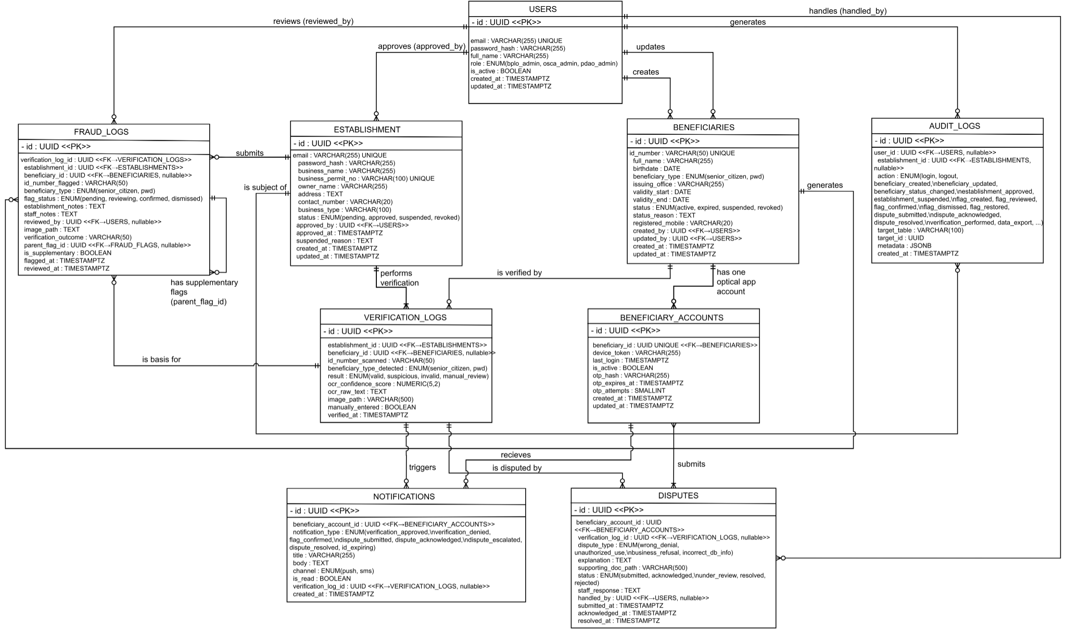
The ERD defines the complete database structure of iDetect and the relationships between its nine core entities. The Users table sits at the center of the diagram, linking to establishments, audit logs, and fraud logs through role-based associations covering admin accounts for BPLO, OSCA, and PDAO. The Establishments table holds business registration data and connects to verification logs, fraud logs, and audit logs, reflecting the establishment's active role in the verification process. The Beneficiaries table stores personal and credential information for Senior Citizens and PWDs, and is associated with verification logs, beneficiary accounts, and disputes. The Beneficiary Accounts table manages authentication data including device tokens and OTP details, serving as the link between beneficiaries and the notifications system. The Verification Logs table records every ID scan performed by establishments and serves as the basis for fraud flags and disputes. The Fraud Logs table tracks flagged verification events, supporting hierarchical flag relationships through a parent flag reference. The Disputes table captures beneficiary-raised disputes against verification outcomes, referencing both the beneficiary account and the specific verification log in question. The Notifications table logs all system-generated alerts tied to verification, fraud, and dispute events. Finally, the Audit Logs table provides a complete trail of all system actions across users, establishments, beneficiaries, and administrative decisions ensuring full accountability throughout the system.

Database Dictionary
ENUMERATED TYPES
User_role
- bplo_admin Business Permit & Licensing Office administrator
- osca_admin Office for Senior Citizens Affairs administrator
- pdao_admin Persons with Disability Affairs Office administrator

Establishment_status
- pending Registered, awaiting BPLO approval
- approved Active; can perform verifications
- suspended Temporarily blocked by BPLO
- revoked Permanently removed

Beneficiary_type
- senior_citizen Managed by OSCA
- pwd Managed by PDAO

Beneficiary_status
- active Valid; verifications return valid
- expired Past validity end date
- suspended Temporarily flagged pending investigation
- revoked Confirmed fraudulent or cancelled by LGU

Verification_result
- valid ID found, status active, not expired
- suspicious ID flagged or cross-validation fields did not match
- invalid ID not found, or status is revoked/expired
- manual_review OCR confidence too low; staff reviewed manually

Flag_status
- pending Flagged by establishment, awaiting LGU review
- reviewing LGU admin has opened the case
- confirmed Confirmed fraudulent; beneficiary record updated
- dismissed Investigated and found to be legitimate

Dispute_type
- wrong_denial Beneficiary claims they are valid but were denied
- unauthorized_use Beneficiary's ID was used without their knowledge
- business_refusal Business refused despite system approval
- incorrect_db_info Beneficiary's record contains wrong information

Dispute_status
- submitted Just received
- acknowledged LGU confirmed receipt (within 24h SLA)
- under_review Staff actively investigating
- resolved Closed with explanation
- rejected Dispute found to be invalid

Notification_channel
- push Firebase FCM / APNs push notification
- sms Works without smartphone or data connection

Notification_type
- verification_approved ID scanned and returned valid
- verification_denied ID scanned and returned suspicious or invalid
- dispute_acknowledged LGU acknowledged the beneficiary's dispute
- dispute_resolved Dispute has been closed
- flag_confirmed Beneficiary's ID confirmed fraudulent
- id_expiring_soon Upcoming expiration reminder
- general Miscellaneous system message

TABLES

Users
Admin staff accounts for BPLO, OSCA, and PDAO portals.

Column Type Null Default Description
id UUID NOT NULL gen_random_uuid() Primary key
email VARCHAR(255) NOT NULL Login email; unique across all staff
password_hash VARCHAR(255) NOT NULL Bcrypt-hashed password
full_name VARCHAR(255) NOT NULL Display name shown in the portal
role user_role NOT NULL Controls portal access and data visibility
is_active BOOLEAN NOT NULL TRUE Soft-disable without deleting audit history
failed_attempts SMALLINT NOT NULL 0 Consecutive failed logins; reset on success
locked_until TIMESTAMPTZ NULL Account locked until this time; locks after 3 failures
created_at TIMESTAMPTZ NOT NULL NOW() Row creation timestamp
updated_at TIMESTAMPTZ NOT NULL NOW() Auto-updated by trigger

2.2 establishments
Food service businesses registered to use the Client Portal. Managed by BPLO.

Column Type Null Default Description
id UUID NOT NULL gen_random_uuid() Primary key
email VARCHAR(255) NOT NULL Login email for the Client Portal; unique
password_hash VARCHAR(255) NOT NULL Bcrypt-hashed password
business_name VARCHAR(255) NOT NULL Registered name of the business
business_permit_no VARCHAR(100) NOT NULL Unique permit number issued by BPLO
owner_name VARCHAR(255) NOT NULL Name of the business owner
address TEXT NOT NULL Full business address
contact_number VARCHAR(20) NOT NULL Primary contact phone number
business_type VARCHAR(100) NOT NULL Food Service Category of business
status establishment_status NOT NULL pending Only approved accounts can perform verifications
approved_by UUID NULL FK -> users.id; BPLO admin who approved this account
approved_at TIMESTAMPTZ NULL Timestamp of approval
suspended_reason TEXT NULL Reason provided when status is suspended
failed_attempts SMALLINT NOT NULL 0 Consecutive failed logins
locked_until TIMESTAMPTZ NULL Login locked until this time
business_permit_expiry DATE NULL Expiry date of the business permit
reset_otp VARCHAR(6) NULL One-time password for self-service password reset
reset_otp_expires TIMESTAMPTZ NULL Expiry timestamp for the reset OTP
created_at TIMESTAMPTZ NOT NULL NOW() Row creation timestamp
updated_at TIMESTAMPTZ NOT NULL NOW() Auto-updated by trigger

2.3 beneficiaries
Official government records for Senior Citizens and PWDs. Source of truth for OSCA and PDAO.

Column Type Null Default Description
id UUID NOT NULL gen_random_uuid() Primary key
id_number VARCHAR(50) NOT NULL ID number on the physical card; primary lookup key; unique
full_name VARCHAR(255) NOT NULL Full name as printed on the physical ID
birthdate DATE NOT NULL Date of birth; used for cross-validation
beneficiary_type beneficiary_type NOT NULL senior_citizen -> OSCA, pwd -> PDAO
disability_type VARCHAR(100) NULL Type of disability (PWD only)
issuing_office VARCHAR(255) NOT NULL LGU office that issued the card
validity_start DATE NOT NULL Start of the card's validity period
validity_end DATE NOT NULL End of validity; past this date record is auto-expired
status beneficiary_status NOT NULL active Only active records return valid during a scan
status_reason TEXT NULL Explanation when status is suspended or revoked
registered_mobile VARCHAR(20) NULL Mobile number for SMS notifications (optional)
created_by UUID NULL FK -> users.id; staff who created the record
updated_by UUID NULL FK -> users.id; staff who last updated the record
created_at TIMESTAMPTZ NOT NULL NOW() Row creation timestamp
updated_at TIMESTAMPTZ NOT NULL NOW() Auto-updated by trigger

2.4 beneficiary_accounts
App accounts for Senior Citizens and PWDs. A beneficiary can exist without an app account.

Column Type Null Default Description
id UUID NOT NULL gen_random_uuid() Primary key
beneficiary_id UUID NOT NULL FK -> beneficiaries.id; one-to-one; cascades on deletion
device_token VARCHAR(255) NULL FCM/APNs push token; updated on each app launch
last_login TIMESTAMPTZ NULL Timestamp of most recent successful login
is_active BOOLEAN NOT NULL TRUE Whether the app account is enabled
otp_hash VARCHAR(255) NULL Hashed OTP for current login session; cleared after verification
otp_expires_at TIMESTAMPTZ NULL OTP expiry timestamp
otp_attempts SMALLINT NOT NULL 0 Failed OTP attempts for the current session
pin_hash VARCHAR(255) NULL Bcrypt-hashed 4-digit PIN for fallback login
pin_attempts SMALLINT NOT NULL 0 Failed PIN attempts; locked after 5 consecutive failures
pin_locked_until TIMESTAMPTZ NULL PIN login locked until this time
created_at TIMESTAMPTZ NOT NULL NOW() Row creation timestamp
updated_at TIMESTAMPTZ NOT NULL NOW() Auto-updated by trigger

2.5 verification_logs
Immutable log of every ID scan. Never delete rows.

Column Type Null Default Description
id UUID NOT NULL gen_random_uuid() Primary key
establishment_id UUID NOT NULL FK -> establishments.id; RESTRICT on delete
beneficiary_id UUID NULL FK -> beneficiaries.id; NULL if no matching record
id_number_scanned VARCHAR(50) NOT NULL Raw ID number read by OCR or entered manually
beneficiary_type_detected beneficiary_type NULL Beneficiary type detected from the card image
result verification_result NOT NULL Outcome of this scan attempt
ocr_confidence_score NUMERIC(5,2) NULL Extraction quality score 0.00-100.00 (heuristic based on text length, character ratios, and keyword presence, not a statistical OCR confidence); below threshold triggers manual_review
ocr_raw_text TEXT NULL Full raw OCR output for debugging
image_path TEXT NULL Supabase Storage URL of the stored ID image
manually_entered BOOLEAN NOT NULL FALSE TRUE when ID number was typed, not scanned
extracted_name VARCHAR(255) NULL Name read by OCR; compared to beneficiaries.full_name
extracted_dob DATE NULL Date of birth read by OCR; compared to beneficiaries.birthdate
name_match_score NUMERIC(4,3) NULL Jaro-Winkler similarity 0.000-1.000 between OCR name and stored name
fields_matched BOOLEAN NULL TRUE if all fields matched; FALSE downgrades result to suspicious
verified_at TIMESTAMPTZ NOT NULL NOW() Timestamp of the verification attempt

2.6 fraud_flags
Suspicious ID reports submitted by establishments. Routed to OSCA or PDAO.

Column Type Null Default Description
id UUID NOT NULL gen_random_uuid() Primary key
verification_log_id UUID NOT NULL FK -> verification_logs.id; RESTRICT on delete
establishment_id UUID NOT NULL FK -> establishments.id; RESTRICT on delete
beneficiary_id UUID NULL FK -> beneficiaries.id; NULL if no matching record
id_number_flagged VARCHAR(50) NOT NULL Stored directly to track flagged IDs without a DB record
beneficiary_type beneficiary_type NOT NULL Routes flag: senior_citizen -> OSCA, pwd -> PDAO
flag_status flag_status NOT NULL pending Current investigation state
establishment_notes TEXT NULL Notes from the establishment when submitting
staff_notes TEXT NULL Notes added by the OSCA/PDAO investigator
reviewed_by UUID NULL FK -> users.id; staff who reviewed this flag
image_path TEXT NULL Denormalized from verification_logs; URL to captured ID image
verification_outcome verification_result NULL Denormalized result at time of flagging
parent_flag_id UUID NULL FK -> fraud_flags.id; links supplementary reports to original case
is_supplementary BOOLEAN NOT NULL FALSE TRUE if merged into an existing active investigation
flagged_at TIMESTAMPTZ NOT NULL NOW() Timestamp when the flag was submitted
reviewed_at TIMESTAMPTZ NULL Timestamp when last reviewed by staff

2.7 disputes
Beneficiary-submitted challenges to incorrect denials or DB errors.
SLA: 24h acknowledgment, 48-72h resolution.

Column Type Null Default Description
id UUID NOT NULL gen_random_uuid() Primary key
beneficiary_account_id UUID NOT NULL FK -> beneficiary_accounts.id; RESTRICT on delete
verification_log_id UUID NULL FK -> verification_logs.id; the transaction being disputed
dispute_type dispute_type NOT NULL Category of the dispute
explanation TEXT NOT NULL Beneficiary's written explanation
supporting_doc_path VARCHAR(500) NULL Supabase Storage URL to an uploaded supporting document
status dispute_status NOT NULL submitted Current resolution state
staff_response TEXT NULL Official response written by the handling staff member
handled_by UUID NULL FK -> users.id; staff handling this dispute
submitted_at TIMESTAMPTZ NOT NULL NOW() Timestamp of submission
acknowledged_at TIMESTAMPTZ NULL Must be filled within 24 hours per SLA
resolved_at TIMESTAMPTZ NULL Target: 48-72 hours from submission

2.8 notifications
Push and SMS alerts sent to beneficiaries on verifications and key system events.

Column Type Null Default Description
id UUID NOT NULL gen_random_uuid() Primary key
beneficiary_account_id UUID NOT NULL FK -> beneficiary_accounts.id; CASCADE on delete
notification_type notification_type NOT NULL Category of event that triggered this notification
title VARCHAR(255) NOT NULL Short title shown in push banner
body TEXT NOT NULL Full message body
channel notification_channel NOT NULL Delivery method: push or sms
verification_log_id UUID NULL FK -> verification_logs.id; enables deep-link in-app
dispute_id UUID NULL FK -> disputes.id; enables deep-link in-app
is_read BOOLEAN NOT NULL FALSE Whether the notification has been read
sent_at TIMESTAMPTZ NOT NULL NOW() Timestamp when the notification was sent

2.9 audit_logs
Immutable audit trail of every admin action. Rows must never be updated or deleted.

Column Type Null Default Description
id UUID NOT NULL gen_random_uuid() Primary key
user_id UUID NULL FK -> users.id; staff who acted (NULL for system entries)
establishment_id UUID NULL FK -> establishments.id; establishment that acted
action audit_action NOT NULL Type of event that occurred
target_table VARCHAR(100) NULL Name of the database table affected
target_id UUID NULL UUID of the affected row
metadata JSONB NOT NULL {} Context blob: previous values, new values, request details
ip_address INET NULL IP address of the client
user_agent TEXT NULL HTTP User-Agent string
created_at TIMESTAMPTZ NOT NULL NOW() Timestamp of event; rows must never change

2.10 staff_alerts
In-portal notifications for LGU admin staff.

Column Type Null Default Description
id UUID NOT NULL gen_random_uuid() Primary key
target_role user_role NOT NULL Staff role this alert targets: osca_admin or pdao_admin
title VARCHAR(255) NOT NULL Short title of the alert
body TEXT NOT NULL Full alert message
related_beneficiary_id UUID NULL FK -> beneficiaries.id; beneficiary this alert concerns
is_read BOOLEAN NOT NULL FALSE Whether the alert has been dismissed by staff
created_at TIMESTAMPTZ NOT NULL NOW() Timestamp when the alert was created

3. FOREIGN KEYS

Table Column References On Delete
establishments approved_by users(id) SET NULL
beneficiaries created_by users(id) SET NULL
beneficiaries updated_by users(id) SET NULL
beneficiary_accounts beneficiary_id beneficiaries(id) CASCADE
verification_logs establishment_id establishments(id) RESTRICT
verification_logs beneficiary_id beneficiaries(id) SET NULL
fraud_flags verification_log_id verification_logs(id) RESTRICT
fraud_flags establishment_id establishments(id) RESTRICT
fraud_flags beneficiary_id beneficiaries(id) SET NULL
fraud_flags reviewed_by users(id) SET NULL
fraud_flags parent_flag_id fraud_flags(id) SET NULL
disputes beneficiary_account_id beneficiary_accounts(id) RESTRICT
disputes verification_log_id verification_logs(id) SET NULL
disputes handled_by users(id) SET NULL
notifications beneficiary_account_id beneficiary_accounts(id) CASCADE
notifications verification_log_id verification_logs(id) SET NULL
notifications dispute_id disputes(id) SET NULL
audit_logs user_id users(id) SET NULL
audit_logs establishment_id establishments(id) SET NULL
staff_alerts related_beneficiary_id beneficiaries(id) SET NULL

4. ENTITY RELATIONSHIPS

users -> approves -> establishments BPLO admin approves establishment accounts
establishments -> perform -> verification_logs Each scan is recorded as a log entry
beneficiaries -> checked via -> verification_logs Logs link back to the beneficiary scanned
verification_logs -> trigger -> fraud_flags Suspicious scans can be escalated as fraud flags
beneficiaries -> have -> beneficiary_accounts Beneficiaries may register a mobile app account
beneficiary_accs -> receive -> notifications Every scan or event generates a push/SMS alert
beneficiary_accs -> submit -> disputes Beneficiaries can challenge incorrect denials
users -> tracked in -> audit_logs All admin actions are permanently logged
users/system -> send -> staff_alerts Portal banners notify LGU staff of system events

Activity Diagram
Figure 29.
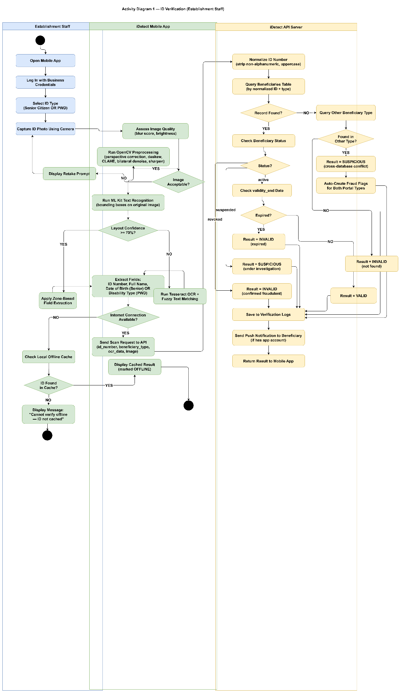
ID Verification (Establishment Staff)

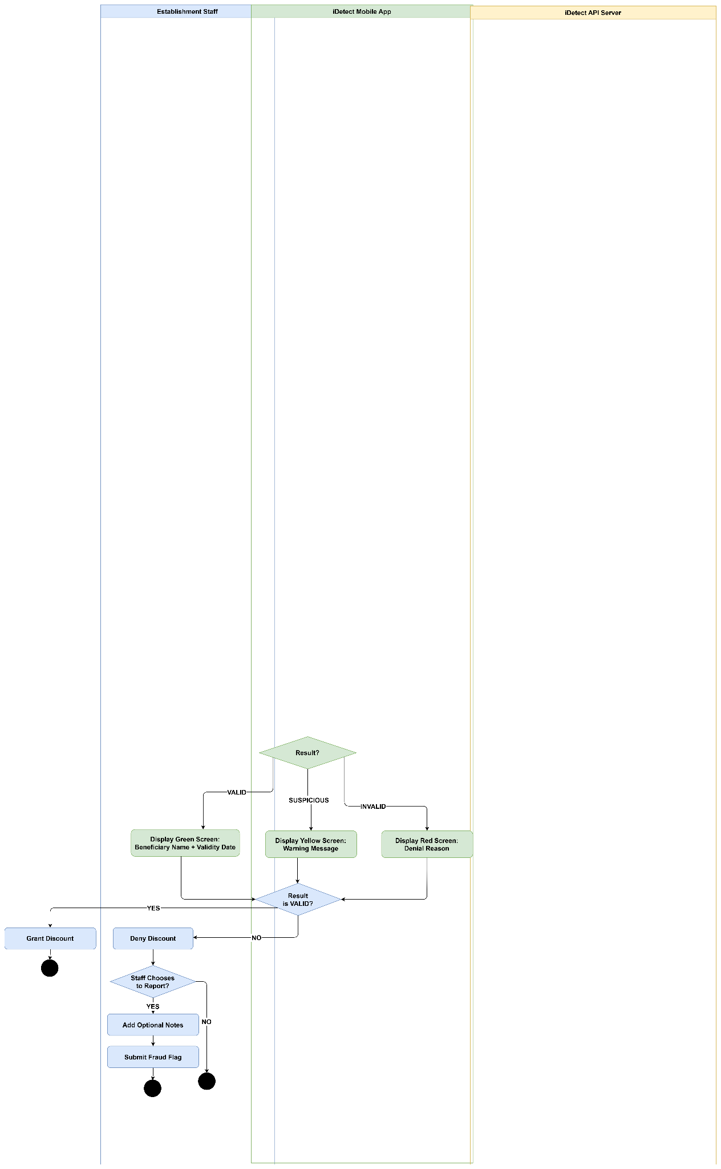

This diagram walks through the complete ID verification process carried out by Establishment Staff using the iDetect mobile app. The staff logs in with business credentials, selects the ID type, and captures the ID photo using the device camera. The app evaluates image quality and, if acceptable, runs OpenCV preprocessing followed by ML Kit text recognition. If layout confidence reaches the 70% threshold, zone-based field extraction is applied; otherwise, Tesseract OCR with fuzzy text matching is used as a fallback.
With the fields extracted, the app checks for internet connectivity. If offline, it checks the local status cache for a revoked or suspended block; otherwise the scan is queued and shown as MANUAL REVIEW until it is verified on reconnection. If online, the scan data is sent to the API server, which normalizes the ID number, queries the beneficiaries database, and evaluates the record's status and validity. The server returns a result of VALID, SUSPICIOUS, INVALID, or MANUAL REVIEW the last of which is triggered when a beneficiary appears under investigation or is found in a conflicting database type, automatically creating fraud flags across both portal types.
The app presents the result through a color-coded screen green for valid, yellow for suspicious, and red for invalid and the discount is granted or denied accordingly. For denied results, the staff may optionally submit a fraud flag with supporting notes before the process ends.

Figure 30.
Fraud Flag Investigation (OSCA / PDAO Admin)

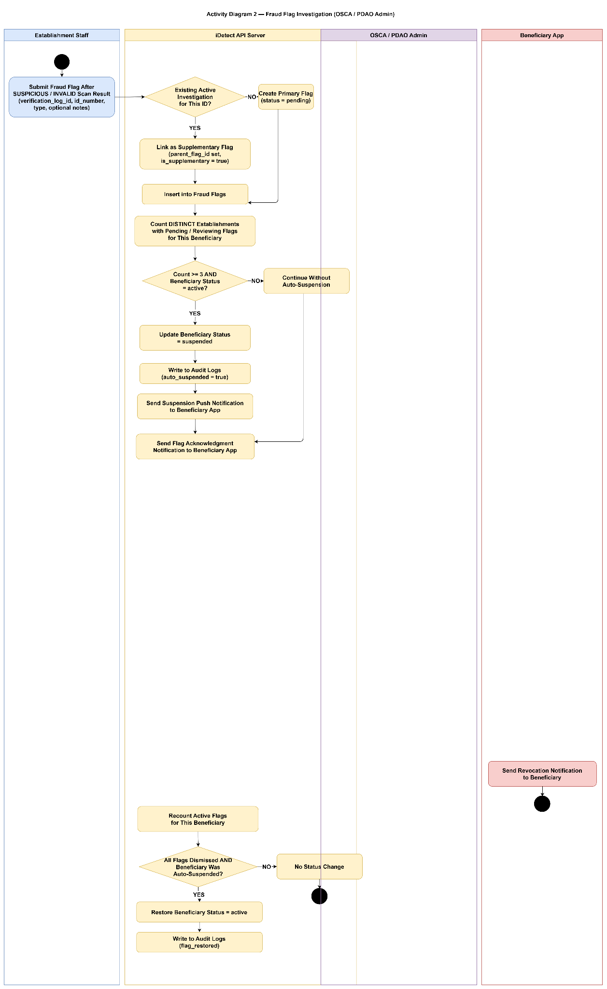

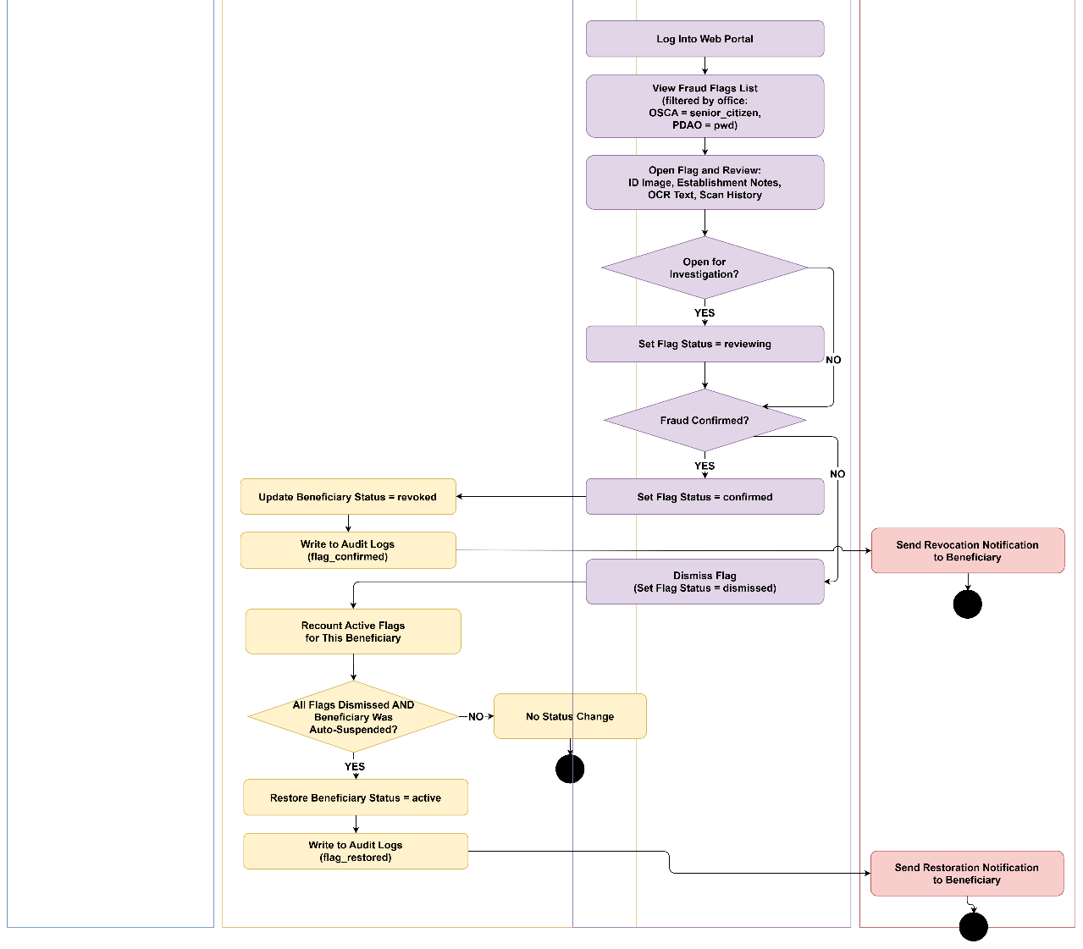
This diagram shows how iDetect processes and investigates fraud flags from submission through resolution. When Establishment Staff submits a fraud flag after a suspicious or invalid scan, the system checks whether an active investigation already exists for that ID. If yes, the new flag is linked as a supplementary flag; if not, a primary flag is created. The system then counts distinct establishments that have flagged the same beneficiary if three or more flags exist and the beneficiary is still active, the system automatically suspends the account, logs the event, and notifies the beneficiary. The admin then logs into the web portal, reviews the flag alongside the ID image, OCR text, and scan history, and decides whether to open a formal investigation. If fraud is confirmed, the beneficiary's status is set to revoked and a revocation notification is sent. If the flag is dismissed, the system rechecks all active flags and if all have been dismissed and the suspension was automatic, the beneficiary's status is restored to active and a restoration notification is dispatched.

Figure 31.
Beneficiary Dispute Submission
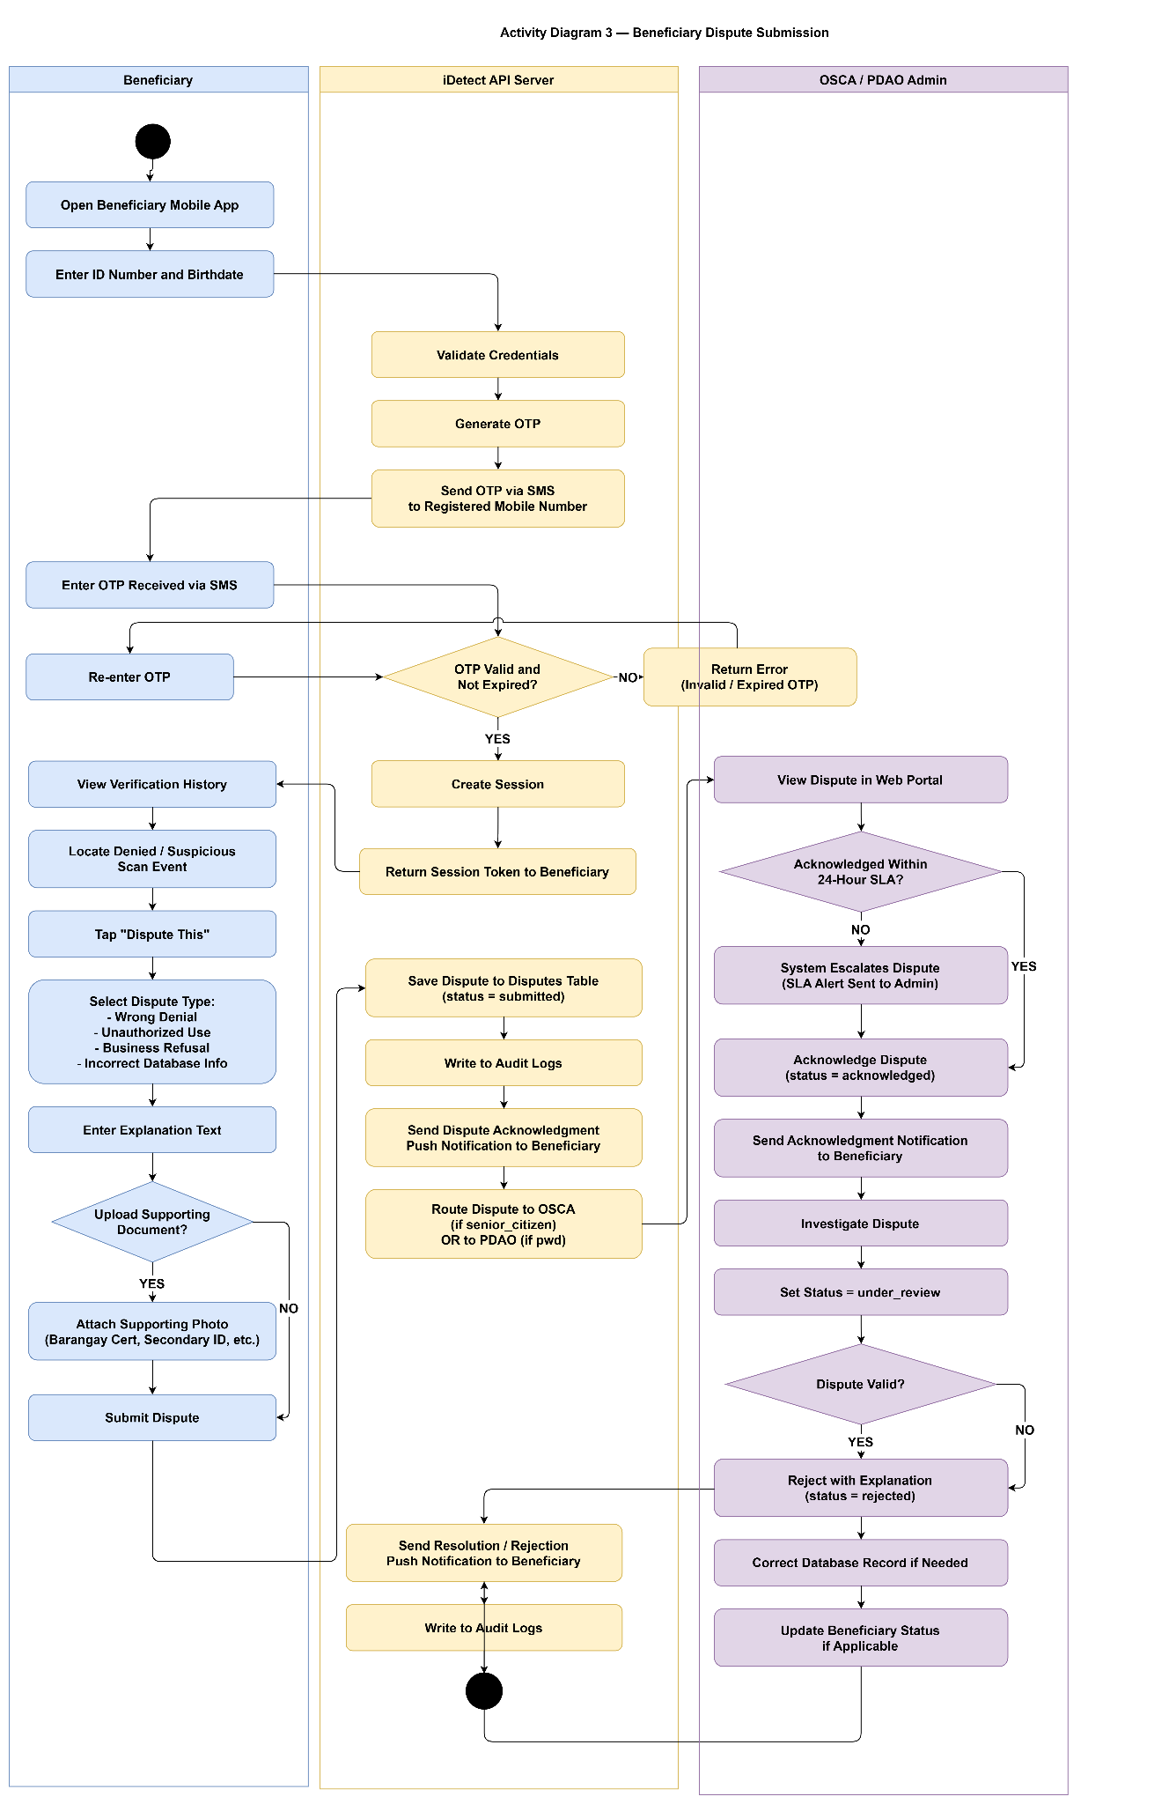
This diagram illustrates the end-to-end flow of a beneficiary raising a dispute against a suspicious or denied verification. The beneficiary logs in through the mobile app using their ID number and birthdate, completes OTP verification via SMS, and accesses their verification history. From there, they locate the scan event in question, select a dispute type such as wrong denial, unauthorized use, or incorrect database info, provide an explanation, and optionally attach supporting documents before submitting. The system saves the dispute, acknowledges it with a push notification, and routes it to OSCA for Senior Citizens or PDAO for PWDs. On the admin side, the dispute must be acknowledged within a 24-hour SLA if not, the system automatically escalates it. The admin then investigates, sets the status to under review, and either rejects it with an explanation or resolves it by correcting the database record and updating the beneficiary's status. The outcome is communicated back to the beneficiary through a push notification, and all actions are logged.

Figure 32.
Establishment Management (BPLO Admin)
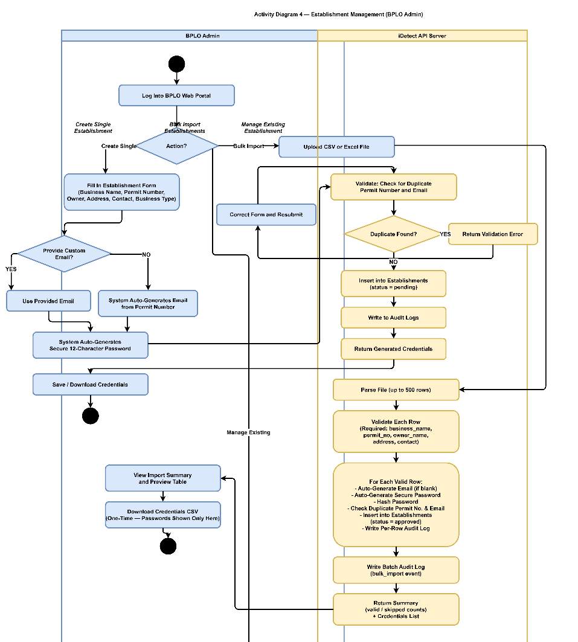

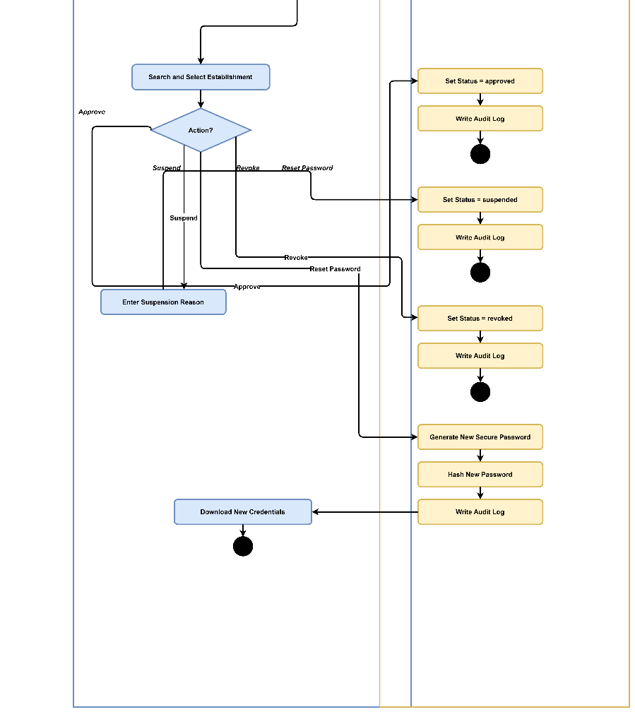
This diagram covers the full range of establishment management actions available to the BPLO Admin. The admin can create a single establishment by filling out a form with business details, optionally providing a custom email or letting the system auto-generate one from the permit number, along with a secure auto-generated password. For bulk onboarding, the admin uploads a CSV or Excel file, which the system parses and validates row by row auto-generating emails and passwords, checking for duplicates, and inserting valid entries into the database before returning a summary and credentials list. For managing existing establishments, the admin can search and select a record and then choose to approve, suspend, revoke, or reset the password. Each action updates the establishment's status and writes a corresponding audit log entry. Password resets generate a new secure password that is hashed server-side, with the new credentials made available for download.

Figure 33.
Beneficiary Record Management (OSCA / PDAO Admin)

This diagram details how OSCA and PDAO Admins manage beneficiary records through the iDetect web portal. Upon login, the admin can choose between three actions: adding a new record, editing an existing one, or changing a beneficiary's status. When adding a record, the admin fills out the beneficiary form including ID number, full name, birthdate, issuing office, and validity and for PWDs, the disability type is also selected. The API server then normalizes the ID number, checks for duplicates, and either returns a validation error or inserts the record as active and logs the event. For edits, the admin searches for the beneficiary, modifies the relevant fields, and submits the server, validates and updates the record accordingly. For status changes, the admin can suspend, revoke, or restore a beneficiary, each requiring a reason text. The server updates the status, writes to audit logs, and sends a notification to the beneficiary's app. The admin can also view a beneficiary's full scan history and export it as a CSV if needed.

Testing and Evaluation Plan
This section presents the testing and evaluation plan for iDetect, describing the procedures, instruments, respondent groups, and criteria that will be used to assess the system's correctness, quality, and stakeholder acceptability. The plan is organized into two sequential phases: an internal functional testing phase conducted by the research team, followed by a structured stakeholder evaluation phase using ISO 25010 quality characteristics as the evaluation framework.
Phase 1: Functional Testing (Internal — Research Team)
Purpose. Functional testing is conducted by the research team prior to stakeholder evaluation to verify that all implemented system features operate correctly according to their specified requirements. This phase ensures that the system presented to external evaluators is complete, stable, and free of critical functional defects that would compromise the validity of stakeholder evaluation results. Functional testing in this study corresponds to black-box testing — test cases are designed from the perspective of expected system behavior based on functional requirements, without reference to internal code implementation.
Testing Approach. Each functional requirement documented in the Requirement Specification section of this chapter has a corresponding set of test cases. Test cases are structured with the following components:
- Test Case ID: A unique identifier referencing the functional requirement being tested (e.g., TC-2.1.1 corresponds to REQ-2.1.1)
- Test Description: A statement of what the test case verifies
- Preconditions: System state and data conditions required before the test is executed
- Test Steps: Sequential actions performed to execute the test
- Test Data: Specific inputs used, including both valid and invalid data scenarios
- Expected Result: The correct system behavior if the requirement is implemented properly
- Actual Result: Recorded during test execution (to be completed in Capstone 2)
- Pass/Fail Status: Determined by comparison of actual result against expected result
Both positive test cases, verifying that the system produces correct outputs for valid inputs, and negative test cases, verifying that the system handles invalid, incomplete, or malicious inputs gracefully, are included for each functional requirement. This dual-scenario approach ensures that the system is tested not only for correct operation under ideal conditions but also for appropriate error handling, fallback behavior, and input validation under adverse conditions.

Functional testing covers all five portals of iDetect across the following functional areas:
Client Portal (Mobile Application)
- ID image capture and OCR preprocessing pipeline
- Field-level data extraction and confidence scoring
- Manual entry fallback activation at below-threshold confidence
- Real-time database verification and validation result display
- Suspicious credential flagging and LGU transmission
- Transaction history access and online-only behavior
- Two-factor authentication for establishment accounts
BPLO Portal (Web-Based)
- Establishment account registration and permit verification
- System access grant, suspension, and revocation
- Technical performance dashboard display
- Role-based access enforcement — BPLO cannot access beneficiary data or flagged records
OSCA Portal (Web-Based)
- Senior Citizen database record management
- Real-time receipt of flagged credential notifications
- Fraud investigation workflow and case management
- Confirmed fraudulent credential marking and network propagation
- Fraud analytics report generation
- Data compartmentalization — OSCA cannot access PWD records
PDAO Portal (Web-Based)
- Parallel functionality to OSCA portal for PWD credential management
- Data compartmentalization — PDAO cannot access Senior Citizen records
Beneficiary Mobile Application
- Account registration with ID number, birthdate, and OTP authentication
- Verification status display synchronized with government records
- Transaction notification delivery via SMS and push notification
- Dispute submission with supporting documentation upload
- Dispute resolution tracking and outcome notification
- Transaction history access
- Unauthorized credential use reporting
- Two-factor authentication security
Functional Testing Procedure
Testing will be conducted in a controlled development environment using seeded test databases that simulate OSCA and PDAO records without using real beneficiary data. Test data sets will include records representing each possible verification outcome: credentials that should return VALID, credentials that should return SUSPICIOUS due to field discrepancies, and credentials that should return INVALID due to absence from the database. The research team will execute each test case in sequence, record the actual system behavior, and assign pass or fail status based on comparison against the expected result documented in the test case.

Defects identified during functional testing will be logged with their associated test case ID, description of the observed failure, severity classification, and resolution status. Testing will be repeated following defect resolution to confirm that fixes produce the expected behavior without introducing new failures in previously passing test cases. The system will proceed to stakeholder evaluation only after all critical and high-severity functional defects have been resolved and the corresponding test cases achieve passing status.
Phase 2: Stakeholder Evaluation (External — ISO 25010)
Purpose. Following successful completion of functional testing, the system will be presented to external stakeholders for structured evaluation against the ISO 25010 software product quality standard. This phase assesses the system's quality from the perspective of its actual users — establishment staff, LGU administrators, and Senior Citizen and PWD beneficiaries — capturing dimensions of quality that internal functional testing cannot measure, including usability, accessibility, real-world performance, and user satisfaction.
The evaluation is structured around the ISO 25010 quality characteristics adopted as the evaluation criteria in the Specific Objectives of this study. Each quality characteristic is assessed through a corresponding set of survey indicators administered to the appropriate respondent group via structured questionnaire using a four-point Likert scale (4 = Strongly Agree, 3 = Agree, 2 = Disagree, 1 = Strongly Disagree).
The weighted mean of responses for each indicator and section will be computed and interpreted using the scale established in Section 3.5 of this chapter:

Weighted Mean Range | Interpretation
3.25 – 4.00 | Strongly Agree
2.50 – 3.24 | Agree
1.75 – 2.49 | Disagree
1.00 – 1.74 | Strongly Disagree

A weighted mean of 2.50 or above (Agree) on each ISO 25010 characteristic is established as the minimum acceptable threshold for the corresponding quality dimension. Characteristics receiving an overall weighted mean below 2.50 will be identified as requiring improvement and addressed in subsequent development iterations during Capstone 2.
ISO 25010 Quality Characteristics and Evaluation Mapping
The following table maps each ISO 25010 quality characteristic to its evaluation focus, the respondent group best positioned to assess it, and the corresponding specific objective it addresses:
ISO 25010 Characteristic | Evaluation Focus | Primary Respondent Group | Specific Objective
Functional Suitability | Completeness, correctness, and appropriateness of all implemented features | All groups | C1
Performance Efficiency | Verification speed, response time, concurrent user handling | Establishment staff | C2
Usability | Learnability, operability, error protection, accessibility, interface aesthetics | All groups | C3
Reliability | System stability, fault tolerance, availability during business hours | Establishment staff, LGU administrators | C4
Security | Data confidentiality, access control, audit log integrity, RA 10173 compliance | LGU administrators, beneficiaries | C5
Compatibility | Integration with OSCA/PDAO databases, cross-platform operation | LGU administrators | C6
Maintainability | Modularity, analyzability, modifiability of system components | Research team assessment | C7
Portability | Cross-device compatibility on Android and iOS, adaptability | Establishment staff, beneficiaries | C8

Evaluation Respondent Groups
The stakeholder evaluation will be conducted with the same respondent groups as the exploratory phase, now in their capacity as system evaluators rather than needs assessment participants. Each group will evaluate the system through the portal specific to their role:
- Group 1 — Business Establishment Staff Evaluate the Client Portal after a structured demonstration and supervised trial of the verification workflow. Assessment covers functional suitability, performance efficiency, usability, and portability from the perspective of point-of-sale operational requirements.
- Group 2 — OSCA Personnel Evaluate the OSCA Portal after demonstration of the fraud reporting reception, investigation workflow, and analytics dashboard. Assessment covers functional suitability, usability, reliability, security, and compatibility with OSCA database management practices.
- Group 3 — PDAO Personnel Evaluate the PDAO Portal under the same conditions as OSCA personnel, with assessment focused on PWD credential management functions and parallel fraud investigation workflows.
- Group 4 — BPLO Personnel Evaluate the BPLO Portal after demonstration of establishment account management and compliance monitoring functions. Assessment covers functional suitability, usability, and security — specifically the enforcement of data access boundaries preventing BPLO from accessing verification intelligence or beneficiary data.
- Group 5 — Senior Citizen and PWD Beneficiaries Evaluate the Beneficiary Mobile Application after a guided walkthrough of account registration, status monitoring, and dispute submission functions. Assessment covers functional suitability, usability, accessibility, security, and portability. Given the age and potential accessibility constraints of this respondent group, evaluation sessions will be conducted face-to-face with researcher assistance available, mirroring the approach used in the exploratory survey phase.

Evaluation Tool
Survey Questionnaire A: Beneficiaries (Senior Citizens and Persons with Disabilities)

DEMOGRAPHIC PROFILE
Name (Optional): ________________________________________
Gender: ☐ Male ☐ Female ☐ Prefer not to say
Age: ________________________________________
Beneficiary Type: ☐ Senior Citizen ☐ Person with Disability (PWD) ☐ Both
Please indicate your level of agreement with each statement using the scale below:
4 | 3 | 2 | 1
Strongly Agree | Agree | Disagree | Strongly Disagree

1. Current Experience with Discount ID Verification
Indicators | 4 | 3 | 2 | 1
1. I regularly use my Senior Citizen/PWD ID to avail of the mandated 20% discount at business establishments.
2. Business staff usually accept my discount ID without questioning its authenticity.
3. I have experienced delays during discount verification at cashier counters.
4. I have been asked to provide additional identification documents beyond my discount ID.
5.I feel that business staff are sometimes skeptical about the authenticity of my discount ID..

2.Challenges and Concerns in Availing Discount Privileges
Indicators | 4 | 3 | 2 | 1
1.I have been wrongfully denied my discount privilege even when presenting a valid ID
2.The manual verification process at establishments takes too much time.
3. I am aware that there are fraudulent Senior Citizen and PWD IDs being used by non-beneficiaries.
4.The existence of fake IDs makes it harder for legitimate beneficiaries like me to avail discounts smoothly.
5.I worry that businesses are becoming more strict with discount verification because of fraud concerns.

3.Need for Improved Verification System
Indicators | 4 | 3 | 2 | 1
1.There is a need for a faster and more reliable way to verify discount IDs.
2. I would be comfortable having my ID information verified digitally through a mobile application.
3. I would like to receive notifications when my ID is used for discount verification.
4.It is important for me to be able to dispute any wrongful denial of my discount privileges.
5.A system that reduces verification time would improve my shopping experience.

4.Data Privacy and Transparency Concerns
Indicators | 4 | 3 | 2 | 1
1. I am concerned about the privacy and security of my personal information in ID verification systems
2.I want to know when and where my discount ID is being verified..
3. I trust that government offices (OSCA/PDAO) will protect my personal data.
4. I believe businesses should only access the minimum information needed to verify my eligibility.
5. I would like the ability to track the history of when my ID was used for verification.

Survey Questionnaire B: Business Establishment Staff

DEMOGRAPHIC PROFILE
Name (Optional): ________________________________________
Gender: ☐ Male ☐ Female ☐ Prefer not to say
Age: ________________________________________
Position / Role in the Establishment: ________________________________________
Type of Business: ________________________________________

Please indicate your level of agreement with each statement using the scale below:
4 | 3 | 2 | 1
Strongly Agree | Agree | Disagree | Strongly Disagree

1. Current Verification Process and Challenges
Indicators | 4 | 3 | 2 | 1
1. Our establishment frequently encounters customers presenting Senior Citizen or PWD discount IDs.
2. The current manual visual inspection method is sufficient for verifying ID authenticity.
3. Staff members find it difficult to distinguish between genuine and fraudulent IDs.
4. The verification process causes delays during peak hours at the cashier.
5. We have encountered suspected fraudulent or fake discount IDs in our establishment.

2. Impact of Fraudulent IDs on Business Operations
Indicators | 4 | 3 | 2 | 1
1. Fraudulent discount claims negatively affect our business's profit margins.
2. Our staff lacks confidence in rejecting suspicious IDs due to legal concerns.
3. We have experienced conflicts or complaints from customers when questioning their IDs.
4. There is no clear process for reporting suspected fraudulent IDs to authorities.
5. Our establishment would benefit from a more reliable method to verify discount IDs.

3. Need for Digital Verification Solution
Indicators | 4 | 3 | 2 | 1
1. A digital verification system would improve the speed of discount transactions.
2. Staff would feel more confident in accepting or rejecting IDs with automated verification support.
3. A mobile application for ID scanning would be practical for our point-of-sale environment.
4. It is important to have a system that can flag suspicious IDs for further review.
5. Our establishment would be willing to adopt a government-approved digital verification tool.

4.Legal and Compliance Concerns
Indicators | 4 | 3 | 2 | 1
1. Our staff is aware of the legal penalties for wrongfully denying legitimate discount privileges
2. We are concerned about potential legal liability when honoring potentially fraudulent IDs.
3. A verification system with government database integration would reduce our legal risk.
4.We need clearer guidelines on how to handle suspected fraudulent IDs without violating laws.
5. A system that documents verification attempts would be valuable for compliance purposes.

Survey Questionnaire C: OSCA and PDAO Personnel

DEMOGRAPHIC PROFILE
Name (Optional): ________________________________________
Gender: ☐ Male ☐ Female ☐ Prefer not to say
Age: ________________________________________
Office: ☐ OSCA (Office for Senior Citizens Affairs) ☐ PDAO (Persons with Disability Affairs Office)
Position / Designation: ________________________________________
Please indicate your level of agreement with each statement using the scale below:
4 | 3 | 2 | 1
Strongly Agree | Agree | Disagree | Strongly Disagree

1. Current Beneficiary Database Management
Indicators | 4 | 3 | 2 | 1
1. Our office maintains an up-to-date database of all registered Senior Citizens/PWDs.
2.The current database system allows easy registration, updating, and deactivation of ID records.
3. Business establishments frequently contact our office to verify the authenticity of discount IDs.
4. The manual verification process (phone calls, walk-ins) is time-consuming for our staff.
5. There is a need for a more efficient system to share beneficiary data with authorized businesses.

2. Fraud Reporting and Investigation Challenges
Indicators | 4 | 3 | 2 | 1
1. Our office receives reports of suspected fraudulent Senior Citizen/PWD IDs from businesses.
2. Investigating fraud reports is challenging due to lack of real-time information sharing.
3. There is no standardized process for businesses to report suspected fraudulent IDs to our office.
4.Fraudulent IDs are often identified only after significant misuse has already occurred.
5. A digital system for fraud reporting would significantly improve our investigation efficiency.

3. Inter-Agency Coordination and Data Sharing
Indicators | 4 | 3 | 2 | 1
1. Coordination between OSCA, PDAO, and BPLO regarding ID verification is currently limited.
2.Real-time data sharing between our office and business establishments would reduce fraud.
3. A centralized verification system would improve collaboration between government offices.
4. Cross-jurisdictional verification (across different municipalities) is currently not feasible
5. Our office would support a government-approved digital verification platform.

4. Data Privacy and Compliance Concerns
Indicators | 4 | 3 | 2 | 1
1. Data privacy (RA 10173) is a key concern when sharing beneficiary information with businesses.
2. Our office needs a system that protects beneficiary data while enabling verification.
3. Audit logs of who accesses beneficiary data are important for accountability.
4. Beneficiaries should be notified when their ID information is accessed for verification.
5. A secure, role-based access system would address our data privacy concerns.

Survey Questionnaire D: Business Permit and Licensing Office (BPLO) Personnel

DEMOGRAPHIC PROFILE
Name (Optional): ________________________________________
Gender: ☐ Male ☐ Female ☐ Prefer not to say
Age: ________________________________________
Position / Designation: ________________________________________
Please indicate your level of agreement with each statement using the scale below:
4 | 3 | 2 | 1
Strongly Agree | Agree | Disagree | Strongly Disagree

1.Monitoring Business Compliance with Discount Laws
Indicators | 4 | 3 | 2 | 1
1. The BPLO actively monitors business establishments' compliance with Senior Citizen and PWD discount laws (RA 9994 and RA 10754).
2. We receive complaints from beneficiaries about wrongful denial of discount privileges.
3. It is challenging to verify whether businesses are complying with discount laws without a tracking system.
4. Businesses often request guidance on how to verify discount IDs without legal liability.
5. A digital verification system would help the BPLO track compliance more effectively.

2. Fraud Prevention and Enforcement Challenges
Indicators | 4 | 3 | 2 | 1
1. Fraudulent discount IDs pose a significant challenge to both businesses and government revenue.
2. The BPLO currently lacks real-time data on fraudulent ID usage across business establishments.
3. Coordinating fraud investigations between BPLO, OSCA, and PDAO is currently difficult.
4. Businesses need a legally defensible method to reject suspicious IDs without facing penalties.
5. A system that generates fraud analytics would support evidence-based enforcement decisions.

3. Need for Integrated Verification and Reporting System
Indicators | 4 | 3 | 2 | 1
1. There is a need for an integrated system that connects BPLO, OSCA, PDAO, and businesses.
2. Real-time fraud reporting from businesses to government offices would improve response time.
3. The BPLO would benefit from a dashboard showing system-wide verification activity.
4. A digital verification platform would reduce the administrative burden on businesses.
5. Our office would support the implementation of a government-approved verification application.

4. Data Management and Revenue Protection
Indicators | 4 | 3 | 2 | 1
1. Fraudulent discount claims contribute to significant government revenue losses.
2. The BPLO needs better tools to analyze patterns of fraudulent ID usage across the city
3. Data privacy compliance (RA 10173) is important when implementing verification systems.
4. Audit logging and transparency features are essential for government accountability.
5. A digital verification system would strengthen the government's anti-fraud campaign.

Test Cases
Table 3.
Test Case ID | Case Name | Case Description | Expected Result | Test Data | Actual Result | P = Passed F = Failed | Remarks
Section 1.1 – System Infrastructure and Environment Setup
TC-ENV-001 | Repo Initialization – Success | System administrator initializes the project repository and configures development tooling (version control, CI/CD pipelines, linters) with valid credentials and configuration. | Repository successfully created; all team members granted appropriate access; development environment confirmed operational. | Valid admin credentials, valid repo config file
TC-ENV-002 | Database Migration – Success | Developer runs database migration scripts to set up all initial schemas for OSCA, PDAO, BPLO, establishment, and beneficiary records. | All schemas created with correct relationships; seed data populated; no migration errors reported. | Valid migration scripts, active DB connection
TC-ENV-003 | API Scaffolding Health Check | Developer deploys API scaffolding across all five portals and executes a health check on each endpoint. | All API endpoints respond with HTTP 200; base infrastructure confirmed stable and ready for feature development. | Deployed API config, health check endpoint URLs
TC-ENV-004 | Repo Init – Permission Error | System administrator attempts to initialize the repository but encounters a configuration or permission error. | System displays specific error message identifying the permission issue; repository setup halted until resolved; no partial repo created. | Admin account with insufficient permissions
TC-ENV-005 | DB Migration – Schema Conflict Rollback | Developer runs migration scripts but encounters a schema conflict or database connection failure mid-migration. | System rolls back all partial migrations; logs full error details; notifies developer that environment setup cannot proceed until DB issue is resolved. | Conflicting schema scripts, unstable DB connection
Section 1.2 – Admin Account Pre-Configuration
TC-ADM-001 | BPLO Admin Account Creation | System administrator creates and pre-configures a BPLO officer admin account prior to system deployment with all required fields. | Account created in BPLO Portal; credentials generated; officer notified with login details; account is active and portal-specific. | Valid officer name, email, role = BPLO Admin
TC-ADM-002 | OSCA Admin Account Creation | System administrator creates and pre-configures an OSCA administrator account ensuring access is limited to Senior Citizen records. | Account created in OSCA Portal only; no PDAO or BPLO portal access granted; credentials delivered to officer. | Valid officer details, role = OSCA Admin
TC-ADM-003 | PDAO Admin Account Creation | System administrator creates and pre-configures a PDAO administrator account ensuring access is limited to PWD records. | Account created in PDAO Portal only; no OSCA or BPLO access; credentials delivered to officer. | Valid officer details, role = PDAO Admin
TC-ADM-004 | Duplicate Username Rejection | System administrator attempts to create an admin account using a username that already exists in the system. | System rejects account creation; displays specific 'duplicate username' validation error; prompts correction before resubmitting. | Username already existing in the database
TC-ADM-005 | Missing Required Fields Blocked | System administrator attempts to create an admin account with one or more required fields left empty. | System rejects submission; highlights all empty mandatory fields with validation messages; account not saved. | Admin creation form with empty email field
Section 2.1 – Logging In and Authenticating Users
TC-AUTH-001 | Establishment Staff Login – Success | Establishment staff enters valid registered username and password in the Client Portal login screen. | System authenticates credentials; verifies active business permit status; grants access to the verification dashboard. | Valid staff username, correct password, active permit
TC-AUTH-002 | Beneficiary Two-Factor Login – Success | Beneficiary enters correct ID number and birthdate as first factor, then submits the valid OTP sent to registered mobile number. | Both authentication factors validated against OSCA/PDAO database; access granted to Beneficiary Mobile Application dashboard. | Valid Senior Citizen ID, correct birthdate, correct OTP
TC-AUTH-003 | LGU Admin Login – Success | BPLO, OSCA, or PDAO administrator enters institutionally issued credentials in their respective portal login screen. | Credentials authenticated; account confirmed active; access granted to the appropriate administrative portal dashboard only. | Valid admin username/password for OSCA portal
TC-AUTH-004 | Account Lockout After 3 Failed Attempts | A user enters incorrect login credentials three consecutive times within the same session. | Account temporarily locked for cooling-off period; lockout notification displayed with instructions to contact administrator; further login attempts blocked. | 3 consecutive wrong password entries
TC-AUTH-005 | Beneficiary Expired OTP Rejection | Beneficiary enters correct ID number and birthdate but submits an OTP that has already expired. | System denies access; displays OTP expired message; prompts beneficiary to request a new OTP; maximum resend limit per session enforced. | Valid ID/birthdate, OTP submitted after 5-minute expiry window
TC-AUTH-006 | RBAC – Wrong Role Access Blocked | Authenticated establishment staff attempts to access the BPLO administrative dashboard URL directly. | System denies access; displays role-based authorization error; logs unauthorized access attempt in audit trail. | Staff session token, admin dashboard URL
Section 2.2 – Provisioning and Managing Establishment Accounts
TC-EST-001 | New Establishment Account Creation | BPLO officer creates a Client Portal account for a newly registered food service establishment using a valid Valenzuela City business permit number. | Account activated immediately; credentials sent to establishment via email/SMS; action logged with officer ID, timestamp, and permit number. | Valid business permit number, staff name, email, mobile
TC-EST-002 | Existing Establishment Account Creation | BPLO officer creates a Client Portal account for an existing food service business upon verifying a valid current business permit. | Account provisioned and activated; onboarding notification sent to establishment; permit number recorded in system log. | Existing business, valid non-expired permit
TC-EST-003 | Invalid Permit – Creation Blocked | BPLO officer attempts to create an account using a business permit number not found in the BPLO registry. | System blocks account creation; displays error identifying the invalid permit; record not saved until a valid permit is entered. | Non-existent or fabricated permit number
TC-EST-004 | Expired Permit – Creation Blocked | BPLO officer attempts to create an account using an expired business permit number. | System blocks account creation; displays specific 'permit expired' error; prompts officer to obtain a renewed permit. | Permit number expired 60 days ago
TC-EST-005 | Account Suspension by BPLO Officer | BPLO officer suspends an active establishment account due to a policy violation. | Client Portal access immediately revoked; establishment staff notified with stated reason; action logged with officer identity, timestamp, and reason. | Active establishment account, policy violation reason
TC-EST-006 | Permit Expiry 30-Day Alert on Dashboard | System monitors business permit expiry dates and an establishment's permit is within 30 days of expiration. | BPLO dashboard displays flagged alert for the affected establishment without automatically suspending the account. | Establishment with permit expiring in 20 days
TC-EST-007 | Self-Service Password Reset – Success | Establishment staff initiates password reset by entering their registered email address on the Client Portal login screen. | One-time reset link sent to registered email; staff sets new password within expiry window; reset event logged in audit trail. | Registered staff email address
TC-EST-008 | Password Reset – Outdated Contact Details | Establishment staff cannot complete self-service password reset because registered contact details are outdated or inaccessible. | System directs staff to contact their BPLO officer; BPLO officer can update contact details and trigger new reset through BPLO Portal. | Deactivated email address on record
Section 2.3 – Capturing and Preprocessing ID Images
TC-CAP-001 | Camera Viewfinder Guidance Display | Establishment staff opens the Client Portal mobile application and points the device camera at a Senior Citizen or PWD ID card. | Real-time camera viewfinder displayed with on-screen guidance indicating optimal ID positioning, lighting, and distance; visual confirmation shown when quality is sufficient. | Mobile device with functional camera, valid ID card
TC-CAP-002 | Preprocessing Pipeline – Success | Staff captures a clear, well-lit, properly positioned ID image that passes the quality assessment threshold. | System automatically applies deskewing, contrast enhancement, and noise reduction to the captured image before passing it to the OCR extraction engine. | Sharp, well-lit ID image under good conditions
TC-CAP-003 | Blurry Image Quality Rejection | Staff captures a blurry ID image that falls below the defined image quality assessment threshold. | System displays image quality warning; rejects captured image; prompts staff to recapture under better conditions; OCR not initiated. | Motion-blurred ID capture
TC-CAP-004 | Poor Lighting Rejection | Staff attempts to capture an ID in very low lighting conditions resulting in an underexposed image. | System detects insufficient lighting; rejects the image; displays guidance prompting staff to improve lighting before recapturing. | ID captured in dim lighting environment
TC-CAP-005 | Damaged ID – Manual Entry Fallback | Staff attempts to capture a physically damaged or heavily worn ID card with multiple illegible sections. | System notifies staff that image quality is insufficient for automated OCR processing; offers manual data entry fallback to continue verification workflow. | Faded, cracked, or physically damaged ID card
Section 2.4 – Extracting and Validating OCR Data Fields
TC-OCR-001 | Successful Full OCR Extraction | Preprocessed ID image passed to OCR engine; all required fields extracted with confidence scores meeting or exceeding threshold. | ID number, full name, beneficiary type, validity period, and issuing office extracted and displayed for staff review; system proceeds to database verification automatically. | Clear preprocessed Senior Citizen ID image
TC-OCR-002 | Low Confidence Field Highlighting | OCR engine extracts data but one or more fields fall below the acceptable confidence threshold. | System highlights low-confidence fields in the form; retains all extractable data; prompts staff to manually correct or confirm flagged fields before proceeding. | Partially legible ID with smudged ID number
TC-OCR-003 | Pattern Validation – Invalid Date Format | OCR extracts a validity date field that does not conform to the expected Philippine LGU date format. | System flags validity period field as invalid during pattern validation; prompts staff to manually enter the correct date before proceeding. | ID image with non-standard date notation
TC-OCR-004 | Complete OCR Failure – Manual Entry Activated | OCR engine is unable to extract any usable data from the preprocessed image. | System displays extraction failure message; activates manual data entry fallback; staff can type all credential details directly into the form. | Unreadable/blank ID image passed to OCR engine
TC-OCR-005 | Staff Manual Edit of OCR Field | OCR extraction returns an incorrect name spelling for a field; staff manually corrects the value before submitting for verification. | System allows editing of any pre-populated OCR field; submits corrected data for database verification without requiring staff to restart the capture process. | OCR-extracted form with misspelled name field
Section 2.5 – Verifying Credentials Against the Beneficiary Registry
TC-VER-001 | VALID Result – Simultaneous DB Query | Staff confirms OCR-extracted credential data and initiates verification; the OSCA or PDAO records matching the detected ID type are queried, with a cross-type check only when no match is found. | VALID result displayed with green visual indicator within 30 seconds; transaction logged; no comprehensive personal data exposed to Client Portal. | Active registered Senior Citizen ID number
TC-VER-002 | INVALID Result – No Record Found | Staff submits an ID number that does not match any record in either the OSCA or PDAO database. | INVALID result displayed with red visual indicator; staff informed of non-match outcome; option presented to flag credential as suspicious for LGU investigation. | Unregistered fabricated ID number
TC-VER-003 | SUSPICIOUS – Conflicting DB Results | Submitted ID number returns a record in one database (e.g., OSCA) but not in the other (PDAO), creating a conflict. | SUSPICIOUS status returned with amber indicator; conflict details logged in audit trail; discrepancy alert automatically routed to both OSCA and PDAO portals. | ID existing in OSCA but absent in PDAO
TC-VER-004 | Verification Completed Within 30 Seconds | Staff submits credential data and the system processes the dual-database verification under normal network conditions. | Full verification cycle from submission to result display completed within 30 seconds as required by the real-time point-of-sale performance requirement. | Valid ID, stable network with normal latency
TC-VER-005 | Offline – Cached Block or Queued Scan | Staff attempts verification while device has no network connection for an ID previously verified online. | System checks the local status cache; a revoked or suspended ID is blocked immediately, and any other scan is saved to the offline queue and displayed as MANUAL REVIEW. | Previously verified ID, Wi-Fi/mobile data off
TC-VER-006 | REVOKED ID Returns INVALID | Staff submits an ID number that has been previously confirmed as fraudulent and marked REVOKED in the master database. | System returns INVALID result immediately; fraudulent status propagated across network prevents any VALID outcome for this credential. | ID number previously marked REVOKED by OSCA admin
Section 2.6 – Flagging and Reporting Suspicious Credentials
TC-FLG-001 | Single-Tap Flag – SUSPICIOUS Result | Staff taps the flag button after receiving a SUSPICIOUS verification result and confirms the action in the confirmation prompt. | Captured image, OCR data, establishment identifier, timestamp, and outcome transmitted to appropriate LGU portal; unique reference number displayed to staff. | SUSPICIOUS verification result, network connected
TC-FLG-002 | Single-Tap Flag – INVALID Result | Staff taps the flag button after receiving an INVALID verification result for a known Senior Citizen ID. | Report transmitted to OSCA Portal with all associated data; confirmation message and reference number displayed; flag submission logged in transaction history. | INVALID result for Senior Citizen type ID
TC-FLG-003 | Offline Flag Queuing and Auto-Submit | Staff attempts to submit a flag report while device has no active network connection. | Flag report queued locally with all associated data; automatically transmitted to appropriate LGU portal upon connectivity restoration; staff notified of pending status. | Flag action attempted, offline device
TC-FLG-004 | Flag Cancellation – No Data Transmitted | Staff opens the flag submission interface after a suspicious result but decides not to proceed and cancels. | System discards flag submission; no data transmitted to any LGU portal; no flag event logged; staff returned to verification result screen. | Flag interface open, cancel button tapped
TC-FLG-005 | INVALID – Manual Beneficiary Type Selection | Staff attempts to flag a credential that returned INVALID because no record was found in either database and beneficiary type is unconfirmed. | System prompts staff to manually select Senior Citizen or PWD before flag submission; routes to OSCA or PDAO based on manual selection. | INVALID result with undetected ID type
TC-FLG-006 | Duplicate Flag Linked to Existing Case | Staff submits a flag for a credential that already has an active open investigation in the OSCA portal. | System detects existing open investigation; logs new submission as supplementary report linked to the existing case; no duplicate investigation record created. | ID with active OSCA investigation already open
Section 2.7 – Managing Senior Citizen Records (OSCA)
TC-OSC-001 | Real-Time Flag Notification to OSCA | A flag report for a Senior Citizen ID is transmitted from the Client Portal to the OSCA Portal. | OSCA administrator immediately notified via portal dashboard; notification displays captured image, extracted data, flagging establishment, and transaction timestamp. | Flagged Senior Citizen ID report from Client Portal
TC-OSC-002 | Admin Confirms Fraudulent Credential | OSCA administrator reviews evidence for a flagged Senior Citizen credential and marks it as confirmed REVOKED. | Credential status updated to REVOKED in OSCA database; change propagated within seconds to all connected Client Portal instances; future verifications return INVALID. | Flagged Senior Citizen credential with investigation evidence
TC-OSC-003 | Admin Dismisses Flag – Legitimate ID | OSCA administrator reviews a flagged credential and determines after investigation that it is legitimate. | Flag dismissed; VALID status restored in database; establishment that submitted the flag notified of investigation outcome. | Flagged credential verified as authentic
TC-OSC-004 | OSCA Cross-Portal Access Denied | OSCA administrator attempts to navigate to PDAO Portal data or PWD ID records from within the OSCA Portal. | System denies access; authorization error displayed; data compartmentalization enforced; OSCA limited to Senior Citizen records only at all times. | OSCA admin session, attempt to access PDAO data URL
TC-OSC-005 | OSCA Fraud Analytics Report Generation | OSCA administrator navigates to the fraud analytics section and requests a report showing flagging trends. | Report generated displaying temporal patterns, geographic distribution of flagged credentials, establishment-specific flagging trends, and flagged-to-confirmed conversion rates. | Date range input, OSCA admin credentials
Section 2.8 – Managing PWD Records (PDAO)
TC-PDA-001 | Real-Time Flag Notification to PDAO | A flag report for a PWD ID is transmitted from the Client Portal to the PDAO Portal. | PDAO administrator immediately notified via portal dashboard; notification displays captured image, extracted data, flagging establishment, and transaction timestamp. | Flagged PWD ID report from Client Portal
TC-PDA-002 | Admin Confirms Fraudulent PWD Credential | PDAO administrator reviews evidence and marks a flagged PWD credential as confirmed REVOKED. | Credential status updated to REVOKED in PDAO database; change synchronized within seconds across all connected Client Portal instances. | Flagged PWD credential with supporting evidence
TC-PDA-003 | PDAO Admin Dismisses Flag – Legitimate PWD ID | PDAO administrator reviews a flagged PWD credential and determines it is legitimate after investigation. | Flag dismissed; VALID status restored in PDAO database; establishment that submitted the flag notified of the resolution outcome. | Flagged PWD credential confirmed authentic
TC-PDA-004 | PDAO Cross-Portal Access Denied | PDAO administrator attempts to access Senior Citizen records or OSCA Portal data from within the PDAO Portal. | System denies access; authorization error displayed; PDAO strictly limited to PWD records through enforced data compartmentalization. | PDAO admin session, attempt to access OSCA data URL
TC-PDA-005 | PDAO Fraud Analytics Report Generation | PDAO administrator navigates to the fraud analytics section and requests a report on PWD ID flagging trends. | Report generated displaying temporal patterns, geographic distribution of flagged PWD credentials, establishment-specific trends, and flagged-to-confirmed conversion rates. | Date range input, PDAO admin credentials
Section 2.9 – Synchronizing Fraud Status Across Establishments
TC-SYN-001 | REVOKED Status Propagation Within Seconds | OSCA administrator marks a credential as REVOKED; multiple Client Portal instances are connected at the time of the update. | Credential status updated in master database and propagated to all connected Client Portal instances within 10 seconds of the database update. | Confirmed fraudulent credential; 3+ connected establishments
TC-SYN-002 | Offline Instance Syncs on Reconnect | A Client Portal instance is offline when OSCA marks a credential REVOKED; the device later reconnects to the network. | System automatically synchronizes the updated REVOKED status to the offline instance upon connectivity restoration; no manual refresh required by staff. | Offline Client Portal device; updated fraudulent credential in DB
TC-SYN-003 | VALID Reinstatement After Dispute Resolution | PDAO administrator reverts a previously REVOKED credential status back to VALID following a successful beneficiary dispute resolution. | Reinstated VALID status propagated across all connected Client Portal instances within seconds; credential can once again return VALID during verification. | Previously REVOKED credential; dispute resolved
TC-SYN-004 | Complete Audit Log of Status Changes | Multiple credential status changes are made by OSCA and PDAO administrators across a working day. | Each change logged in audit trail with administrator account ID, credential affected, previous status, new status, and exact timestamp; records are non-repudiable. | Series of REVOKED and VALID status updates
Section 2.10 – Registering a Beneficiary Account
TC-BRG-001 | Successful Beneficiary Registration | Beneficiary submits valid Senior Citizen ID number and birthdate; system verifies against OSCA database; correct OTP entered within allowed window. | Account activated and linked to beneficiary ID record in OSCA database; beneficiary navigated to account dashboard. | Registered Senior Citizen ID, correct birthdate, valid OTP
TC-BRG-002 | ID/Birthdate Mismatch – Registration Denied | Beneficiary enters an ID number and birthdate combination that does not match any record in the beneficiary registry for either beneficiary type. | System denies registration; displays message advising beneficiary to verify details with their local OSCA or PDAO office. | Valid ID number paired with wrong birthdate
TC-BRG-003 | OTP Timeout – Resend Offered | Beneficiary fails to enter the OTP within the allowed time window. | OTP expired; timeout notification displayed; beneficiary offered option to request new OTP; maximum resend limit per session enforced. | Valid ID/birthdate; OTP submitted after expiry
TC-BRG-004 | Wrong OTP – Access Denied | Beneficiary enters an incorrect OTP during the registration process. | System denies registration step completion; displays OTP mismatch error; allows retry until maximum attempt limit is reached. | Valid ID/birthdate; incorrect 6-digit OTP
TC-BRG-005 | Registration Optional – Discount Not Gated | Beneficiary without a registered application account presents their physical Senior Citizen ID at a participating establishment. | Establishment is required to provide mandated discount based on physical ID regardless of beneficiary's registration status in the application. | Unregistered beneficiary, valid physical Senior Citizen ID
Section 2.11 – Sending Real-Time Transaction Notifications
TC-NOT-001 | Approval Notification – SMS and Push | Establishment staff completes a VALID verification of a beneficiary ID through the Client Portal. | SMS and push notification sent to beneficiary's registered mobile number containing establishment name, transaction date/time, and 'Approved' outcome. | VALID verification result; beneficiary with registered mobile
TC-NOT-002 | Denial Notification with Specific Reason | Verification transaction results in a Denied outcome due to the ID number mismatch. | Notification delivered to beneficiary includes the specific denial reason (ID number mismatch); both SMS and push channels used. | INVALID verification result; reason = ID number mismatch
TC-NOT-003 | SMS Delivery Without Internet | Beneficiary's device has no mobile data but remains on the cellular network. | SMS notification delivered successfully via cellular network independent of mobile data access; push notification queued for delivery when internet is available. | Beneficiary device: mobile data off, SMS reception active
TC-NOT-004 | Unauthorized Use Alert from Notification | Beneficiary receives a transaction notification for an establishment they confirm they did not visit. | Direct action available within the notification interface; beneficiary submits unauthorized use alert which is automatically routed to appropriate OSCA or PDAO portal. | Notification for unrecognized establishment transaction
TC-NOT-005 | Notification Queued – Device Unreachable | Verification occurs but beneficiary's mobile device is temporarily powered off or out of coverage. | System logs transaction; queues notification for delivery once device is reachable; establishment verification workflow not delayed or disrupted. | Beneficiary device powered off during verification
Section 2.12 – Checking ID Verification Status
TC-STS-001 | Active ID Status Display | Authenticated beneficiary navigates to the ID Status screen in the Beneficiary Mobile Application. | Current ID status (Active) displayed synchronized with OSCA/PDAO master database; last successful verification details and upcoming expiration date shown. | Authenticated beneficiary, active ID record
TC-STS-002 | Suspended Status with Dispute Pathway | Beneficiary checks their ID status and finds it has been marked as Suspended. | System displays 'Suspended' status with explanation of what it means; applicable dispute/appeal pathway provided; OSCA or PDAO contact details shown. | Authenticated beneficiary, suspended ID record
TC-STS-003 | Expired ID Status Display | Beneficiary checks their status and their ID has passed the validity expiration date. | Status displayed as 'Expired'; expiration date shown; issuing office contact information provided to enable renewal process. | Authenticated beneficiary, ID past validity date
TC-STS-004 | Offline – Cached Status with Timestamp | Beneficiary accesses the ID Status screen with no network connectivity available. | Last cached ID status displayed with retrieval timestamp; clear notification that displayed status may not reflect current database record. | Authenticated beneficiary, device in airplane mode
Section 2.13 – Submitting and Tracking Dispute Resolutions
TC-DSP-001 | Dispute Initiated from Denied Transaction | Beneficiary selects a denied transaction from their notification history and taps the Dispute button. | Dispute form opened pre-populated with transaction reference number, establishment details, and denial reason; dispute category selection menu presented. | Denied transaction entry in notification history
TC-DSP-002 | Successful Dispute Submission | Beneficiary completes dispute form by selecting 'Wrong Denial' category, entering a written explanation, uploading a supporting photo of their physical ID, and submitting. | Dispute routed to OSCA or PDAO investigation queue; unique reference number generated; acknowledgment notification sent within 24 hours confirming receipt. | Complete dispute form with ID photo attachment
TC-DSP-003 | Empty Explanation Field Blocks Submission | Beneficiary attempts to submit the dispute form without entering any text in the mandatory written explanation field. | System displays validation error on explanation field and prevents submission; on-screen message indicates why form cannot be submitted. | Dispute form with all fields except explanation filled
TC-DSP-004 | SLA Breach – Automated Escalation | A submitted dispute is not resolved by the OSCA or PDAO within the 72-hour SLA timeframe. | System escalates overdue dispute within the LGU portal; status update notification sent to beneficiary confirming case still under active review; escalation recorded in audit trail. | Dispute submitted 73 hours ago with no resolution
TC-DSP-005 | Dispute Status Tracking in App | Beneficiary navigates to the dispute tracking section in the Beneficiary Mobile Application to check the status of a submitted dispute. | Dispute displayed with current status (e.g., Under Review); status updates reflect OSCA/PDAO progress; final resolution notification delivered with explanation upon case closure. | Beneficiary with one active submitted dispute
Section 2.14 – Reporting Fraud as a Beneficiary
TC-FRD-001 | Unauthorized Use Alert – Submission | Beneficiary submits an unauthorized use alert after receiving a transaction notification for an establishment they confirm they did not visit. | Alert routed immediately to appropriate OSCA or PDAO portal with transaction reference, establishment details, and beneficiary confirmation statement; acknowledgment with reference number sent. | Transaction notification for unvisited establishment
TC-FRD-002 | Business Refusal Report – Routed to BPLO | Beneficiary submits a business refusal report indicating the establishment denied their discount despite the system returning a VALID result. | Report routed to BPLO Portal for DOJ Opinion compliance investigation; BPLO officer presented with transaction reference, establishment ID, and beneficiary confirmation; acknowledgment sent. | VALID verification result; establishment discount refusal
TC-FRD-003 | Database Discrepancy Alert | Beneficiary identifies incorrect personal information (e.g., wrong birthdate) in their displayed ID record and submits a database discrepancy alert. | Report routed to OSCA or PDAO for verification and correction of master database; receipt acknowledged with reference number; record updated upon LGU admin confirmation. | Incorrect birthdate displayed in beneficiary profile
TC-FRD-004 | Insufficient Details Blocks Submission | Beneficiary attempts to submit a fraud report without providing sufficient details for investigation  . | System displays validation prompt identifying minimum required information; provides guidance on what details are needed; submission blocked until requirements met. | Fraud report form with only category selected, no details
Section 2.15 – Operating Offline and Synchronizing Data
TC-OFF-001 | Offline Verification – Cached Block | Staff attempts to verify a revoked or suspended ID while the device has no network connection; the status is in the local status cache. | System blocks the ID immediately from the cached status; a revoked ID is shown as INVALID and a suspended ID as SUSPICIOUS. | Previously verified ID, airplane mode enabled
TC-OFF-002 | Offline Scan – Queued as MANUAL REVIEW | Staff attempts to verify an ID while the device is offline and the ID is not revoked or suspended in the local status cache. | System saves the scan to the offline queue and displays MANUAL REVIEW, stating that the scan will be verified on reconnection; staff may defer the transaction or proceed provisionally per DOJ requirements. | Unverified ID, offline device
TC-OFF-003 | Queued Reports Auto-Sync on Reconnect | Multiple fraud flag reports were queued locally during a period of offline operation; device reconnects to network. | All queued reports automatically submitted to appropriate LGU portals upon reconnection; local status cache refreshed with latest database statuses; no manual intervention required. | 3 queued flag reports, device reconnects after 2 hours
TC-OFF-004 | Persistent Offline Mode Indicator | Establishment staff enters offline mode during an active session in the Client Portal. | Persistent offline mode indicator displayed throughout the offline session; clearly distinguishes queued offline scans from live verification outcomes at all times. | Active session, internet disconnected mid-session
TC-OFF-005 | Sync Failure Retry on Server Error | Device reconnects to network but synchronization of queued reports fails due to a server-side error. | System retains queued reports locally; retries synchronization automatically at next opportunity; persistent pending synchronization indicator shown to staff. | Queued reports, server returns 500 on sync attempt
Section 2.16 – Logging Audit Trails and Transaction History
TC-AUD-001 | Verification Transaction Logged Immediately | Establishment staff completes any verification transaction through the Client Portal. | System immediately logs credential data submitted, verification status, establishment identifier, staff account ID, and timestamp to the audit database. | Any completed verification (VALID, SUSPICIOUS, INVALID, or MANUAL REVIEW)
TC-AUD-002 | Admin Status Change Logged | OSCA administrator marks a credential as REVOKED in the OSCA Portal. | Audit trail entry created with administrator account ID, credential identifier, previous status (Active), new status (REVOKED), and exact timestamp. | OSCA admin marks credential REVOKED
TC-AUD-003 | Fraud Flag Submission Logged | Staff submits a fraud flag report from the Client Portal for a SUSPICIOUS verification result. | Flag submission logged in audit trail with reference number, establishment identifier, transaction timestamp, and routing destination (OSCA or PDAO). | Submitted flag report with reference number
TC-AUD-004 | Audit Record Tamper Prevention | A user with elevated access attempts to delete or modify an existing audit log record. | System denies modification; maintains full integrity of all audit records; attempted modification logged as a security event in the audit trail. | API request to DELETE or UPDATE an audit log entry
TC-AUD-005 | Compliance Report Generation by Staff | Establishment staff selects a date range and requests a compliance report summary from the transaction history screen. | Summary report generated with counts of VALID, SUSPICIOUS, and INVALID verification outcomes within the specified period; displayed on screen for review. | Date range: last 30 days, staff account
TC-AUD-006 | Audit Log 5-Year Retention Policy | System administrator checks whether audit logs older than 5 years are flagged for archival. | All audit records retained for minimum of 5 years from creation date; records older than 5 years marked available for archival to long-term storage per policy. | Audit records dated 5+ years ago
Section 2.17 – Securing Data and Ensuring Privacy Compliance
TC-SEC-001 | Encrypted Transmission – Verification Request | Establishment staff submits a verification transaction that queries the OSCA or PDAO database. | All data transmitted over encrypted channels using industry-standard protocols; only VALID/SUSPICIOUS/INVALID status returned; no comprehensive personal data exposed to Client Portal. | Verification request; network traffic captured for inspection
TC-SEC-002 | Unauthenticated API Request Blocked | External actor attempts to query the OSCA database directly through the API without a valid authentication token. | Request rejected with HTTP 401; unauthorized access attempt logged with request source and timestamp in security audit trail; system administrator notified. | API request with no Authorization header
TC-SEC-003 | Beneficiary Data Access Right (RA 10173 §16) | Authenticated beneficiary exercises their RA 10173 Section 16 right to access their verification records from within the Beneficiary Mobile Application. | Beneficiary provided access to current ID status, full transaction history, and any dispute records associated with their credential. | Authenticated beneficiary with prior verification transactions
TC-SEC-004 | Session Expiry on Inactivity | Authenticated establishment staff leaves the Client Portal idle beyond the defined inactivity timeout period. | System enforces automatic session expiry; user required to re-authenticate before resuming access; session expiry event logged. | Authenticated staff session; inactivity exceeds defined timeout
TC-SEC-005 | Permission Violation Logged | Authenticated OSCA admin attempts to access BPLO business account data through a crafted API request. | Access denied; authorization error displayed; permission violation logged in audit trail with account ID, timestamp, and type of violation. | OSCA admin session token; BPLO data endpoint request
TC-ACC-001 | Elderly-Friendly First Launch | A beneficiary aged 60 or above opens the Beneficiary Mobile Application for the first time. | The application displays large touch targets meeting WCAG 2.1 AA size guidelines; high-contrast text; clear iconography; bilingual onboarding in English and Filipino. | First-time launch on Android device, no prior account
TC-ACC-002 | Three-Step Verification Workflow Enforced | Establishment staff with no prior training opens the Client Portal on their first day of use. | System guides staff through exactly three actions: launch, scan, view result; inline contextual prompts shown at each step; no intermediate confirmation dialogs required. | First-time staff login, Client Portal mobile app
TC-ACC-003 | Language Switch – English to Filipino | Beneficiary switches the application language preference from English to Filipino within the settings screen. | All interface labels, instructions, notifications, and status messages rendered in Filipino immediately upon toggle; no session restart required. | Language toggle setting, English → Filipino
TC-ACC-004 | Progressive Disclosure – Advanced Features | Establishment staff navigates beyond the primary three-step verification workflow to explore advanced features. | Advanced features such as fraud analytics dashboards and bulk management tools revealed only upon deliberate navigation; primary workflow remains uncluttered. | Staff navigating deep into settings/reports
TC-ACC-005 | Minimal Text Input – Auto-Populated Fields | Establishment staff initiates a verification transaction; OCR has already extracted all credential fields. | All known fields pre-populated from OCR extraction and authenticated session context; staff required to enter minimal additional text input; burden reduced. | Verified OCR extraction; active staff session

CHAPTER 4 ANALYSIS, PRESENTATION, AND INTERPRETATION OF DATA
This chapter presents, analyzes, and interprets the data gathered from the respondents who evaluated the iDetect system. The results of the IT Experts, Business Establishment Staff, OSCA and PDAO Personnel, and Beneficiaries are presented together so that the findings can be compared easily. The weighted mean of each item was computed from the tallied responses using the four-point Likert scale described in Chapter 3. The survey of the Business Permits and Licensing Office (BPLO) Personnel has not yet been completed, so their results are not yet included.

Demographic Profile of Respondents
This section presents the demographic profile of the respondent groups.
Respondents | Number
BPLO | 1
OSCA | 2
PDAO | 2
Senior Citizen | 5
PWD | 5
Business Establishment | 20
IT Expert | 3
The table presents the frequency and percentage distribution of the 38 respondents according to their respective stakeholder groups. Business Establishments recorded the highest frequency, with 20 respondents (52.6%), followed by Senior Citizens and PWDs, with five respondents each (13.2%). IT Experts accounted for three respondents (7.9%), while OSCA and PDAO each contributed two respondents (5.3%). BPLO had the lowest number of respondents, with one respondent (2.6%). The total frequency of 38 respondents corresponds to 100% of the study's participants.
The distribution demonstrates that the study gathered responses from various groups relevant to the implementation and evaluation of iDetect. Business Establishments provide perspectives from the intended users who may perform discount ID verification, while Senior Citizens and PWDs represent the beneficiaries of the verification process. Meanwhile, BPLO, OSCA, PDAO, and IT Experts contribute perspectives related to regulatory oversight, beneficiary concerns, and technical evaluation. Overall, the table summarizes the composition of the respondents and provides a basis for understanding the results of the system evaluation.

Graph 1. Stakeholder Group (Count)
The pie chart illustrates the distribution of respondents involved in the evaluation of the iDetect system, consisting of 38 respondents from seven stakeholder groups. Business Establishments represent the largest group, with 20 respondents or 52.6% of the total. This is followed by Senior Citizens and Persons with Disabilities (PWD), with five respondents each, equivalent to 13.2% per group. IT Experts account for three respondents or 7.9%, while the Office of the Senior Citizens Affairs (OSCA) and the Persons with Disability Affairs Office (PDAO) each have two respondents, representing 5.3% per group. Lastly, the Business Permits and Licensing Office (BPLO) has one respondent, equivalent to 2.6% of the total.
The chart indicates that Business Establishments constitute the majority of respondents, reflecting their significant role in evaluating the iDetect system. The inclusion of government offices, intended beneficiaries, and IT Experts also provides perspectives from different stakeholders regarding the system's functionality, usability, and overall suitability for verifying discount identification cards.

Results and Discussion
The respondents rated the iDetect system using a four-point Likert scale: 4 (Strongly Agree), 3 (Agree), 2 (Disagree), and 1 (Strongly Disagree). The weighted mean of each item was computed using the formula below and interpreted using the class interval that follows.

Weighted Mean

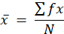
where x̅ is the weighted mean, f is the frequency of each rating, x is the rating value, and N is the number of respondents. For the combined OSCA/PDAO column, the frequencies of the two offices were added and N is the total number of OSCA and PDAO respondents (n = 4).

Class Interval
RANGE OF SCORES | INTERPRETATION
3.01 - 4.00 | HIGH
2.01 - 3.00 | MODERATE
1.00 - 2.00 | LOW

Because the IT Experts (n = 3) and the combined OSCA/PDAO (n = 4) groups are small, each respondent accounts for a large share of the group’s responses, and their results should be read with caution.
Table Weighted Mean of the ISO/IEC 25010 Sub-Qualities by Respondent Group

ISO/IEC 25010 | IT EXPERTS | BUSINESS ESTABLISHMENT | OSCA/PDAO | BENEFICIARIES
ISO/IEC 25010 | Weighted Mean | Weighted Mean | Weighted Mean | Weighted Mean
Functional Completeness | 3.33 | 3.75 | 4.00 | 3.20
Functional Appropriateness | 3.67 | 3.80 | 4.00 | 3.20
Functional Correctness | 3.67 | 3.85 | 3.75 | 3.70
Time Behaviour | 4.00 | 3.85 | 3.75 | 3.40
Capacity | 3.00 | 3.55 | 4.00 | 3.30
Co-Existence | 3.00 | 3.90 | 3.75 | 3.60
Interoperability | 3.00 | 3.80 | 4.00 | 3.60
Appropriateness Recognizability | 3.33 | 3.80 | 4.00 | 3.70
Learnability | 3.33 | 3.90 | 4.00 | 3.70
Operability | 3.33 | 3.90 | 3.75 | 3.60
User Error Protection | 3.33 | 3.95 | 3.50 | 3.00
User Assistance | 3.00 | 3.85 | 3.75 | 3.30
Self-Descriptiveness | 3.00 | 3.75 | 4.00 | 3.30
Faultlessness | 3.00 | 3.65 | 3.75 | 3.20
Availability | 3.33 | 3.75 | 3.75 | 3.40
Recoverability | 2.67 | 3.70 | 3.75 | 3.00
Confidentiality | 2.33 | 3.90 | 4.00 | 3.30
Integrity | 2.67 | 3.80 | 4.00 | 3.20
Non-Repudiation | 3.33 | 3.75 | 4.00 | 3.80
Accountability | 3.33 | 3.80 | 4.00 | 3.60
Authenticity | 3.67 | 3.55 | 4.00 | 3.80
Analyzability | 2.67 | 3.70 | 3.75 | 3.50
Modifiability | 3.33 | 3.70 | 3.75 | 3.50
Adaptability | 3.67 | 3.70 | 4.00 | 3.50
Installability | 3.33 | 3.90 | 4.00 | 3.40
Replaceability | 3.33 | 3.65 | 4.00 | 3.50
Risk Identification | 3.33 | 3.80 | 4.00 | 3.30
Overall Weighted Mean | 3.22 | 3.78 | 3.89 | 3.43
Interpretation per Respondent Group
The weighted means of the ISO/IEC 25010 sub-qualities were interpreted using the class interval: High (3.01–4.00), Moderate (2.01–3.00), and Low (1.00–2.00). Ratings are described by their values (4, 3, 2, and 1), and the characteristic-level means are the average of the weighted means of the sub-qualities under each characteristic.
A. IT Experts
The IT Experts’ weighted means ranged from 2.33 to 4.00, with an overall mean of 3.22 (High). Of the 27 sub-qualities, 17 were rated High and 10 were rated Moderate, and none was rated Low. This is the lowest overall rating among the groups. Of the 81 ratings given, 26 (32.10%) were 4, 47 (58.02%) were 3, and 8 (9.88%) were 2. The group had only three respondents, so one different rating moves a weighted mean by 0.33 (for example, from 3.00 to 3.33 or 2.67).
Highest-rated items. Time Behaviour received the highest weighted mean of 4.00 (High), as all three experts gave a rating of 4. This suggests that the experts found the system’s response and processing times acceptable. At the characteristic level, Functional Suitability (3.56), Performance Efficiency (3.50), and Flexibility (3.44) were rated highest, all in the High range. This suggests that the experts saw the system as providing the functions it was built to provide and as adaptable to different conditions.
Lowest-rated items. Confidentiality had the lowest weighted mean of 2.33 (Moderate), with two experts giving a rating of 2. Recoverability, Integrity, and Analyzability followed at 2.67 (Moderate). At the characteristic level, Compatibility, Reliability, and Maintainability each had a weighted mean of 3.00 (Moderate), the lowest among the characteristics, and Security followed at 3.07 (High, only just above the Moderate range). These areas may need further testing, for example access-control checks, recovery after interruption, and testing together with other systems, before the next development stage.
Link to the system. The low Confidentiality and Integrity ratings matter because iDetect handles Senior Citizen and PWD records. The feature-based items point the same way: the experts rated the component structure highest (F1, 3.67, High), while access control (F2, 3.00) and audit records (F3, 2.67) were both Moderate. Since both the security sub-qualities and the access-control and audit-logging features were rated lower by the technical evaluators, they may need stricter access control and more complete audit logs.
B. Business Establishment Staff
The staff gave consistently high ratings. The weighted means ranged from 3.55 to 3.95, all 27 sub-qualities were rated High, and the overall mean was 3.78 (High). Of the 540 ratings given, 424 (78.52%) were 4, 112 (20.74%) were 3, and 4 (0.74%) were 2, with no rating of 1. The characteristic means were close to one another (3.70 to 3.86), which means no single quality area was rated far above or below the others.
Highest-rated items. User Error Protection had the highest weighted mean at 3.95, followed by Co-Existence, Learnability, Operability, Confidentiality, and Installability at 3.90 each. Interaction Capability had the highest characteristic mean (3.86), followed by Compatibility (3.85). This suggests that the staff found the system easy to learn and use and that it helped them avoid mistakes while checking IDs, which is the main use of the Client Portal.
Lowest-rated items. Capacity and Authenticity had the lowest means at 3.55, but these are still High. The four ratings of 2 came from one respondent each on Functional Appropriateness, Capacity, Non-Repudiation, and Adaptability. Because Capacity concerns how much load the system can handle, load testing at the volume of a busy establishment could confirm this result. At the characteristic level, Performance Efficiency, Reliability, and Maintainability had the lowest means (3.70 each), which are still High.
C. OSCA/PDAO Personnel
The combined OSCA/PDAO group gave the highest overall mean of 3.89 (High). The weighted means ranged from 3.50 to 4.00, and all 27 sub-qualities were rated High. Of the 108 ratings given, 96 (88.89%) were 4 and 12 (11.11%) were 3, with no rating of 2 or 1. The ratings of the two offices were combined (n = 4), so each respondent accounts for 25% of the group’s responses and the results should be read with caution.
Highest-rated items. Sixteen of the 27 sub-qualities received the maximum mean of 4.00, including Functional Completeness, Functional Appropriateness, Capacity, Interoperability, Learnability, Confidentiality, Integrity, Non-Repudiation, Accountability, Authenticity, Adaptability, Installability, Replaceability, and Risk Identification. At the characteristic level, Security, Flexibility, and Safety each had a mean of 4.00, followed by Functional Suitability (3.92). This suggests that the personnel who manage beneficiary records and flagged IDs rated the security, risk-identification, and adaptability qualities of the system very highly.
Lowest-rated items. User Error Protection had the lowest weighted mean at 3.50, and it was the only sub-quality below 3.75, although it is still High. Reliability and Maintainability had the lowest characteristic means (3.75 each), followed by Interaction Capability (3.83).

D. Beneficiaries
The Beneficiaries’ weighted means ranged from 3.00 to 3.80, with an overall mean of 3.43 (High). Of the 27 sub-qualities, 25 were rated High and 2 were rated Moderate (User Error Protection and Recoverability, both 3.00). Of the 270 ratings given, 116 (42.96%) were 4 and 154 (57.04%) were 3, and no respondent gave a rating of 2 or 1.
Highest-rated items. Non-Repudiation and Authenticity had the highest weighted mean at 3.80, followed by Functional Correctness, Appropriateness Recognizability, and Learnability at 3.70. At the characteristic level, Compatibility (3.60), Security (3.54), and Maintainability (3.50) were rated highest. This suggests that the Senior Citizens and PWDs rated most highly the qualities related to trusting the identity information and results shown in the app.
Lowest-rated items. User Error Protection and Recoverability had the lowest means at 3.00 (Moderate). At the characteristic level, Reliability had the lowest mean (3.20), followed by Safety (3.30) and Performance Efficiency (3.35), all in the High range. Protection against input errors and recovery after an interruption may deserve further attention in the next development stage.

Summary of Results per Respondent Group
Table . Weighted Mean per ISO/IEC 25010 Quality Characteristic by Respondent Group
Quality Characteristic | IT EXPERTS | BUSINESS ESTABLISHMENT | OSCA/PDAO | BENEFICIARIES
Quality Characteristic | Weighted Mean | Weighted Mean | Weighted Mean | Weighted Mean
Functional Suitability | 3.56 | 3.80 | 3.92 | 3.37
Performance Efficiency | 3.50 | 3.70 | 3.88 | 3.35
Compatibility | 3.00 | 3.85 | 3.88 | 3.60
Interaction Capability | 3.22 | 3.86 | 3.83 | 3.43
Reliability | 3.00 | 3.70 | 3.75 | 3.20
Security | 3.07 | 3.76 | 4.00 | 3.54
Maintainability | 3.00 | 3.70 | 3.75 | 3.50
Flexibility | 3.44 | 3.75 | 4.00 | 3.47
Safety | 3.33 | 3.80 | 4.00 | 3.30
Overall Weighted Mean | 3.22 | 3.78 | 3.89 | 3.43
Comparison Across Respondent Groups
Across the groups, the OSCA/PDAO Personnel gave the highest overall mean (3.89), followed by the Business Establishment Staff (3.78), the Beneficiaries (3.43), and the IT Experts (3.22); all four overall means fall in the High range. Moderate ratings appeared only among the IT Experts (10 sub-qualities) and the Beneficiaries (2 sub-qualities). Recoverability was rated Moderate by both groups (2.67 and 3.00), which makes it the sub-quality most worth reviewing. No group gave a Low rating. The BPLO Personnel results will be added once their survey is completed.

Feature-Based Evaluation
The feature-based statements differ by respondent group because each group evaluated the portal or application designed for its role. They are therefore listed under each group in one table.
Weighted Mean of the Feature-Based Statements by Respondent Group
Table . Feature-Based Results of the IT Experts
FEATURE-BASED STATEMENT | Weighted Mean
IT EXPERTS (n = 3)
F1. The iDetect system is organized into separate but connected components, including the Client Portal app, Beneficiary app, BPLO Portal, OSCA/PDAO Portal, shared API, database, OCR services, notification services, and audit-log services. | 3.67
F2. The iDetect system applies role-based access control and separate authentication mechanisms so that Business Establishment Staff, Beneficiaries, BPLO Personnel, and OSCA/PDAO Personnel receive only the access appropriate to their roles. | 3.00
F3. The iDetect system records important authentication, verification, fraud, dispute, status-change, administrative, and export activities in audit records that can support technical investigation and accountability | 2.67
Overall Weighted Mean | 3.11

Table 1 shows that the IT Experts gave an overall weighted mean of 3.11, interpreted as High, although this is only slightly above the lower limit of the High range (3.01). F1, on the organization of the system into separate but connected components, obtained the highest weighted mean of 3.67 (High), with 2 of the 3 respondents (66.67%) giving a rating of 4 and 1 (33.33%) giving a rating of 3. F2, on role-based access control and separate authentication, obtained 3.00 (Moderate); its three ratings were 4, 3, and 2, one respondent each (33.33%). F3, on audit records that support technical investigation and accountability, obtained the lowest weighted mean of 2.67 (Moderate), with 2 respondents (66.67%) giving a rating of 3 and 1 (33.33%) giving a rating of 2.
These results suggest that the IT Experts rate the component structure of the system highly, while they rate the separation of access by role and the recording of activities in audit records at a moderate level. The rating of 2 on each of F2 and F3, each from one expert, points to the access-control and audit-logging features as the parts of the system that may be reviewed further. No feature was rated Low. Because only three experts responded, a single rating changes a feature’s percentage by 33.33 points, so these results should be read with caution.

Table . Feature-Based Results of the Business Establishment Staff
FEATURE-BASED STATEMENT | Weighted Mean
BUSINESS ESTABLISHMENT (n = 20)
F1. I can log in securely, and the camera guides me to capture a clear, well-positioned ID image. | 3.85
F2. Extracted ID data is shown for my review, and verification results (VALID/SUSPICIOUS/INVALID) display clearly within 30 seconds. | 3.85
F3. I can flag a suspicious credential with one tap, and confirmed fraud status updates automatically without a manual refresh. | 3.75
F4. The portal still works offline with clearly labeled cached results, and I can generate compliance reports for my transactions. | 3.75
F5. The launch-scan-view workflow is simple enough to use effectively without prior formal training. | 3.70
Overall Weighted Mean | 3.78

Table 2 shows that the Business Establishment Staff gave an overall weighted mean of 3.78, interpreted as High, and all five features were rated High. Of the 100 ratings given, 82 (82%) were 4, 15 (15%) were 3, 2 (2%) were 2, and 1 (1%) was 1. F1 (secure login and guided ID capture) and F2 (clear display of verification results within 30 seconds) obtained the highest weighted mean of 3.85, with 17 of the 20 respondents (85%) giving a rating of 4 and 3 (15%) giving a rating of 3. F3 (one-tap flagging with automatic fraud-status update) and F4 (offline use and compliance reports) each obtained 3.75, with 16 respondents (80%) giving a rating of 4, 3 (15%) a rating of 3, and 1 (5%) a rating of 2. F5 (a simple workflow that can be used without formal training) obtained the lowest weighted mean of 3.70, with 16 respondents (80%) giving a rating of 4, 3 (15%) a rating of 3, and 1 (5%) a rating of 1.
These results show that the staff who verify discount IDs at the counter rate the Client Portal highly on the steps they perform, from capturing the ID to reading the result and flagging suspicious credentials. The highest means went to the capture and result-display features, which are the first steps of the verification process. Although F5 had the lowest mean, it is still High, and the single rating of 1 on it, together with the ratings of 2 on F3 and F4, are isolated responses that can be reviewed when refining the portal.

Table . Feature-Based Results of the OSCA/PDAO Personnel
FEATURE-BASED STATEMENT | Weighted Mean
OSCA/PDAO (n = 4) BPLO (n=1)
F1. I receive real-time flag notifications for Senior Citizen/PWD IDs and can mark confirmed fraud, updating status instantly network-wide. | 4.00
F2. My access is restricted strictly to my assigned beneficiary records (Senior Citizen for OSCA; PWD for PDAO), with no visibility into the other beneficiary type or BPLO data. | 4.00
F3. I can generate fraud analytics reports and manage record corrections from resolved disputes. | 4.00
Overall Weighted Mean | 4.00

Table 3 shows that the OSCA/PDAO Personnel gave a weighted mean of 4.00, interpreted as High, on all three features, and an overall weighted mean of 4.00. The ratings of the two offices were combined, so each feature was rated by 4 respondents, and all 12 ratings (100%) were 4. No respondent gave a rating of 3, 2, or 1. The features covered real-time flag notifications and fraud marking (F1), access restricted to the office’s own beneficiary records (F2), and fraud analytics reports with record corrections (F3).
These results indicate that the OSCA and PDAO personnel who evaluated the portal rate it highly on the functions they need to monitor flagged IDs, work only with their own records, and review fraud reports. Since the group has only four respondents and every rating is the same, the results cannot show differences among the three features, and they should not be generalized beyond the respondents. The results of the Business Permits and Licensing Office (BPLO) Personnel are not included in these computations.
Table . Feature-Based Results of the Beneficiaries
BENEFICIARIES (n = 10)
F1. I can securely log in and optionally register using my ID, birthdate, and OTP verification. | 3.20
F2. I receive instant SMS/push notifications every time my ID is used, including approval or denial reasons. | 3.60
F3. I can check my current ID status and expiration details, and submit or track disputes for wrongly denied transactions. | 3.30
F4. I can report unauthorized ID use or a business's refusal to honor my discount directly from the app. | 3.40
F5. The app remains usable offline, protects my data per the Data Privacy Act, and uses large text and bilingual support for easy use. | 3.20
Overall Weighted Mean | 3.34
Table 4 shows that the Beneficiaries gave an overall weighted mean of 3.34, interpreted as High, and all five features were rated High. Of the 50 ratings given, 17 (34%) were 4 and 33 (66%) were 3, and no respondent gave a rating of 2 or 1. F2 (instant SMS/push notifications whenever the ID is used) obtained the highest weighted mean of 3.60, with 6 of the 10 respondents (60%) giving a rating of 4 and 4 (40%) giving a rating of 3. F4 (reporting unauthorized ID use or a refused discount) obtained 3.40 and F3 (checking ID status and tracking disputes) obtained 3.30. F1 (secure login and optional registration with OTP verification) and F5 (offline use, data privacy, and accessibility support) obtained the lowest weighted mean of 3.20, with 2 respondents (20%) giving a rating of 4 and 8 (80%) giving a rating of 3 for each.
These results suggest that the Senior Citizens and PWDs rate most highly the notifications that tell them when their IDs are used. The login and registration process and the offline, privacy, and accessibility support were also rated High, but with the lowest means in the group, so these are the features where the beneficiaries were least likely to give the top rating. Because every rating was 3 or 4, the beneficiaries generally rate the mobile app highly on the features designed for them.
Summary Across Respondent Groups
Comparing the four groups, the OSCA/PDAO Personnel gave the highest overall weighted mean (4.00), followed by the Business Establishment Staff (3.78) and the Beneficiaries (3.34). The IT Experts gave the lowest overall weighted mean (3.11); all four overall means are interpreted as High. The IT Experts were also the only group with features rated Moderate, namely F2 on access control (3.00) and F3 on audit records (2.67). This indicates that the users of the system rate the features built for their roles highly, while the technical review points to the access-control and audit-logging features as the areas to examine further. The BPLO Personnel results are pending and are not included in these comparisons.

Overall Summary of Findings
The general objective of the study is to design, develop, and evaluate iDetect as a reliable, secure, and mobile-accessible platform for validating Senior Citizen and PWD identification cards. Based on the 37 respondents who have answered so far, the results support this objective: the overall weighted means of the four groups for the ISO/IEC 25010 items (3.22 to 3.89) and for the feature-based statements (3.11 to 4.00) all fall in the High range, and no group gave a Low rating on any sub-quality or feature.
The results also show where the system may need further work. Recoverability was the only sub-quality rated Moderate by two groups (the IT Experts at 2.67 and the Beneficiaries at 3.00). The IT Experts rated Confidentiality (2.33), Integrity (2.67), and Analyzability (2.67) as Moderate and rated the audit-logging feature (2.67) and the access-control feature (3.00) as Moderate, which points to the security and traceability functions as the main technical areas for review. The Beneficiaries also rated User Error Protection as Moderate (3.00). The Business Establishment Staff and the OSCA/PDAO Personnel rated every sub-quality and feature High. Because the IT Experts and the OSCA/PDAO groups are small and the BPLO Personnel have not yet been surveyed, these findings are preliminary and will be updated once the remaining data are available.

CHAPTER 5 SUMMARY, CONCLUSION, AND RECOMMENDATION

The study entitled “Design and Development of iDetect: An OCR-Driven Discount ID Validity Checker System for Food Service Establishments in Valenzuela City” was conducted in response to the widespread use of fake Senior Citizen and PWD identification cards. These cards reduce government tax revenue, place a heavy financial and legal burden on food service businesses, and expose legitimate beneficiaries to doubt, delays, and wrongful denials. iDetect addresses this by linking establishments, the BPLO, OSCA, PDAO, and the beneficiaries through five portals, so that an ID can be scanned, checked against official records, flagged when suspicious, and followed up by the office concerned.
Based on the evaluation, 37 respondents have answered the survey so far. They consist of 3 IT Experts, 20 Business Establishment Staff, 4 OSCA and PDAO Personnel (two from each office), and 10 Beneficiaries (five Senior Citizens and five PWDs). The Business Establishment Staff make up the largest group, or a little over half of the respondents. The BPLO Personnel survey is still incomplete, so their ratings are not yet part of the results.
The Business Establishment Staff, who use the Client Portal at the counter, gave an overall weighted mean of 3.78, and all 27 ISO/IEC 25010 sub-qualities were rated High. User Error Protection received the highest mean (3.95), followed by Learnability and Operability (3.90 each). Their feature ratings were just as strong, with guided ID capture and the display of results within 30 seconds both at 3.85. These results suggest that the staff found the system easy to pick up and forgiving of mistakes during a transaction, which is consistent with Liu et al. (2022), who observed that modern OCR can handle document capture reliably enough for practical use.
The OSCA and PDAO Personnel gave the highest overall mean of 3.89, with 16 of the 27 sub-qualities reaching the maximum of 4.00 and Security rated at 4.00. All three of their features, namely real-time flag notifications, access limited to their own beneficiary records, and fraud analytics with record corrections, also received 4.00. This indicates that the offices responsible for the records see the system as suited to monitoring flagged IDs and acting on them. Since this group has only four respondents, the result should be read with caution.
The Beneficiaries gave an overall mean of 3.43 for the quality characteristics and 3.34 for the features, both High. They valued most the instant notifications whenever their IDs are used (3.60), and they gave Non-Repudiation and Authenticity the highest sub-quality means (3.80). This shows that the Senior Citizens and PWDs welcomed the visibility the app gives them over how their IDs are used. At the same time, Recoverability and User Error Protection were rated Moderate (3.00), which means the app can still be made more forgiving for first-time and older users.
The IT Experts gave the lowest overall mean (3.22), although it is still High. They rated Time Behaviour at 4.00, but they rated Confidentiality (2.33), Integrity, Recoverability, and Analyzability (2.67 each) as Moderate, together with the audit records feature (2.67) and the role-based access control feature (3.00). Because iDetect handles Senior Citizen and PWD records protected by the Data Privacy Act of 2012, these ratings point to security and traceability as the parts of the system that need the most attention.
Taken together, all four groups rated iDetect within the High range, with overall means from 3.22 to 3.89 for the quality characteristics, and no group gave a Low rating to any sub-quality or feature. The Moderate ratings came only from the IT Experts and the Beneficiaries, and Recoverability was the one sub-quality that both groups rated Moderate.
Therefore, based on the results gathered, iDetect achieves what it was designed to do. It gives establishments a faster and more guided way to check discount IDs, gives the LGU offices a channel to receive and act on flagged credentials, and gives beneficiaries a way to monitor and question the use of their own IDs. This supports the idea of Protecht Group (2025) that coordinated, integrated validation strengthens fraud prevention, although this study measured perceptions only and did not measure the actual reduction in fraudulent discounts. The findings are also preliminary because the IT Expert and OSCA/PDAO groups are small and the BPLO results are pending. Improvements, especially in security, audit logging, and recovery, can still be made by future developers.

Recommendations
First, the research team should complete the pending evaluation of BPLO personnel and reconcile the respondent records and totals used in the profile, tables, abstract, and conclusions before submitting the final manuscript. The methods should specify how participants were recruited, the eligibility criteria, when data were collected, and how many respondents completed each instrument. If the sample permits, OSCA and PDAO results should be presented separately rather than combined. Future evaluations should include a broader, clearly described set of technical experts, business users, LGU personnel, and beneficiaries; small stakeholder groups should continue to be interpreted cautiously.
Second, future testing should measure the scanner and verification workflow objectively, not rely only on agreement ratings. Using a consented, de-identified and independently labelled sample of Senior Citizen and PWD IDs, the team should report field-level OCR accuracy by card type and image condition, manual-review frequency, false acceptance and false rejection rates, and end-to-end response time (including median and 95th-percentile measurements). The online and offline paths should be evaluated separately, and the same tasks should be timed using the existing manual workflow as a baseline. Until these tests are completed, the present survey results should be described as perceived quality and acceptability, not proof of accuracy, time savings, or fraud reduction.
Third, the implementing offices and development team should arrange a documented security and privacy assessment before wider operational use. Scenario-based tests should verify that each office can access only its authorized records, that sensitive beneficiary data remain masked unless access is necessary, and that verification and administrative actions are recorded with adequate attribution and integrity. The IT experts' moderate ratings for confidentiality, integrity, analyzability, access control, and audit records should be converted into specific test cases and tracked to resolution. The offices should also define data-retention, access-review, and incident-response procedures. Because the application repository does not demonstrate a complete backup-and-restore process, deployment owners should document provider responsibilities, recovery objectives, backup schedules, and successful restoration exercises.
Fourth, the beneficiary experience should be refined and tested with older adults and PWDs, with particular attention to the moderate recoverability and user-error-protection ratings. Scenario-based sessions should cover sign-in, unclear or unexpected scan results, incorrect entries, interrupted use, connectivity loss, stale cached status, and submitting or tracking a dispute. Findings should guide improvements to plain-language instructions, accessible controls, error messages, and ways to recover without losing entered information. The establishment application's offline capabilities should clearly distinguish cached guidance from a current authoritative decision and explain when staff must verify the card online or manually.
Finally, the participating LGU offices should conduct a limited field pilot across the Client Portal, BPLO, OSCA, PDAO, and Beneficiary Application before considering broader adoption. The pilot should include role-specific training, an operational contact for support, and agreed procedures for manual review, disputes, suspected fraud, privacy incidents, and system downtime. Before the pilot begins, define a baseline and measures such as verification time, manual-review and error rates, dispute-resolution time, and follow-up on fraud reports; report results with their limitations. Any conclusion that the system reduces fraudulent claims or wrongful denial should be supported by such measured outcomes rather than by satisfaction ratings alone.

References:
Alampay, E. G., Cureg, E. F., & Querabal, D. J. (2018). Assessment of local mechanisms for programs and services for PWDs: Focus on Persons with Disabilities Affairs Office [Research report]. https://www.researchgate.net/publication/337026594
Arceo A. (2024, December 7). With fake PWD IDs on the rise, 'everybody loses'. Rappler. https://www.rappler.com/newsbreak/in-depth/increase-fake-person-with-disability-ids-philippines
Arnaldo, M. S. F. (2024, September 28). Fake PWD cards: Restaurants hit by discount abuse, profits suffer. BusinessMirror. https://businessmirror.com.ph/2024/09/28/fake-pwd-cards-restaurants-hit-by-discount-abuse-profits-suffer/
Bacelonia, W. (2024, December 5). Senate panel probes tax leakage from fake PWD IDs. Philippine News Agency. https://www.pna.gov.ph/articles/123939
Bacolod City Government. (2024, November 27). Bacolod City strengthens senior citizen and PWD security with QR code-enabled ID cards. https://bacolodcity.gov.ph/bacolod-city-strengthens-senior-citizen-and-pwd-security-with-qr-code-enabled-i-d-cards/
Bautista J. (2025, February 3). ID verification not needed for PWD discounts. Inquirer.net. https://newsinfo.inquirer.net/2030770/id-verification-not-needed-for-pwd-discounts
Baymard Institute. (2024). Mobile e-commerce UX benchmark study. https://baymard.com/mobile
Bonneau, J., Herley, C., van Oorschot, P. C., & Stajano, F. (2024). The quest to replace passwords: A framework for comparative evaluation of web authentication schemes. Proceedings of the IEEE Symposium on Security and Privacy, 553–567.
Bordey, H. (2024, December 5). Fake PWD IDs lost gov’t ₱88 billion in taxes in 2023—Gatchalian. GMA News Online. https://www.gmanetwork.com
Budiu, R., & Nielsen, J. (2021). Mobile user experience: Principles and best practices. Nielsen Norman Group.
Cervantes, F. (2025, February 7). PWD discounts cannot be denied over ID verification issues: Lawmaker. Philippine News Agency. https://www.pna.gov.ph/articles/1243596
City Government of Valenzuela. (2024). Valenzuela unveils new design for PWD and senior citizen ID cards, launches VALID validation portal. https://valenzuela.gov.ph
CodeREADR Inc. (2024). CodeREADr: Barcode scanner and data capture application. https://www.codereadr.com
Concepcion, G. (2024). How to verify PWD and senior citizen IDs: Complete guide for Philippine SMEs. BusinessMindedPinoy. https://www.businessmindedpinoy.com/pwd-senior-id-verification-guide.html
Constantine, L. L., & Lockwood, L. A. D. (2021). Software for use: A practical guide to the models and methods of usage-centered design. Addison-Wesley.
Creswell, J. W. (2014). Research design: Qualitative, quantitative, and mixed methods approaches (4th ed.). SAGE Publications. https://www.researchgate.net/publication/332246566
Curry, B. (2025, November 3). Deploying fraud detection models to production: A comparative analysis of AWS, Azure, and GCP implementation strategies. Medium. https://medium.com/@brian-curry-research/deploying-fraud-detection-models-to-production-a-comparative-analysis-of-aws-azure-and-gcp-e914ee1002dc
De Villa, K. (2025, January 10). Coming soon: Unified PWD ID design, database system. Philippine Daily Inquirer. https://newsinfo.inquirer.net/2023166/coming-soon-unified-pwd-id-design-database-system
Frost & Sullivan Institute. (2025). Estonia’s digital transformation: A comprehensive case study. Digital Governance Review, 8(1), 12–28. https://frostandsullivaninstitute.org/why-estonia-is-europes-digital-powerhouse-a-study-in-e-governance-transformation/
Gayer, A., Ershova, V., & Arlazarov, V. (2023). Real-time MRZ detection on mobile devices using YOLO architecture. International Journal of Document Analysis and Recognition, 26(3), 215–230.
Go, D. (2025, October 4). Navigating the proper use of PWD cards and senior discounts in restaurants. Inquirer Lifestyle. https://lifestyle.inquirer.net/538774/fake-pwd-cards/
Goede, M. (2019). E-Estonia: The e-government cases of Estonia, Singapore, and Curaçao. Archives of Business Research, 7(2). https://doi.org/10.14738/abr.72.6174
Gonzales, A. L. (2024, December 12). BIR to launch nationwide crackdown vs fake PWD IDs. Philippine News Agency. https://www.pna.gov.ph/articles/1239790
Hamdi, A. Jean-Caurant, A. Sidère, N. Coustaty M., Doucet, A. (2019, June) An Analysis of the Performance of Named Entity Recognition over OCRed Documents. 2019 ACM/IEEE Joint Conference on Digital Libraries (JCDL), Champaign, United States. pp.333-334, ff10.1109/JCDL.2019.00057ff. ffhal-02364693f
Harrison, R., Flood, D., & Duce, D. (2024). Usability of mobile applications: Literature review and rationale for a new usability model. Journal of Interaction Science, 1(1), 1–16.
House of Representatives of the Philippines. (2024). Committee report on the proliferation of fake PWD identification cards [CR01030]. https://docs.congress.hrep.online/legisdocs/first_19/CR01030.pdf
Ibor, A., Hooper, M., Maple, C., Crowcroft, J., & Epiphaniou, G. (2024). Considerations for trustworthy cross-border interoperability of digital identity systems in developing countries. AI & Society, 40(4), 2729–2750. https://doi.org/10.1007/s00146-024-02008-9
IDScan.net. (2024). VeriScan: ID verification scanner and age verification software. https://idscan.net
Inabangan, A. K. A., Garcia, L. L., & Abocejo, F. T. (2019). Evaluation of the Philippine Expanded Senior Citizens Act (RA 9994) on mandated privileges for the elderly. European Academic Research, 6(10), 6127–6170.
Jumio Corporation. (2023). Jumio: Identity verification and mobile ID verification platform. https://www.jumio.com
Kothari, C. R. (2004). Research methodology: Methods and techniques (2nd ed.). New Age International Publishers. https://archive.org/details/researchmethodol0000koth
Kumar, A., & Singh, R. (2024). Multi-factor authentication in financial fraud detection: A machine learning approach. Applied Sciences, 14(5), 2156.
Laqui, I. (2025, February 3). Can establishments deny PWD benefits over unverified IDs? An explainer. Philstar.com. https://www.philstar.com/headlines/2025/02/03/2418923/can-establishments-deny-pwd-benefits-over-unverified-ids-explainer
Lerouge, M., Visani, M., Chevalier, C., Pham, N. K., & Burie, J. C. (2024). DocXPand-25k: A comprehensive benchmark for field-level accuracy in identity document OCR. Computer Vision and Pattern Recognition, 42(4), 567–583.
Liu, X., James, A. P., Gupta, R., & Raviv, D. (2022). Machine-readable zone extraction using convolutional neural networks for passport verification. IEEE Transactions on Pattern Analysis and Machine Intelligence, 44(8), 4521–4535.
Luna, F. (2020, September 6). NGO: Database needed to spot fake PWD IDs, ease doubt on disability community. Philippine Star. https://www.philstar.com/headlines/2020/09/06/2039879/ngo-database-needed-spot-fake-pwd-ids-ease-doubt-disability-community
Margetts, H., & Naumann, A. (2017). Government as a platform: What can Estonia show the world? Oxford Internet Institute.
Martinez, J. (2025, March 5). 67 Data Entry Statistics for 2025 DocuClipper. https://www.docuclipper.com/blog/data-entry-statistics/
Mays, J. A., & Mathias, P. C. (2019). Measuring the rate of manual transcription error in outpatient point-of-care testing. Journal of the American Medical Informatics Association, 26(3), 269–272. https://doi.org/10.1093/jamia/ocy170
Mello, A. M. de, & Thomaz Wood Jr. (2019). What is applied research anyway? Revista de Gestão, 26(4), 338–339. https://doi.org/10.1108/REGE-10-2019-128
Microblink. (2024). IDSafe: AI-powered identity verification with NFC and OCR technology. https://www.idsafe.com
National Council on Disability Affairs. (2025, April 21). Board Resolution No. 5 Series of 2025: A resolution creating the inter-agency technical working group on the development of the unified ID system for persons with disabilities. https://ncda.gov.ph/a-resolution-creating-the-inter-agency-technical-working-group-on-the-development-of-the-unified-id-system-for-persons-with-disabilities-board-resolution-no-5-series-of-2025/
Nielsen, J., & Molich, R. (2016). Heuristic evaluation of user interfaces. In Proceedings of the ACM CHI Conference (pp. 249–256).
Nitayavardhana, P., Liu, K., Fukaguchi, K., Fujisawa, M., Koike, I., Tominaga, A., Iwamoto, Y., Goto, T., Suen, J. Y., Fraser, J. F., & Ng, P. Y. (2025). Streamlining data recording through optical character recognition: a prospective multi-center study in intensive care units. Critical Care, 29(1), Article 100. https://doi.org/10.1186/s13054-025-05347-1
Office of the Senior Citizens Affairs Taguig. (n.d.). Senior ID verification system. https://osca.taguig.gov.ph/verify
Pagsolingan J.(2025). The recent rise of fake PWD ID users. https://www.remotestaff.ph/blog/fake-pwd-ids/
Persons with Disabilities Office Taguig. (2024). PWD ID verification system. https://pdao.taguig.info/id-verification
Philippine Statistics Authority. (2024). eVerify: National ID verification system technical documentation. https://psa.gov.ph
Protecht Group. (2025). Comprehensive guide to fraud detection techniques and prevention strategies. https://www.protechtgroup.com
PWD Philippines Coalition. (2020). Congressional hearing report: Fake PWD identification and proposed solutions.
Respicio, J. (2026, March 16). How to verify a senior citizen ID number in the Philippines. Respicio & Co. Law Firm. https://www.respicio.ph/commentaries/how-to-verify-a-senior-citizen-id-number-in-the-philippines
Respicio Law. (2024). Philippine PWD identification requirements and legal standards. https://respiciolaw.com
Rita J. (2024, January 23). Seniors, PWDs complain of denied discounts, benefits — gov't agencies. GMA News Online. https://www.gmanetwork.com/news/topstories/nation/895086/seniors-pwds-complain-of-denied-discounts-benefits-gov-t-agencies/story/
Scanova. (2024). Scanova QR code generator and scanner. https://scanova.io
Seffah, A., Donyaee, M., Kline, R. B., & Padda, H. K. (2016). Usability measurement and metrics: A consolidated model. Software Quality Journal, 14(2), 159–178.
Stančić, H., & Trbušić, M. (2020). Comparative analysis of OCR engines on historical typewritten documents. Digital Scholarship in the Humanities, 35(4), 892–906.
Tan, S. Y., Taeihagh, A., & Tripathi, A. (2019). Tensions and complementarities in digital identity governance: A comparative analysis of Singapore and Estonia. Government Information Quarterly, 36(4), 101404.
Team, F. (2026, January 21). Why Estonia is Europe’s digital powerhouse: A study in e-governance transformation. Frost & Sullivan Institute. https://frostandsullivaninstitute.org/why-estonia-is-europes-digital-powerhouse-a-study-in-e-governance-transformation/
Thompson, R., Smith, J., & Lee, K. (2023). User action limits in point-of-sale technology adoption. Journal of Retailing and Consumer Services, 72, 103267.
Udeh, E. O., Amajuoyi, P., Adeusi, K. B., & Scott, A. O. (2024). The role of big data in detecting and preventing financial fraud in digital transactions. World Journal of Advanced Research and Reviews, 22(2), 1746-1760. https://doi.org/10.30574/wjarr.2024.22.2.1575
Wang, J., Liu, Y., & Chen, X. (2024). Ensemble machine learning methods for fraud detection: A comparative study. World Journal of Advanced Research and Reviews, 21(1), 45–62.
Wilhelm, W. K. (2004). The Fraud Management Lifecycle Theory: A holistic approach to fraud management. Journal of Economic Crime Management, 2(2), 1–38. https://scispace.com/pdf/the-fraud-management-lifecycle-theory-a-holistic-approach-to-4ihdork7j3.pdf
Yang, A. (2023, May 25). PH still far from becoming PWD-inclusive, says UP study. Rappler. https://www.rappler.com/moveph/205726-pwd-inclusive-ph-study-pdao-up-erwin-alampay/

Appendices:
Client Interview (Proof of Interview)

OSCA.

PDAO.

Transcription (Client Interview - OSCA )
Interviewee: Ms. Evan | Interviewer: Researcher – Ishmael Santiago
Researcher [00:00:01]
Introduce muna our system. Uh, ang system na ginagawa namin for our thesis is a verification system na ang ginagawa niya is meron tayong OCR technology which is pagka tinapat mo yung phone mo sa IDs, ma-e-extract niya lahat ng data doon. And then through that, magiging streamlined yung verifications ano natin through, through your databases, OSCA, PDAO. And with that, ma-- mas ma-i-streamline yung pagka-- pag-veri-verify or pag-validate ng mga business establishments sa mga IDs w-- kung fake ba siya or hindi.
Okay. So for our first question regarding this issue, uh, how does the system of OSCA currently manage the databases or yung records ng mga IDs?
Ms. Evan [00:00:56]
So ngayon, we actually have-- have you seen yung record ng-- pinakita ba sa inyo yung, yung system ngayon-
Researcher [00:01:03]
No, no
Ms. Evan [00:01:04]
... ng PDAO kanina?
Researcher [00:01:05]
Mm-hmm.
Ms. Evan [00:01:05]
So we manage our system this way. Sige, ipakita ko sa inyo. So this is, uh, recent lang siya na ni-release actually ng Valenzuela yung Val ID. Uh, I thi- I think last year lang siya pi-promote. So, meron kami ditong-- dito naka-e-encode lahat even-- kasi dati parang dito sa amin sa OSCA, lumang na yung database, database. Actually, mas medyong okay, okay pa siya compared sa PDAO.
Researcher [00:01:42]
Mm.
Ms. Evan [00:01:42]
Kasi PDAO previously before this system, ay naka, parang naka Excel lang sila.
Researcher [00:01:48]
[tumatawa] Okay.
Ms. Evan [00:01:49]
Oo, naka-Excel lang sila as far as I know. Tapos at least dito, medyo mas ano siya, mas-
Researcher [00:01:58]
Mm
Ms. Evan [00:01:58]
... centralized siya. So this is how we, we manage yung systems ng ano, ng S-SC senior citizen and PDAO. Though ako, yung ano kase, yung ID ko kase in-encode, ang or in-input ko kase na account, ang na-access ko lang doon is si, uh, senior. Nakakapag-input ako, encode ako. Pero ito is accessible din sa mga clients even sa inyo. Pero hindi sila makakapag-encode. Maka-- magag-- makikita lang nila.
Researcher [00:02:25]
Yes. Ah.
Ms. Evan [00:02:26]
So, yun.
Researcher [00:02:27]
Okay. So how often do business establishments contact your office kung magve-verify sila ganun, authenticity?
Ms. Evan [00:02:34]
Kasi ano eh, since may system na, hindi-- compared doon sa dati-
Researcher [00:02:40]
Yes
Ms. Evan [00:02:40]
... hindi na ganun ka ano, ka-frequent-
Researcher [00:02:44]
Mm
Ms. Evan [00:02:44]
... kasi since accessible siya. Ano siya eh, uh, pi-promote to ni mayor na. Nagkaroon na rin kami nito ng, uh, citywide, uh, info dissemination. Nag-live pa nga no-- I think last year lang ba ito, Joebel? Kailan yung nag-- may ano pa tayo, yung parang sabay-sabay yung sa fake ID kina so parang last year lang ba 'to or this year? Last year lang. Last year lang yan, 'di ba? So parang around ano, la-- fourth quarter last year, nag-citywide na sila. So ang nangyayari, aware din sila dito sa Val ID portal.
Researcher [00:03:19]
Yes.
Ms. Evan [00:03:19]
So naka-access na rin sila. Once na-encode na naman, na-encode ha.
Researcher [00:03:23]
Yes.
Ms. Evan [00:03:23]
I mean, nag-ano sila, na-encode sila. Tapos ang ginawan kasi naming measure, nagpa-ikot kami lalo na sa mga Mercurys. Kadalasan yun. So like, uh, like Puregold. Pero ang number one namin talaga Mercury.
Researcher [00:03:38]
Mm.
Ms. Evan [00:03:38]
Uh, even yung mga fast food chains.
Researcher [00:03:40]
Yes.
Ms. Evan [00:03:40]
Ang inaano namin, may, may sample kami nung fake ID at saka meron kaming malaking ID. Wait. Ate Vicky, pakuha nga ng malaking ID. Harap mo lang. Yun? Malaking ID. Big ID. ID sample. Tay, 100%. Oo, kasi kapag ito pi-present niya, 100%. Charot.
Researcher [00:04:00]
[tumatawa]
Ms. Evan [00:04:00]
So yan, no to fake. Kaya, kaya-- ha, pa-- ayan, te. Yan. Ganyan. Oh. So parang bukod diyan, hindi yun binigay namin. [tumatawa] 100% discount ganyan. Joke lang. Okay na, te. Thank you. Ano, ang nagpa- nagpa- nagbigay-- okay. Nagpaano kami, nagpa-ikot kami niyan sa mga establishments or hindi yung ganyang kalaki. [tumatawa] Kumbaga meron kaming mga pictures ganyan even sa Facebook makikita niyo, baka makita niyo din.
Researcher [00:04:25]
Yes.
Ms. Evan [00:04:25]
Uh, na yun yung inaaccept.
Researcher [00:04:26]
Mm.
Ms. Evan [00:04:27]
Kasi I, I, I [tsk] I believe ang isa sa target ng ano niyo, ng system ninyo bukod sa encode because sabihin na lang natin totoo, may ID naman siya.
Researcher [00:04:36]
Yes.
Ms. Evan [00:04:36]
Pero what if fake yung pinipresent niya?
Researcher [00:04:38]
Yes.
Ms. Evan [00:04:38]
Yung fake yung physical ID na pinipresent niya.
Researcher [00:04:41]
Yes.
Ms. Evan [00:04:41]
So I, kaya I think okay din naman yung system niyo. Siguro doon sa part na yun kayo ma-a-improve.
Researcher [00:04:47]
Ah. Then next, yung nung wala pa yung Val ID-
Ms. Evan [00:04:50]
Mm-hmm
Researcher [00:04:50]
... ano yung limitations natin nung sobrang hirap pa mag-verify ng mga IDs?
Ms. Evan [00:04:55]
Siguro kasi ang a-available namin dito na line is landline.
Researcher [00:04:59]
Ah, okay.
Ms. Evan [00:05:00]
So hindi naman kami nataatawagan agad-agad.
Researcher [00:05:02]
Ah.
Ms. Evan [00:05:02]
Pa-- wala naman din halos po na landline ang mga tao lalo na sa mga bahay. Well, establishments, yes.
Researcher [00:05:08]
Mm.
Ms. Evan [00:05:09]
Pero iba yung mga establishment wala namang landline. Bihira lang din.
Researcher [00:05:12]
Mm-hmm.
Ms. Evan [00:05:12]
So siguro yun yung-- tapos yung mga senior citizen natin hindi rin naman sobrang ano, uh, techie pa.
Researcher [00:05:20]
Mm.
Ms. Evan [00:05:20]
Meron tayong mga yung emails. Yung, yung email namin open. Posted din naman siya even nga yung landline. So sa term na yun, yung mga reports or yun nga, yung pagve-verify nila, naneli-limit siguro through that. Kasi ka-- kaysa pumunta pa sila lalo na nung pandemic, hindi naman din halos nakakalabas-
Researcher [00:05:37]
Mm
Ms. Evan [00:05:38]
... yung mga establishments din naman natin. Instead of naka-- yung iba naka-work from home o kaya naka-- yung personal nila, hindi 100% yung workforce.
Researcher [00:05:47]
Mm.
Ms. Evan [00:05:47]
So hindi naman na para pumunta pa dito sa amin to verify kasi nga yung-- hindi sila 100% workforce. Siyempre, yung anong work nila na magtitinda nung kung ano yung mga yung establishment, kung ano yung goods nila, mas magfo-focus sila doon-
Researcher [00:05:59]
Mm
Ms. Evan [00:05:59]
... instead of going here to verify if fake yung ID or not.
Researcher [00:06:03]
Ah. And then when it-- when regards to reports or investigations na nangyayari, after you get na information na fake yun, ano'ng nangyayaring investigations within OSCA?
Ms. Evan [00:06:14]
Ano, meron kasi kami ritong, ah, meron kami ritong form.
Researcher [00:06:20]
Mm-hmm.
Ms. Evan [00:06:21]
Ano lang siya, all complaints naman siya. Hindi naman siya, hindi naman siya, ah, strictly for the fraudulent IDs lang. Kadalasan yun kapag-- meron kasi, meron kasi tayong ano eh, meron kasi tayong ordinance.
Researcher [00:06:36]
Mm.
Ms. Evan [00:06:36]
Meron tayong ordinance. Sa'bin na say ordinance nga po. Ordinance siya na ano... Ordinance siya na, na nagpapakita kung nasaan yung ano, parang nakalagay doon sino yung, sino yung personal owner. Actually, ang office, ang OSCA, meron tayong right, meron kaming right na kunin yung ID since kami ang nag, kami ang nag-issue nun.
Researcher [00:07:00]
Yes.
Ms. Evan [00:07:00]
So indicated doon naman doon na pwede naman mag-confiscate ang, ah, establishments.
Researcher [00:07:05]
Mm.
Ms. Evan [00:07:05]
Pero yung magta-ticket, kasi may penalty, may one thousand fake I-- for fake IDs. Baka maka-help din yun sa study niyo. Kunin niyo yung ordinance namin. Ah, yung one thousand pesos tapos meron din yun, may ano kase, ne, first offense, second offense tapos meron din siyang ano, meron din siyang yung sa community, yung para maglinis ka, magganon, kasama rin siya doon. So ang-- pero the usual naman kase lalo na kapag si-senior kase ang nakukuha namin alam mo yung ano, photocopy.
Researcher [00:07:34]
Ah.
Ms. Evan [00:07:35]
Photocopy. May ID sila.
Researcher [00:07:36]
Mm-hmm.
Ms. Evan [00:07:36]
Eh kasi nga, natatakot silang mawala. Pinag-photocopy nila.
Researcher [00:07:39]
Ah.
Ms. Evan [00:07:39]
So hindi naman nila, hindi naman, parang hindi naman nila mini-mean na as in mameke na parang mag-- para mangdaya or what.
Researcher [00:07:46]
Yes.
Ms. Evan [00:07:46]
Ang inaano nila-- pero kase, yung nasabi naman namin na hindi pa rin siya pwede.
Researcher [00:07:50]
Mm.
Ms. Evan [00:07:50]
Kasi pwede pa rin yung ID nila.
Researcher [00:07:52]
Dapat yung-
Ms. Evan [00:07:52]
Magdubplicate po.
Researcher [00:07:53]
Kayo nag-issue.
Ms. Evan [00:07:54]
Yes po.
Researcher [00:07:54]
Yes.
Ms. Evan [00:07:54]
Kasi duplicate siya. Kadalasan din, nagiging process din namin, meron kasi kami kapag Pamaskong Handog and Pasko sa Hulyo. Yung Pamaskong Handog kase and Pasko sa Hulyo, sa-- yung Pasko sa Hulyo, sampung kilong bigas binibigay sa lahat ng senior citizen.
Researcher [00:08:09]
Mm.
Ms. Evan [00:08:09]
While sa Pamaskong Handog naman every December, ah, namimigay din kami ng bigas, dalawang kilo tapos grocery yun. Isa, isa-- itong program na to, actually ginaganawan ng program na to, ah, nava-validate namin kung naka-napapunta sa Valenzuela and then yung mga fake IDs. Sobra ramming mga ganyan, kapara ganyan, ganyan, nakukuha namin na mga IDs. Ang ginagawa namin, meron kaming validation form. So i-interviewhin namin bakit, kung sino ba siya, eh, kung si, kung sa, I mean siya ba yung senior, kung ano yung a-- kung bakit siya may fake IDs, ganiyan. Tapos sinasabihan na lang muna namin tapos dire-refer lang namin as mas may na, nakukuha namin siya ng ID.
Researcher [00:08:44]
Mm.
Ms. Evan [00:08:44]
Kasi ayaw rin naman namin na to the point na yung senior citizen mismo tas magbabayad pa ng isang libo.
Researcher [00:08:48]
Oo.
Ms. Evan [00:08:49]
Kasi nga. But as long as ha, hindi ginagamit yun para manloco.
Researcher [00:08:54]
Yes.
Ms. Evan [00:08:54]
Talagang ang pagganon naman sa-- nag, nagsabi ako sa mga staff na mag-relate tayo sa mga ganon. Paggalitan natin, pagsabihan natin sila. Lagyan natin sila ng record na ganito, ganiyan, ganiyan. Ipali-- ipaintindi din natin na yes, kapag nawala yung ID, kukuha na lang sa amin ng bago. Hindi na kailangan mag-ano, hindi na kailangan mag, ah, pag-photocopy.
Researcher [00:09:13]
Mm-hmm.
Ms. Evan [00:09:13]
Pero ibang usapan kapag ginamit na yung fake ID or talaga hindi senior citizen tapos biglang nagkaroon siya ng ID. Ibang ano na siya, nirereport na siya sa police na.
Researcher [00:09:23]
Ah, okay. Ah, in terms of challenges, kapag ka nag-iinvestigator or ganiyan nga may fraud-
Ms. Evan [00:09:30]
Mm.
Researcher [00:09:30]
Ano yung most common challenges na nafa-face mo?
Ms. Evan [00:09:33]
Yung pag-locate si Gu-- kasi ang ma-ma-ang na-encounter namin yun mostly sa Pidaoig. Pero yung, yung na-encounter namin last time noon is mahirap siyang ma-locate kung san galing-
Researcher [00:09:44]
Ah.
Ms. Evan [00:09:44]
Yung mismong ID.
Researcher [00:09:45]
Mm.
Ms. Evan [00:09:45]
Kasi hindi naman naamin eh.
Researcher [00:09:46]
Yes.
Ms. Evan [00:09:46]
Nagpagawa lang siya sa Recto. "Ma'am, nagpagawa lang ako sa Recto."
Researcher [00:09:49]
Mm-hmm.
Ms. Evan [00:09:50]
Ganyan. Pa-- Facebook lang kase yan eh.
Researcher [00:09:52]
Mm.
Ms. Evan [00:09:52]
So iche-contact namin yung ano, ay naka-block na ganiyan, ano na.
Researcher [00:09:56]
Yeah.
Ms. Evan [00:09:56]
Hindi namin mala-loca-- parang oo, eh, parang like ikaw kunwari ikaw yung, ikaw yung may fake ID, pero hindi namin ma, makukuha kung sinu-- san galing.
Researcher [00:10:05]
Yes.
Ms. Evan [00:10:06]
Parang hindi namin maalam kasi sobrang dami naman na rin kase talaga.
Researcher [00:10:09]
Mm-hmm.
Ms. Evan [00:10:09]
Marami rin lalo na sa Recto ganiyan or sa Facebook ganiyan. Hindi nga lang senior ID even yung mga ano, ang nahirapan kami even the police po, nahihirapan doon sa part na san yung pinag-root, yung root nung-
Researcher [00:10:23]
Sa'n naggaling.
Ms. Evan [00:10:23]
Nung ID.
Researcher [00:10:24]
Yes.
Ms. Evan [00:10:24]
Yung san nagmula, parang yun. Kasi even yung senior minsan sabihin niya pinagawa niya lang yan, gano'n tas di niya na alam ganiyan.
Researcher [00:10:31]
Mm-hmm.
Ms. Evan [00:10:31]
Or hindi namin-- latin sure kung sabi ba talaga sa kanya yun or hindi nila alam.
Researcher [00:10:35]
Mm-hmm.
Ms. Evan [00:10:36]
Yan, anyway yan.
Researcher [00:10:37]
Ah. For the next question, ah, pano yung nagiging process ng businesses? Kunwari sila, nakakuha sila ng fake ID-
Ms. Evan [00:10:43]
Mm.
Researcher [00:10:43]
Naconfirm nila as fake.
Ms. Evan [00:10:44]
Mm-hmm.
Researcher [00:10:44]
Paano nila nabibigay sa inyo na fake ID?
Ms. Evan [00:10:47]
Ano yun. Yung, ang usapan doon, actually wala pa naman so far nung na, na, sa experience ko from the past months, wala pa naman kaming na-encounter ulit na, wala-- meron kaming infa-- na-encounter ulit na ganun kasi nga nag-PVC na tayo.
Researcher [00:11:01]
Mm-hmm.
Ms. Evan [00:11:02]
Nakabago lang natin ng ID from ano, from yung-- nakakita na ba kayo ng ID ng senior?
Researcher [00:11:09]
Yes, yung laminated na.
Ms. Evan [00:11:10]
Oo, yung laminated.
Researcher [00:11:11]
Yes.
Ms. Evan [00:11:11]
Nakita na kayo ng bago?
Researcher [00:11:13]
Not yet.
Ms. Evan [00:11:15]
Ma'am Lou? Yes? Parak nga ako ng ID ng senior, yung bago. Kahit yung ano natin. Yung may ano naman? Okay lang, oo. Sample lang. [tumatawa] Ano ba yan? Ha? Nagging mukha ako. Okay lang. Okay lang, sample lang naman. Ipapakita ko lang yung ano. Ano ba yan? Oo, okay lang. Ginawa mo naman siyempre. Pinabasa ko kay Ma'am na totoo siya. Pero natakpan ko yung seal. Seal. Yung ginawa ko. Oo. Anyway, kaya ano siya, kaya naghi-strict tayo actually, ito na yung itsura niya.
Researcher [00:11:56]
Mm.
Ms. Evan [00:11:56]
Ano to, mali to ha kasi nga naging female niya si Ate Ma'am girl.
Researcher [00:11:59]
Ah.
Ms. Evan [00:11:59]
So ano siya, kinag-ano niya kaya bumaba rin yung incident na ganun. May seal kasi tayo. Na hindi na nila-- if you can, ano-
Researcher [00:12:08]
Puwede naming picturein?
Ms. Evan [00:12:09]
Opo, sige. Gusto nga female nga ni. [laughs] Wag na ano eh.
Researcher [00:12:12]
Okay lang. Ano lang po siya-
Ms. Evan [00:12:13]
Oh sige.
Researcher [00:12:13]
Preference lang yan.
Ms. Evan [00:12:15]
Oh sige. Ano 'nyo na lang. Kaya, ah, sample lang siya. Nagkamali ata yung ano, ayan. Pero kapag gagamitin niyo, pwede niyo i-blur na lang yung faces-
Researcher [00:12:22]
Ay yes.
Ms. Evan [00:12:23]
-yung details, ha? Wala namang problemang sa details niya. Pero yun. Kaya mas ano, un-unlike yung papel, nakakita na kayo ba yung papel lang?
Researcher [00:12:31]
Yes.
Ms. Evan [00:12:31]
Itong ano, last year, nagsimula nga tayong mag-roll out ng ganito. Kaya medyo mas nababawasan kasi yung sa sticker niya, hindi, hindi pa nila nagagaya so far.
Researcher [00:12:40]
Ah okay.
Ms. Evan [00:12:41]
Oo.
Researcher [00:12:41]
So yung mga may dating IDs, pwede nila ipagano yun?
Ms. Evan [00:12:44]
Actually, ang advice noon ni Mayor initially na ito, ang magpapabago lang nito yung mga ano, yung mga sira na yung ID-
Researcher [00:12:52]
Ah.
Ms. Evan [00:12:52]
- nawala, ganyan. Tapos yung mga bago. Pero kapag maayos pa yung ID nila, as much as possible-
Researcher [00:12:59]
Mm-hmm.
Ms. Evan [00:12:59]
-hindi namin muna pinapapalitan. Kasi honestly speaking, this costs two hundred pu-- this costs us two hundred pesos each.
Researcher [00:13:06]
Ah okay.
Ms. Evan [00:13:07]
Kaya kung kaya pa naman. Pero kung hindi naman na talaga ano, pinapalitan naman na namin. Kasi eventually mawawala din naman talaga yung mga-- kasi di na kami nagre-release nun eh. So medyo mahal kasi yung production nito. Naging ano pa nga siya though other issues naman siya kasi hindi pwede-- sa PWD kasi pwede na kapag nawala, in-initial, initial issuance, free. Pero kapag nawala kasi, pwede-- may pe-- may ano sila, may bayad na.
Researcher [00:13:32]
May bayad.
Ms. Evan [00:13:32]
Sa OSCA kasi nakalagay sa RA 994 hindi pwede magbayad. Though, nilaban ko yun kasi nakalagay doon walang bayad yung ID.
Researcher [00:13:40]
Mm.
Ms. Evan [00:13:40]
Pero ang akin may baya-- wala naman nakalagay doon sa batas na walang bayad yung replacement. So sabi ko pwede siya sa re-- baka pwedeng ilaban. Pero meron pa rin naman tayo kahong-- as may mga senior na wala lang talaga ng pera.
Researcher [00:13:53]
Mm-hmm.
Ms. Evan [00:13:53]
Naintindihan yun. Okay lang yun. Ang akin, mag-se-secure na lang sila ng ber-- ng indigency rito sa amin. Kasi iba ang indigency sa barangay. Ang indigency sa barangay, kuha ka lang, bibigyan ka na. Dito kasi sa amin, social workers ang nagbibigay. Kino-compute pa namin yan, inaa assess pa namin yan. So anyway, yun lang. She addressed ko lang.
Researcher [00:14:09]
[laughs] Okay. So dito sa range ng fake IDs na lumaganap-
Ms. Evan [00:14:13]
Mm-hmm.
Researcher [00:14:13]
-sa tingin niyo, what are the damages? Gaano ka grabe damages na nagawa niya sa business establishments and for the government itself?
Ms. Evan [00:14:21]
Siguro kasi yung, ah, hindi ko alam kung sobrang, sobrang talamak ba dito sa atin. Pero prior to this, prior to this incident-
Researcher [00:14:36]
Mm.
Ms. Evan [00:14:36]
-meron akong na-encounter, though hindi siya senior kasi PWD siya. Ako mismo yung tumayo sa court noon ta-- noong time na yun. Before pandemic. Before pandemic pa yun na talaga nakulong siya ng seven days-
Researcher [00:14:47]
Mm.
Ms. Evan [00:14:47]
-kasi talaga ginamit niya yung PWD ID dito sa amin.
Researcher [00:14:52]
Ah, dito mismo?
Ms. Evan [00:14:53]
Oo, dito sa amin. Kumbaga hindi pa siya PW-- hindi siya PWD. Gumamit siya ng PWD ID para makakuha kasi ng assistance.
Researcher [00:15:01]
Mm.
Ms. Evan [00:15:01]
Para mag-apply ng medical assistance.
Researcher [00:15:04]
Mm.
Ms. Evan [00:15:04]
So siguro, hindi lang siya yung, hindi lang siya-- ayaw niyang umamin kasi doon siya nakulong. So hindi lang siya. Siguro at most, sa Valenzuela per se, prior to improvement ng ID, siguro sa hundred percent, siguro mga sixty-five, seventy, ganun siguro yung damage. Kasi kung hindi nakita siya and yung item, yung, yung lalakapin niya sa amin is ten thousand pesos, pwede siyang makakuha ng ten thousand pesos noon.
Researcher [00:15:32]
Mm.
Ms. Evan [00:15:32]
At pwede hindi lang yun yung unang beses na makakuha siya kasi nakita niya na umuubra pala. So possibly, ulitin ko 'to sa iba naman or kaya ipapakala-- pwede niyang sabihin sa mga kasamahan niya na umuubra 'to, hindi naman napapa-notice. Dito ka na lang pumunta sa staff na 'to kasi siya yung nalagpasan nito. So most likely lalagpas ka rin sa kanya.
Researcher [00:15:51]
Mm.
Ms. Evan [00:15:51]
So possibly, yung mga ganun. Tapos may mga ibang establishments tayo na hindi aware. Da-data doon sa kung-- kasi yung ID natin dati, sobrang madali na ng ano-
Researcher [00:16:00]
Yes.
Ms. Evan [00:16:00]
-sobrang, since papel lang siya eh. So sobrang madali niyang gayahin. So may mga pag nakita lang yun, kahit mukhang faded, kahit photocopy, umuubra sa kanila.
Researcher [00:16:09]
Ah.
Ms. Evan [00:16:09]
So siguro sa establishment, mas malaki kaysa doon sa mga government agencies. Kasi sa government agencies, ang nilalapitan lang naman dito ang ng soc-- kami, kasi kami, business social service kasi kami. Hindi naman yan lumalapit sa HR, hindi naman yun lumalapit sa ano. Eh yung IDs na yan sa amin galing.
Researcher [00:16:26]
Mm.
Ms. Evan [00:16:26]
So mas mabubusisi namin unlike sa mga establishments-
Researcher [00:16:29]
Yeah.
Ms. Evan [00:16:29]
-na hindi naman sila ganun ka-familiar doon sa mga ID. So hindi nila ganung ka-ano na fake 'to. Unlike sa amin, kasi sa amin, sa amin galing.
Researcher [00:16:36]
Mm.
Ms. Evan [00:16:36]
So everyday nakikita namin.
Researcher [00:16:38]
Yes.
Ms. Evan [00:16:38]
Everyday alam namin kung anong itsura niya at kung gaano siya dapat kakapal and all.
Researcher [00:16:42]
Mm.
Ms. Evan [00:16:42]
So yun, siguro mas malaki ang damage sa establishments.
Researcher [00:16:45]
Ah. Dito naman tayo sa ano, inter-agency cooperation natin. So sa tingin niyo, ano yung state ng current cooperation within OSCA, PDAO and DPLO diyan sa fake IDs issues na yan?
Ms. Evan [00:16:58]
Actually hindi namin siya-- ako ha, hindi-- kasi sa DPLO parang hindi namin siya masyado-
Researcher [00:17:03]
Kasi ano eh, of course yung business-
Ms. Evan [00:17:05]
Oo.
Researcher [00:17:05]
-ah, magre-report sila mga fake IDs.
Ms. Evan [00:17:07]
Mm-hmm.
Researcher [00:17:07]
Nagkakaroon sila ng losses-
Ms. Evan [00:17:09]
Mm-hmm.
Researcher [00:17:09]
-because of the fake IDs.
Ms. Evan [00:17:11]
Actually, ang nagiging issue namin sa kanila is sa discounts.
Researcher [00:17:14]
Ah yes.
Ms. Evan [00:17:15]
Not they fake. Though ito, yung sa, yung sa PDAO, since iisang office kami, harmonious naman kami.
Researcher [00:17:22]
Ah.
Ms. Evan [00:17:23]
Dahil nakapag-ano, harmonious naman yung, yung, ah, yung conversation, yung, I mean, yung connection namin with them.
Researcher [00:17:31]
Mm.
Ms. Evan [00:17:31]
Yung pagkaharon namin ng system. Kasi lagi yung sabay kung paano mage-encode ganyan.
Researcher [00:17:36]
Mm.
Ms. Evan [00:17:36]
Okay naman yung-- nakaka-access din naman kami kung kailangan namin or kung kailangan nila. Kasi minsan, pag senior citizen na kasi, hindi na kailangan ng PD-- tas PWD ka ta senior citizen ka rin, hindi mo na kailangan- Na-advise na 'yung 'wag nang mag-- hindi na kailangan ng dalawa.
Researcher [00:17:49]
Mm-hmm.
Ms. Evan [00:17:49]
Kahit isa na lang since almost same benefits naman siya. With regards naman sa PPLO, usually nagko-connect sila sa amin in terms naman sa mga complaints about discounts.
Researcher [00:17:57]
Mm.
Ms. Evan [00:17:58]
Hindi pa naman sila nag-- kasi yung ano nga po ay si establishments nga po ang dumidirekta sa amin.
Researcher [00:18:04]
Ah.
Ms. Evan [00:18:04]
So parang hindi na sila establishment, PPLO, PPLO to us. Usually si establishment na nama-direct sa amin tapos naman po si PPLO, minsan 'yan kapag may complaint na si senior or hindi kami nabigyan ng discount sa ganitong establishment. Establishment ang ano complain sa PPLO. So si PPLO will invite us to have a conversation, to have a dialogue with the senior citizen and the establishment concerned. Yun.
Researcher [00:18:29]
So, so far between the sectors okay naman ang cooperation niyo?
Ms. Evan [00:18:32]
Yes, kasi ano naman amin eh, pag may mga ganun nagle-letter lang naman din sila.
Researcher [00:18:36]
Ah okay.
Ms. Evan [00:18:36]
Eh importante lang din po sa amin lahat ng letter. Pag with the PPLO. Pero pag dito sa amin sa ano, hindi ko sasabihin kung sa'n kasi baka okay na. [laughs] Oo.
Researcher [00:18:43]
And sa tingin niyo with having a centralized system, ano yung magiging impact niya and what do you think the improvements will be?
Ms. Evan [00:18:53]
Yung katulad ng mga nabanggit ko kanina.
Researcher [00:18:55]
Yes.
Ms. Evan [00:18:55]
Na yung kasi, dati kasi sila nga, sa pagkakalam ko ang hawak nila is ano lang, uh, Excel?
Researcher [00:19:05]
Ah yes.
Ms. Evan [00:19:05]
Na sobrang-- nabanggit ba ni ma'am yun? Na ni ma'am, hindi ko alam kung nandito siya ngayon ma'am Sux. Pero yung sa amin naman kasi sobrang lumang system.
Researcher [00:19:12]
Mm-hmm.
Ms. Evan [00:19:12]
To the point na kailangan, mag-aalis ka ng senior sa system namin, kailangan itatag mo siya as deceased. Kahit lumipat lang ng barangay sabi ko, "Ba't niyo siya pinapatay?" [laughs] Ano yung unang delete, delete doon. Patay ka agad ganun. [laughs] Ano dito ganyan. Ala, di-- wala kaming delete data.
Researcher [00:19:28]
Mm-hmm.
Ms. Evan [00:19:28]
Patay ka agad ganun.
Researcher [00:19:30]
Oo.
Ms. Evan [00:19:30]
Tsaka dito kasi ang kinaganda, kahit yung deceased hindi namin na-inalis.
Researcher [00:19:33]
Mm-hmm.
Ms. Evan [00:19:34]
Hindi namin siya inalis agad. So kung kailangan ng ma-- namin ng record mas mabilis. Also dito nakakapag-extract kami.
Researcher [00:19:40]
Ah oo.
Ms. Evan [00:19:40]
Nakakapag-extract kami ng datas kapag kailangan namin ng, kung kailangan namin ng ano, ng eighteen, nine-- eighty-five, nineteen, ninety-five. If you heard yung mga may ten thousand sila from the national government. So mabilis kami makapag-extract. Also yun nga, since dito kaya medyo nag-lessen yung aming problem with regards to fake IDs kasi hindi pa, kasi bago palang ayun.
Researcher [00:20:01]
[laughs]
Ms. Evan [00:20:01]
So hindi pa nila nagagaya.
Researcher [00:20:02]
Yes.
Ms. Evan [00:20:02]
Kasi wala pa, wala pa rin sila ang seal.
Researcher [00:20:04]
Mm-hmm.
Ms. Evan [00:20:04]
Kasi alam ng mga establishment, well-informed na sila actually na, ah, meron tayong, na ano, na alam na may bago t- na may bago tayong system.
Researcher [00:20:13]
Mm-hmm.
Ms. Evan [00:20:14]
So plus having this nga rin po, accessible din kasi siya sa phones.
Researcher [00:20:18]
Yes.
Ms. Evan [00:20:18]
So yung mga establishments natin, ah, nakaka-access din diyan even us. Minsan kapag mas kumahantog, ano, s-sumasagot din sila ng information. [boses sa background] Kaya, yan. Tapos-- sige, sige. Tapusin mo muna yung question.
Researcher [00:20:32]
Ah sige.
Ms. Evan [00:20:32]
Kasi may isa sa address ako sa study.
Researcher [00:20:34]
Ah. So dito sa within PDAO and OSCA na lang, uh, do you-- how often do you share information with each other with regards to the issue o kaya data naman bawat tao ganun? Paano yung nagiging system niyo?
Ms. Evan [00:20:48]
Ano po, kasi meron, yun nga sabi ko na katulad nabanggit ko nakaka-access, heto yung, yung ano ko, yung ID ko is nakaka-access ko rin sa senior. Hindi ko na kailangan sumagot sa PD. I mean nakaka-edit. Pero naka- nakaka-check naman ako sa kanila kung ano yung, yung nakikita ko lang.
Researcher [00:21:04]
Yes.
Ms. Evan [00:21:04]
Hindi ko pwedeng ma-edit, ma-edit. Unlike dito nakakapag-input ako, nakakapag-delete din ako.
Researcher [00:21:08]
Mm-hmm.
Ms. Evan [00:21:08]
Yung sa kanila kasi ganun, nakakatingin lang. Also kapag din kasi k-need namin ng collaboration may ganyan, sasabihin na may term na ayuda, ayuda ganyan, nagko-connect na lang din kami.
Researcher [00:21:19]
Mm-hmm.
Ms. Evan [00:21:19]
So mabilis lang naman yon kasi iisa lang din naman yung head namin, si Ma'am Dorothy. So nakakapag-share din kami tapos halimbawa meron mag-sasabi sila naman, "Sa amin kasi yung, kailangan namin ng ganito, ganyang, ganyan. Gusto niyo ba yung sa inyo din?" Like, "Ma'am kailangan kasi namin ano mas maganda may mga fa-- yung family members may birthday din ganyan."
Researcher [00:21:38]
Mm-hmm.
Ms. Evan [00:21:38]
Tapos, "Ma'am maganda yung sa family members, lagyan na lang siguro natin ng remarks." Kasi halimbawa eh kung hindi naman nakatira yung anak doon.
Researcher [00:21:45]
Mm-hmm.
Ms. Evan [00:21:45]
So nakakatulong din yun sa amin. Minsan yung mga ano, yung mga sp-- since social workers kami sa SWD, may mga clients kami minsan minsan nagbibigay yung matatanda or di kaya naman ano, ah, nakukuha sa ibang, nakukuha sa ibang LGU.
Researcher [00:21:58]
Mm-hmm.
Ms. Evan [00:21:58]
Isearch lang namin dito tas makikita namin yung mga kamag-anak, mga anak o kaya mga ano, makikita namin kung saan. So yun, nagsha-share na lang din kami ng mga pwede pang ma-improve dito sa system tapos, ah, yung mga kailangan namin yung para minsan kapag mga opinion namin mas maka-improve or di kaya naman ito hindi naman masyadong kailangan. Baka mas okay na instead of ganito, ganito na lang ilagay. So ganoon naman kaming dalawa ni PDAO.
Researcher [00:22:22]
Ah. Uh, when it comes to audit logs or sa record ng mga IDs ganun.
Ms. Evan [00:22:27]
Mm-hmm.
Researcher [00:22:28]
Uh, how important do you think it is kapag ka-- yung, yung consistent records walang, walang, walang namimiss, walang ano-
Ms. Evan [00:22:37]
Mm-hmm. Okay. Actually, bukod dito sa system namin meron kami dito na logbook.
Researcher [00:22:41]
Yes.
Ms. Evan [00:22:42]
Na ganun oh.
Researcher [00:22:42]
Mm-hmm.
Ms. Evan [00:22:43]
Thicker than this one. Ano, nakalog talaga siya.
Researcher [00:22:46]
Mm-hmm.
Ms. Evan [00:22:47]
Yung ito yung araw na nag-accredit ka, ito yung a- ito yung araw actually na na-release. Kinaganda nun kasi minsan may mga complain.
Researcher [00:22:54]
Mm-hmm.
Ms. Evan [00:22:54]
May mga complain sa amin na, "Ah pero na-isang, isang staff parang kinamtin siya sa ethics." So since kinamtin siya sa ethics medyo marugdugan yun.
Researcher [00:23:03]
Ah.
Ms. Evan [00:23:03]
Kasi kailangan siya na dumaan pa sa legal, sa lawyer, may court ano talaga siya. One of the evidences na pwede mag-present is yung the logbook.
Researcher [00:23:14]
Mm-hmm.
Ms. Evan [00:23:14]
Kasi wala pa noon yun eh. Tsaka ano, kinaganda rin na mo-monitor namin kung, kung, kung ano, kung ilan-- kasi meron kami ano, annual accomplishment report. Yung accomplishment report. So through that kailangan-- kasi namin yung, kailangan din namin mga MOVs or yung mode of verification.
Researcher [00:23:30]
Mm-hmm.
Ms. Evan [00:23:31]
Para rin po yun sa accreditation ng city, accreditation namin kay DSWD or pwede rin yun para sa SGLG, yung Seal of Good Local Governance. Isa yun sa mga hinahanap kasi as MOV o yung mode of verification na proof na may ganito kami, may ganyan kami. Ito yung araw na 'to, ito yung ganyan na 'to. So yun, madali siyang, mas madali siyang ma-track. Kasi ito minsan nag-- hindi naman perfect din alam niyo naman as IT students hindi na, hindi naman nagiging perfect ang mga systems. Minsan katulad last two days, two days ago ano medyo nag- nag up-- nag-update naman yung ano, yung ano tawag doon, yung pinaka gumawa nito? Developer.
Researcher [00:24:09]
Ah, developer.
Ms. Evan [00:24:10]
Yung developer is nag-update naman na magdi-down yung system.
Researcher [00:24:13]
Ah.
Ms. Evan [00:24:13]
So if down yung system, wala talaga magbu-book up kayo kami.
Researcher [00:24:17]
Wala naman.
Ms. Evan [00:24:17]
So at least, may backup kami-
Researcher [00:24:19]
Ah.
Ms. Evan [00:24:19]
Instead of the system.
Researcher [00:24:20]
Ah. So that's it for our questions. Uh, ask lang namin ah, what are your recommendations for our system, uh, base sa slight information na nakuha niyo sa-- tungkol sa system namin and if you have anything to add?
Ms. Evan [00:24:34]
Tama ba? Claritin ko lang bago mag-exit.
Researcher [00:24:37]
Yes.
Ms. Evan [00:24:37]
iPhone ako. Merong system.
Researcher [00:24:39]
Yes.
Ms. Evan [00:24:39]
Kailangan ko ng internet?
Researcher [00:24:40]
Ah yes, kailangan.
Ms. Evan [00:24:41]
Ah, kailangan ko ng internet data.
Researcher [00:24:42]
Mm-hmm.
Ms. Evan [00:24:43]
Pero hindi naman kailangan na yung-- ma-- hindi siya mabigat.
Researcher [00:24:46]
No, no, no.
Ms. Evan [00:24:47]
Hindi siya mabigat.
Researcher [00:24:47]
No.
Ms. Evan [00:24:47]
Kasi hindi-- yung mga phones din ng iba hindi high-end. So, minsan may mga system na mga, mga apps na hindi kaya ng phone. Okay.
Researcher [00:24:55]
Ah.
Ms. Evan [00:24:55]
One point, na hindi siya ano. Tapos anong kailangan niya? Camera?
Researcher [00:24:59]
Camera lang.
Ms. Evan [00:25:00]
Camera. Front or back?
Researcher [00:25:01]
Back camera.
Ms. Evan [00:25:02]
Back cam. Back cam, ita-tap siya?
Researcher [00:25:04]
No, no, no.
Ms. Evan [00:25:05]
Paano?
Researcher [00:25:05]
Camera, i-
Ms. Evan [00:25:07]
Ah, okay. Ipu-picturan.
Researcher [00:25:08]
Yes.
Ms. Evan [00:25:08]
So what do you-- you must you-
Researcher [00:25:10]
Parang QR code. I-scan niya yung ID mismo.
Ms. Evan [00:25:12]
I-scan niya yung ID mismo. Tapos?
Researcher [00:25:13]
Yes. And then e-extract nung system yung details ng ID.
Ms. Evan [00:25:16]
Okay, ito.
Researcher [00:25:17]
Yes. And then-
Ms. Evan [00:25:18]
What details? Lahat?
Researcher [00:25:19]
Yeah.
Ms. Evan [00:25:19]
Like ID number, ganito na na ganyan?
Researcher [00:25:21]
Yes. Name, ID number, address, everything. Tapos after nun, ico-crosscheck niya sa database.
Ms. Evan [00:25:27]
Ito?
Researcher [00:25:28]
Yes.
Ms. Evan [00:25:30]
So nagaron, nag, nag, nagaron kayo ng ano, nagaron kayo ng, uh, agreement with the LGU?
Researcher [00:25:40]
Uh, not yet. Wala pa kami sa phase na yun.
Ms. Evan [00:25:42]
Ah, sa phase na yun, okay.
Researcher [00:25:42]
Pero ang mangyayari niyan if ever is gagawa kami ng mock-up database na ire-replicate na yun yung ginagawa niya.
Ms. Evan [00:25:48]
Mm-hmm.
Researcher [00:25:49]
For, for the proof of our thesis lang.
Ms. Evan [00:25:51]
Ah, okay.
Researcher [00:25:52]
Yes.
Ms. Evan [00:25:52]
Sige. Para kung hindi pa naman natin ano kasi medyo madudulog-
Researcher [00:25:55]
Yes, yes.
Ms. Evan [00:25:56]
Kung i-aano sa system natin.
Researcher [00:25:58]
Mm-hmm.
Ms. Evan [00:25:58]
Kasi nabasa ko-
Researcher [00:25:59]
Tsaka Data Privacy Act na yun.
Ms. Evan [00:26:01]
Sobrang ligpit nila kasi-
Researcher [00:26:02]
Yes.
Ms. Evan [00:26:02]
Regarding this one. So, hmm. So i-end ko-- siguro mas makakaano ako kung makikita ko rin muna yung ano niyo.
Researcher [00:26:10]
System.
Ms. Evan [00:26:11]
Yung system.
Researcher [00:26:11]
Ah.
Ms. Evan [00:26:11]
Tsaka ano, kung anong yung lalalaman. Like ito, 'di ba parang ang point natin as of now parang ibebenta natin siya sa mga establishment eh. Kumbaga-
Researcher [00:26:23]
Yes.
Ms. Evan [00:26:23]
Hindi ibebenta pes-- in a, in a way na kinakailangan ng pera. I mean, ilalako mo siya na i-ano, na magamit nila.
Researcher [00:26:29]
Magamit nila.
Ms. Evan [00:26:29]
Tama.
Researcher [00:26:30]
Yes.
Ms. Evan [00:26:30]
So, siguro mas maigi na-
Researcher [00:26:34]
Kaya ang naging client din namin is BPLO.
Ms. Evan [00:26:36]
Mm-hmm.
Researcher [00:26:36]
Kasi sila ang magiging yan, sila Sir Yul.
Ms. Evan [00:26:39]
Mm-hmm. Kasi ang iniisip ko, kakailanganin pa ba ng agreement with the senior na ipapicturan yung ID?
Researcher [00:26:48]
Uh, most likely not kasi sila naman yung magbibigay eh, 'di ba? Sila magbibigay.
Ms. Evan [00:26:55]
Yung system niyo ba is accessible sa mga PC?
Researcher [00:26:59]
Ah, yes. Meron kaming portal for OSCA, PDAO and BPLO.
Ms. Evan [00:27:02]
Kasi minsan mas maigi para hindi makita ng mga tao. Minsan sensitive sila, minsan nila ka-PWD tapos ang case nila is mental, mental disability. Medyo sensitive sila sa ganun. So kasi kapag napinisan nila, pinapicturan s-- yung ID nila-
Researcher [00:27:16]
Ah.
Ms. Evan [00:27:16]
Kasi hindi, na hindi nila alam-
Researcher [00:27:17]
Mm.
Ms. Evan [00:27:18]
Na ano, is baka ma-offend sila.
Researcher [00:27:20]
Yes.
Ms. Evan [00:27:20]
Possible yun kung hindi 'to at least pahawak na lang po ng, ng, ng ID niyo. Ito lang po ipipicturan okay ma'am, pero po ID i-scan ko lang po.
Researcher [00:27:29]
Ah.
Ms. Evan [00:27:29]
So 'pag ganun at least nakikita na-- isang computer lang 'yung ginagamit ng client.
Researcher [00:27:34]
Mm-hmm.
Ms. Evan [00:27:34]
Medyo mas safe din yun dun sa kli-- dun sa client. So siguro yung ganun. Pero siguro mas makapag-suggest pa 'pag nakita ko yung system.
Researcher [00:27:43]
Ah.
Ms. Evan [00:27:43]
Kasi 'di ko makaba sa loob. Siguro yun lang yung mga naiisip ko pa lang ngayon.
Researcher [00:27:47]
Okay.
Ms. Evan [00:27:47]
Medyo sensitive kasi sila.
Researcher [00:27:49]
Yes.
Ms. Evan [00:27:49]
Tapos kung-- ma, maka-connect lang naman yun 'di ba, so hindi siya magkuha ng masyadong mahabang oras.
Researcher [00:27:57]
Ah, no, no, no.
Ms. Evan [00:27:58]
Okay.
Researcher [00:27:58]
Yes, ganun lang.
Ms. Evan [00:28:01]
Kasi yun lang.
Researcher [00:28:02]
Actually-
Ms. Evan [00:28:03]
Medyo yung ano, pala init sila. Teka papapatakbo. Ate Vicky, oh sorry naman ako please. Pa-receive sa admin pero sabihin niyo po kausap ko naman na. Kailangan ko lang mamaya patakbo. Anyway.
Researcher [00:28:21]
Ah, so yun lang. That's it for our interview.
Ms. Evan [00:28:24]
Okay.
Researcher [00:28:24]
So now, uh, yung survey questionnaire.

Transcription (Client Interview - PDAO)
Interviewee: Ms. Snooky | Interviewer: Researcher – Ishmael Santiago
Researcher [00:00:03]
Bale ano po, ah-
Ms. Snooky [00:00:04]
Yung questionnaire?
Researcher [00:00:06]
Ano po muna, introduce ko lang po muna.
Ms. Snooky [00:00:09]
Ah, okay. Sige.
Researcher [00:00:10]
Ang thesis po na ginagawa namin is for OSCA and PDAO talaga siya. Ang client po namin is BPLO which is the Business Permit and Licensing Office. Ang ginagawa po kasi ng system na ginagawa namin for IT is gumagawa kami ng system na nakakapag-scan ng IDs which is yung mga PWD IDs at nakikita kung fake siya or hindi.
Ms. Snooky [00:00:31]
Mm-hmm.
Researcher [00:00:32]
Ganoon yung ginagawa namin system. So ngayon po, ang kailangan lang namin actually for PDAO is the collaboration para magkaroon kami ng idea kung ano ba yung mga problema niyo within the system kasi marami yung lumalaganap na fake IDs eh 'di ba?
Ms. Snooky [00:00:46]
Mm-hmm.
Researcher [00:00:46]
Yun talaga yung naging main purpose ng system namin. Yun lang po.
Ms. Snooky [00:00:51]
Okay. Sige. Ano ang unang question, Ishmael?
Researcher [00:00:55]
So for our first question is what is the biggest challenges in keeping your, your database or yung mga listahan ng mga IDs niyo up to date?
Ms. Snooky [00:01:09]
Up to date?
Researcher [00:01:09]
Yes po.
Ms. Snooky [00:01:10]
Oo. Ang biggest challenges namin sa, sa system mismo or sa encoding ay kung ang information ay hindi tama yung ibinibigay nila.
Researcher [00:01:26]
Yes po.
Ms. Snooky [00:01:26]
Halimbawa na, halimbawa nag-ah, fill up sila ng form then minsan hindi nila nakokumpleto yung mga inputs ng pangalan nila. Minsan na ilalagay nila is nickname nila or kung si parents ang nag-apply, ang nailalagay niya is the birth-- yung kanyang birthday, hindi yung birthday ng, ng anak niya. So once na siyempre in-encode natin lalo na ngayon naka-DOH na kami, um, it takes three to five days na ma-process yung encoding. Then kung magkakaroon ng problem, siyempre na mali yung-- kung palagay natin mali ay yung spelling ng pangalan and the birthday or the any information doon sa ID, it takes three weeks to a month para maayos sa system ni DOH. So malaking ano yun, ah-
Researcher [00:02:25]
Sobrang tagal po 'no?
Ms. Snooky [00:02:26]
Oo, matagal. Siyempre alam naman natin na kailangan na ang ID ay tugma talaga-
Researcher [00:02:33]
Yes
Ms. Snooky [00:02:33]
... sa mga ibang ID na ini-issue ng ibang, ah, government agency. So yun yung isang factor na challenging sa amin ngayon. Okay?
Researcher [00:02:45]
Okay po. And for the next question po is ngayon po ba sa system natin dito sa mga business establishments, kunwari restaurants or yung mga pharmacies, ano po ba yung nagiging way nila para ma-verify kung, kung tama ba yung ID, kung legitimate ba siya or fake?
Ms. Snooky [00:03:00]
Okay. Ah, I think last, last year May, nagkaroon tayo ng launching sa bagong portal natin na which is, ah, pareho lang din naman kami ng portal ng, ng OSCA. So nag, ah, invest ang LGU natin, si Mayor Wes, ng isang system para ma-verify kung legit nga yung ano, yung ating, ah, mga IDs na ini-issue.
Researcher [00:03:32]
Which is, ah, if I'm not mistaken, yun po yung Val ID 'di ba?
Ms. Snooky [00:03:36]
Yes. Yun yun.
Researcher [00:03:38]
Okay. And then ngayon po sa workload natin sa PDAO, around PDAO, ano po yung limitations natin dahil sobrang manual pa ng processes? Tsaka doon sa pag-verify sa system, diba nga meron tayong Val ID. Kapag nagve-verify tayo ng Val ID, ano po yung nakikita niyong limitations ng system?
Ms. Snooky [00:04:00]
Siyempre, ang ano nun eh, hanggang during office hour mo lang ma-che-check.
Researcher [00:04:06]
Yes po.
Ms. Snooky [00:04:07]
Hindi siya, ah, pwede nang after five or weekend kasi siyempre naka-ano sa amin yun.
Researcher [00:04:18]
Mm-hmm.
Ms. Snooky [00:04:18]
So kung may mga complaint about the, "O, eto hindi namin ma-- hindi ma-verify," hindi nila ma-ve-verify sa amin kasi wala kaming pasok.
Researcher [00:04:30]
Yes po.
Ms. Snooky [00:04:30]
Yun.
Researcher [00:04:31]
Okay and sa system po natin ngayon, sa mga lumalaganap na fake IDs, paano niyo nalalaman exactly kung fake ba siya or hindi?
Ms. Snooky [00:04:42]
Una, kung actual namin na veri-- naka hawakan yung ID kasi meron tayong secret code diyan.
Researcher [00:04:50]
Ah, okay.
Ms. Snooky [00:04:51]
So alam namin kasi every LGU or every, ah, city and municipality within the Philippines may kanya-kanya niyang code. So kung sa ikaw gumagawa ka ng ID tsaka alam mo kung ano yung area code mo or yung ano, sequence number ng ID, ma-dedetect mo na. Eh what more kung i-be-verify mo talaga sa system mo? Kasi minsan, 'di ba ngayon kasi medyo white na yung ano natin eh. Minsan tingin mo pa lang makikita mo na iba yung texture ng ano, iba yung kulay, may mga pu-- that-- before kasi blue yung ibinibigay natin eh, yung all blue yung PVC.
Researcher [00:05:40]
Mm-hmm.
Ms. Snooky [00:05:40]
So alam mong hindi galing dito-
Researcher [00:05:44]
Ah
Ms. Snooky [00:05:44]
... kasi may mga naka-input silang hindi naman namin ini-input. Yun. Yun yung mga madali naming ma-verify.
Researcher [00:05:54]
So basically yung mga detail sa ID-
Ms. Snooky [00:05:56]
Mm-hmm
Researcher [00:05:57]
... na hindi naman kayo naglagay, nandoon.
Ms. Snooky [00:06:00]
Oo, nandoon. Tapos ang ano pa nga doon is kapag bina-verify mo lalo sa system-
Researcher [00:06:05]
Yes po
Ms. Snooky [00:06:05]
... eh wala talaga.
Researcher [00:06:06]
Ah. For our next question is, ano po yung mga biggest obstacles niyo kapag kunwari may nag-report ng fraud? Ano po nagiging sistema nun?
Ms. Snooky [00:06:16]
Ah, yung obstacle namin diyan siyempre pag na-verify or na-find out namin na fraud or fake yung ID nila at na-invite namin sila dito. Kasi minsan, naaa ano naman namin, nalolocate namin yung person.
Researcher [00:06:33]
Bali nahuhuli niyo rin po pala?
Ms. Snooky [00:06:34]
Oo. Meron nagre-report, nappa-find out naman namin, napupuntahan namin. Pero or minsan accidentally nagpupunta sila dito na not knowing na yung hawak nilang ID is fake.
Researcher [00:06:50]
Ah okay.
Ms. Snooky [00:06:51]
Oo. Then may mga instance na siyempre dahil fake nga yung-- iba yung address. So kahit sulatan namin siya at puntahan ng staff, hindi ano. Minsan tama yung address pero walang taong nakatira na ganun ang pangalan. So yun yung mga obstacle namin para bago namin makuha yung ID. Then yung second, kapag dito sila nagpunta at na-identified na fake, siyempre meron tayong ordinance na may mga penalty pagdating doon. Nandiyan na yung alam mo yung maaawa ka.
Researcher [00:07:34]
Ah yes.
Ms. Snooky [00:07:35]
Kasi though meron talaga silang disability, kaya lang alam mo hindi mo rin kasi masabi kung, ah, hindi nila talaga alam na walang bayad dito.
Researcher [00:07:47]
Ah.
Ms. Snooky [00:07:47]
O baka kasi iyan yung common na, "Ma'am hindi naman namin alam na wala pala bayad dito kasi hindi lumapit na ganun."
Researcher [00:07:54]
Okay.
Ms. Snooky [00:07:55]
Eto, eto naman yung medical certificate namin.
Researcher [00:07:59]
Mm-hmm.
Ms. Snooky [00:07:59]
Andiyan na yung wala kaming pera.
Researcher [00:08:03]
Ah.
Ms. Snooky [00:08:03]
O na makaawa kami ganun. May mga ganun-
Researcher [00:08:06]
Bali kadalasan talaga ang nangyayari is walang information yung tao.
Ms. Snooky [00:08:11]
Mm-hmm.
Researcher [00:08:11]
Kaya nakakagawa rin sila ng mali.
Ms. Snooky [00:08:13]
Mm-hmm. Hindi mo nga alam kung talagang wala silang information or dahil alam nilang medyo may mga mahigpit na yung pag-aapply. So that's why pumupato sila sa fake ID. Hindi naman natin masasabing, ah, hindi nila alam na yung mga ID ay wala namang bayad.
Researcher [00:08:39]
Mm-hmm.
Ms. Snooky [00:08:39]
Minsan kasi ignorance sa, sa loob minsan ginagawang reason para hindi sila mapa- ano, mapenalize.
Researcher [00:08:50]
Yes.
Ms. Snooky [00:08:50]
Di ba? Yan.
Researcher [00:08:52]
Okay. So, doon nga po sa pinag-usapan natin na every time na merong fake ID na pumapasok sa mga business, kunwari restaurant. Is there a way for the business na masabi sa inyo na ganito karami yung IDs na ano namin fake-
Ms. Snooky [00:09:07]
May mga business na establishment na nagda-direct sa amin through email.
Researcher [00:09:12]
Ah through email? Ah okay.
Ms. Snooky [00:09:14]
Through email, through calls.
Researcher [00:09:16]
And then after po nun, ano pong nangyayari?
Ms. Snooky [00:09:19]
Ayan. Kung na-naiforward nila sa amin yung ID, ayun pinupun-- idadala ko ng letter.
Researcher [00:09:30]
Ah.
Ms. Snooky [00:09:31]
Pero it so happen gaya nito recent, last week lang, may pino-forward sa amin yung isang establishment. So ginawa namin ng letter, pinuntahan ng messenger ko.
Researcher [00:09:42]
Mm-hmm.
Ms. Snooky [00:09:42]
Hindi kilala.
Researcher [00:09:44]
Ah.
Ms. Snooky [00:09:44]
So pano namin siya mapupuntahan? Yung number na nandoon sa contact person, hindi rin. So talagang yung information hindi tama pero yung pangalan mukha siguro as is. Kasi siyempre ibibigay mo yung ID mo, di ba? Ganun yun.
Researcher [00:10:04]
So in this range po na biglang lumaganap yung fake ID na mas- sa tingin niyo po ano, ah, gaano ka grabe yung damage na nagawa niya sa mga businesses and of course sa government natin?
Ms. Snooky [00:10:16]
Malaki. Malaki yung damages kasi siyempre yung mga businesses nag-lose din sila somehow.
Researcher [00:10:23]
Yes.
Ms. Snooky [00:10:23]
Plus na pa, yung mga legit na PWD nagkaroon tuloy ng alam mo yung, ng doubtful yung mga tao lalo na pag non-apparent. Medyo questionable. Eh siyempre mahirap naman na i-ano mo na, "Uy hindi ka ano, ah, hindi ka PWD" or something like that. So minsan yung mga like si Melo-
Researcher [00:10:50]
Mm-hmm.
Ms. Snooky [00:10:52]
Non-apparent siya.
Researcher [00:10:53]
Mm-hmm.
Ms. Snooky [00:10:53]
Eh kung, kung kanyang disability ay magkakaroon ng, I mean yung hindi niya makukuha yung, yung privilege niya.
Researcher [00:11:05]
Yes.
Ms. Snooky [00:11:05]
Dahil lang akala mukhang ano eh, paalamit sis, may autism siya.
Researcher [00:11:10]
Mm-hmm.
Ms. Snooky [00:11:12]
Alam mo yung magkakaroon ng-
Researcher [00:11:14]
Mga businesses nagda-doubt sila-
Ms. Snooky [00:11:16]
Oo.
Researcher [00:11:16]
Kasi ang dami nang fake ganun.
Ms. Snooky [00:11:19]
Oo, yun.
Researcher [00:11:21]
Okay.
Ms. Snooky [00:11:21]
Kaya yung mga sector na talagang li-- I mean yung mga taong legit na PWD, sa kanila nagkaroon yung ano yan.
Researcher [00:11:29]
Yeah.
Ms. Snooky [00:11:30]
Sa pinagdududahan sila. Binibigyan-- nagkakaroon ng para doubtful sa, sa kanila.
Researcher [00:11:38]
Mm-hmm.
Ms. Snooky [00:11:40]
Ayan.
Researcher [00:11:40]
Ah, okay po. Next tayo is ano naman, ah, coordination niyo with yung other sectors. So sa tingin niyo po ba ano po ang current state ng OSCA, PDAO and DPLO with regards dito sa buong ID issue na 'to? Sa tingin niyo po ba ano tayo, ah, coordinated tayo?
Ms. Snooky [00:11:58]
Yes.
Researcher [00:11:59]
Yes?
Ms. Snooky [00:12:00]
Kasi hindi naman magagawa yung portal natin or yung mga ibang action natin kung hindi kami coordinated that flow.
Researcher [00:12:08]
Mm-hmm.
Ms. Snooky [00:12:09]
Usually the even mayor- Very ano siya yung, ah, support niya.
Researcher [00:12:16]
Mm-hmm.
Ms. Snooky [00:12:16]
At saka naging eye niya ito kasi alam niyang very lumalaki na yung issue. Kaya nga kami nagpalit ng ID.
Researcher [00:12:26]
Ah, oo.
Ms. Snooky [00:12:26]
Kaya mas sini-cure niya na mas hindi na magagawa na makapag-fake ID kasi yung hologram, which is napakahirap ng ano yun.
Researcher [00:12:40]
Ah.
Ms. Snooky [00:12:40]
'Di katulad ng ori-- ah, papel or PVC lang na plain or ano, kahit yung QR code, medyo madali rin i-ano yan eh. Not unless may pang-scan yung establishment at meron silang system na mismo. Kasi malaking budget yun kung maka-- lahat ng establishment bibigyan mo ng access doon sa system.
Researcher [00:13:08]
Yes.
Ms. Snooky [00:13:08]
At least yung portal natin, kahit ikaw, kung may PWD yung kaibigan mo or yung parents mo ay senior, kahit ikaw mismo, mabe-verify mo. Kasi napaka-easy.
Researcher [00:13:25]
Yes. And sa tingin niyo po ba, ano, in terms of improvement, sa tingin niyo ano, ah, what can a centralized system, what-- pag centralized po ang sinasabi nun is isang system na gumagana within the BPLO, ah, OSCA, PDAO and then yung mga business establishments. Sa tingin niyo anong klaseng improvement ang mabibigay nun kapag ka napalaganap yun?
Ms. Snooky [00:13:52]
Malaki kasi mas madali natin ma-matetrace yung mga fakes natin, then matetrace din natin hindi only the fakes even the deceased.
Researcher [00:14:06]
Yes.
Ms. Snooky [00:14:06]
Kasi kapag hindi sinurender ng relative yung IDs nila at hindi rin nag-claim ng assist-- burial assistance, so may chances na pwedeng pa nilang gamitin ang ID. So kung ang system natin ay coordinated ng lahat, mas madaling maaano, ah, matetrace.
Researcher [00:14:33]
Yes.
Ms. Snooky [00:14:33]
Kasi dito sa portal natin, hindi nakalagay yung deceased.
Researcher [00:14:36]
Hindi nga po eh. Tsaka ano lang po eh, ah, literal na verification lang talaga.
Ms. Snooky [00:14:41]
Ah.
Researcher [00:14:41]
Ang goal po kasi namin sa thesis namin is isang system na magagamit ng business establishment and then yung system na yun is directly connected sa lahat ng sectors ng gobyerno.
Ms. Snooky [00:14:52]
Oo, maganda nga yun even the Comelec. Malaki ang ano niyan, civil registrant, Comelec kasi health. Sana magkaroon nga ng link na pag ang isang deceased ay nag-apply ng, ah, death certificate, automatic tatanggalin na siya sa record ng Comelec.
Researcher [00:15:20]
Ah, yes.
Ms. Snooky [00:15:21]
Na sa record kung OSCA siya, automatic matatanggal sa OSCA.
Researcher [00:15:27]
Ah.
Ms. Snooky [00:15:27]
Mga ganun.
Researcher [00:15:28]
Mga ganon, yes.
Ms. Snooky [00:15:29]
Yung link niya isa.
Researcher [00:15:32]
Isa. Mm-hmm.
Ms. Snooky [00:15:34]
Pa-pati sa mga financial assistance.
Researcher [00:15:36]
Mm-hmm.
Ms. Snooky [00:15:36]
Kung nag-a-avail siya before.
Researcher [00:15:40]
Mm-hmm.
Ms. Snooky [00:15:40]
Matatanggal din yung pangalan niya.
Researcher [00:15:42]
Yun yung naging-
Ms. Snooky [00:15:42]
Yung isang office pa lang sa isa, sa health pa lang kasi sila yung unang step eh.
Researcher [00:15:47]
Yes.
Ms. Snooky [00:15:47]
Napapasok ka ng, ng request eh. Kasi siyempre hindi ka naman ma-malilibing kung wala kang death certificate.
Researcher [00:15:56]
Yes.
Ms. Snooky [00:15:56]
Eh yun yung para alam na rin ng Comelec-
Researcher [00:16:01]
Mm-hmm
Ms. Snooky [00:16:01]
... na deceased ka na. Tatanggalin din nila sa system nila sa ano. Kaya 'di ba pag ano, alam niyo naman yun.
Researcher [00:16:08]
Yes.
Ms. Snooky [00:16:09]
Nakakaboto yung patay.
Researcher [00:16:10]
Yes, yes.
Ms. Snooky [00:16:11]
Limang taon nang patay pero nandoon pa rin yung pangalan.
Researcher [00:16:15]
Ah.
Ms. Snooky [00:16:15]
So ibibigyan, hindi updated si Comelec kasi wala namang nagbibigay ng, ah, record-
Researcher [00:16:24]
Yes
Ms. Snooky [00:16:24]
... sa kanya na oh ito na yung mga deceased. Walang nagsasabit even kahit sabihin natin quarterly or yearly na lang, na pag mage-election, lilinisin nila.
Researcher [00:16:40]
Yes.
Ms. Snooky [00:16:40]
Di ba?
Researcher [00:16:41]
Mm-hmm.
Ms. Snooky [00:16:41]
Or every three years kasi ayun yung election period oh. Oh health, mag-submit ka kay, kay Comelec ng list ng mga deceased.
Researcher [00:16:52]
Ah.
Ms. Snooky [00:16:52]
O health, mag-submit ka sa civil registrant ng mga bagong panganak.
Researcher [00:16:57]
Ah.
Ms. Snooky [00:16:57]
Kasi pag na-- pin-- born and death mo, nasa health.
Researcher [00:17:07]
Mm-hmm.
Ms. Snooky [00:17:07]
Kukuha ka ng birth certificate, sa health. So may record, di ba?
Researcher [00:17:11]
So ano po talaga 'no?
Ms. Snooky [00:17:12]
Kaya-
Researcher [00:17:12]
Wala, wala talaga tayong system na-
Ms. Snooky [00:17:14]
Sys-- wala.
Researcher [00:17:16]
-central. Wala na-
Ms. Snooky [00:17:16]
Wala tayong centralized system.
Researcher [00:17:17]
Sa lahat po yun eh. Ah, based po sa mga na-research namin, lahat ng ano, wala talaga tayong sa kahit anong sector-
Ms. Snooky [00:17:25]
Wala
Researcher [00:17:25]
... wala po talaga.
Ms. Snooky [00:17:26]
Mm-hmm.
Researcher [00:17:26]
Bali lahat nagiging mano-mano.
Ms. Snooky [00:17:27]
Mm-hmm.
Researcher [00:17:27]
Yun ang hirap. Yun yung sino-solve namin eh.
Ms. Snooky [00:17:30]
Oo.
Researcher [00:17:30]
In terms of-
Ms. Snooky [00:17:30]
Yung maganda yan, malaking tulong kasi given na ngayon may mga Excel tayo, may mga gaya namin may binabaang DOH na system then ang DSWD may national ID sila.
Researcher [00:17:46]
Yes.
Ms. Snooky [00:17:46]
Pero hindi pa rin lahat.
Researcher [00:17:48]
Yes.
Ms. Snooky [00:17:49]
Di ba? Marami pa ring, ah, constituent natin ang walang national ID.
Researcher [00:17:55]
Exactly.
Ms. Snooky [00:17:56]
Kahit mo sabihin digi-digital na yung eGov-
Researcher [00:18:00]
Yes
Ms. Snooky [00:18:00]
... marami pa ring hindi nag-aapply. Pero ngayon may binabaang DSWD na kailangan lahat ng nag-aapply ng ah ayuda o social pension, lahat ng mga programa ng DSWD, lahat dapat ang ID na nila na ipe-present is national ID.
Researcher [00:18:22]
Mm-hmm. Okay.
Ms. Snooky [00:18:23]
Para-
Researcher [00:18:26]
Para lahat magprosiger ang mga-
Ms. Snooky [00:18:27]
Oo, para lahat. Kasi kung hindi mo imamandatory na ganun yung na ano, hindi, hindi ka kukuha.
Researcher [00:18:34]
Oo.
Ms. Snooky [00:18:35]
Ba't pa ako sasabihin ng ganon, "Bakit ka di may national ID?" Hindi, wala naman akong paggagamitan.
Researcher [00:18:39]
Yes po.
Ms. Snooky [00:18:40]
Pero ngayon mandatory na na meron na. Sana yun-
Researcher [00:18:45]
Oo.
Ms. Snooky [00:18:45]
Ma-work out yun na eh ito.
Researcher [00:18:47]
Sa amin naman po, ah basically ang sinusolve muna namin is yung in terms of IDs talaga. Kasi nga, katulad nga oh, merong isang tao na fake yung ID. Hindi alam ng ibang, ibang sectors na ganun.
Ms. Snooky [00:19:01]
Mm-hmm.
Researcher [00:19:01]
So wala ring nangyayari. Pwede pa ring gamitin sa iba.
Ms. Snooky [00:19:04]
Mm-hmm.
Researcher [00:19:04]
Ganun po.
Ms. Snooky [00:19:04]
Okay. Kasi yung ID dito sa Valenzuela ma-identify mo na fake. Pero kung yung ID na yun pupunta ng, ipalagay mo na ng Baguio, kasi Baguio hindi niya ma-ano na fake yun.
Researcher [00:19:19]
Kahit dito nga lang po sa Valenzuela eh.
Ms. Snooky [00:19:21]
Mm-hmm.
Researcher [00:19:22]
Ibang district lang nagkakalituhan pa eh 'di ba?
Ms. Snooky [00:19:24]
Yes.
Researcher [00:19:26]
Okay. So for our next question is, pano nasi-- nababalance ng OSCA and PDAO yung pagse-share ng data sa isa't isa?
Ms. Snooky [00:19:37]
Ano naman kasi kami eh, sa amin walang problema eh.
Researcher [00:19:42]
Ah.
Ms. Snooky [00:19:42]
Ang ano, kasi hindi naman ako nanghihingi ng uh senior with disability kasi sa akin yun.
Researcher [00:19:49]
Yeah.
Ms. Snooky [00:19:50]
I mean, may mga certificate lang kami na binibigay pag senior with disability ganun.
Researcher [00:19:56]
Mm-hmm.
Ms. Snooky [00:19:56]
So si, si OSCA, hindi naman siya nanghihingi sa'kin ng information na, "Ma'am, ilan ba yung senior na ano-"
Researcher [00:20:04]
Ah ganun. Yes, opo.
Ms. Snooky [00:20:06]
So kumbaga naka uh ano-
Researcher [00:20:09]
May kanya-kanya pa rin.
Ms. Snooky [00:20:10]
Oo.
Researcher [00:20:10]
Op. And for the next question po is, na-maintain po ba yung audit logs natin?
Ms. Snooky [00:20:19]
Paano yung audit?
Researcher [00:20:20]
Yung mga record po ng mga IDs or mga fake.
Ms. Snooky [00:20:24]
Yes.
Researcher [00:20:24]
Bali throughout updated pa rin?
Ms. Snooky [00:20:27]
Mm-hmm.
Researcher [00:20:27]
Kahit mahirap?
Ms. Snooky [00:20:28]
Yes.
Researcher [00:20:28]
Kahit mahirap ma-mano-mano 'yan.
Ms. Snooky [00:20:30]
Oo.
Researcher [00:20:31]
Ah op.
Ms. Snooky [00:20:31]
Ayan, tamo oh. Dami naming mga [tumatawa]
Researcher [00:20:34]
Ganyan po.
Ms. Snooky [00:20:35]
Ayan na sana naming, isa sa gusto naming maano-
Researcher [00:20:39]
Sana ma-digi-- ma-digitalize na lang lahat.
Ms. Snooky [00:20:41]
Yes. Yung i-scan, i-scan mo lang tapos babalik mo sa client yung hard copy nila. Pero wala kaming scanner. [tumatawa] Maganda kasi yung gaganoon mo lang yung oh, sa-submit sila, oh sige. Kumbaga naka-link na sa amin lang. Hindi yung every five years, pupunta sila, fill up again.
Researcher [00:21:09]
So ang ano lang po 'to, uh more of a personal question and dito sa questionnaire namin. Dito po sa system namin based sa kung ano yung narinig mo, uh tingin niyo po ba masuportahan ng, masuportahan ng sector niyo-
Ms. Snooky [00:21:27]
Mm-hmm.
Researcher [00:21:27]
Yung system namin? Yes po.
Ms. Snooky [00:21:29]
Oo naman.
Researcher [00:21:30]
[tumatawa]
Ms. Snooky [00:21:30]
Willing kami na mar-- may mga student na mag-research kung paano namin mas mapapa-improve, mai-improve yung system na ma-- mas gusto naming mapadali.
Researcher [00:21:45]
Yes.
Ms. Snooky [00:21:45]
Like katulad nga sa DOH, three to five days.
Researcher [00:21:48]
Yeah.
Ms. Snooky [00:21:48]
Kasi ibabato pa naman na, ibabato namin sa kanila then hindi namin alam kung kailan nila-
Researcher [00:21:54]
Ayusin.
Ms. Snooky [00:21:55]
Oo.
Researcher [00:21:56]
Mm-hmm.
Ms. Snooky [00:21:57]
Ano yung server ba nila eh mabilis.
Researcher [00:21:59]
Yes.
Ms. Snooky [00:21:59]
Eh minsan magno-notify, may notification sa GC namin or something na or naka-down ang system ni DOH.
Researcher [00:22:07]
Mm-hmm.
Ms. Snooky [00:22:07]
Wala.
Researcher [00:22:10]
Di natin alam kung kailan ba magkakaroon ng resulta, ganun.
Ms. Snooky [00:22:14]
Mm-hmm. Sana po, makatulong.
Researcher [00:22:16]
[tumatawa] Thank you. Uh bali lang po yun for our interview.
Ms. Snooky [00:22:20]
Ah ha.
Researcher [00:22:20]
Ang next naman is, ito po ano lang-
Ms. Snooky [00:22:22]
Survey.
Researcher [00:22:23]
Survey questionnaire lang po.
Ms. Snooky [00:22:25]
Optional. Oh.
Researcher [00:22:26]
Name niyo po uh and yung details lang. Then ito po is ano lang, uh tse-check niyo lang po. Bali kapag four, strongly disagree, three agree, two disagree, one strongly. Ito po yung questions namin.
Ms. Snooky [00:22:38]
Okay, sige. Wala akong pamie-- ano sa inyo.
Researcher [00:22:42]
Okay lang po. [tumatawa]
Ms. Snooky [00:22:44]
[mga tunog sa likod]
Researcher [00:22:54]
Sobrang busy po ng munisipyo ngayon ah.
Ms. Snooky [00:22:56]
Oo.
Researcher [00:22:59]
[tumatawa]
Ms. Snooky [00:23:01]
[mga tunog sa likod] Agree. Strongly agree. [mga tunog sa likod]
Researcher [00:24:13]
Hey, ano? Sumbong mo ba? [tumatawa] Sentinel. [tumatawa] Hindi ako magpapay. Ano po? Ah, so ano po. Ito po ang ano, speaker mah.
Ms. Snooky [00:25:05]
Ah, oo.
Researcher [00:25:06]
Name po signature. And then, noted by name and signature.
Ms. Snooky [00:25:29]
Saan?
Researcher [00:25:30]
Dito noted by.
Ms. Snooky [00:25:31]
Well-
Researcher [00:25:32]
Tama ba?
Ms. Snooky [00:25:32]
Hindi sila po eh. Sa akin letter 'to eh.
Researcher [00:25:36]
Ito lang.
Ms. Snooky [00:25:37]
Iyan lang. Ito lang.
Researcher [00:25:40]
Hayaan mo na po. [tumatawa] Thank you po. Thank you very much po sa-
Ms. Snooky [00:25:44]
Kukunin mo yung letter ko? [tumatawa]
Researcher [00:25:48]
Hindi po.
Ms. Snooky [00:25:49]
Sige na. [tumatawa]
Researcher [00:25:49]
Dalaw po. Dahil ano po pala, ah, ask ko lang po please if is there any way para maka-makakuha kami ng data sa inyo?
Ms. Snooky [00:25:59]
Ano, ah, kasi wala pa yung galing sa legal office about the sa data privacy natin. Though may sinabi sila pag may mga student for research ay, um, magkaroon tayo ng 'di ko matandaan. Wait, ah. Parang agreement. Parang- May ginamit, tinalakay na ano. May sinabi silang term na dapat gagawin ng mga estudyante para sa data privacy kung tama ang aking ano. Hanapin ko yung akin. Letter of undertaking.
Researcher [00:26:58]
Ah.
Ms. Snooky [00:26:59]
Kung ano yung purpose ninyo for getting the ano, pero ang maibibigay lang namin sa inyo is the bill, ah, bilang lang.
Researcher [00:27:07]
Ah, ganun? Pwede niyo po mabigay sa'kin?
Ms. Snooky [00:27:09]
Yan na oh.
Researcher [00:27:11]
Ay, yan na po. [tumatawa]
Ms. Snooky [00:27:12]
As of December 31, 19,700.
Researcher [00:27:15]
Ano, PWD school?
Ms. Snooky [00:27:17]
Yes.
Researcher [00:27:17]
19,700.
Ms. Snooky [00:27:18]
As of December 31.
Researcher [00:27:22]
Thank you very much po.
Ms. Snooky [00:27:23]
Ay, kahit 'di ka nag-ano.
Researcher [00:27:24]
[tumatawa]
Ms. Snooky [00:27:24]
Sagwina na tayo. [tumatawa]
Researcher [00:27:26]
If ever po ano, if ever po ah, siguro pagka may kailangan pa kami ni ano-
Ms. Snooky [00:27:30]
Oh, sure. Pag ano naman eh, anyone naman pwedeng si Ma'am Rowie-
Researcher [00:27:35]
Allyn.
Ms. Snooky [00:27:35]
Or si Ma'am Maria, yung social worker natin.
Researcher [00:27:38]
Ay.
Ms. Snooky [00:27:39]
Pwede naman na. Dahil mostly naman talaga na may mga student naman na pumupunta dito sa'kin.
Researcher [00:27:45]
Okay.
Ms. Snooky [00:27:45]
Good luck sa thesis ninyo.
Researcher [00:27:46]
Yes po. Thank you very much po.

Project Planning

Work Breakdown Structure
This figure presents the Work Breakdown Structure of IDetect, an OCR-Based Discount ID Verification System, organized across four decomposition levels. At Level 1, IDetect serves as the single root of the system. At Level 2, it branches into five stakeholder-specific subsystems: the BPLO Portal, PDAO Portal, Client Portal, OSCA Portal, and Beneficiary App. At Level 3, each subsystem decomposes into its core functional modules, such as Establishment Provisioning, PWD Record Management, OCR Data Extraction, Real-time Verification, and Fraud Flag Investigation. At Level 4, these modules are further broken down into specific features including Camera Guidance, Image Preprocessing, Confidence Scoring, Dual DB Query, Dispute Resolution, and Fraud Analytics, among others. This hierarchical structure reflects the modular and role-based design of IDetect, ensuring clear separation of responsibilities across government offices, business establishments, and beneficiaries within a unified verification and fraud management workflow.

Work Breakdown Structure Dictionary
LEVEL | CODE | NAME | DESCRIPTION | PREDECESSORS | DURATION | OWNER
2 | 1.1 | SYSTEM INFRASTRUCTURE AND ENVIRONMENT SETUP | THE FOUNDATIONAL DEVELOPMENT ENVIRONMENT, PROJECT REPOSITORY, DATABASE SCHEMAS, AND API SCAFFOLDING MUST BE ESTABLISHED BEFORE ANY PORTAL FEATURE CAN BE BUILT OR TESTED | N/A | N/A
3 | 1.1.1 | DEVELOPMENT ENVIRONMENT SETUP | PROJECT REPOSITORY, DEVELOPMENT TOOLS, MOBILE AND WEB FRAMEWORKS, DATABASE INSTANCES, AND API SCAFFOLDING MUST BE CONFIGURED AND VERIFIED SO THAT ALL PORTAL DEVELOPMENT TASKS HAVE A WORKING BASELINE | N/A | 3
3 | 1.1.2 | DATABASE SCHEMA AND API SCAFFOLDING | ALL DATABASE TABLES, RELATIONSHIPS, AND INITIAL SEED DATA FOR THE OSCA, PDAO, BPLO, ESTABLISHMENT, AND BENEFICIARY RECORDS MUST BE DEFINED, ALONG WITH THE RESTFUL API ENDPOINT STRUCTURE ACROSS ALL FIVE PORTALS | 1.1.1 | 2
2 | 1.2 | ADMIN ACCOUNT PRE-CONFIGURATION | ADMINISTRATOR ACCOUNTS FOR BPLO, OSCA, AND PDAO OFFICERS MUST BE PRE-CONFIGURED PRIOR TO SYSTEM DEPLOYMENT, WITH EACH OFFICE MANAGING ITS OWN PERSONNEL CREDENTIALS THROUGH ITS RESPECTIVE PORTAL AND NO CROSS-PORTAL ADMINISTRATIVE ACCESS PERMITTED | N/A | N/A
3 | 1.2.1 | BPLO ADMIN ACCOUNT SETUP | BPLO ADMINISTRATOR ACCOUNTS MUST BE CREATED AND VERIFIED WITH CORRECT PORTAL ACCESS PERMISSIONS BEFORE ESTABLISHMENT ACCOUNT PROVISIONING CAN BEGIN. | 1.1.1 | 2
3 | 1.2.2 | OSCA AND PDAO ADMIN ACCOUNT SETUP | OSCA AND PDAO ADMINISTRATOR ACCOUNTS MUST BE CREATED AND VERIFIED WITH CORRECT PORTAL ACCESS PERMISSIONS, ENSURING EACH OFFICE MANAGES ONLY ITS OWN RECORDS WITH NO CROSS-PORTAL ACCESS. | 1.2.1 | 2
2 | 2.1 | LOGGING IN AND AUTHENTICATING USERS | ALL SYSTEM USERS MUST BE ABLE TO SECURELY LOG IN TO THEIR RESPECTIVE PORTALS USING ROLE-SPECIFIC CREDENTIALS | N/A | N/A
3 | 2.1.1 | ESTABLISHMENT STAFF LOGIN | ESTABLISHMENT STAFF MUST BE ABLE TO ENTER REGISTERED USERNAME AND PASSWORD IN THE CLIENT PORTAL TO AUTHENTICATE | 1.1.1 | 2
3 | 2.1.2 | BENEFICIARY TWO-FACTOR LOGIN | BENEFICIARY MUST BE ABLE TO AUTHENTICATE USING ID NUMBER AND BIRTHDATE PLUS OTP SENT TO REGISTERED MOBILE NUMBER | 2.1.1 | 2
3 | 2.1.3 | ADMINISTRATOR LOGIN | BPLO, OSCA, AND PDAO ADMINISTRATORS MUST BE ABLE TO LOG IN USING INSTITUTIONALLY ISSUED CREDENTIALS IN THEIR RESPECTIVE PORTAL | 2.1.1 | 2
3 | 2.1.4 | ACCOUNT LOCKOUT | SYSTEM MUST TEMPORARILY LOCK ACCOUNT AFTER THREE CONSECUTIVE FAILED LOGIN ATTEMPTS AND NOTIFY THE ACCOUNT HOLDER | 2.1.1 | 1
3 | 2.1.5 | ROLE-BASED ACCESS CONTROL | SYSTEM MUST ENFORCE ROLE-BASED ACCESS CONTROL SO EACH USER TYPE CAN ONLY ACCESS PORTAL FEATURES CORRESPONDING TO THEIR ASSIGNED ROLE | 2.1.3 | 2
2 | 2.2 | PROVISIONING AND MANAGING ESTABLISHMENT ACCOUNTS | BPLO OFFICERS MUST BE ABLE TO CREATE, MANAGE, AND CONTROL CLIENT PORTAL ACCOUNTS FOR FOOD SERVICE ESTABLISHMENTS | N/A | N/A
3 | 2.2.1 | CREATE ESTABLISHMENT ACCOUNT | BPLO OFFICER MUST BE ABLE TO CREATE A CLIENT PORTAL ACCOUNT BY ENTERING A VALID BUSINESS PERMIT NUMBER AND STAFF CREDENTIALS IN THE BPLO PORTAL | 2.1.3 | 2
3 | 2.2.2 | VALIDATE BUSINESS PERMIT | SYSTEM MUST VALIDATE SUBMITTED BUSINESS PERMIT NUMBER AGAINST BPLO REGISTRY IN REAL TIME AND BLOCK INVALID OR EXPIRED PERMITS | 2.2.1 | 1
3 | 2.2.3 | DELIVER LOGIN CREDENTIALS | SYSTEM MUST AUTOMATICALLY DELIVER LOGIN CREDENTIALS AND ONBOARDING INSTRUCTIONS TO ESTABLISHMENT VIA EMAIL OR SMS UPON ACCOUNT CREATION | 2.2.1 | 1
3 | 2.2.4 | MANAGE ACCOUNT STATUS | BPLO OFFICER MUST BE ABLE TO ACTIVATE, SUSPEND, OR REVOKE ESTABLISHMENT ACCOUNTS THROUGH THE BPLO ADMINISTRATIVE DASHBOARD | 2.2.1 | 1
3 | 2.2.5 | PERMIT EXPIRY MONITORING | SYSTEM MUST MONITOR BUSINESS PERMIT EXPIRY DATES AND DISPLAY FLAGGED ALERTS FOR PERMITS APPROACHING EXPIRY WITHIN 30 DAYS | 2.2.4 | 1
3 | 2.2.6 | SELF-SERVICE PASSWORD RESET | ESTABLISHMENT STAFF MUST BE ABLE TO RESET CLIENT PORTAL PASSWORD THROUGH A SELF-SERVICE MECHANISM USING REGISTERED EMAIL OR MOBILE NUMBER | 2.2.1 | 1
3 | 2.2.7 | BPLO OPERATIONAL DASHBOARD | BPLO PORTAL MUST DISPLAY TOTAL ACTIVE ACCOUNTS, RECENTLY PROVISIONED ACCOUNTS, AND PENDING ADMINISTRATIVE ACTIONS | 2.2.4 | 2
2 | 2.3 | CAPTURING AND PREPROCESSING ID IMAGES | ESTABLISHMENT STAFF MUST BE ABLE TO CAPTURE SENIOR CITIZEN OR PWD ID IMAGES USING THE CLIENT PORTAL MOBILE CAMERA FOR OCR PROCESSING | N/A | N/A
3 | 2.3.1 | REAL-TIME CAMERA VIEWFINDER | SYSTEM MUST PROVIDE REAL-TIME CAMERA VIEWFINDER OVERLAY DISPLAYING GUIDANCE ON ID POSITIONING, DISTANCE, AND LIGHTING | 2.2.1 | 2
3 | 2.3.2 | IMAGE QUALITY ASSESSMENT | SYSTEM MUST PERFORM AUTOMATED IMAGE QUALITY ASSESSMENT AND REJECT IMAGES THAT FALL BELOW THE DEFINED QUALITY THRESHOLD | 2.3.1 | 2
3 | 2.3.3 | IMAGE PREPROCESSING PIPELINE | SYSTEM MUST APPLY DESKEWING, CONTRAST ENHANCEMENT, AND NOISE REDUCTION TO ALL ACCEPTED CAPTURED ID IMAGES BEFORE OCR PROCESSING | 2.3.2 | 2
3 | 2.3.4 | MANUAL DATA ENTRY FALLBACK | SYSTEM MUST ALLOW ESTABLISHMENT STAFF TO SWITCH TO MANUAL DATA ENTRY WHEN OCR CONFIDENCE FALLS BELOW ACCEPTABLE THRESHOLD | 2.3.3 | 1
3 | 2.3.5 | MOBILE PLATFORM COMPATIBILITY | CLIENT PORTAL MUST SUPPORT ANDROID 8.0 AND LATER AND IOS 12.0 AND LATER FOR COMPATIBILITY WITH ESTABLISHMENT DEVICES | 2.3.1 | 1
2 | 2.4 | EXTRACTING AND VALIDATING OCR DATA FIELDS | SYSTEM MUST AUTOMATICALLY EXTRACT AND VALIDATE CREDENTIAL DATA FROM PREPROCESSED ID IMAGES USING OCR ENGINE | N/A | N/A
3 | 2.4.1 | OCR DATA EXTRACTION | SYSTEM MUST USE OCR ENGINE TO AUTOMATICALLY EXTRACT ID NUMBER, FULL NAME, BENEFICIARY TYPE, VALIDITY PERIOD, AND ISSUING OFFICE FROM PREPROCESSED ID IMAGES | 2.3.3 | 3
3 | 2.4.2 | FIELD-LEVEL PATTERN VALIDATION | SYSTEM MUST APPLY FIELD-LEVEL PATTERN VALIDATION TO ALL OCR-EXTRACTED DATA VERIFYING ID NUMBER FORMAT, DATE RANGES, AND ISSUING OFFICE CODES | 2.4.1 | 2
3 | 2.4.3 | STAFF CONFIRMATION DISPLAY | SYSTEM MUST DISPLAY OCR-EXTRACTED FIELDS TO STAFF FOR CONFIRMATION ONLY WHEN ONE OR MORE FIELDS CARRY LOW CONFIDENCE SCORE OR FAIL VALIDATION | 2.4.2 | 1
3 | 2.4.4 | MANUAL FIELD EDITING | SYSTEM MUST ALLOW ESTABLISHMENT STAFF TO MANUALLY EDIT ANY PRE-POPULATED FIELD RETURNED BY OCR ENGINE BEFORE SUBMITTING FOR DATABASE VERIFICATION | 2.4.3 | 1
2 | 2.5 | VERIFYING CREDENTIALS AGAINST DUAL DATABASES | SYSTEM MUST PERFORM QUERIES AGAINST THE SINGLE BENEFICIARY REGISTRY, SCOPED BY ID TYPE, TO RETURN A VERIFICATION STATUS WITHIN 30 SECONDS | N/A | N/A
3 | 2.5.1 | DUAL DATABASE QUERY | SYSTEM MUST SIMULTANEOUSLY QUERY BOTH OSCA AND PDAO DATABASES THROUGH SECURE RESTFUL API INTEGRATION USING SUBMITTED ID NUMBER AND BENEFICIARY TYPE | 2.4.2 | 3
3 | 2.5.2 | VERIFICATION RESULT DISPLAY | SYSTEM MUST DISPLAY VERIFICATION RESULT USING COLOR-CODED VISUAL INDICATORS: GREEN FOR VALID, AMBER FOR SUSPICIOUS, AND RED FOR INVALID | 2.5.1 | 1
3 | 2.5.3 | PERFORMANCE REQUIREMENT | SYSTEM MUST COMPLETE FULL VERIFICATION CYCLE FROM CREDENTIAL SUBMISSION TO RESULT DISPLAY WITHIN 30 SECONDS UNDER NORMAL NETWORK CONDITIONS | 2.5.1 | 1
3 | 2.5.4 | TRANSACTION AUDIT LOGGING | SYSTEM MUST LOG EACH VERIFICATION TRANSACTION INCLUDING CREDENTIAL DATA SUBMITTED, STATUS RETURNED, TIMESTAMP, AND ESTABLISHMENT IDENTIFIER | 2.5.1 | 1
3 | 2.5.5 | CONFLICTING RESULTS HANDLING | SYSTEM MUST RETURN SUSPICIOUS STATUS AND GENERATE DISCREPANCY ALERT TO BOTH OSCA AND PDAO PORTALS WHEN DATABASES RETURN CONFLICTING RESULTS | 2.5.1 | 1
3 | 2.5.6 | OFFLINE BLOCKING AND QUEUED VERIFICATION | SYSTEM MUST BLOCK LOCALLY CACHED REVOKED OR SUSPENDED IDS AND QUEUE OTHER SCANS AS MANUAL REVIEW WHEN NETWORK IS UNAVAILABLE | 2.5.1 | 1
2 | 2.6 | FLAGGING AND REPORTING SUSPICIOUS CREDENTIALS | ESTABLISHMENT STAFF MUST BE ABLE TO FLAG SUSPICIOUS OR INVALID CREDENTIALS WITH A SINGLE TAP FOR ROUTING TO THE APPROPRIATE LGU PORTAL | N/A | N/A
3 | 2.6.1 | ONE-TAP FLAG SUBMISSION | SYSTEM MUST ALLOW ESTABLISHMENT STAFF TO FLAG A SUSPICIOUS CREDENTIAL WITH A SINGLE TAP FROM THE VERIFICATION RESULT SCREEN | 2.5.2 | 1
3 | 2.6.2 | FLAG REPORT TRANSMISSION | SYSTEM MUST INCLUDE CAPTURED ID IMAGE, OCR-EXTRACTED DATA, ESTABLISHMENT IDENTIFIER, TIMESTAMP, AND VERIFICATION OUTCOME IN EVERY FRAUD FLAG TRANSMISSION | 2.6.1 | 1
3 | 2.6.3 | FLAG REFERENCE NUMBER | SYSTEM MUST GENERATE A UNIQUE REFERENCE NUMBER FOR EACH SUBMITTED FLAG REPORT AND DISPLAY IT TO THE ESTABLISHMENT STAFF UPON SUCCESSFUL TRANSMISSION | 2.6.2 | 1
3 | 2.6.4 | OFFLINE FLAG QUEUING | SYSTEM MUST QUEUE FRAUD FLAG REPORTS LOCALLY WHEN THE MOBILE DEVICE IS OFFLINE AND AUTOMATICALLY SUBMIT UPON CONNECTIVITY RESTORATION | 2.6.1 | 1
3 | 2.6.5 | BENEFICIARY TYPE SELECTION | SYSTEM MUST PROMPT STAFF TO MANUALLY SELECT BENEFICIARY TYPE BEFORE ROUTING A FLAG REPORT WHEN VERIFICATION RETURNED INVALID DUE TO NO RECORD FOUND | 2.6.1 | 1
3 | 2.6.6 | DUPLICATE FLAG DETECTION | SYSTEM MUST DETECT WHEN FLAG REPORT IS SUBMITTED FOR A CREDENTIAL WITH AN ACTIVE OPEN INVESTIGATION AND LOG NEW SUBMISSION AS A SUPPLEMENTARY REPORT | 2.6.2 | 1
2 | 2.7 | MANAGING SENIOR CITIZEN RECORDS AND INVESTIGATING FRAUD (OSCA) | OSCA ADMINISTRATORS MUST BE ABLE TO MANAGE SENIOR CITIZEN ID DATABASE AND INVESTIGATE SUSPICIOUS CREDENTIALS FLAGGED BY ESTABLISHMENTS | N/A | N/A
3 | 2.7.1 | OSCA FLAG NOTIFICATIONS | OSCA PORTAL MUST RECEIVE NOTIFICATIONS OF EACH FLAG REPORT WITHIN SECONDS TRANSMITTED FROM CLIENT PORTAL FOR SENIOR CITIZEN IDS | 2.6.2 | 1
3 | 2.7.2 | REVOKED ID CONFIRMATION | OSCA ADMINISTRATOR MUST BE ABLE TO MARK CONFIRMED REVOKED IDS AS REVOKED WITHIN THE OSCA PORTAL TRIGGERING A DATABASE STATUS UPDATE WITHIN SECONDS | 2.7.1 | 1
3 | 2.7.3 | OSCA DATA COMPARTMENTALIZATION | SYSTEM MUST RESTRICT OSCA PORTAL ACCESS TO SENIOR CITIZEN ID RECORDS ONLY PREVENTING ACCESS TO PWD RECORDS OR PDAO AND BPLO DATA | 2.7.1 | 1
3 | 2.7.4 | SENIOR CITIZEN RECORD MANAGEMENT | OSCA PORTAL MUST ENABLE ADMINISTRATORS TO ADD, UPDATE, AND MANAGE SENIOR CITIZEN ID RECORDS INCLUDING STATUS CHANGES AND RECORD CORRECTIONS | 2.7.1 | 2
3 | 2.7.5 | OSCA FRAUD ANALYTICS REPORTS | OSCA PORTAL MUST GENERATE FRAUD ANALYTICS REPORTS DISPLAYING TEMPORAL PATTERNS, GEOGRAPHIC DISTRIBUTION, AND FLAGGED-TO-CONFIRMED CONVERSION RATES | 2.7.4 | 2
2 | 2.8 | MANAGING PWD RECORDS AND INVESTIGATING FRAUD (PDAO) | PDAO ADMINISTRATORS MUST BE ABLE TO MANAGE PWD ID DATABASE AND INVESTIGATE SUSPICIOUS CREDENTIALS FLAGGED BY ESTABLISHMENTS | N/A | N/A
3 | 2.8.1 | PDAO FLAG NOTIFICATIONS | PDAO PORTAL MUST RECEIVE NOTIFICATIONS OF EACH FLAG REPORT WITHIN SECONDS TRANSMITTED FROM CLIENT PORTAL FOR PWD IDS | 2.6.2 | 1
3 | 2.8.2 | REVOKED PWD ID CONFIRMATION | PDAO ADMINISTRATOR MUST BE ABLE TO MARK CONFIRMED REVOKED IDS AS REVOKED WITHIN THE PDAO PORTAL TRIGGERING A STATUS UPDATE WITHIN SECONDS | 2.8.1 | 1
3 | 2.8.3 | PDAO DATA COMPARTMENTALIZATION | SYSTEM MUST RESTRICT PDAO PORTAL ACCESS TO PWD ID RECORDS ONLY PREVENTING ACCESS TO SENIOR CITIZEN RECORDS OR OSCA AND BPLO DATA | 2.8.1 | 1
3 | 2.8.4 | PWD RECORD MANAGEMENT | PDAO PORTAL MUST ENABLE ADMINISTRATORS TO ADD, UPDATE, AND MANAGE PWD ID RECORDS INCLUDING STATUS CHANGES FROM INVESTIGATION OUTCOMES | 2.8.1 | 2
3 | 2.8.5 | PDAO FRAUD ANALYTICS REPORTS | PDAO PORTAL MUST GENERATE FRAUD ANALYTICS REPORTS DISPLAYING TEMPORAL PATTERNS, GEOGRAPHIC DISTRIBUTION, AND FLAGGED-TO-CONFIRMED CONVERSION RATES | 2.8.4 | 2
2 | 2.9 | SYNCHRONIZING FRAUD STATUS ACROSS ESTABLISHMENTS | SYSTEM MUST IMMEDIATELY PROPAGATE REVOKED CREDENTIAL STATUS TO ALL CONNECTED CLIENT PORTAL INSTANCES ACROSS ALL PARTICIPATING ESTABLISHMENTS | N/A | N/A
3 | 2.9.1 | REAL-TIME STATUS PROPAGATION | SYSTEM MUST PROPAGATE ANY CREDENTIAL STATUS CHANGE CONFIRMED BY OSCA OR PDAO ADMINISTRATOR TO ALL CONNECTED CLIENT PORTAL INSTANCES WITHIN 10 SECONDS | 2.7.2, 2.8.2 | 2
3 | 2.9.2 | REVOKED CREDENTIAL BLOCKING | SYSTEM MUST RETURN INVALID VERIFICATION RESULT FOR ANY CREDENTIAL WHOSE STATUS HAS BEEN UPDATED TO REVOKED REGARDLESS OF WHICH ESTABLISHMENT VERIFIES IT | 2.9.1 | 1
3 | 2.9.3 | OFFLINE STATUS SYNCHRONIZATION | SYSTEM MUST SYNCHRONIZE PENDING STATUS UPDATES TO OFFLINE CLIENT PORTAL INSTANCES AUTOMATICALLY UPON CONNECTIVITY RESTORATION | 2.9.1 | 1
3 | 2.9.4 | STATUS CHANGE AUDIT LOG | SYSTEM MUST MAINTAIN COMPLETE AUDIT LOG OF ALL CREDENTIAL STATUS CHANGES INCLUDING ADMINISTRATOR, TIMESTAMP, PREVIOUS STATUS, AND NEW STATUS | 2.9.1 | 1
2 | 2.10 | REGISTERING A BENEFICIARY ACCOUNT | SENIOR CITIZENS AND PWDS MUST BE ABLE TO REGISTER ACCOUNTS IN THE BENEFICIARY MOBILE APPLICATION USING THEIR ID NUMBER AND BIRTHDATE | N/A | N/A
3 | 2.10.1 | BENEFICIARY REGISTRATION INITIATION | SYSTEM MUST ALLOW A BENEFICIARY TO INITIATE ACCOUNT REGISTRATION BY SUBMITTING THEIR SENIOR CITIZEN OR PWD ID NUMBER AND BIRTHDATE FOR DATABASE VERIFICATION | 1.1.1 | 2
3 | 2.10.2 | REGISTRATION OTP VERIFICATION | SYSTEM MUST SEND A ONE-TIME PIN TO THE MOBILE NUMBER REGISTERED IN THE BENEFICIARY DATABASE RECORD AS THE SECONDARY VERIFICATION FACTOR DURING REGISTRATION | 2.10.1 | 1
3 | 2.10.3 | ACCOUNT ACTIVATION | SYSTEM MUST ACTIVATE BENEFICIARY ACCOUNT ONLY UPON SUCCESSFUL VALIDATION OF BOTH THE PRIMARY AUTHENTICATION FACTOR AND THE OTP SECONDARY FACTOR | 2.10.2 | 1
3 | 2.10.4 | OPTIONAL REGISTRATION | SYSTEM MUST TREAT BENEFICIARY ACCOUNT REGISTRATION AS OPTIONAL ENSURING ESTABLISHMENTS PROVIDE MANDATED DISCOUNTS REGARDLESS OF REGISTRATION STATUS | 2.10.1 | 1
2 | 2.11 | SENDING REAL-TIME TRANSACTION NOTIFICATIONS | SYSTEM MUST DELIVER IMMEDIATE SMS AND PUSH NOTIFICATIONS TO BENEFICIARIES UPON EACH VERIFICATION ATTEMPT OF THEIR ID AT PARTICIPATING ESTABLISHMENTS | N/A | N/A
3 | 2.11.1 | VERIFICATION NOTIFICATION DELIVERY | SYSTEM MUST DELIVER SMS AND PUSH NOTIFICATION TO BENEFICIARY UPON EACH VERIFICATION TRANSACTION INCLUDING ESTABLISHMENT NAME, TIMESTAMP, AND OUTCOME | 2.5.4 | 2
3 | 2.11.2 | DENIAL REASON NOTIFICATION | SYSTEM MUST INCLUDE SPECIFIC DENIAL REASON IN NOTIFICATION WHEN A VERIFICATION TRANSACTION RETURNS A DENIED OUTCOME | 2.11.1 | 1
3 | 2.11.3 | SMS INDEPENDENT DELIVERY | SYSTEM MUST DELIVER SMS TRANSACTION NOTIFICATIONS INDEPENDENTLY OF MOBILE DATA ACCESS TO ENSURE BENEFICIARIES WITHOUT INTERNET STILL RECEIVE ALERTS | 2.11.1 | 1
3 | 2.11.4 | UNAUTHORIZED USE ALERT | SYSTEM MUST ALLOW BENEFICIARY TO SUBMIT AN UNAUTHORIZED CREDENTIAL USE ALERT DIRECTLY FROM WITHIN THE TRANSACTION NOTIFICATION INTERFACE | 2.11.1 | 1
3 | 2.11.5 | NOTIFICATION HISTORY | SYSTEM MUST MAINTAIN COMPLETE TRANSACTION NOTIFICATION HISTORY ACCESSIBLE WITHIN THE BENEFICIARY MOBILE APPLICATION IN CHRONOLOGICAL ORDER | 2.11.1 | 1
2 | 2.12 | CHECKING ID VERIFICATION STATUS | AUTHENTICATED BENEFICIARIES MUST BE ABLE TO VIEW THEIR CURRENT ID VERIFICATION STATUS SYNCHRONIZED WITH OSCA OR PDAO MASTER DATABASES | N/A | N/A
3 | 2.12.1 | ID STATUS DISPLAY | SYSTEM MUST DISPLAY BENEFICIARY CURRENT ID STATUS: ACTIVE, UNDER REVIEW, SUSPENDED, OR EXPIRED SYNCHRONIZED WITH OSCA OR PDAO MASTER DATABASE | 2.10.3 | 1
3 | 2.12.2 | LAST VERIFICATION DETAILS | SYSTEM MUST DISPLAY LAST SUCCESSFUL VERIFICATION TRANSACTION DETAILS INCLUDING ESTABLISHMENT NAME, DATE, AND OUTCOME ALONGSIDE CURRENT ID STATUS | 2.12.1 | 1
3 | 2.12.3 | EXPIRATION DATE AND CONTACT INFO | SYSTEM MUST DISPLAY BENEFICIARY ID EXPIRATION DATE AND ISSUING OFFICE CONTACT INFORMATION WITHIN THE ID STATUS SCREEN | 2.12.1 | 1
3 | 2.12.4 | CACHED STATUS OFFLINE DISPLAY | SYSTEM MUST DISPLAY LAST CACHED ID STATUS WITH RETRIEVAL TIMESTAMP WHEN BENEFICIARY ACCESSES ID STATUS SCREEN WITHOUT NETWORK CONNECTIVITY | 2.12.1 | 1
2 | 2.13 | SUBMITTING AND TRACKING DISPUTE RESOLUTIONS | BENEFICIARIES MUST BE ABLE TO CHALLENGE ERRONEOUS VERIFICATION DENIALS THROUGH A STRUCTURED DISPUTE MECHANISM ROUTED TO OSCA OR PDAO FOR ADJUDICATION | N/A | N/A
3 | 2.13.1 | DISPUTE INITIATION | SYSTEM MUST ALLOW BENEFICIARY TO INITIATE A DISPUTE FROM A DENIED TRANSACTION RECORD PRE-POPULATING FORM WITH TRANSACTION REFERENCE AND DENIAL REASON | 2.11.2 | 1
3 | 2.13.2 | DISPUTE CATEGORY SELECTION | SYSTEM MUST PRESENT BENEFICIARY WITH THREE DISPUTE CATEGORIES: WRONG DENIAL, ID USED WITHOUT AUTHORIZATION, OR DATABASE CONTAINS INCORRECT INFORMATION | 2.13.1 | 1
3 | 2.13.3 | DISPUTE FORM SUBMISSION | SYSTEM MUST REQUIRE A WRITTEN EXPLANATION AND ALLOW OPTIONAL UPLOAD OF SUPPORTING DOCUMENTATION BEFORE DISPUTE SUBMISSION CAN PROCEED | 2.13.2 | 1
3 | 2.13.4 | DISPUTE ROUTING AND ACKNOWLEDGMENT | SYSTEM MUST ROUTE DISPUTE TO APPROPRIATE OSCA OR PDAO QUEUE, SEND ACKNOWLEDGMENT WITHIN 24 HOURS, AND PROVIDE A UNIQUE DISPUTE REFERENCE NUMBER | 2.13.3 | 1
3 | 2.13.5 | DISPUTE STATUS TRACKING | SYSTEM MUST ENABLE BENEFICIARY TO TRACK STATUS OF SUBMITTED DISPUTE FROM WITHIN THE APPLICATION DISPLAYING STATUS UPDATES UNTIL FINAL RESOLUTION | 2.13.4 | 1
3 | 2.13.6 | SERVICE LEVEL ENFORCEMENT | SYSTEM MUST ENFORCE SERVICE-LEVEL AGREEMENTS OF 24-HOUR ACKNOWLEDGMENT AND 48-TO-72-HOUR RESOLUTION AND ESCALATE OVERDUE CASES AUTOMATICALLY | 2.13.4 | 1
2 | 2.14 | REPORTING FRAUD AS A BENEFICIARY | BENEFICIARIES MUST BE ABLE TO REPORT UNAUTHORIZED CREDENTIAL USE, BUSINESS DISCOUNT REFUSAL, AND DATABASE DISCREPANCY INCIDENTS | N/A | N/A
3 | 2.14.1 | UNAUTHORIZED USE REPORT | SYSTEM MUST ALLOW BENEFICIARY TO SUBMIT AN UNAUTHORIZED CREDENTIAL USE ALERT ROUTING THE ALERT TO APPROPRIATE OSCA OR PDAO PORTAL WITH TRANSACTION DETAILS | 2.11.4 | 1
3 | 2.14.2 | BUSINESS REFUSAL REPORT | SYSTEM MUST ALLOW BENEFICIARY TO SUBMIT A BUSINESS REFUSAL REPORT WHEN AN ESTABLISHMENT DENIES A DISCOUNT DESPITE SYSTEM RETURNING A VALID VERIFICATION | 2.14.1 | 1
3 | 2.14.3 | DATABASE DISCREPANCY ALERT | SYSTEM MUST ALLOW BENEFICIARY TO SUBMIT A DATABASE DISCREPANCY ALERT WHEN THEY IDENTIFY INCORRECT PERSONAL INFORMATION IN THEIR DISPLAYED RECORD | 2.14.1 | 1
3 | 2.14.4 | FRAUD REPORT ACKNOWLEDGMENT | SYSTEM MUST GENERATE AN ACKNOWLEDGMENT NOTIFICATION WITH A REFERENCE NUMBER FOR EACH BENEFICIARY-SUBMITTED FRAUD REPORT | 2.14.1 | 1
2 | 2.15 | OPERATING OFFLINE AND SYNCHRONIZING DATA | SYSTEM MUST PROVIDE LIMITED OFFLINE CAPABILITY FOR THE CLIENT PORTAL AND ALLOW BENEFICIARY APP TO DISPLAY PREVIOUSLY LOADED INFORMATION WITHOUT NETWORK | N/A | N/A
3 | 2.15.1 | OFFLINE CREDENTIAL CACHING | SYSTEM MUST CACHE THE REVOKED AND SUSPENDED ID STATUS LIST LOCALLY ON THE CLIENT PORTAL DEVICE TO ENABLE OFFLINE BLOCKING | 2.5.6 | 2
3 | 2.15.2 | QUEUED ACTIONS AUTO-SYNC | SYSTEM MUST QUEUE FRAUD FLAG REPORTS AND OTHER PENDING ACTIONS LOCALLY WHEN OFFLINE AND AUTOMATICALLY SUBMIT UPON CONNECTIVITY RESTORATION | 2.15.1 | 1
3 | 2.15.3 | OFFLINE MODE INDICATOR | SYSTEM MUST DISPLAY A PERSISTENT OFFLINE MODE INDICATOR TO ESTABLISHMENT STAFF AND BENEFICIARY WHENEVER REAL-TIME DATABASE VERIFICATION IS UNAVAILABLE | 2.15.1 | 1
3 | 2.15.4 | BENEFICIARY OFFLINE VIEW | BENEFICIARY MOBILE APPLICATION MUST ALLOW BENEFICIARIES TO VIEW PREVIOUSLY LOADED TRANSACTION HISTORY AND ID STATUS WHEN NETWORK ACCESS IS UNAVAILABLE | 2.15.1 | 1
2 | 2.16 | LOGGING AUDIT TRAILS AND TRANSACTION HISTORY | ALL VERIFICATION TRANSACTIONS, FRAUD FLAGS, DATABASE STATUS CHANGES, ADMINISTRATOR ACTIONS, AND DISPUTE EVENTS MUST BE PERMANENTLY LOGGED IN A TAMPER-EVIDENT AUDIT TRAIL | N/A | N/A
3 | 2.16.1 | VERIFICATION TRANSACTION LOG | SYSTEM MUST PERMANENTLY LOG EVERY VERIFICATION TRANSACTION IMMEDIATELY UPON COMPLETION INCLUDING CREDENTIAL DATA, STATUS, ESTABLISHMENT ID, STAFF ID, AND TIMESTAMP | 2.5.4 | 2
3 | 2.16.2 | ADMIN ACTION AUDIT LOG | SYSTEM MUST LOG ALL DATABASE STATUS CHANGES BY OSCA OR PDAO ADMINISTRATORS INCLUDING ADMINISTRATOR ID, AFFECTED CREDENTIAL, PREVIOUS AND NEW STATUS, AND TIMESTAMP | 2.7.2, 2.8.2 | 1
3 | 2.16.3 | FRAUD EVENT LOG | SYSTEM MUST LOG ALL FRAUD FLAG SUBMISSIONS, DISPUTE EVENTS, AND ADMINISTRATOR INVESTIGATION OUTCOMES WITH ASSOCIATED REFERENCE NUMBERS AND USER IDENTIFIERS | 2.16.1 | 1
3 | 2.16.4 | TAMPER-EVIDENT RECORDS | SYSTEM MUST PREVENT ANY USER FROM DELETING OR MODIFYING AUDIT LOG RECORDS MAINTAINING TAMPER-EVIDENT TRANSACTION HISTORY FOR REGULATORY COMPLIANCE | 2.16.1 | 1
3 | 2.16.5 | COMPLIANCE REPORT GENERATION | SYSTEM MUST ALLOW ESTABLISHMENT STAFF TO GENERATE COMPLIANCE REPORT SUMMARIES FROM TRANSACTION HISTORY FOR DEFINED DATE RANGES SHOWING COUNTS AND OUTCOMES | 2.16.1 | 1
3 | 2.16.6 | AUDIT LOG RETENTION | SYSTEM MUST RETAIN ALL AUDIT LOG RECORDS FOR A MINIMUM OF 5 YEARS FROM DATE OF CREATION BEFORE ARCHIVING TO LONG-TERM STORAGE | 2.16.4 | 1
3 | 2.16.7 | AUDIT TRAIL ACCESS RESTRICTION | SYSTEM MUST RESTRICT AUDIT TRAIL READ ACCESS BASED ON ROLE: BPLO FOR BUSINESS LOGS, OSCA FOR SENIOR CITIZEN LOGS, PDAO FOR PWD VERIFICATION LOGS | 2.16.4 | 1
2 | 2.17 | SECURING DATA AND ENSURING PRIVACY COMPLIANCE | SYSTEM MUST IMPLEMENT SECURITY CONTROLS, ENCRYPTED DATA TRANSMISSION, DATA MINIMIZATION PRINCIPLES, AND RA 10173 COMPLIANCE MECHANISMS ACROSS ALL PORTALS | N/A | N/A
3 | 2.17.1 | ENCRYPTED DATA TRANSMISSION | SYSTEM MUST TRANSMIT ALL DATA BETWEEN CLIENT PORTAL, LGU PORTALS, AND BACKEND DATABASES OVER ENCRYPTED CHANNELS USING INDUSTRY-STANDARD ENCRYPTION PROTOCOLS | 2.5.1 | 2
3 | 2.17.2 | ROLE-BASED ACCESS CONTROL | SYSTEM MUST IMPLEMENT ROLE-BASED ACCESS CONTROL ACROSS ALL PORTALS ENSURING EACH ROLE CAN ONLY ACCESS DATA AND FEATURES CORRESPONDING TO THEIR ASSIGNED ROLE | 2.1.5 | 1
3 | 2.17.3 | PRIVACY-PRESERVING QUERY DESIGN | SYSTEM MUST RETURN ONLY BINARY VERIFICATION STATUS TO CLIENT PORTAL WITHOUT TRANSMITTING COMPREHENSIVE BENEFICIARY PERSONAL DATA TO BUSINESS ESTABLISHMENTS | 2.5.1 | 1
3 | 2.17.4 | DATA SUBJECT ACCESS RIGHTS | SYSTEM MUST PROVIDE BENEFICIARIES WITH ACCESS TO THEIR VERIFICATION STATUS, TRANSACTION HISTORY, AND DISPUTE RECORDS FULFILLING RA 10173 SECTION 16 RIGHTS | 2.10.3 | 1
3 | 2.17.5 | SECURITY AUDIT TRAIL | SYSTEM MUST LOG ALL UNAUTHORIZED ACCESS ATTEMPTS, AUTHENTICATION FAILURES, AND PERMISSION VIOLATION EVENTS IN A DEDICATED SECURITY AUDIT TRAIL | 2.16.1 | 1
3 | 2.17.6 | BREACH INCIDENT REPORT | SYSTEM MUST SUPPORT GENERATION OF A BREACH INCIDENT REPORT CONTAINING NATURE OF BREACH, AFFECTED DATA CATEGORIES, AND NUMBER OF AFFECTED DATA SUBJECTS | 2.17.5 | 1
3 | 2.17.7 | SESSION AUTO-EXPIRY | CLIENT PORTAL AND BENEFICIARY MOBILE APPLICATION MUST ENFORCE AUTOMATIC SESSION EXPIRY AFTER A DEFINED PERIOD OF INACTIVITY REQUIRING RE-AUTHENTICATION | 2.1.1 | 1
2 | 2.18 | DESIGNING AN ACCESSIBLE AND MULTILINGUAL INTERFACE | ALL IDETECT INTERFACES MUST EMPLOY LARGE TOUCH TARGETS, HIGH-CONTRAST COLOR SCHEMES, BILINGUAL SUPPORT, AND WCAG 2.1 AA ACCESSIBILITY STANDARDS | N/A | N/A
3 | 2.18.1 | WCAG 2.1 AA COMPLIANCE | CLIENT PORTAL AND BENEFICIARY MOBILE APPLICATION MUST EMPLOY LARGE TOUCH TARGETS MEETING WCAG 2.1 AA MINIMUM SIZE GUIDELINES AND HIGH-CONTRAST COLOR SCHEMES | 2.3.1 | 2
3 | 2.18.2 | BILINGUAL LANGUAGE SUPPORT | ALL IDETECT PORTALS AND MOBILE APPLICATIONS MUST PROVIDE FULL BILINGUAL SUPPORT IN ENGLISH AND FILIPINO WITH INSTANT LANGUAGE SWITCHING WITHOUT SESSION RESTART | 2.3.1 | 2
3 | 2.18.3 | THREE-ACTION VERIFICATION WORKFLOW | CLIENT PORTAL WORKFLOW MUST ADHERE TO THREE-ACTION LIMIT OF LAUNCH,SCAN, AND VIEW RESULT WITH AUTOMATIC BACKGROUND PROCESSING | 2.3.1 | 2
3 | 2.18.4 | PROGRESSIVE DISCLOSURE | SYSTEM MUST APPLY PROGRESSIVE DISCLOSURE ACROSS ALL PORTALS SURFACING ONLY CONTROLS REQUIRED FOR IMMEDIATE TASK DURING PRIMARY WORKFLOWS | 2.18.1 | 1
3 | 2.18.5 | MINIMALTEXT INPUT | ALL IDETECT INTERFACES MUST MINIMIZE MANDATORY TEXT INPUT REQUIREMENT BY PRE-POPULATING FIELDS | 2.18.1 | 1

Critical Path Method

Gantt Chart

The Gantt Chart shows how all systems tasks are distributed across the 32-day timeline, with multiple development streams running in parallel to maximize efficiency. In the first phase covering Days 1 to 9, the team establishes the system infrastructure and builds the authentication layer across all five portals, including role-based access control that ensures BPLO administrators can only access business account data, OSCA administrators can only access Senior Citizen records, PDAO administrators can only access PWD records, and beneficiaries can only access their own information. The BPLO Portal features, account creation, permit validation, credential delivery, account status management, and the operational dashboard are also completed in this phase.
In the second phase from Days 10 to 15, the OCR capture and extraction system is built, along with the image preprocessing pipeline and mobile platform compatibility for Android 8.0 and iOS 12.0 and later. Accessibility features including WCAG 2.1 AA compliance, bilingual English and Filipino support, and the three-action verification workflow are also implemented during this period. The third phase from Days 16 to 24 covers the verification engine, fraud flagging system, the OSCA and PDAO fraud investigation portals, beneficiary account registration, and the real-time SMS and push notification system that alerts beneficiaries of every verification attempt on their ID. The fourth and final phase from Days 25 to 32 completes the beneficiary dispute resolution system, fraud reporting features, offline credential caching, automatic synchronization upon reconnection, the complete tamper-evident audit trail, and all data privacy compliance mechanisms required under Republic Act 10173, including encrypted data transmission, session auto-expiry, and breach incident reporting capability.

Stakeholder Engagement Plan
Stakeholder | Power / Interest | Engagement Strategy | Communication Method | Frequency
Research Adviser | High / High | Manage Closely: Ensure academic standards and logic traceability (e.g., FR to WBS) are met. | Formal Consultation / Consultation Log | Weekly
Technical Adviser | High / High | Manage Closely: Focus on the "Ancestry" of technical artifacts like DFD-to-ERD mapping. | Technical Walkthrough / Email | Bi-weekly
BPLO Officer | High / Low | Keep Satisfied: Focus on high-level milestones and how the system enforces business permit compliance. | Executive Summary / Demo | Monthly
OSCA/PDAO  Admins | High / High | Manage Closely: Involve in Use Case Scenario validation and data compartmentalization rules. | User Interviews / Surveys | As Needed
Establishment  Staffs | Low / High | Keep Informed: Involve them in UI/UX testing to ensure the 3-action workflow is realistic. | User Testing / Walkthrough | As Needed
Senior Citizen & PWDs | Low / High | Keep Informed: Gather feedback on notification clarity and accessibility compliance (WCAG 2.1 AA). | Usability Tests / Surveys | As Needed
Proponents & Students | High / High | Keep Informed: Gather feedback on notification clarity and accessibility compliance (WCAG 2.1 AA). | Daily Stand-ups / Discord / Slack | Daily

The Stakeholder Analysis identifies the key groups whose power and interest levels shaped iDetect's engagement and communication strategy throughout development. The Research Adviser and Technical Adviser, both rated High Power and High Interest, are managed closely, the Research Adviser through weekly formal consultations ensuring logic traceability from Functional Requirements to the Work Breakdown Structure, and the Technical Adviser through bi-weekly technical walkthroughs focused on the ancestry of technical artifacts such as the DFD-to-ERD mapping. The BPLO Officer, rated High Power but Low Interest, is kept satisfied through monthly executive summaries centered on high-level milestones and how the system enforces business permit compliance, consistent with the BPLO Portal's defined scope of managing establishment accounts without accessing beneficiary verification data. Establishment staff, rated Low Power and High Interest, are kept informed through user interviews and surveys to validate that the three-action workflow: launch, scan, view accurately reflects real point-of-sale conditions in Valenzuela City food service establishments. The Proponents and Students group, rated High Power and High Interest, are engaged daily through stand-ups and Discord or Slack to maintain accountability for Critical Path assignments and sprint deliverables across the full capstone development cycle.

RACI Matrix
The RACI Matrix below defines the responsibility assignment for each project deliverable across all team roles. Each deliverable is assigned R (Responsible), A (Accountable), C (Consulted), or I (Informed) per role.

LEGEND
R | Responsible
A | Accountable
C | Consulted
I | Informed

Deliverable / Activity | Project Lead | Dev Lead | Design Lead | Docu Lead | TA | Research Adviser
1. Functional Requirements Document (FRD, 105 Requirements) | C | R | C | R | C | C
2. System Analysis (DFD, Use Cases, FRs) | A | R | C | R | C | C
3. System Design (ERD, Schema, UI/UX) | I | R | A/R | I | C | I
4. OCR Engine Integration (Preprocessing Spec, Confidence Scoring) | I | A/R | R | I | C | I
5. Stakeholder Analysis (RACI, Power-Interest Grid) | A/R | I | I | R | C | C
6. Security & Privacy Compliance (RA 10173, Data Privacy Act) | A | R | R | R | C | C
7. UI/UX Prototype (WCAG 2.1 AA, Bilingual EN/FIL) | I | R | A/R | I | C | I
8. System Testing & QA (UAT, Test Cases, Verification Report) | A | R | R | R | I | C
9. Deployment & Integration (API, Portals, Offline Sync) | I | A/R | R | I | C | I
10. Final Manuscript & Defense (Capstone Document, Defense Slides) | I | I | I | A/R | I | C

The RACI Matrix assigns responsibility designations across five major deliverables and six roles: Project Lead, Dev Lead, Design Lead, Documentation Lead, Technical Adviser, and Research Adviser, ensuring every component of iDetect has a clear point of ownership. For Project Management covering the Project Plan, SEP, and WBS, the Project Lead is Accountable and Responsible while the Documentation Lead is co-Responsible for producing the documents. For System Analysis covering the Functional Requirements, Use Cases, and DFD, the Project Lead is Accountable and the Dev Lead is Responsible, reflecting the six core system capabilities detailed in the manuscript.
For System Design covering the ERD, schema, and UI/UX, the Design Lead holds joint Accountable and Responsible status alongside the Dev Lead, consistent with the requirement to achieve WCAG 2.1 AA compliance and a bilingual English and Filipino interface. For Testing and Quality Assurance, the Project Lead is Accountable with the Dev Lead, Design Lead, and Documentation Lead all Responsible, aligned with the ISO 25010 evaluation framework covering eight quality characteristics. For the Final Manuscript and Submission, the Documentation Lead is solely Accountable and Responsible with the Research Adviser as Consulted. Across all deliverables, both advisers are consistently Consulted or Informed rather than Responsible, reinforcing their supervisory function while the four core team members carry full operational accountability for delivering a system designed to address the ₱88.2 billion annual fraud crisis in Valenzuela City.

Actual System Screenshot

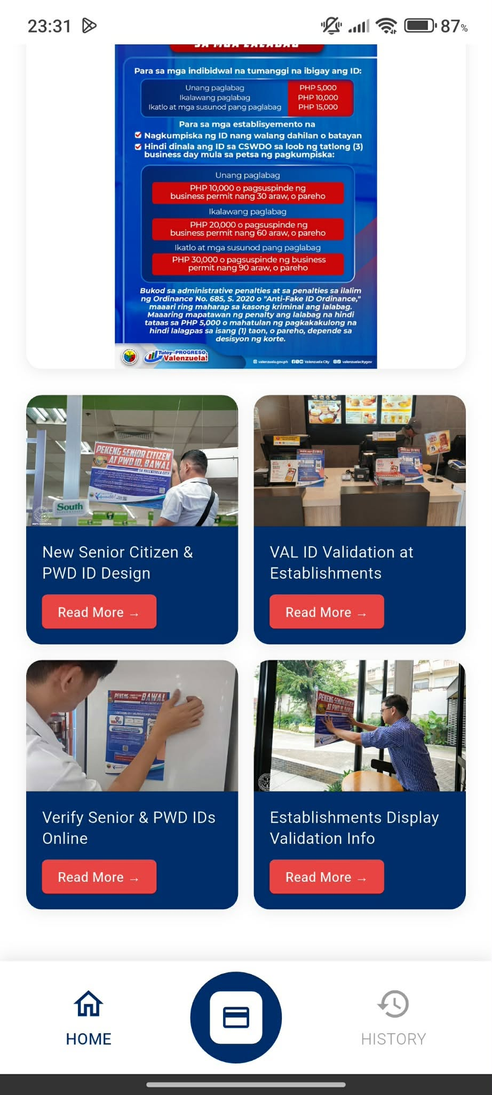
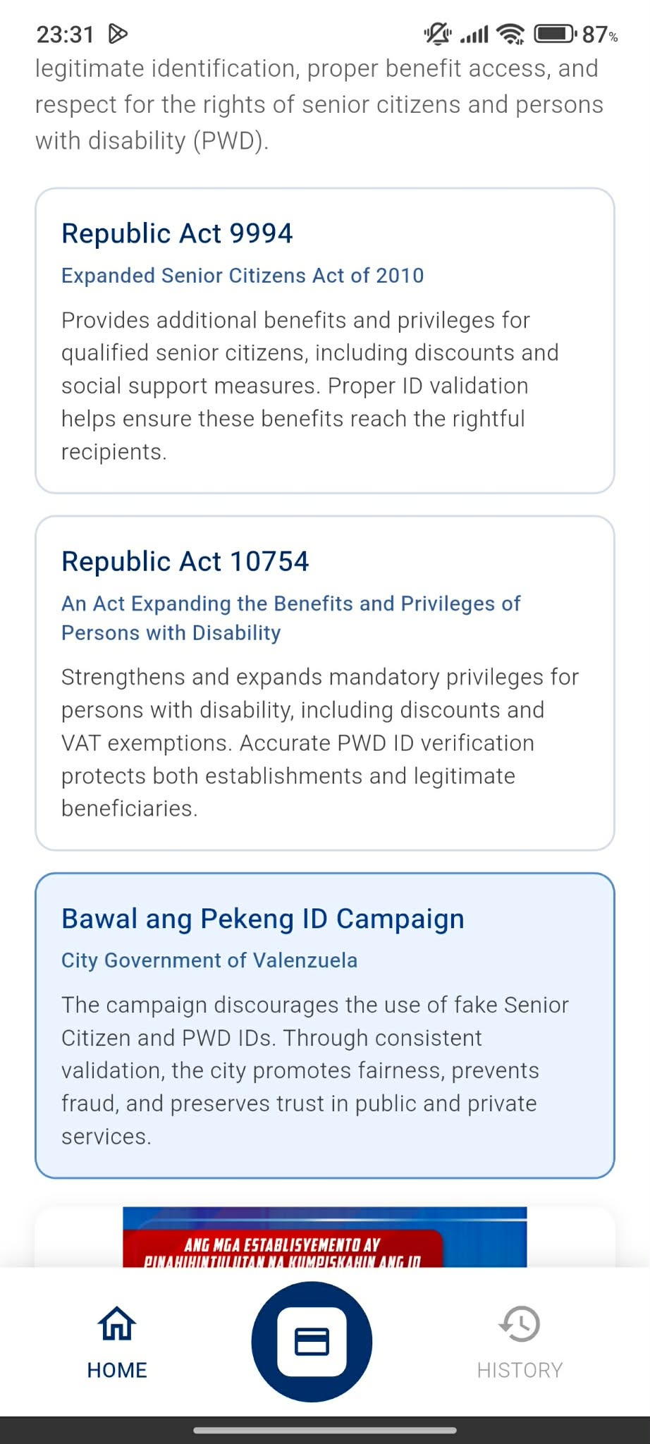
IDetect Mobile App
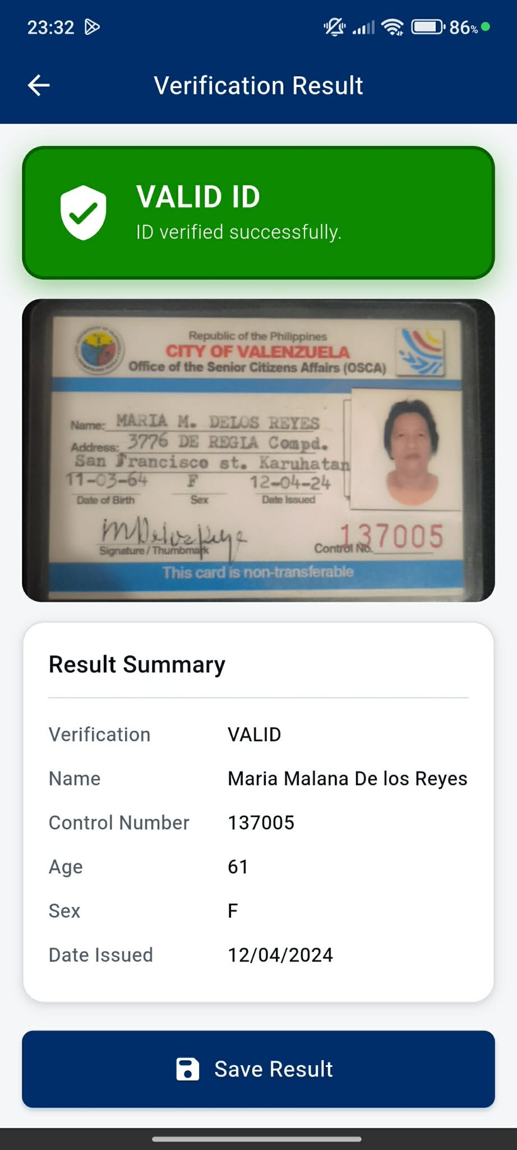
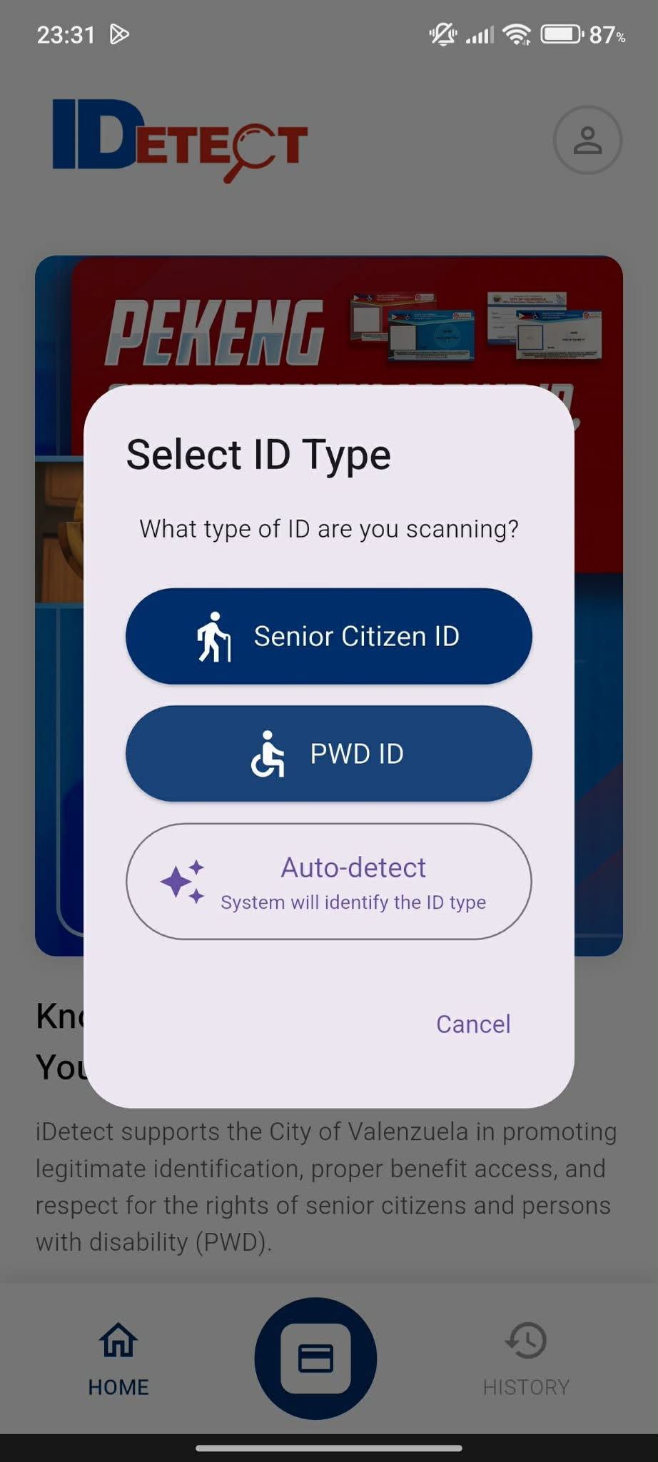
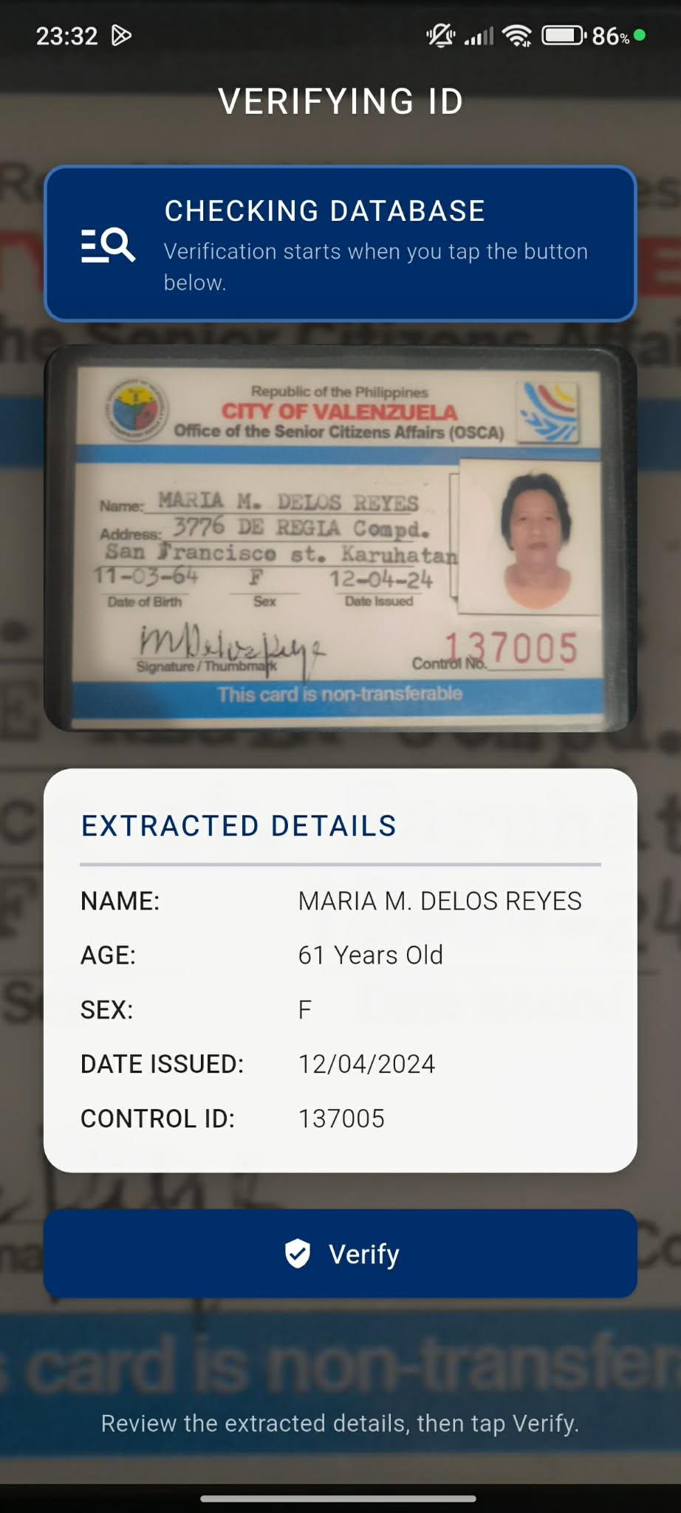
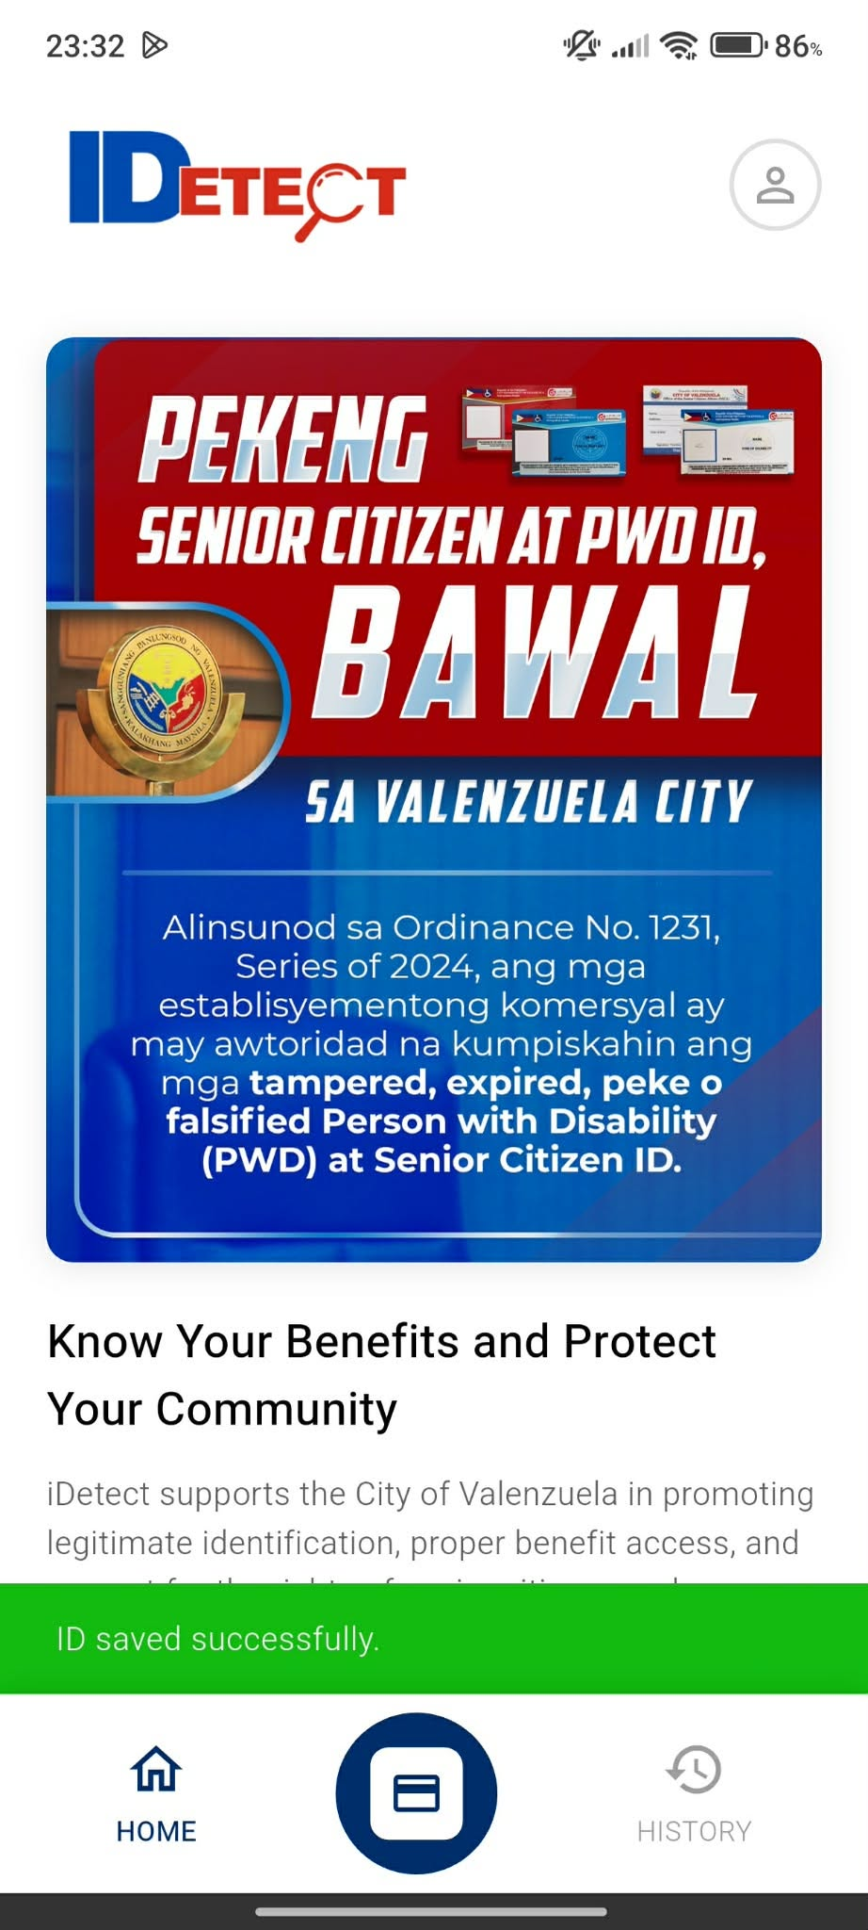
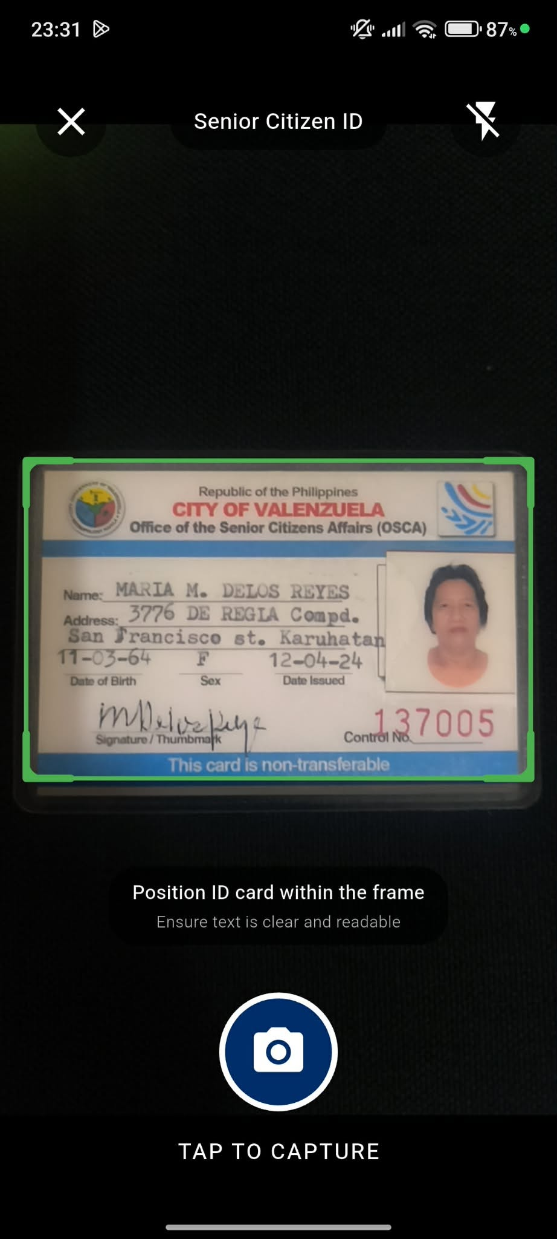
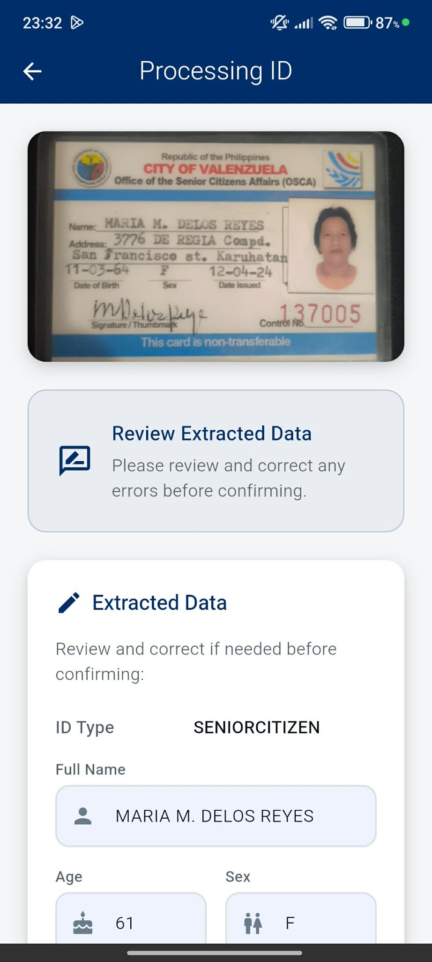
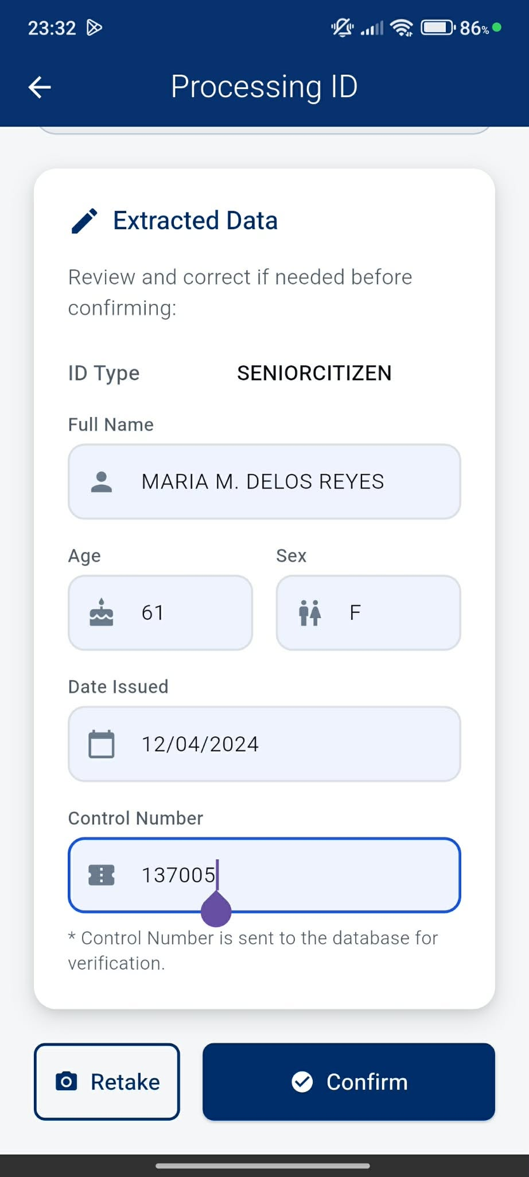

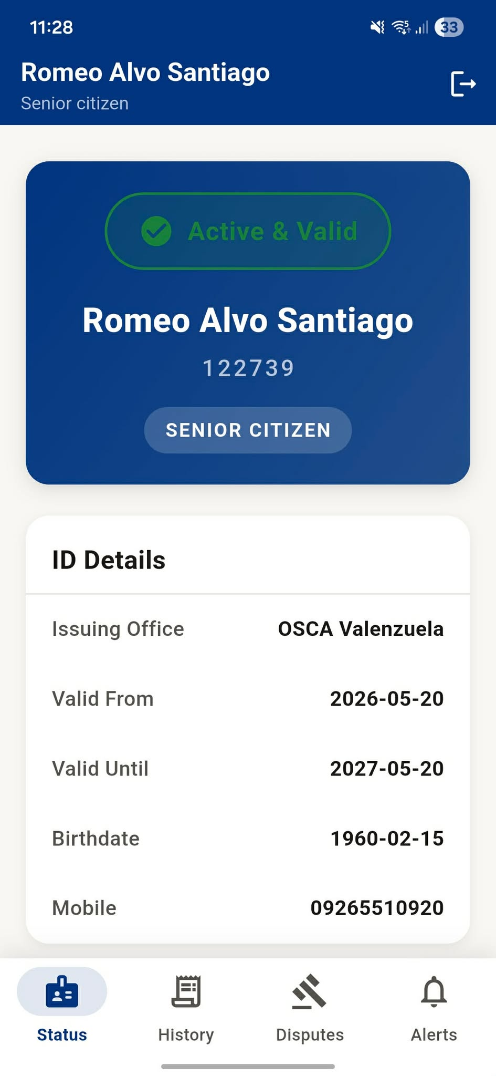
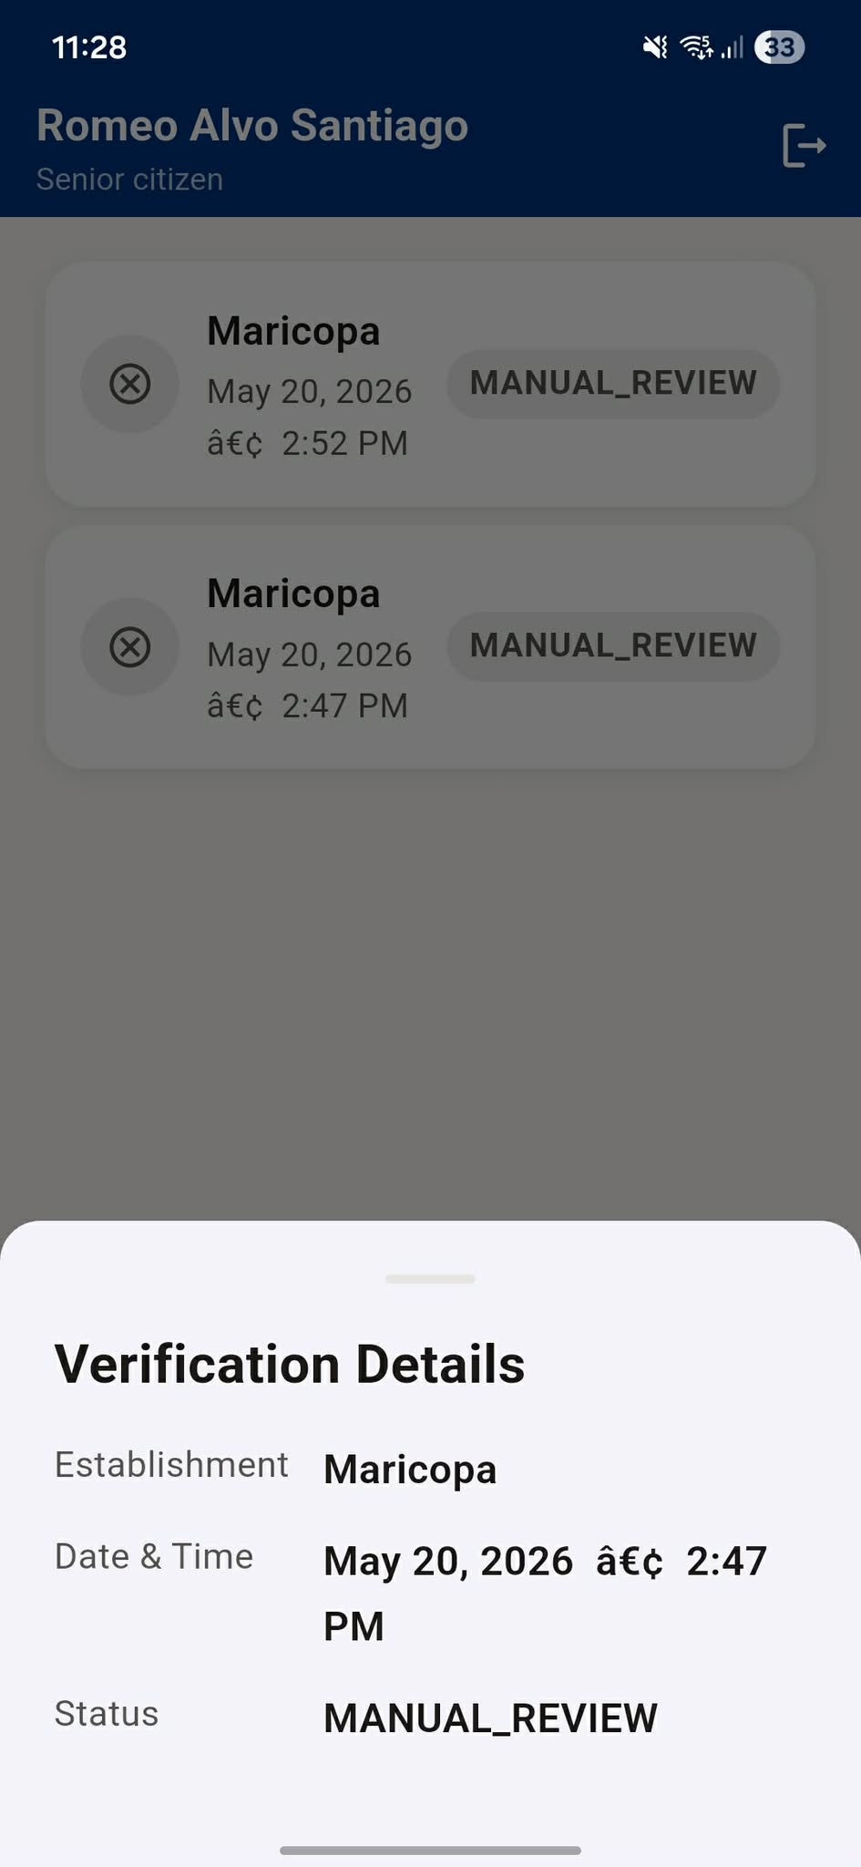
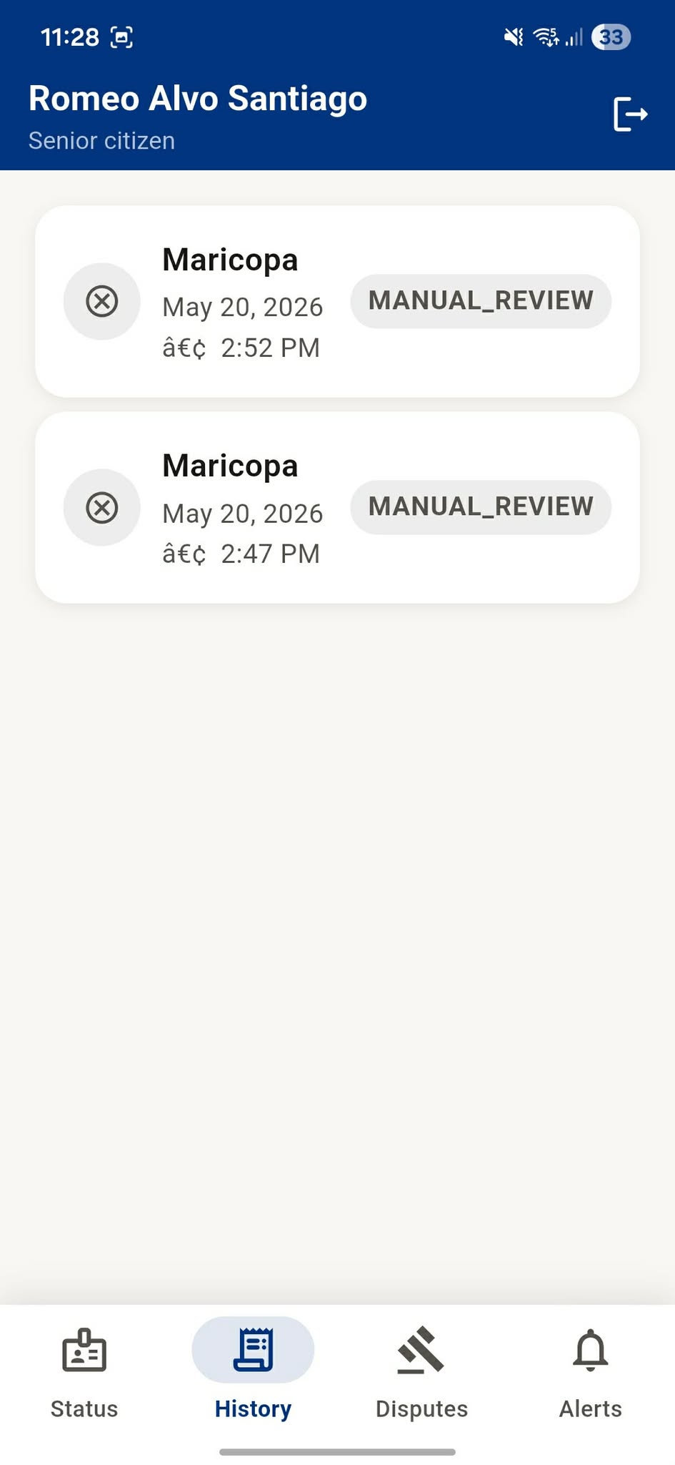
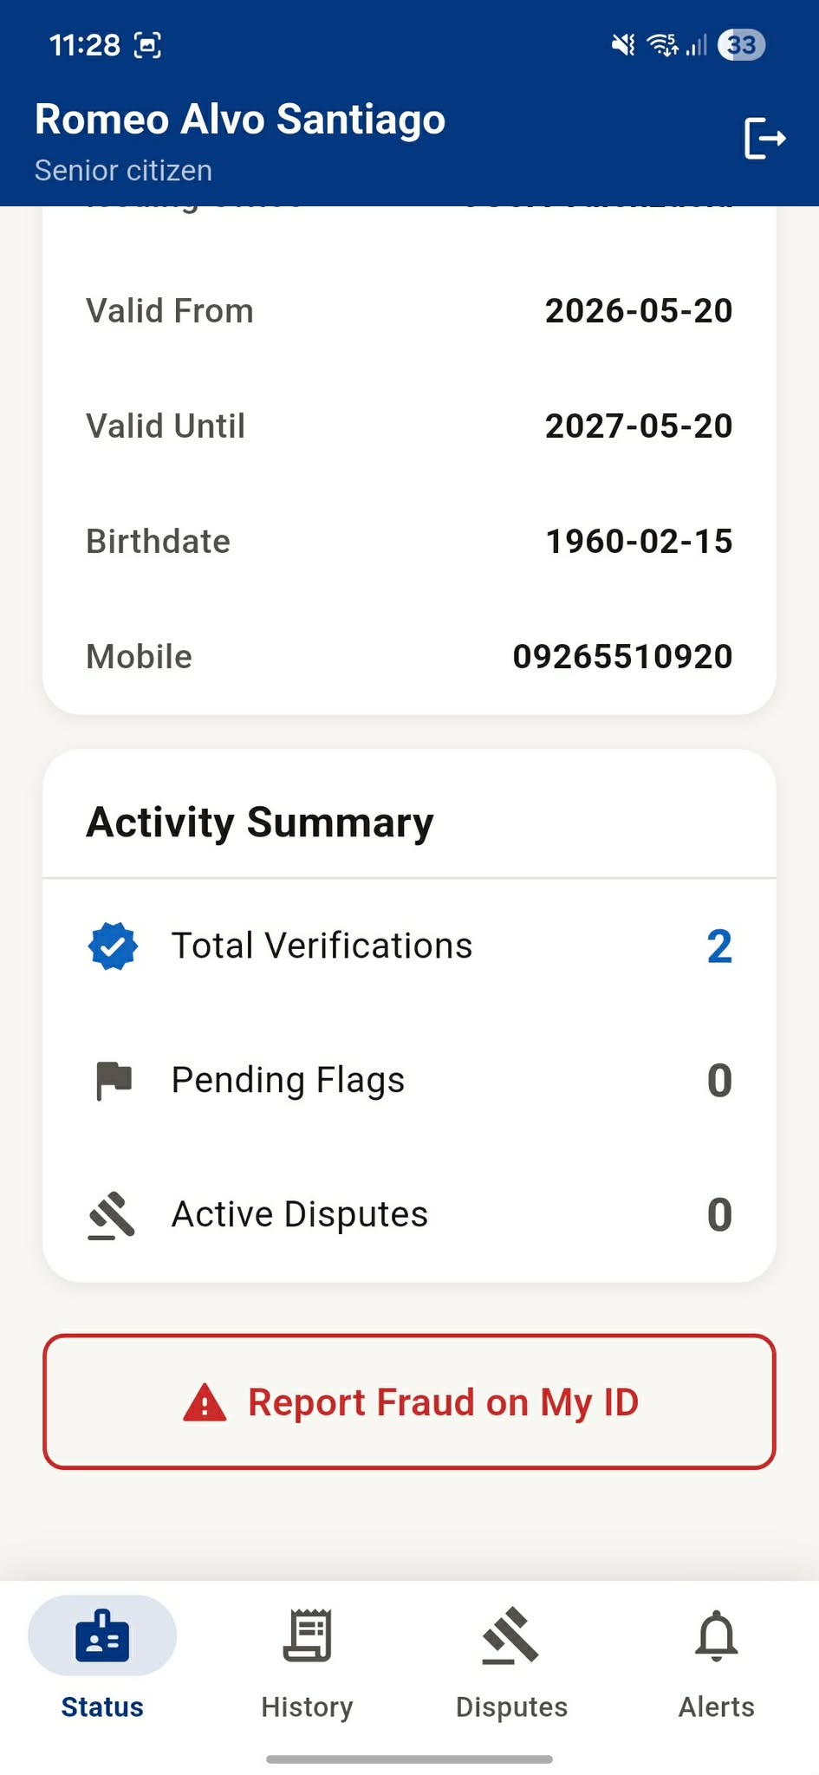

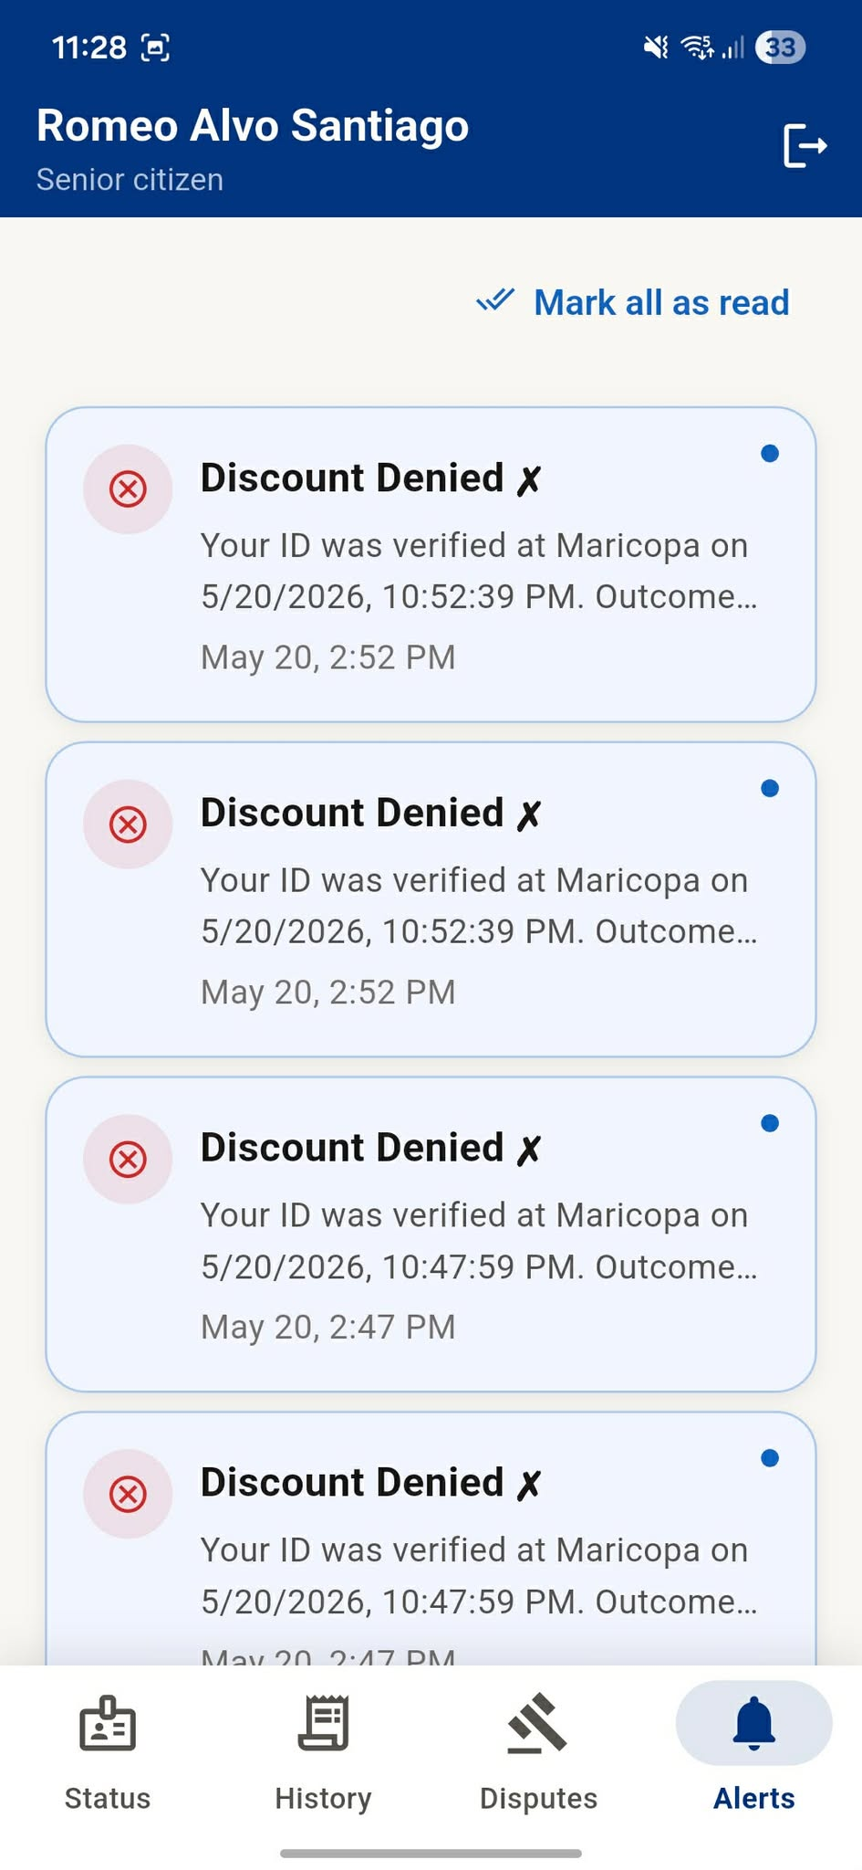
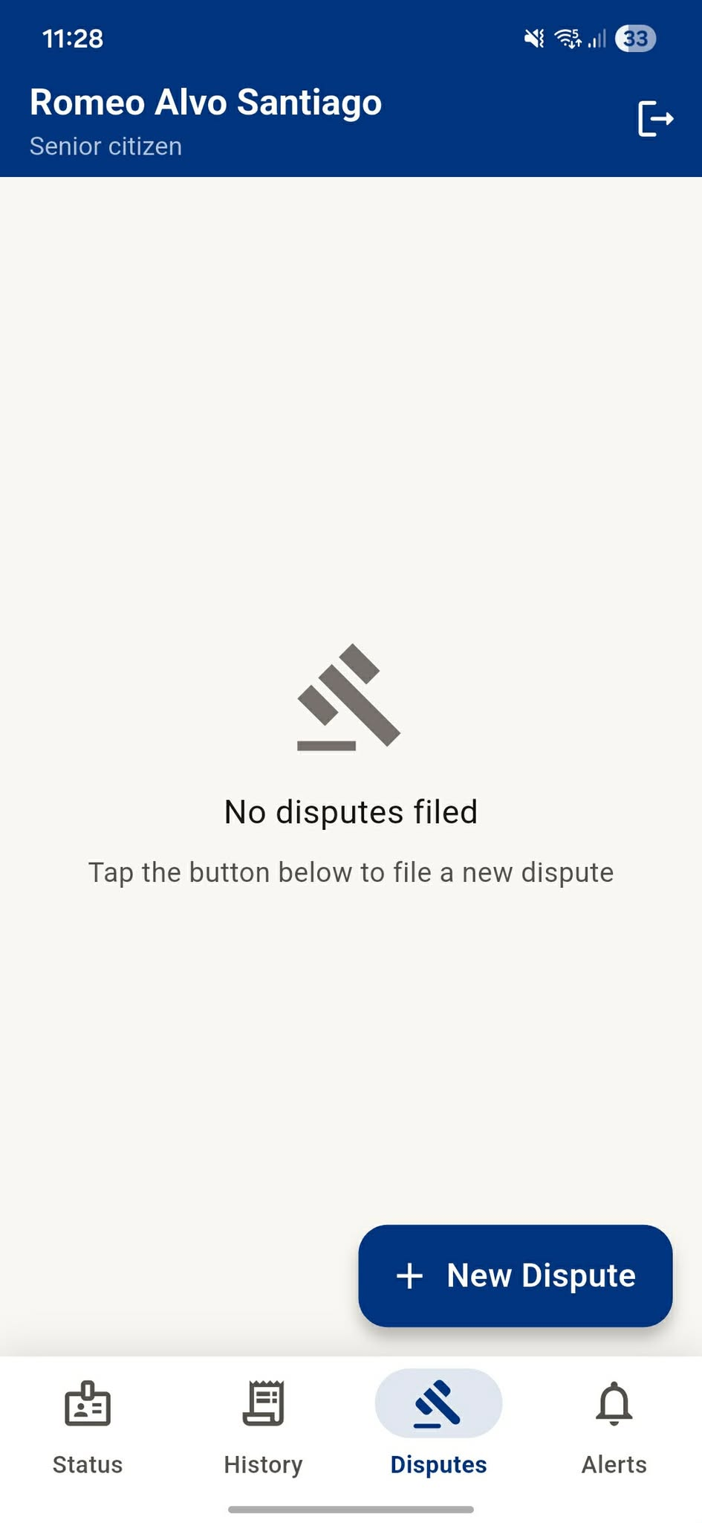

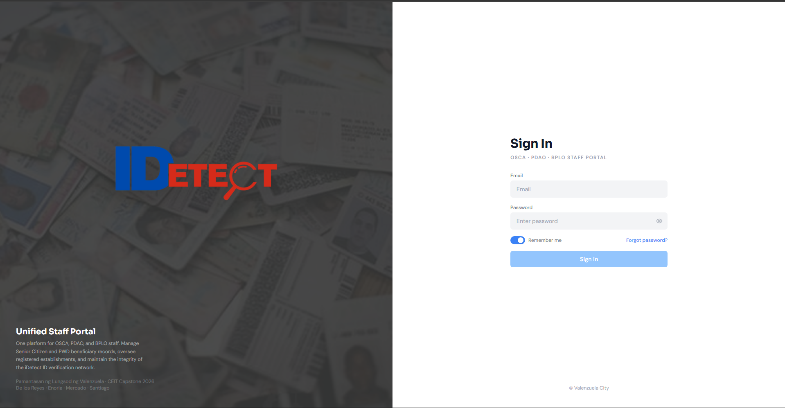
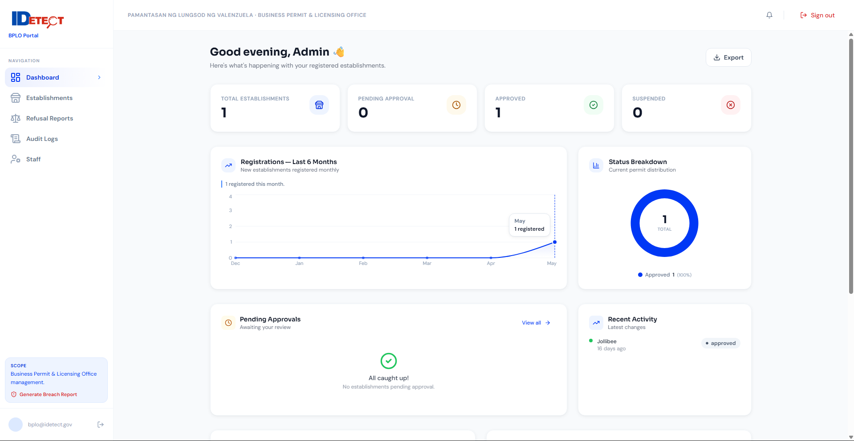
BPLO Portal
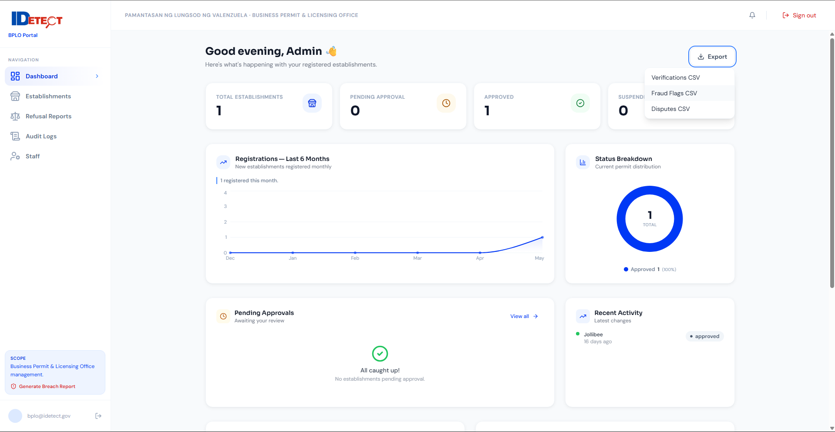
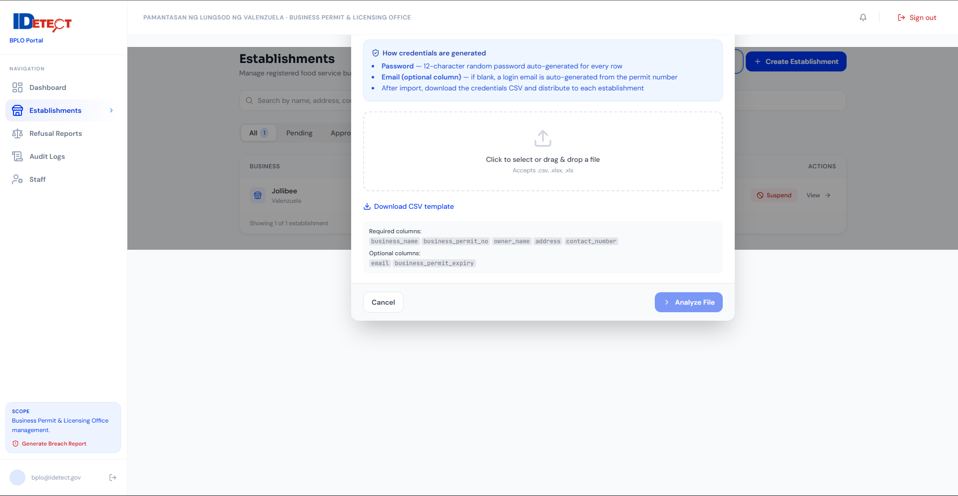
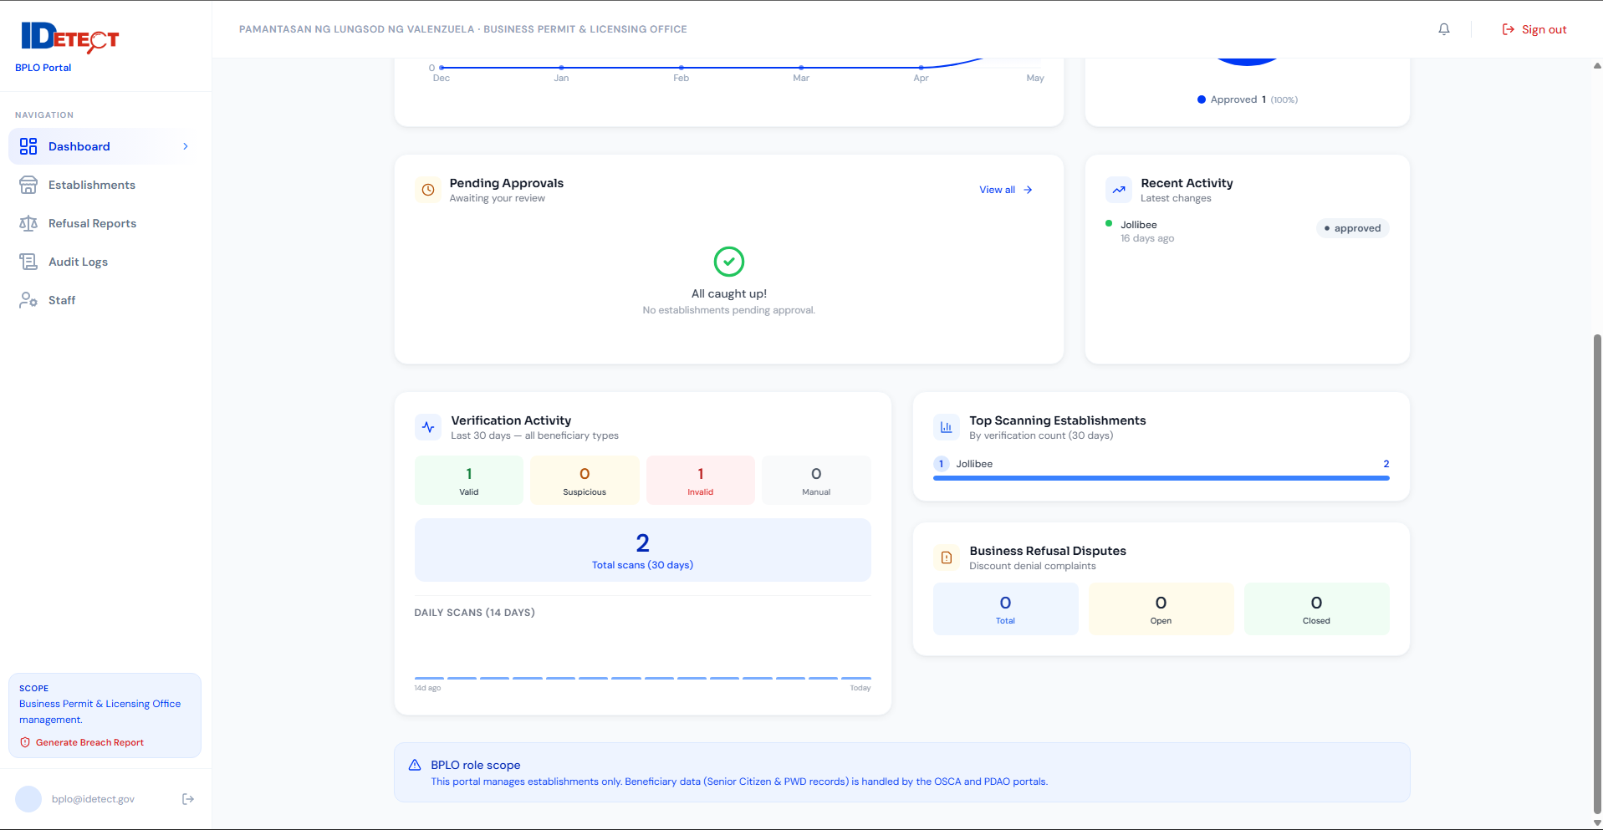
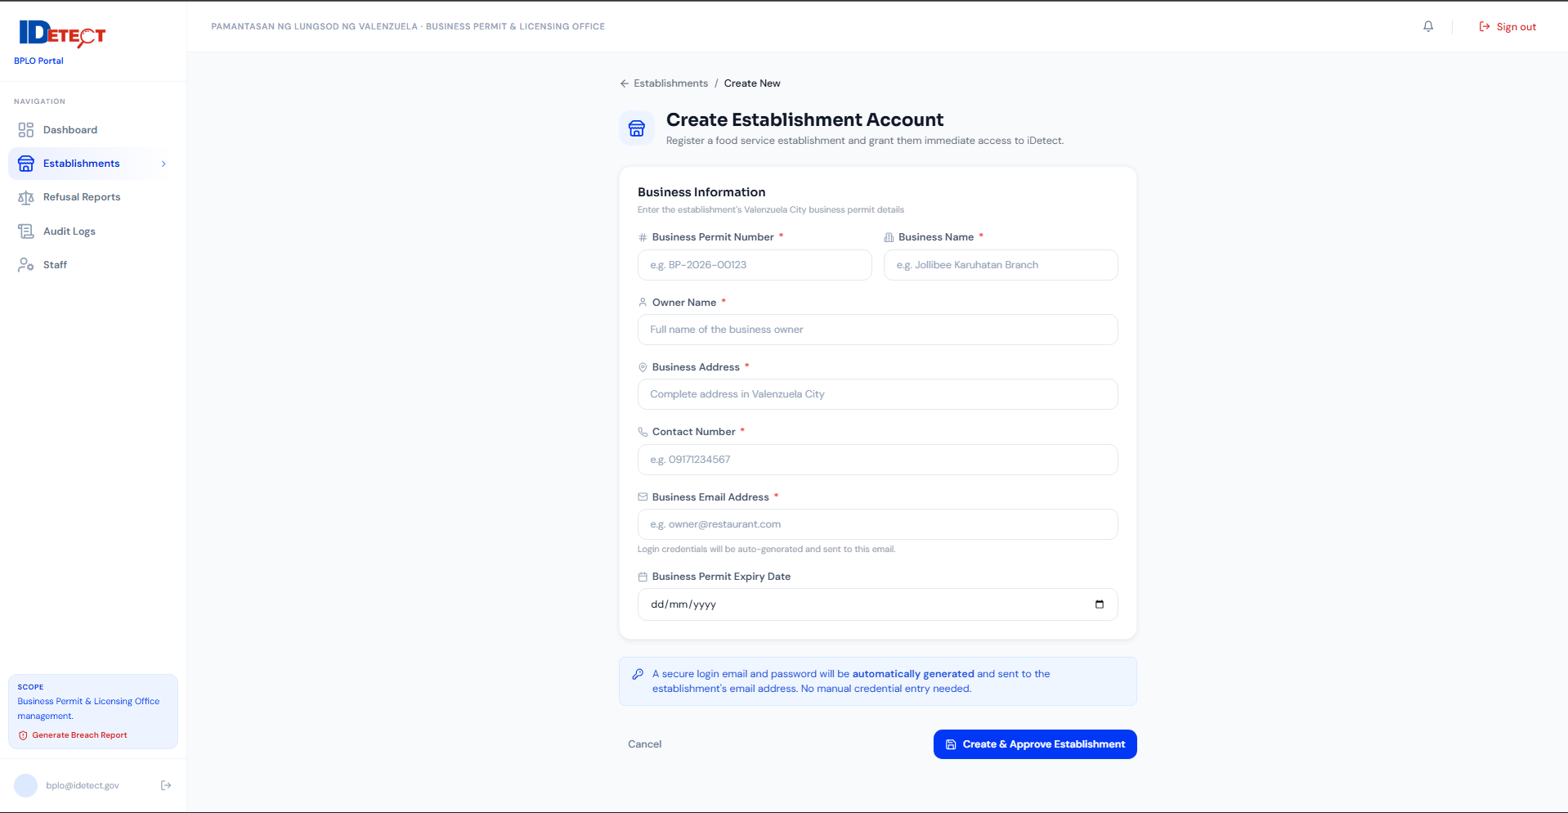
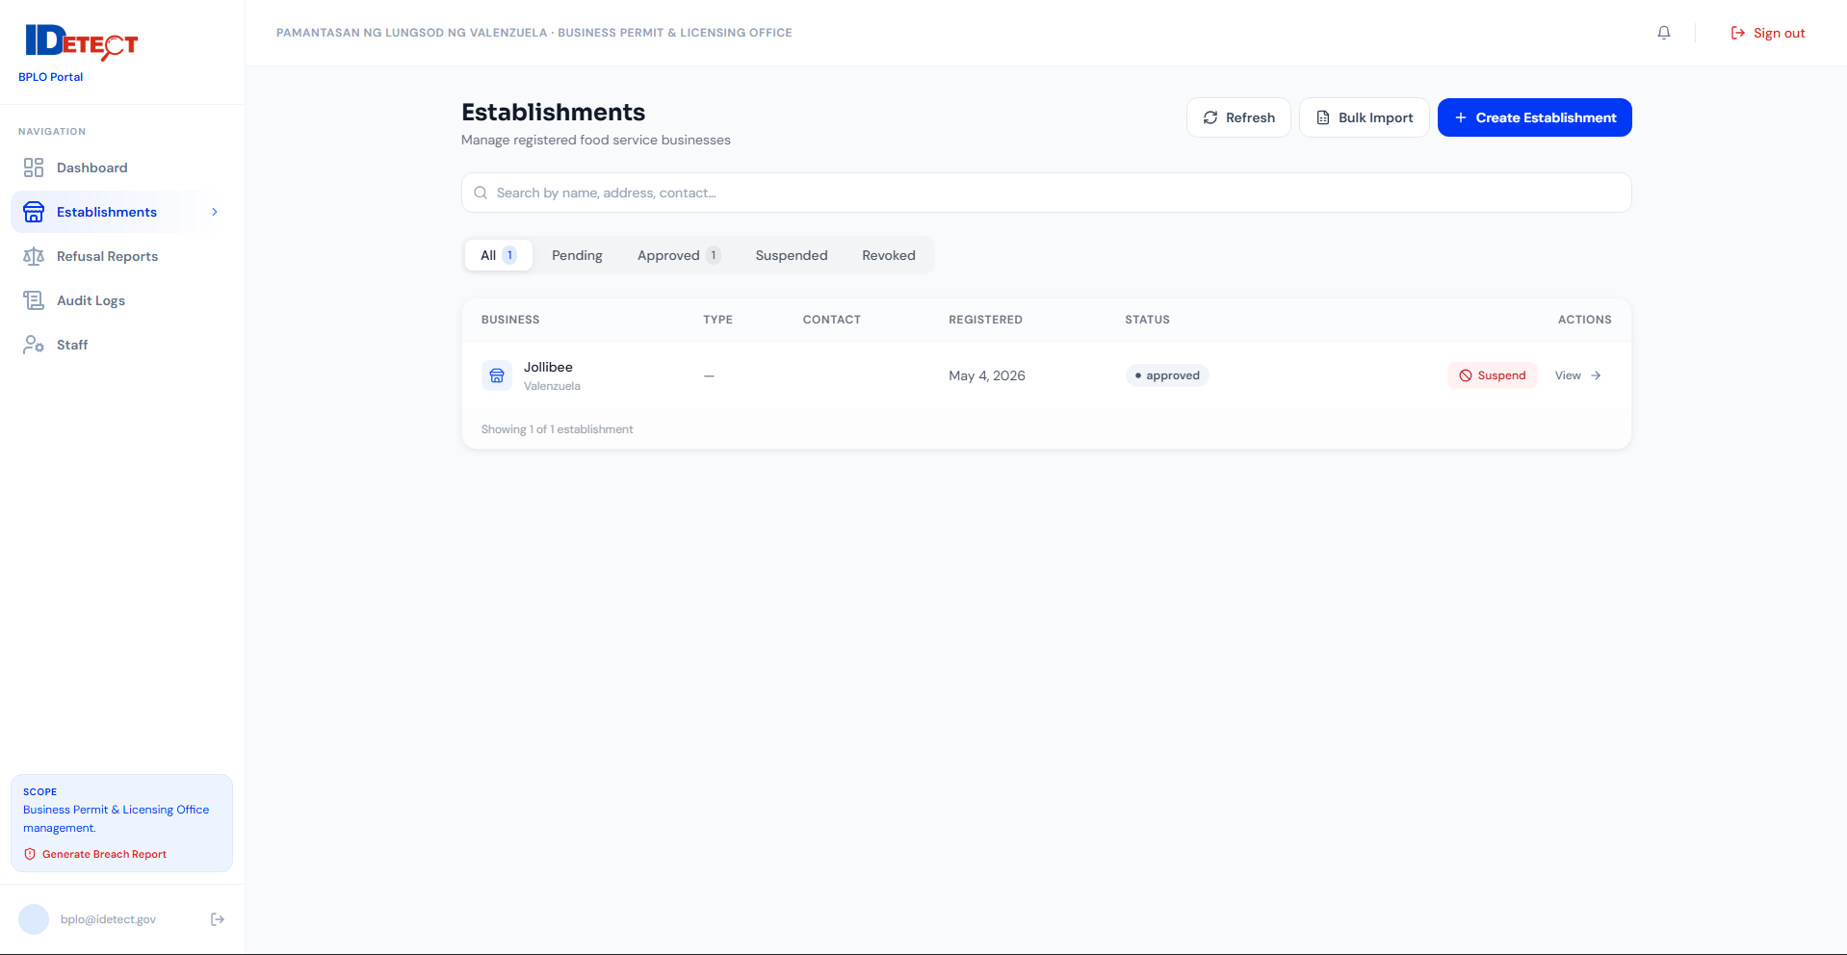
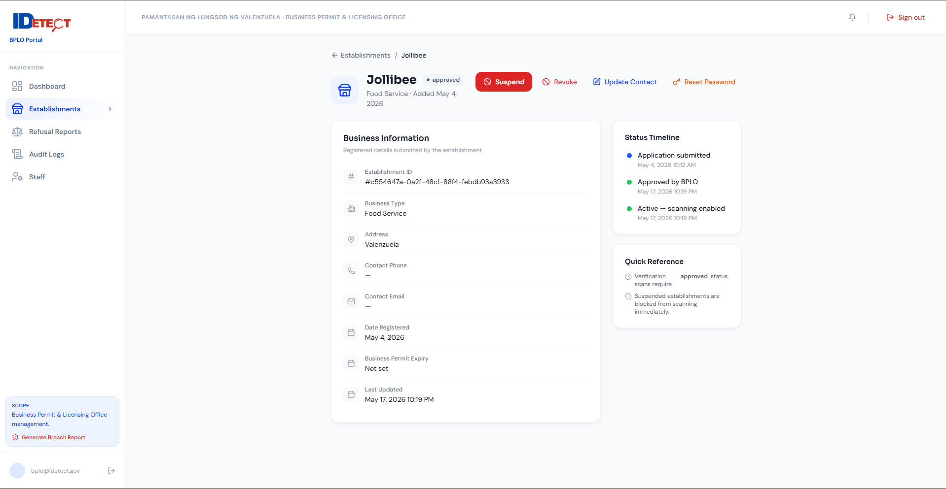
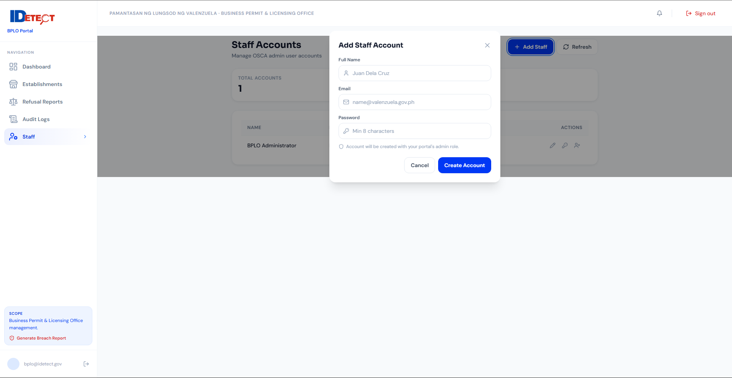
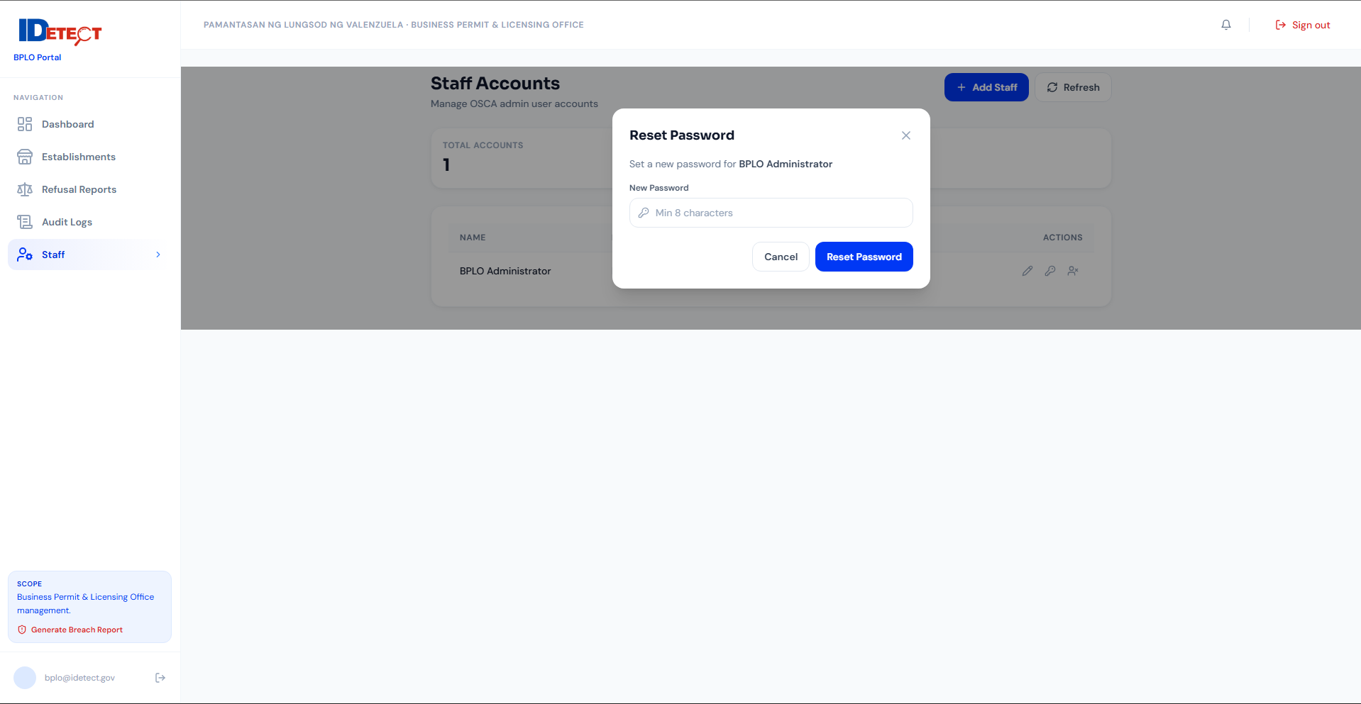
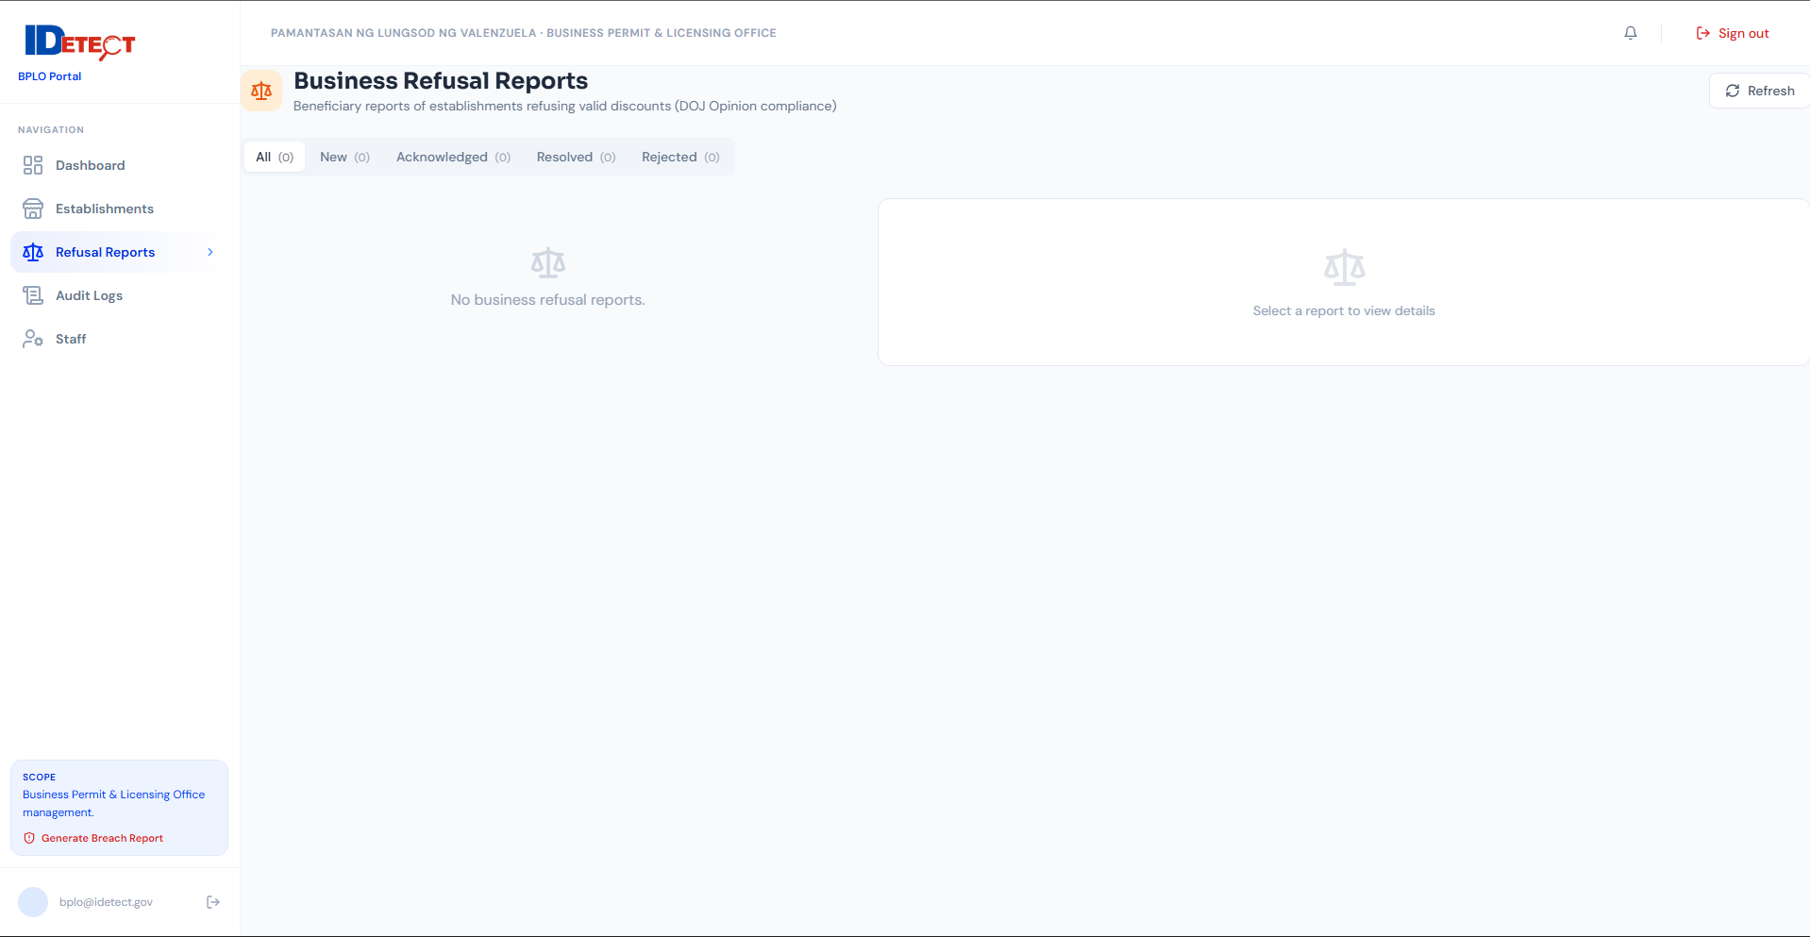
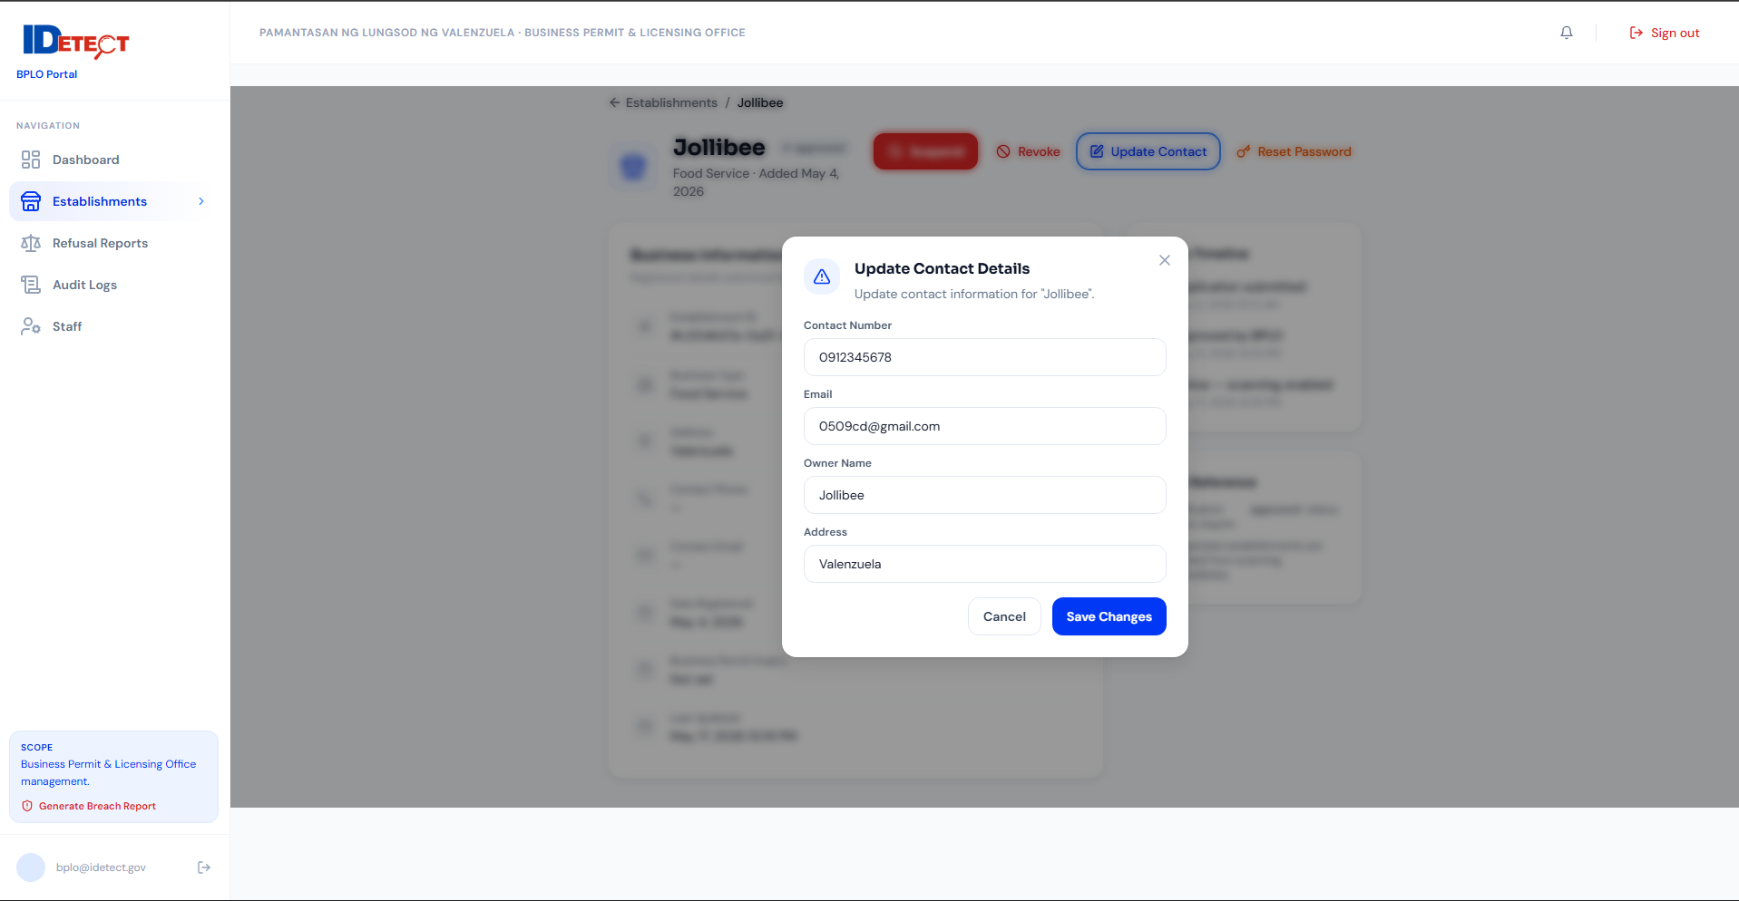
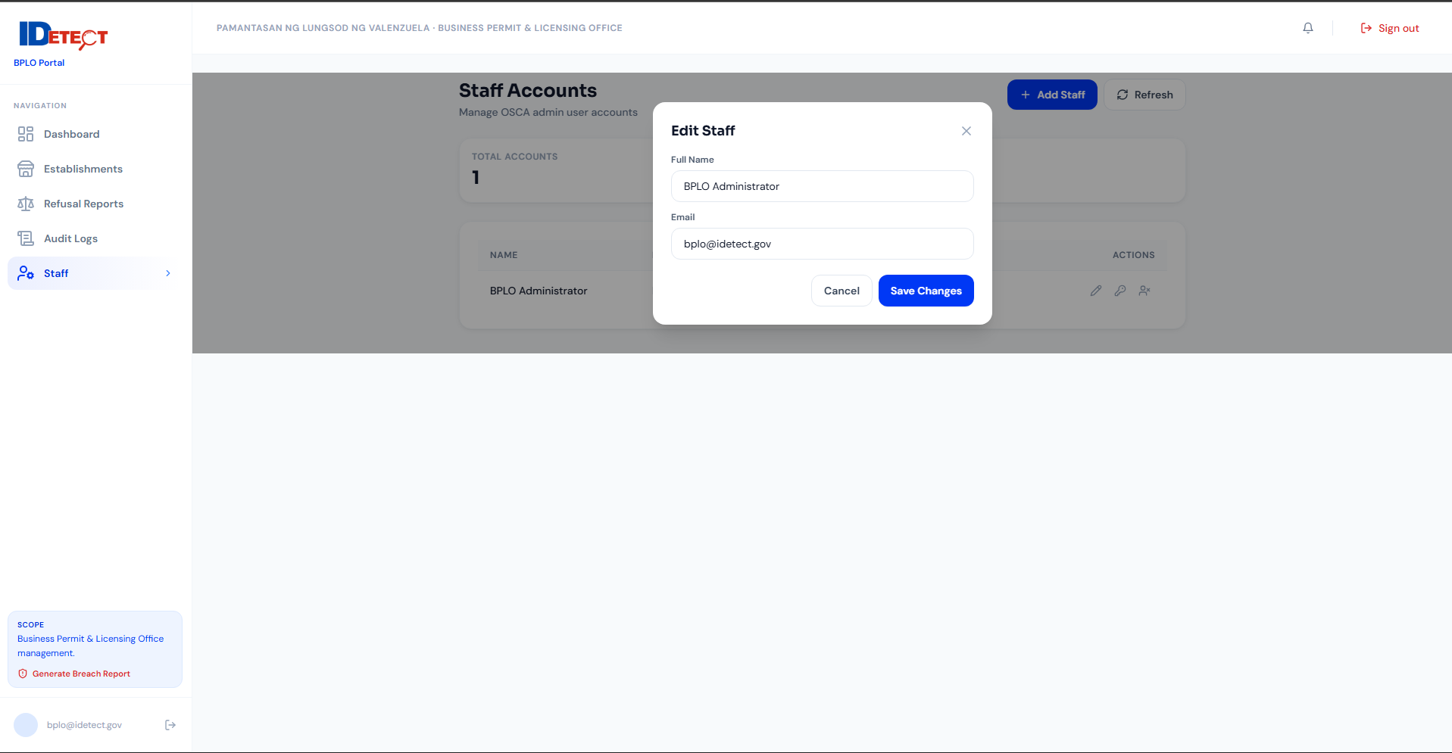
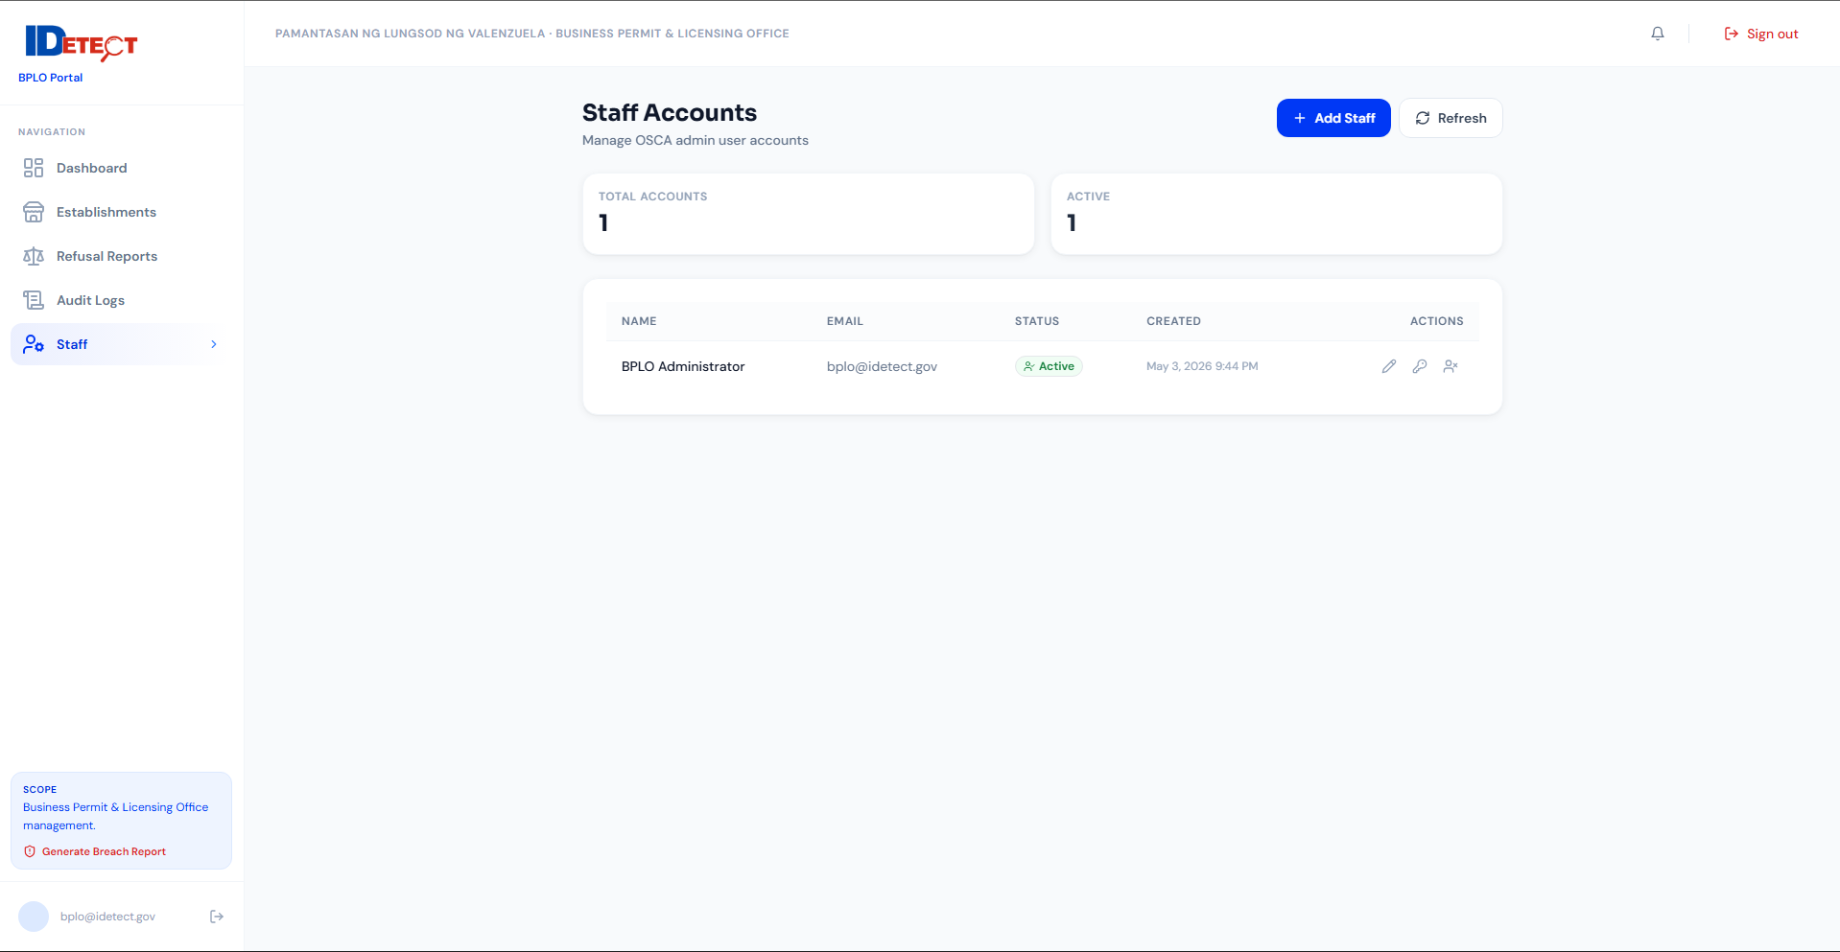
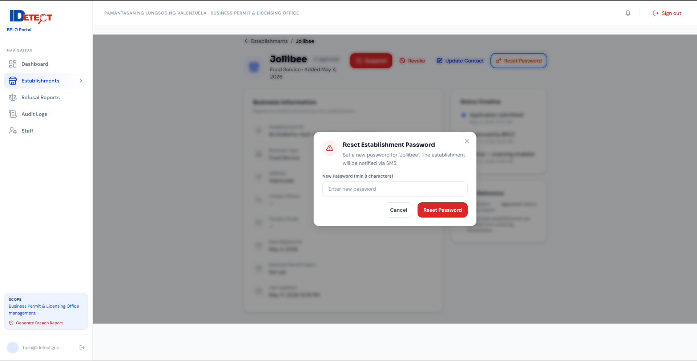
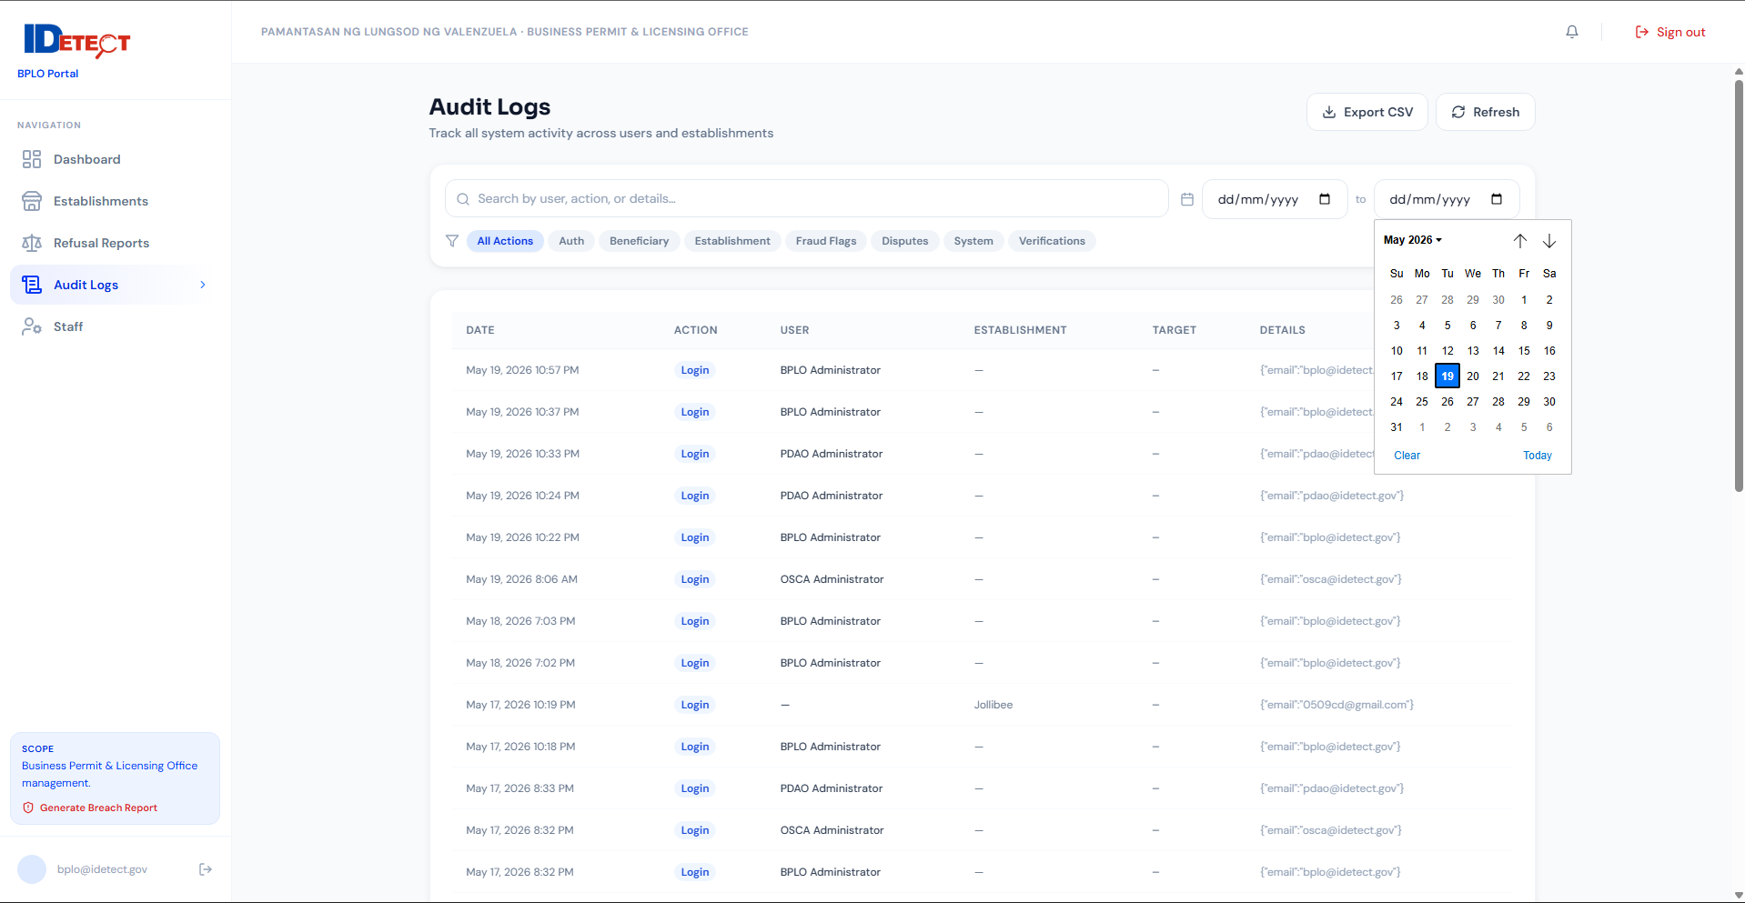

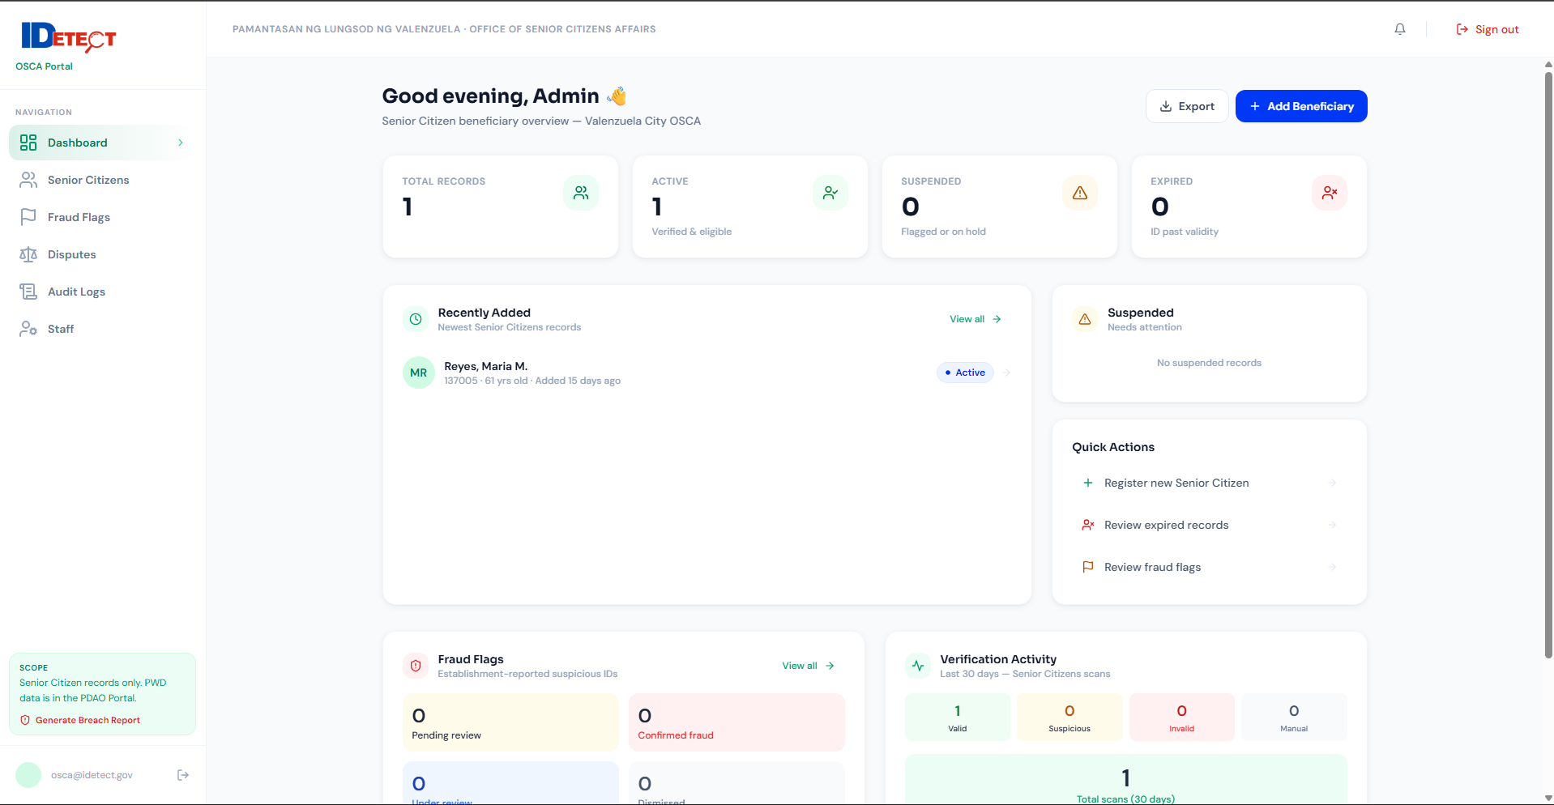
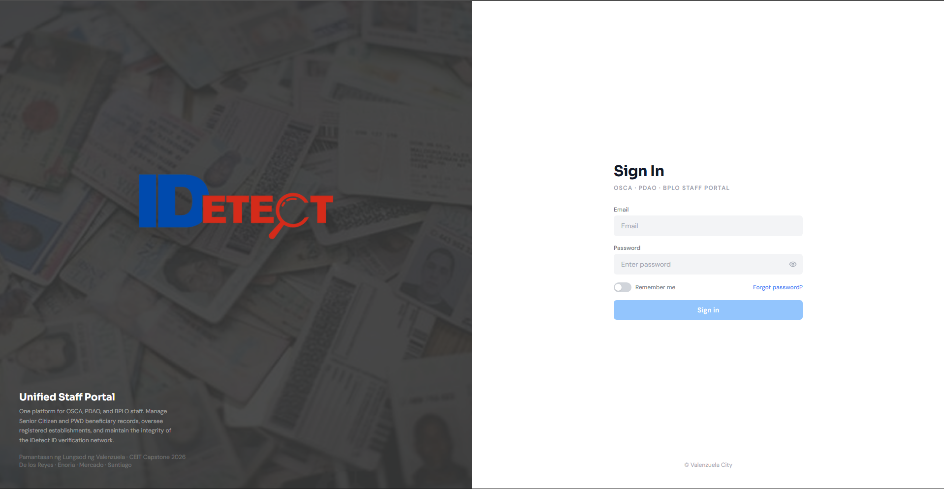
OSCA Portal
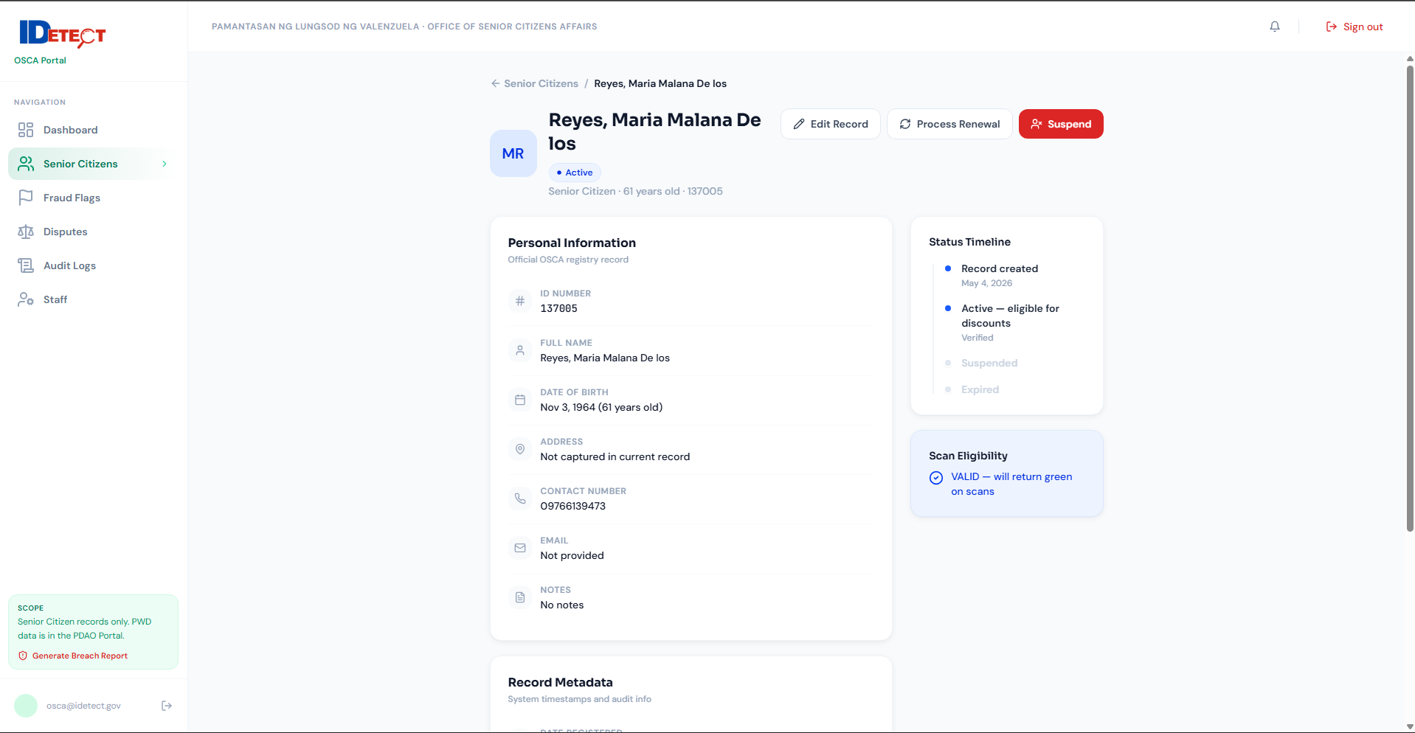
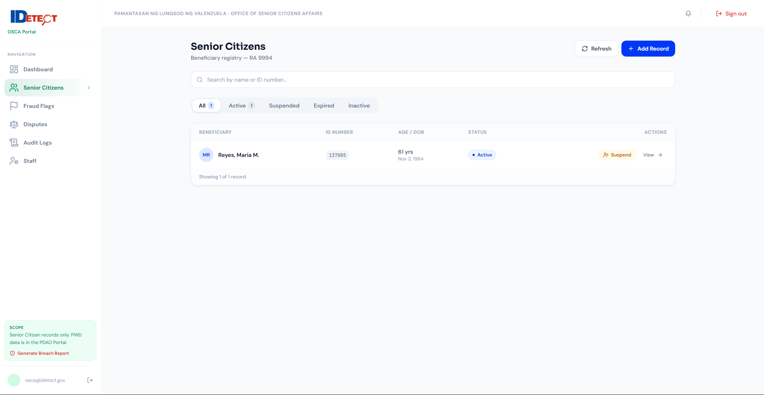
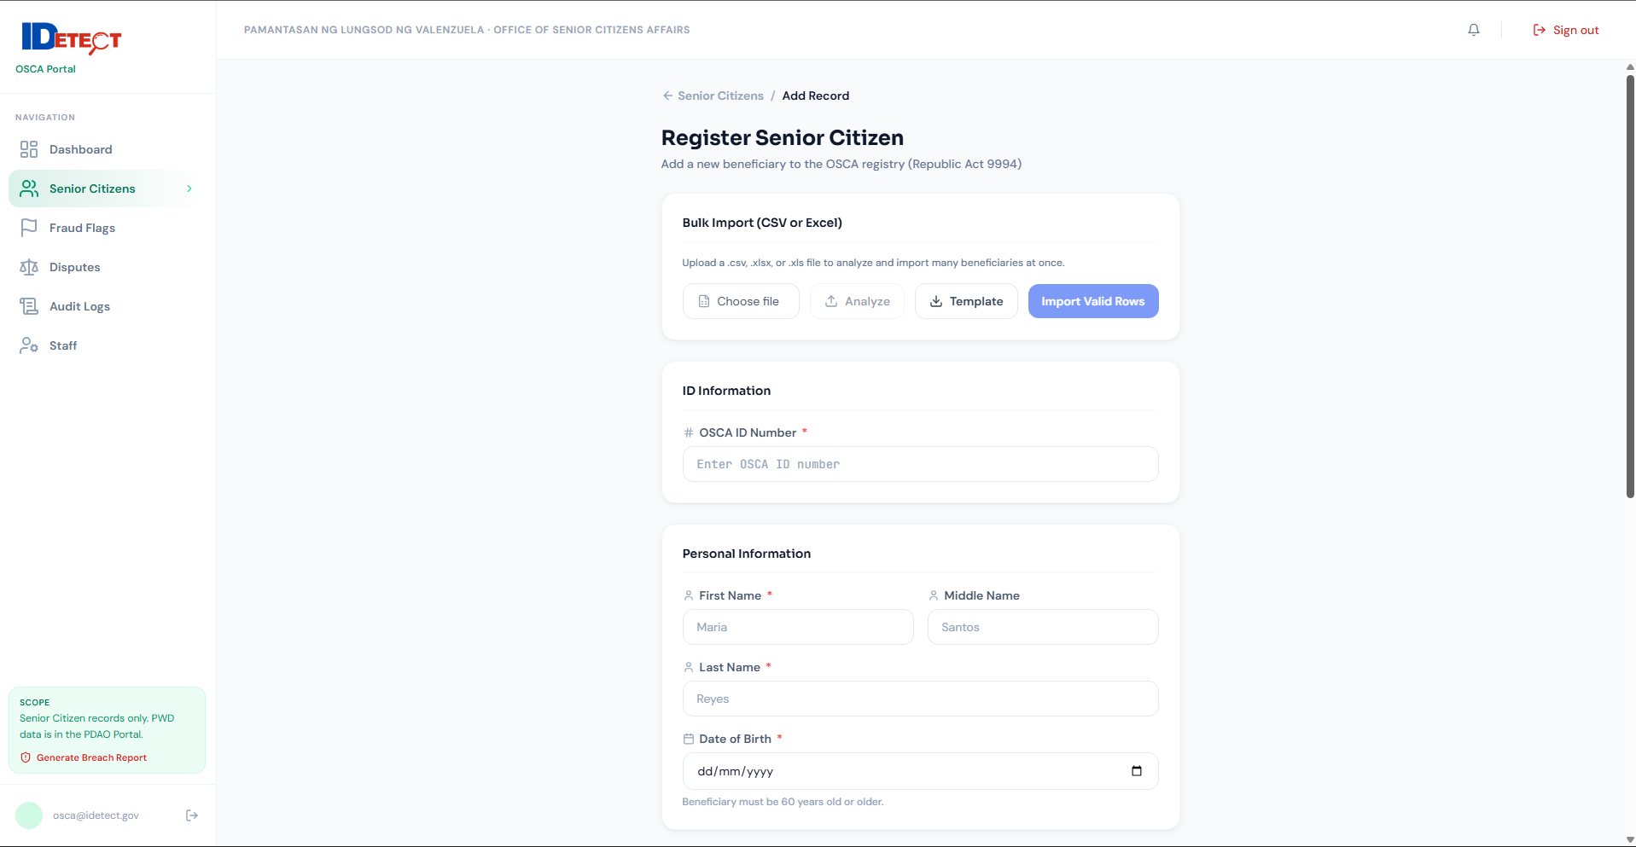
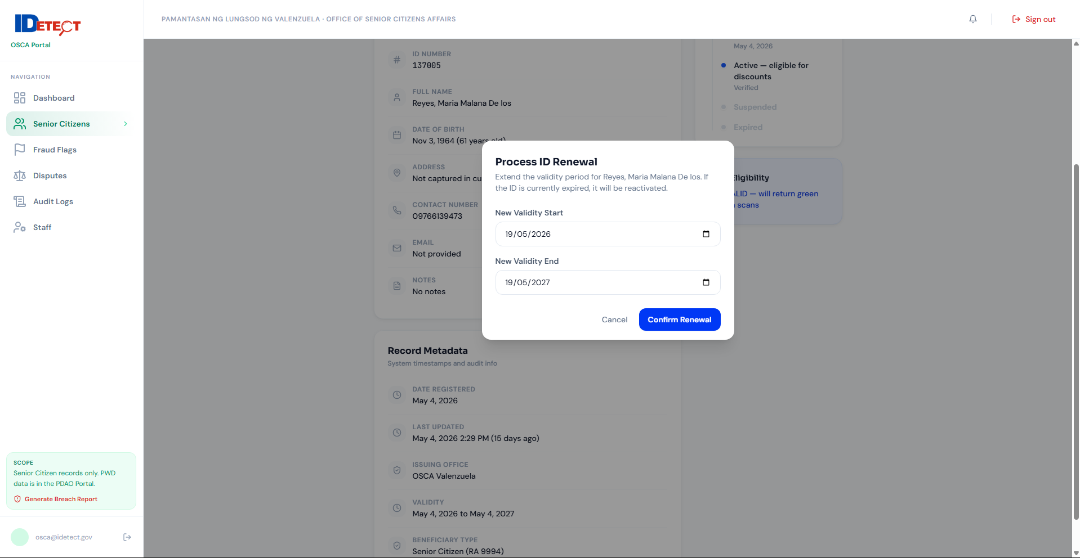
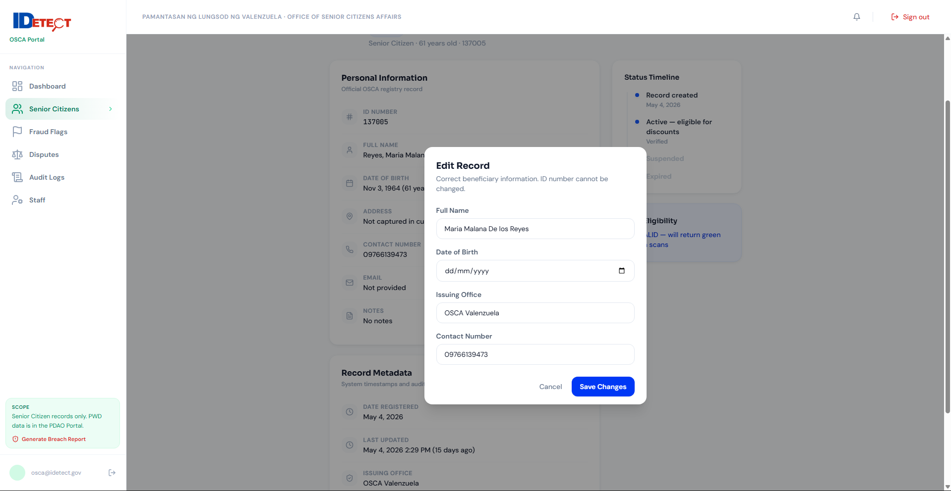
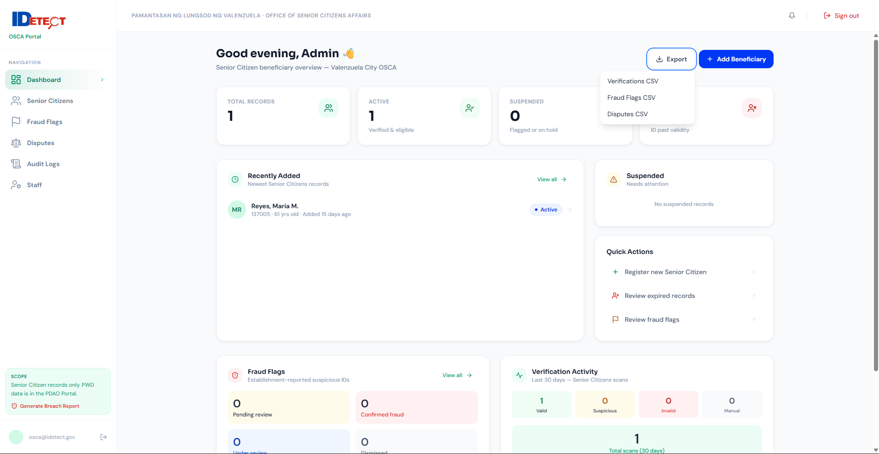

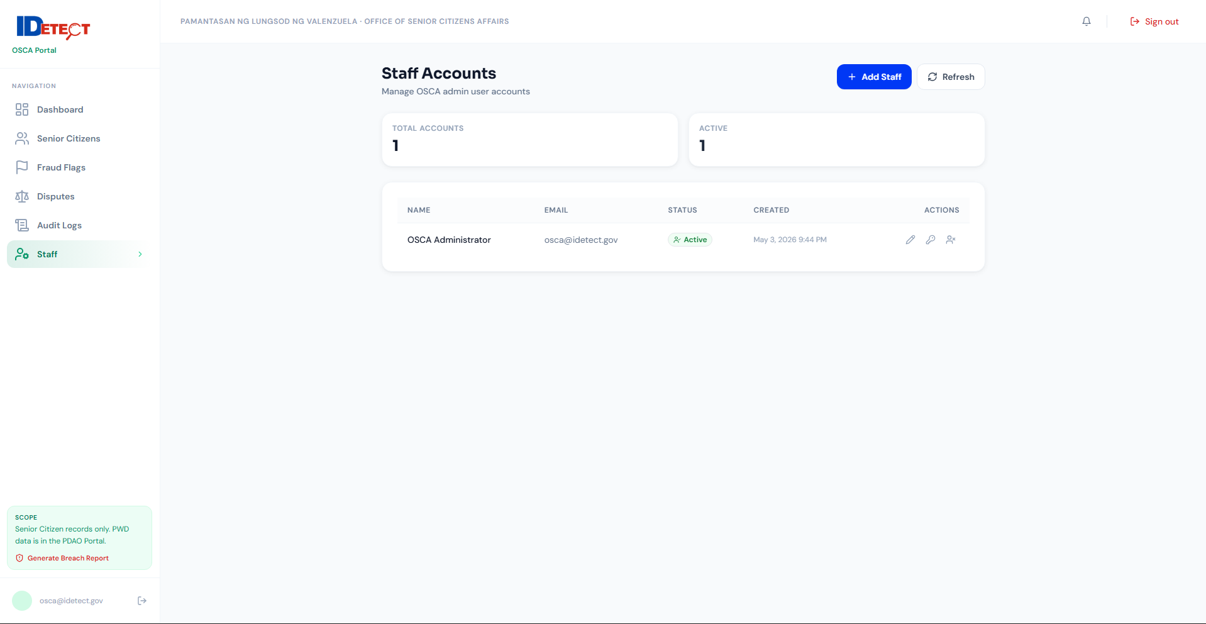
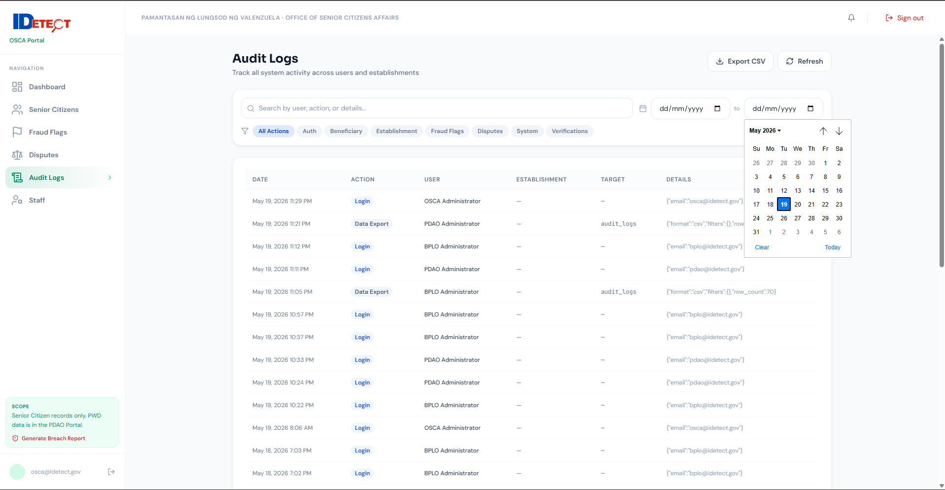
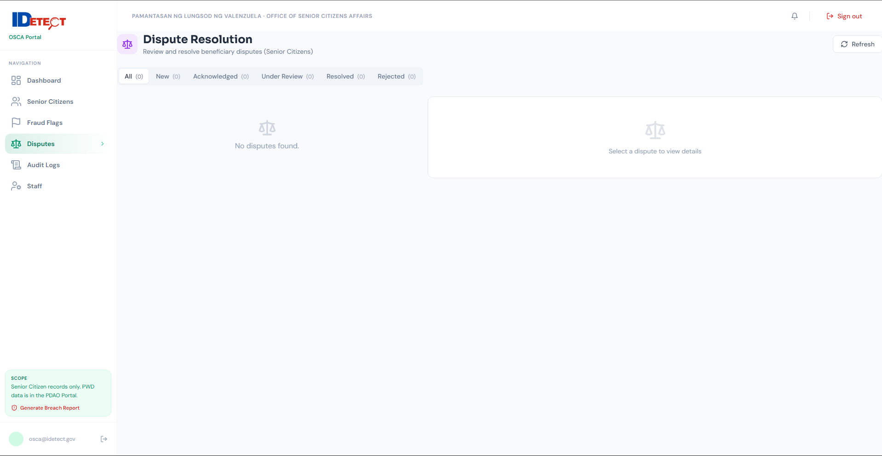
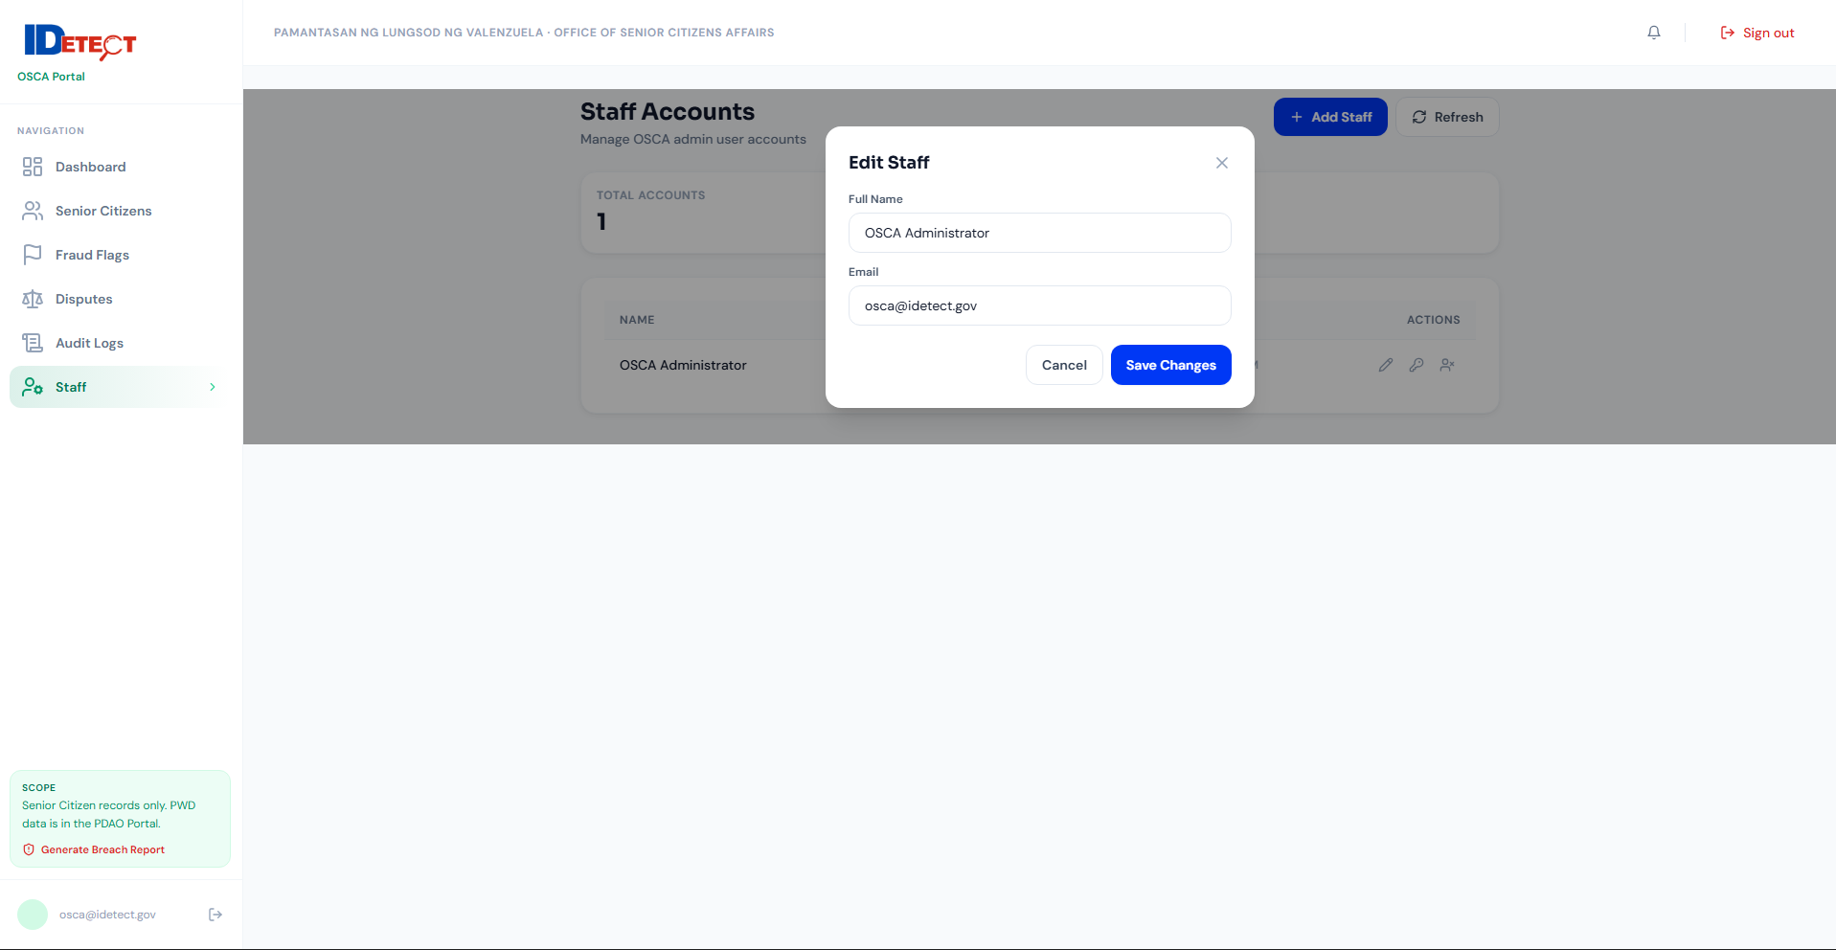
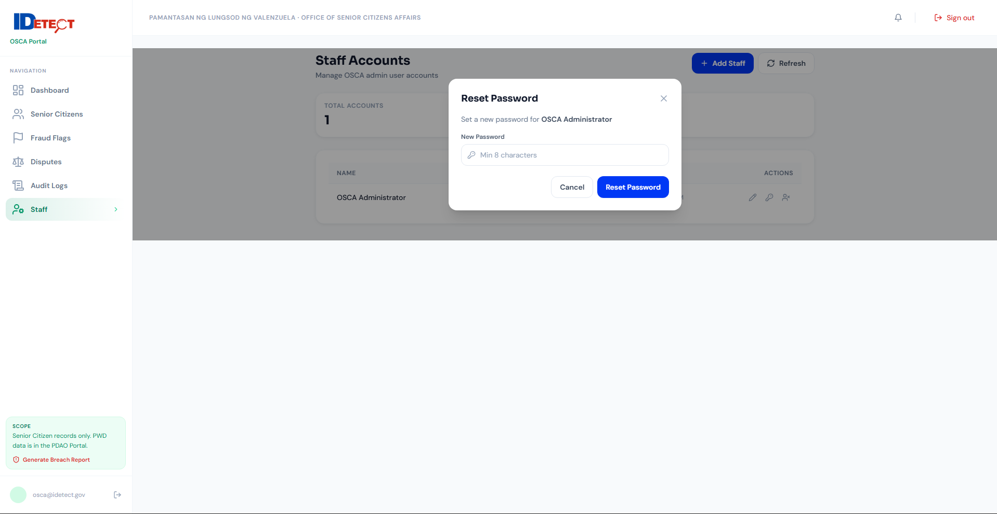
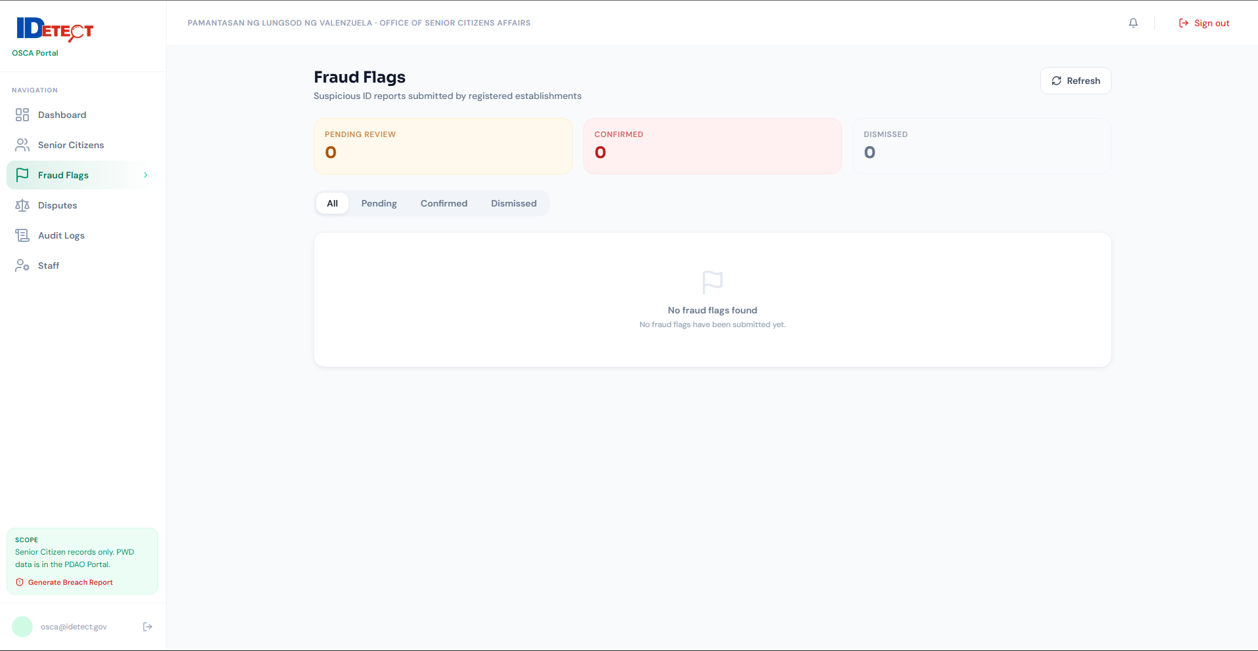
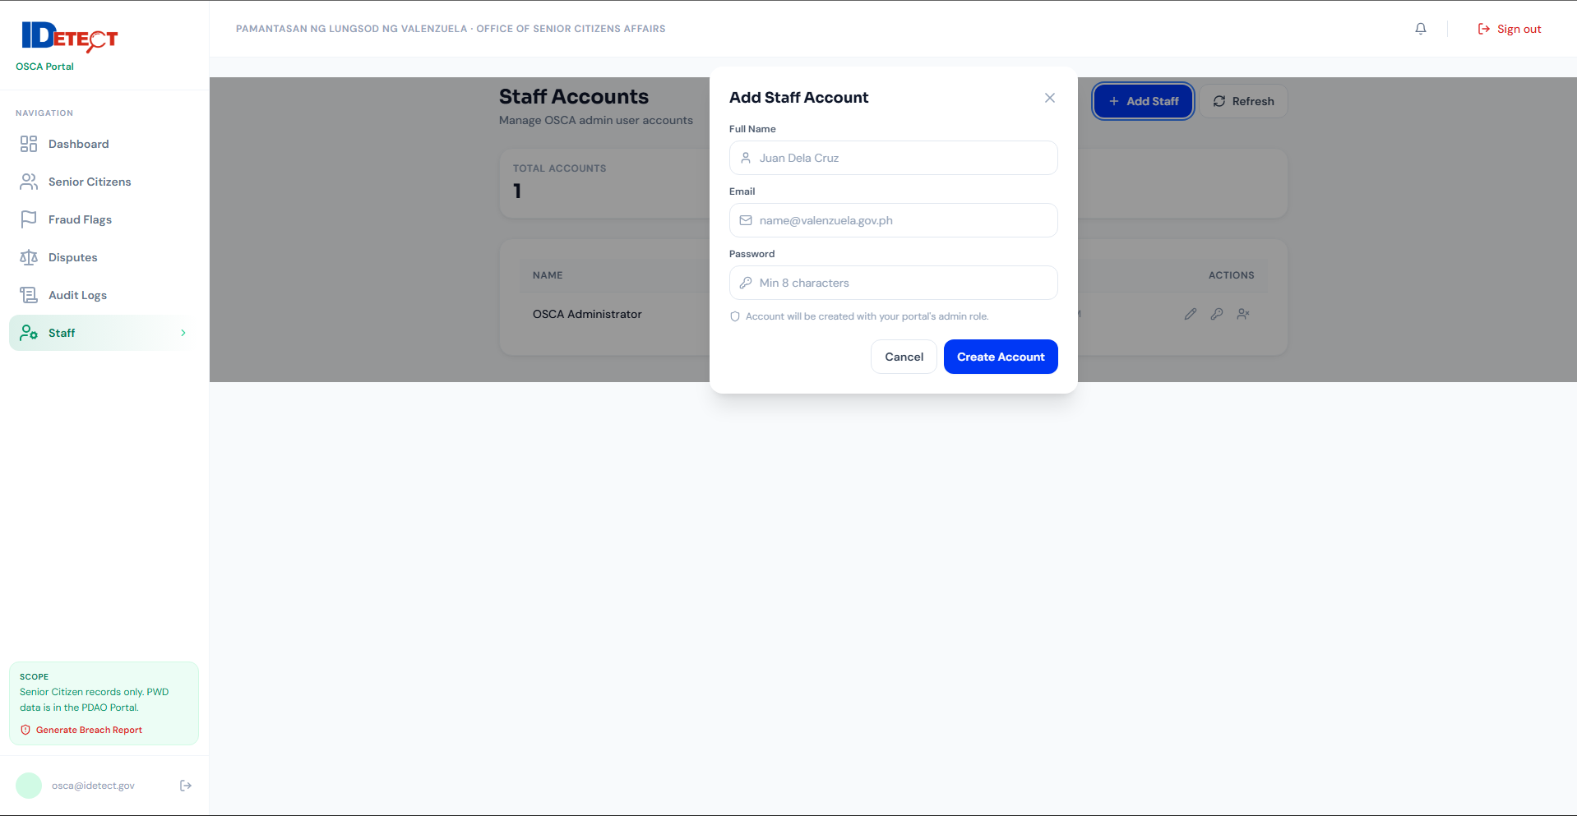

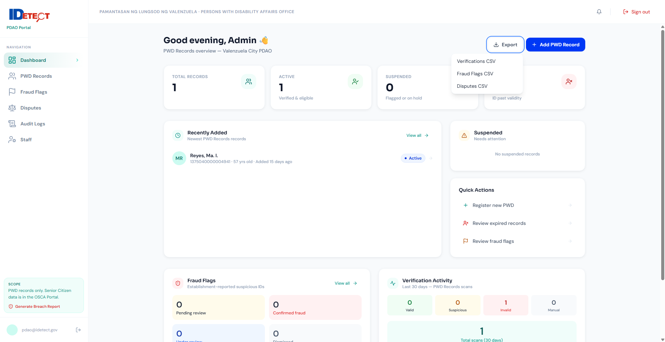
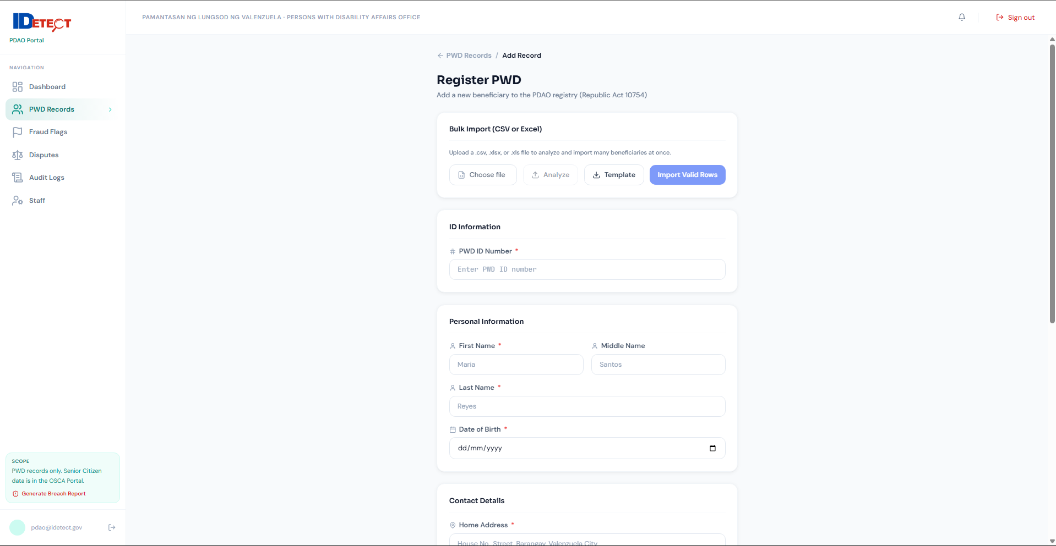
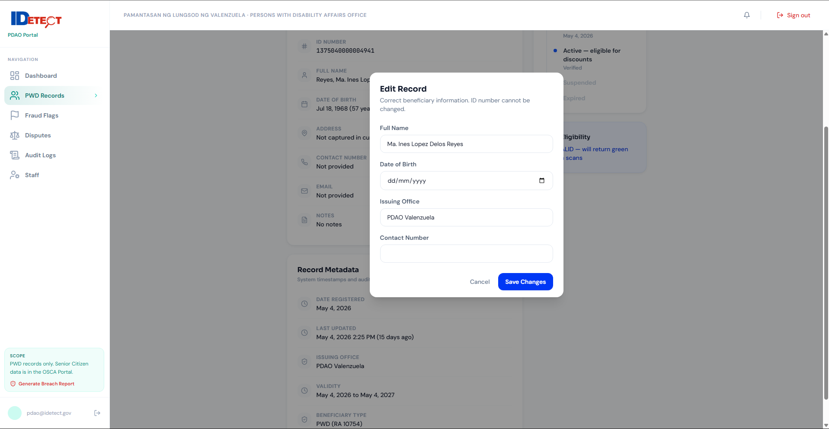
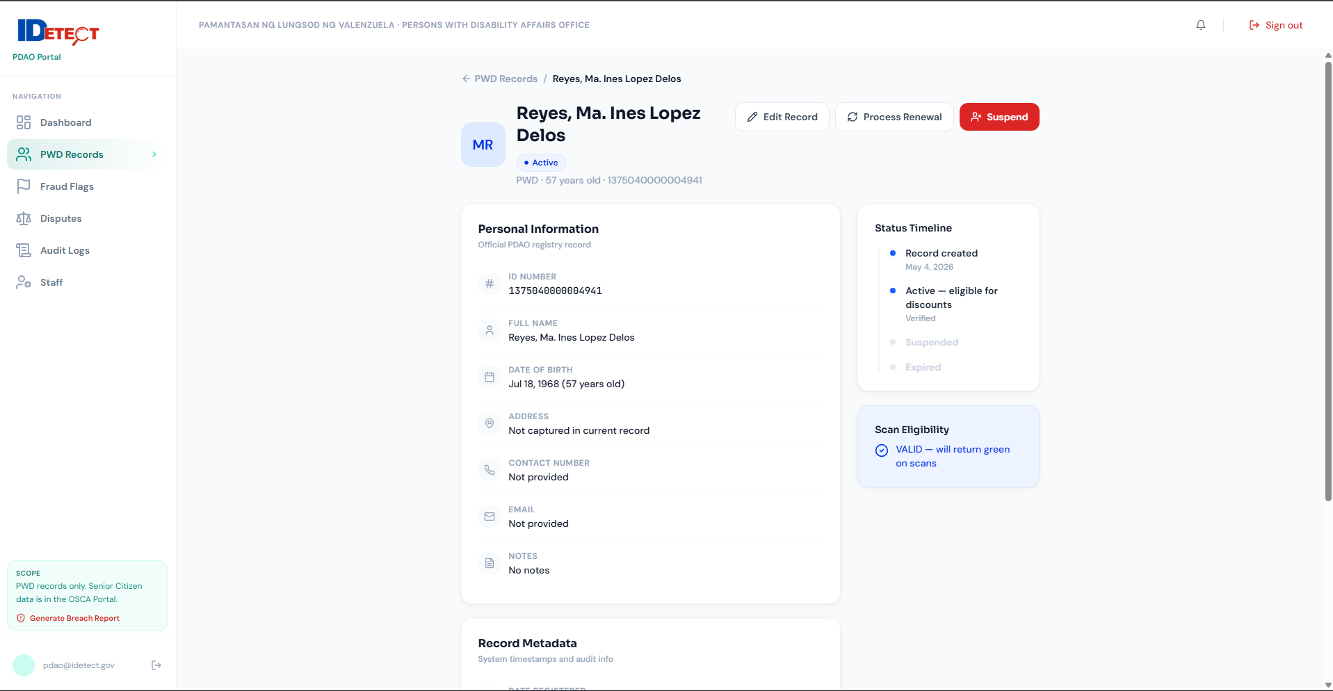
PDAO Portal
